stop | stop
wait | wait
look | look
listen | listen

throw | throw
catch | catch
roll | roll
hop | 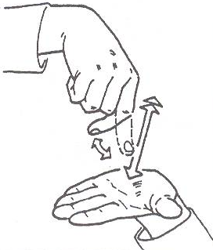  hop

climb | climb
run | run
kick | kick
skip | skip

balance | balance
jump | jump
forwards | forwards
backwards | backwards

