Informal Planning Guidance

Large-Scale Shared Living Accommodation (Co-living)




June 2026
Quick Guide to the Large-Scale Shared Living Accommodation Informal Planning Guidance document

This guidance document provides an interim policy framework to address the emerging trend of large-scale shared living accommodation (co-living) developments as this is not yet fully addressed by national policy or the adopted Nottingham City Local Plan Part 2.

Its purpose is to ensure clarity and consistency in decision-making by outlining expectations, design standards, and assessment criteria for these new forms of emerging residential developments. This guidance supplements Policies 2 and 8 of the Aligned Core Strategy (ACS) and Policies DE1, DE2, HO1, HO3, HO4, and IN4 of the Land and Planning Policies Document (LAPP, 2020). The guidance will remain in place until the 2020 Local Plan Part 2 is formally revised. Other policies within the Local Plan may also be applicable depending on the specific nature of the proposed scheme.


For illustrative purposes only

All images and illustrative material within this document are indicative only and are intended to help visualise how co-living schemes could be delivered. However, they do not imply policy support or acceptability. Each proposal will be assessed on its own merits in accordance with the local plan, this guidance, and other material considerations.

Contents

1. Purpose and Status of the Document 1
2. Consultation 3
3. Introduction 4
4. Planning Policy Context 6
National Planning Policy Framework (NPPF) 6
Emerging Draft NPPF December 2025 7
Nottingham City Aligned Core Strategy (ACS) (adopted 2014) 8
Local Plan Part 2 - Nottingham City Land and Planning Policies Development Plan Document (LAPP) (adopted 2020) 8
Greater Nottingham Strategic Plan (GNSP) Publication Version 10
Sustainability Appraisal (SA) 10
5. Co-living Developments in Nottingham 11
6. Assessment of Need & Suitability 13
7. Design of Co-living Developments 14
Private and Communal Amenity Space 14
Unit Mix and Diversity 14
Co-Living Space Standards 15
Designing Effective Internal/External Communal Space 16
Accessibility Standards 18
Washing and Drying Amenities 18
Occupancy Profile 18
Shared Living for Older Persons 19
Change of use of existing buildings including Purpose Built Student Accommodation 20
Part-conversion of existing PBSA schemes 20
Waste and Recycling facilities 21
8. Planning Obligations and Viability 22
9. Pre-application Advice 24
Glossary 25
Appendix A: Evidence and Precedent 27
Appendix B: Illustrative Designs 31

Purpose and Status of the Document

  - Large-scale shared living accommodation (referred to as co-living throughout this document) is an emerging housing model with no standard definition in adapted national planning policy. Nottingham City Council does not currently have a dedicated policy for co-living schemes within its adopted Local Plan, creating a need for this interim guidance to inform planning decisions.

  - This guidance adopts a clear and consistent decision‑making approach by setting out measurable expectations for the design, quality and appropriateness of co‑living schemes. It provides a transparent framework for assessing proposals in accessible and sustainable locations, ensuring high‑quality accommodation and efficient use of land.

  - This document serves as a position statement, setting out how existing Local Plan policies will be interpreted when assessing co-living proposals. It outlines expectations around design, amenity, sustainability, occupancy, and developer contributions. While not carrying the statutory weight of policies within an adopted Local Plan or Supplementary Planning Document, it will be treated as a material consideration in planning decisions until a specific co-living policy is adopted in the revised Local Plan.

  - In the absence of national or local policy on co-living, this guidance provides a consistent framework for interpreting relevant policies. Nottingham City Council recognises the varied approaches taken by other authorities and aims to ensure transparency and consistency in its own decision-making.

  - The guidance supplements policies in the Nottingham City Aligned Core Strategy (ACS, 2014) and the Land and Planning Policies Document (LAPP, 2020), particularly those relating to housing mix, design quality, sustainability, and infrastructure. It is intended to bridge the current policy gap until the Local Plan is formally updated.

  - Co-living proposals will be assessed on a case-by-case basis. In general, well-designed schemes that meet the standards set out in this guidance and are located in accessible locations with good access to services and employment via walking, cycling, and public transport will normally be supported, subject to compliance with the national and local planning policy and other material considerations.

  - Rather than prescribing specific design formats, the guidance establishes minimum standards to ensure quality, functionality, and resident wellbeing. It encourages flexibility and innovation in response to the unique characteristics of emerging co-living developments.

  - This guidance does not introduce new policy requirements but clarifies how existing local plan policies will be applied to co-living schemes to support consistent and transparent decision-making.

Conversion of Existing Buildings Including PBSA

  - In addition to guiding new co-living developments, this document also provides a framework for assessing proposals involving the conversion of existing buildings, particularly Purpose Built Student Accommodation (PBSA).

  - PBSA schemes, typically designed for short-term student occupancy, differ significantly from co-living in terms of layout, amenity provision, and management. As such, conversions to co-living use will generally require substantial adaptation to meet the expectations of longer-term residents such as working professionals. Whilst internal works may not require planning permission, the change of use of PBSA is likely to represent a material change and in most cases will require planning permission. The guidance outlines the design, policy, and infrastructure considerations necessary to ensure such conversions are feasible, sustainable, and policy compliant. Additional developer obligations (e.g. Section 106 contributions) may also apply and will be assessed on a case-by-case basis.

  - This interim planning guidance document will be kept under review and updated as appropriate. Any new government legislation/guidance or other evidence will supplement the information contained within this document.

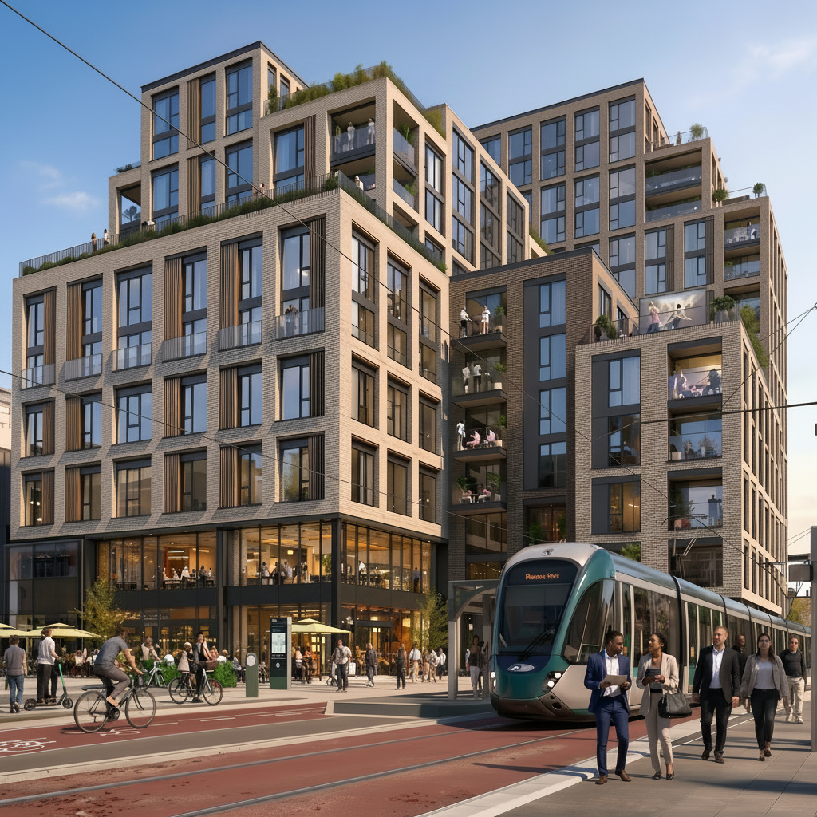
For illustrative purposes only

Consultation

  - This Informal Planning Guidance (IPG) has been subject to public consultation, in line with the Council’s approach to the preparation of non‑statutory planning guidance. The consultation ran from 12 March and Friday 17 April 2026, with an extension on the original 4-week period being made on the original closing date (9 April). The Council sought to engage with a broad range of stakeholders, including residents, statutory bodies, professional interests, institutional stakeholders, known national co-living providers and elected members, to ensure that the guidance was informed by a wide spectrum of perspectives.

  - The comments received through the consultation process have been carefully considered and have informed a number of refinements and amendments to the IPG, as set out in the accompanying Report of Consultation (RofC). This summarises the representations received and the Council’s responses, it is published separately and is available on the Council’s website alongside this IPG.

Introduction

  - Co-living is an emerging new form of residential development. Although all schemes vary, they typically comprise large-scale (50 or more beds), purpose-built, and professionally managed accommodation that fosters communal living. Such schemes generally include a combination of private living spaces such as studio units with private ensuite and cooking facilities and shared units, where multiple residents occupy a single housing unit with private bedrooms but share common areas like bathrooms, kitchens, or living spaces within the unit itself, similar to a shared flat or House in Multiple Occupation (HMO).

  - Co‑living is most suited to locations where higher‑density residential development can be supported by strong access to public transport, employment and services. This approach aligns with wider national objectives to optimise land use in well‑connected urban areas and support high density forms of development.

  - For the purposes of this guidance, a development will be regarded as co-living (and therefore sui generis) only where all of the following characteristics are present:

- The scheme is purpose-built or results from the conversion of a non-residential building (e.g. office, hotel, or other commercial building) or Purpose-Built Student Accommodation; it does not include the subdivision or change of use of an existing C3 dwellinghouse (including a former single-family house) unless the building has already been in lawful use as a large HMO (7+ occupiers) or PBSA.
- It comprises 50 or more bedspaces under single professional management.
- It provides extensive communal amenity facilities that are integral to the concept and operation of the scheme.
- Private units (studios or bedrooms in shared flats) are predominantly let on individual licences/tenancies with a minimum stay of 3 months and are supported by the communal facilities as the primary means of meeting daily living needs (cooking, dining, socialising, working, recreation).
- The accommodation is marketed and managed as a co-living product aimed primarily at working young adults rather than families with children.

  - Proposals that do not meet all of the above criteria will normally be assessed as C3 dwellinghouses, C4 HMOs, or large (sui generis) HMOs as appropriate, and will be expected to comply fully with Nationally Described Space Standards (NDSS) and normal private amenity requirements without recourse to the aggregated amenity approach set out in this guidance.

  - A key aspect of Co-living developments is the extensive shared communal amenities, such as communal kitchens, lounges, workspaces, gyms, laundry rooms, roof terraces and other social or recreational areas, which are integral to the daily living of the occupiers.

  - Co-living schemes are operated under a single management regime, with flexible but professionally managed tenancies, usually requiring a minimum stay of three months or more. They are generally aimed at working professionals, graduates, or key workers, but can also include some students. They are not typically designed for families and are intended to support high-density, urban lifestyles in well-connected and accessible locations.

  - This document considers the requirements for new-build co-living development as well as the repurposing of existing buildings, including the change of use of established Purpose Built Student Accommodation (PBSA).

Build to Rent (BtR)

  - Build to Rent (BtR) developments are another distinct form of residential accommodation within the private rented sector (PRS). They are typically professionally managed, purpose-built rental homes held in single ownership, often including shared amenities similar to co-living such as lounges, co-working spaces, gyms, and concierge services. While BtR and co-living schemes share characteristics such as communal facilities and professional management, BtR developments are generally designed for longer-term occupancy for single households and typically comply with the NDSS ensuring adequate internal space and amenity provision. As such, in most cases, this guidance will not apply to Build to Rent schemes, unless the proposal deviates from NDSS or raises specific concerns around amenity, tenure mix, or community integration.


For illustrative purposes only

Planning Policy Context

National Policy Context

National Planning Policy Framework (NPPF)

  - The National Planning Policy Framework (NPPF) (2024) does not explicitly address co-living but provides broader guidance that local planning authorities (LPAs) can apply to assess co-living proposals, focusing on meeting diverse housing needs and ensuring quality accommodation.

  - The NPPF (paragraph 63) emphasises the need to address the housing needs of specific groups, including young professionals, who are often a target demographic for co-living. LPAs are encouraged to assess local housing needs, which can include demand for co-living arrangements, as part of their development plans

  - National planning guidance does not explicitly define or directly promote “co-living” (as it does for Build to Rent or HMOs), but local authorities can count co-living schemes towards housing supply targets when justified based on established planning principles and interpretations of the NPPF providing flexibility in housing delivery.

  - Co-living is likely to be considered ‘Sui Generis,’ as it does not fit within standard residential (C3), houses in multiple occupation (C4), or other use classes. This means full planning permission is generally required for co-living developments or conversions of such schemes, allowing LPAs to scrutinise proposals thoroughly.

  - The NPPF stresses delivering high-quality, well-designed housing that supports residential amenity. Therefore, co-living developments should provide sufficient communal spaces (e.g., kitchens, lounges) and private units that meet basic functional needs (e.g. sleeping, bathroom, storage). LPAs are expected with all residential development to assess the quality of accommodation, including accessibility and integration with local communities.

  - In particular, policy 135(f) states that: ‘planning policies and decisions should ensure that developments: … f) create places that are safe, inclusive and accessible and which promote health and well-being, with a high standard of amenity for existing and future users.’ In footnote 51 it then references the NDSS, ‘where the need for an internal space standard can be justified.’

  - This is expanded upon in the National Design Guide. Paragraph 126 states that: “Well-designed homes and communal areas within buildings provide a good standard and quality of internal space. This includes room sizes, floor-to-ceiling heights, internal and external storage, sunlight, daylight and ventilation. The quality of internal space needs careful consideration in higher density developments, particularly for family accommodation, where access, privacy, daylight and external amenity space are also important.”

  - This sets a clear policy requirement of ensuring that any new developments, including co-living, ‘promote health and well-being,’ and have a ‘high standard of amenity.’

Emerging Draft NPPF December 2025

  - The Government released a new draft National Planning Policy Framework (NPPF) in December 2025. Whilst the draft document is not afforded the weight of adopted National Policy, it can still be a material consideration, with weight given depending on the stage of consultation of an emerging plan, the extent of unresolved objections and alignment with adopted local policy.

  - The glossary to the Draft document includes definition of ‘large-scale shared living accommodation’ as a distinct non-C3 use. This can be considered the term used to describe co-living developments. The exact NPPF definition of large-scale shared living accommodation’ is:

‘Non‑self‑contained accommodation which provides private rooms alongside shared communal spaces and facilities. This type of accommodation does not constitute self‑contained dwellings (use class C3), HMOs, student accommodation, hotels, or other residential institutions. Tenancies should be for a minimum of 3 months.’

  - On Living Standards and Internal/Communal Space the draft NPPF states that:

HO9: Specialist forms of accommodation

1. Development proposals to address specialist housing needs should provide living conditions and access to services which are appropriate to the needs of their residents and users. This includes:
c. .. large-scale shared living accommodation:
i. being located where residents will be able to access frequently-used services (..) easily and safely by walking, wheeling or public transport;
ii. providing adequate living and storage space and sufficient shared cooking, laundry and amenity areas (..); and
iii. being supported by a management plan which shows how the development will be managed and maintained to ensure the continued quality of the accommodation, communal facilities and services (and which should be secured by means of a planning condition).

  - The requirement of ‘providing adequate living and storage space and sufficient shared cooking, laundry and amenity areas’ is particularly important, as it creates a requirement and places an obligation on local authorities to consider what exactly constitutes ‘adequate’ and ‘sufficient’ ‘living and storage spaces,’ and shared ‘cooking, laundry and amenity areas,’ as no further guidance is provided on the criteria and quantum for this, beyond the general provisions for housing.

  - The Draft NPPF continues to strengthen the government’s ambition for higher‑density, efficient use of land, particularly in sustainable urban locations. It aims to contribute towards a diversified housing offer that meets the needs of different groups, including renters, students, and those seeking non‑traditional housing typologies. However, there remains a strong expectation for design quality, management, and living standards, especially for higher‑intensity forms of accommodation.

  - The Draft NPPF sets out specific requirements for large‑scale shared living. Regarding location and Accessibility, developments should be located where residents can access everyday services easily and safely by walking, wheeling or public transport. They should demonstrate good connectivity and reduce reliance on private car use.
  - Under the Draft guidance, co‑living proposals would be required to demonstrate a robust management plan showing how the building and shared facilities will be managed and maintained long‑term. This must be secured by planning condition and form part of the planning submission.

Local Policy Context

Nottingham City Aligned Core Strategy (ACS) (adopted 2014)

  - Policy 2 - The Spatial Strategy of the ACS supports a minimum of 17,150 new homes in Nottingham City by 2028, with a focus on regeneration and brownfield sites. Co-living projects, which typically target compact, urban sites, fit within this framework by contributing to housing targets in central and accessible and sustainable locations.

  - Policy 8 - Housing Size, Mix and Choice encourages developments to provide a mix of housing sizes and tenures, including affordable housing, to address local needs. It specifically notes the importance of smaller units (e.g., one- and two-bedroom homes) in urban areas, which aligns with the typical unit size in co-living schemes. Additionally, the policy supports innovative housing solutions to meet changing demographic needs.

  - Of particular importance is the wording in Policy 8 that “Residential development should maintain, provide and contribute to a mix of housing tenures, types and sizes in order to create sustainable, inclusive and mixed communities. All residential developments should contain adequate internal living space. …

  - This, in conjunction with the requirements from the NPPF, places an obligation on local authorities to ensure that any residential development approved, including those for co-living, that the quantum of space provided is adequate for residents’ needs.

Local Plan Part 2 - Nottingham City Land and Planning Policies Development Plan Document (LAPP) (adopted 2020)

  - The Nottingham Local Plan does not include specific policies for co-living schemes but includes several relevant policies that will be considered when assessing co-living schemes.

  - Policy DE1 - Building Design and Use is relevant to co-living developments as it promotes high-quality design and sustainable development in Nottingham. The policy emphasises creating well-designed, inclusive, and adaptable living spaces that meet diverse housing needs, aligning with the co-living model’s focus on shared, flexible, and community-oriented accommodations. The Policy sets out the requirement for all residential developments in NCC to meet NDSS (as set out in table 5 of the LAPP), with the caveat that these standards are specifically set for dwellings of 1 to 6 bedrooms.

  - While “dwelling” is not explicitly defined, the established Gravesham test is that a dwelling is ‘a unit of residential accommodation which provides the facilities needed for day-to-day private domestic existence.’ A co-living studio can in principle meet these criteria, noting that a dwelling can, at least in part, be non-self-contained, provided that the unit has at least the elementary requirements for ‘day-to-day private domestic existence,’ and where communal reliance does not undermine the “private” nature of day‑to‑day living. This requirement is also not affected by the use class of the unit, provided that its primary use is residential. Thus, whether a unit is a dwelling is thus a matter of fact and degree, not typology.

  - Policy DE1 also emphasises in paragraph 4.78 that ‘dwellings should provide a satisfactory environment for occupants’, echoing the requirement of ACS Policy 8. It further states that new dwellings are ‘expected to meet the Government’s Nationally Described Space Standard unless there is clear evidence to demonstrate that this would not be viable or technically feasible and that a satisfactory standard of accommodation can still be achieved.’

  - Policy DE2 - Context and Place Making focuses on context and place-making. It requires new developments to respect and enhance the character, context, and identity of their surroundings through high-quality design. Proposals must consider local distinctiveness, topography, heritage, and landscape features, ensuring they create safe, inclusive, and sustainable places. The policy emphasises integrating developments with existing communities, promoting accessibility, and enhancing the public realm to support vibrant urban environments.

  - Policy HO1 - Housing Mix requests delivering a mix of housing types, sizes, and tenures to meet diverse community needs. It encourages innovative housing solutions, including those that address affordability and cater to specific groups such as young professionals or students, which aligns with the co-living model’s emphasis on shared, flexible, and cost-effective living spaces. For co-living schemes, schemes are encouraged to have a mix of types of accommodation to adhere to the requirements of this guidance.

  - Policy HO3 - Affordable Housing covers on affordable housing. It requires developments of 15 or more dwellings to provide a proportion of affordable housing, typically 20% in most areas, subject to viability. The policy aims to address local housing needs by ensuring a mix of tenures, including social rented and intermediate housing, and supports contributions from Purpose-Built Student Accommodation (PBSA) schemes via commuted sums, as detailed in the associated Supplementary Planning Document (SPD). For clarification, this policy also applies to co-living developments. There may be flexibility on these requirements for co-living, build to rent and other specialist accommodation, but this will be dependent on a viability assessment being submitted to justify any deviation from normal targets.

  - Policy IN4 - Developer Contributions sets out managing the impacts of new development on infrastructure, ensuring adequate provision of services and facilities. Co-living developments, which often cater to young professionals, and having shared amenities, require robust infrastructure support, such as improvements to open space, highways, public realm, etc. Policy IN4 supports these developments by requiring contributions to infrastructure improvements, ensuring co-living projects are sustainable and integrated into Nottingham’s urban form, enhancing their viability and community benefits. As a starting point it is likely that contributions will be requested for affordable housing, off-site public open space/public realm, and financial contribution to facilitate the delivery of the local employment and training opportunities. Other contributions may also be negotiated on a case-by-case basis.

  - In applying local plan policies to co‑living proposals, significant weight will be placed on accessibility, design quality, efficient land use and the contribution that such schemes make to meeting identified housing needs. This provides a consistent and transparent basis for assessing proposals in well‑connected locations. Other policies within the Local Plan may also be applicable depending on the specific nature of the proposed scheme.

Greater Nottingham Strategic Plan (GNSP) Publication Version

  - Nottingham City is currently working jointly on this emerging plan with Rushcliffe Borough and Broxtowe Borough Councils. The plan was submitted for examination on 22 December 2025. On adoption, the GNSP will replace Part 1 (ACS) of the Nottingham Local Plan, while Part 2 (LAPP) remains in force.

  - Policy 8: Housing Size, Mix and Choice (extract 8.1) establishes the importance of delivering residential development that contributes to a mix of housing types, sizes and tenures in order to support sustainable and inclusive communities. It also requires that residential development provides adequate internal living space, with the NDSS identified as the relevant benchmark. In the context of co‑living, this policy provides the basis for assessing whether proposals deliver acceptable living conditions, while recognising that the NDSS may not be a perfect fit for this typology.

Sustainability Appraisal (SA)

  - Sustainability Appraisal is a statutory process that must be undertaken for every new planning document in accordance with the Planning and Compulsory Purchase Act (2004). The purpose of SA is to assess the economic, social and environmental impacts of projects, strategies or plans, so that the preferred option promotes, rather than inhibits sustainable development. A specific SA has not been carried out for this interim guidance as the SA of the relevant policies in the Local Plan is relied upon. Please reference the SA for Policies 2 and 8 of the Nottingham City Aligned Core Strategy – ACS (2014) (Part 1 Local Plan) and Policies DE1, DE2, HO1, HO3, HO4 and IN4, of the Land and Planning Policies Document - LAPP (2020) (Part 2 Local Plan).

Co-living Developments in Nottingham

  - A Housing Needs Update (HNU) has been prepared for Greater Nottingham (excluding Erewash) and Ashfield area to support the preparation of Local Plans looking at an extended plan period to 2041, and to provide evidence drawing on the latest data including the 2021 Census to support housing market interventions and prospective future funding bids.

  - Nottingham’s demographic profile makes it a suitable candidate for appropriately designed co-living developments. The city has a high proportion of younger adults, particularly those aged 20–34. In 2021, 8,074 individuals aged 20–34 lived in one‑person households in Nottingham (excluding communal establishments), representing approximately 2.7% of all individuals living in households in the city. Additionally, Nottingham is home to a significant student population, alongside a growing number of graduates and young professionals. These groups often face financial constraints that prevent them from achieving home ownership, making co-living an attractive option. Co-living provides flexible, professionally managed tenancies and can foster communal living environments, which align well with the lifestyle preferences and economic realities of these demographics.

  - The city’s housing market is characterised by significant affordability pressures. With a home ownership rate of just 46% and a high proportion of private renters at 29%, many residents face challenges in accessing affordable housing. The affordability gap between lower quartile rents and Local Housing Allowance (LHA) rates is particularly pronounced for one-bedroom and four-bedroom properties. Co-living offers a potential solution by providing more affordable rental options compared to traditional private renting. By incorporating shared amenities and smaller private units, co-living schemes can reduce costs while maintaining quality, making them an appealing alternative for some Nottingham’s renters.

  - Nottingham’s need for sustainable and accessible housing solutions further supports the case for co-living. The city faces land supply constraints, necessitating higher-density housing to meet demand. Co-living schemes, with their more compact private units and shared facilities, can enable high-density development without compromising liveability or quality. This approach aligns with Nottingham’s urban planning goals, particularly in regeneration areas and near key transport hubs, where maximising land use is critical. By focusing development at highly accessible locations, co-living can contribute to sustainable urban growth in sustainable locations while supporting the city’s regeneration efforts.

  - The flexibility of co-living also addresses the evolving needs of Nottingham’s housing market. The Housing Needs Assessment (HNA) underscores the demand for adaptable housing models that respond to changing lifestyles and economic conditions. Co-living provides shorter-term tenancies, community-focused living spaces, and amenities tailored to modern needs, such as support for remote working. These features make it well-suited to meet the preferences of younger residents and professionals who value flexibility and community in their living arrangements.

  - Nottingham’s existing housing stock presents opportunities for co-living through repurposing. The city has a mature Purpose-Built Student Accommodation (PBSA) market, with an increasing number of vacant bedspaces in recent years, some of which are in older stock. Converting these buildings as well as other suitable properties into co-living spaces with appropriate adaptations could unlock valuable housing resources. With a pipeline of new student accommodation, repurposing underutilised PBSA offers a practical and efficient way to expand co-living options in Nottingham.

  - The Council is unlikely to support the use of co-living standards or the aggregated amenity approach for schemes that are essentially the subdivision or adaptation of existing C3 houses into shared accommodation. Such proposals will continue to be assessed against HMO policies and, where applicable, the full NDSS without offset from communal facilities.

  - The definition provided in the introduction sets out the characteristics that must be present for a proposal to be considered genuine co-living. Schemes that would result in the net loss of existing or potential family housing (C3) are unlikely to normally be accepted as co-living unless they involve the comprehensive redevelopment or non-residential conversion of a site.

Licensing Requirements

  - Depending on the type of units being created, they may be subject to licensing. Additional licensing would apply to HMOs and the current designation applies City wide until 2028. Selective Licensing of private rented accommodation is only required within a prescribed designated area. For further advice see Licensing for Landlords

Assessment of Need & Suitability

  - Co‑living developments represent a relatively new and distinct form of residential accommodation. While a formal needs assessment will not normally be required, applicants are encouraged to explain within their Planning Statement, Design and Access Statement, or other supporting documentation (whichever is most appropriate), how the proposal responds to local circumstances and aligns with the objectives of the Local Plan and national planning policy.

  - Such information may be particularly helpful if elements of a proposal depart from the guidelines set out in this IPG. In these cases, applicants may wish to provide contextual justification to demonstrate that the development will still deliver adequate internal living space and a high standard of residential amenity. In such instances, it should be assumed that there will be a higher evidentiary burden to justify the development in terms of national and local planning policy.

  - Co-living developments are generally best suited to highly accessible locations, where residents can readily access employment, services and leisure opportunities by public transport, walking or cycling. Applicants are therefore encouraged to outline how the site’s accessibility and surrounding context support a high-density, shared-living model and align with wider sustainability and placemaking objectives.

  - Where relevant, co‑living schemes may also be appropriate on sites identified in the Local Plan as capable of accommodating higher‑density or innovative housing formats. Applicants may find it helpful to explain how the proposal makes efficient use of land and integrates with its surroundings.

Indicative matters that may be addressed (where relevant)

Local Evidence Base and Market Analysis | Reference to relevant local housing studies, demographic trends (e.g. growth in single‑person households), rental market conditions, or comparable schemes, where this assists in explaining the nature of the proposal.
Role in Housing Provision | An explanation of how the scheme fills a gap in current housing supply for example, by offering high-quality, managed accommodation for residents priced out of ownership or traditional renting.
Sustainability and Location Justification | Confirmation that the proposed site is in a highly accessible location, close to major transport hubs or frequent public transport corridors and will support active travel.
Design and Occupancy Standards: | Developers should demonstrate:  - High quality design and good integration with surrounding uses.  - Details on all unit/room sizes and specifically set out minimum unit sizes, what shared facilities are to be provided, and proposed management arrangements.

Design of Co-living Developments

Private and Communal Amenity Space

  - Co-living developments should provide well-designed, integrated, and accessible shared amenity spaces, typically with some element of distribution throughout the scheme. Well-designed co-living schemes can offer an opportunity to foster a positive and supportive community through high-quality shared spaces, often providing the added benefit of reduced overall living costs due to these shared amenities and accessible location.

  - Policy DE1 of the LAPP emphasises the importance of providing appropriate private or communal amenity space for residential developments, including Houses in Multiple Occupation (HMOs) and other forms of shared living, to ensure a high quality of life for residents. It requires that such spaces are well-designed, accessible, and sufficient to meet residents' needs. Policy DE2 supports the creation of well-designed places, including the provision of defensible space and high-quality communal areas that promote community interaction to meet the functional needs of residents.

  - Nottingham City Council will ensure that co-living developments deliver an appropriate level of amenity space. This will include both internal and external communal areas which should be design-led, considering the composition of spaces, their interrelationships within the building, and their intended use(s). These spaces should be inclusive, well-designed, appropriately sized, well-ventilated, easily accessible, and sufficient to meet the needs of the expected number of residents. They should also be adaptable for flexible use, enabling residents to exercise a reasonable degree of autonomy and fostering a sense of community. Layouts that discourage interaction, such as those with narrow corridors leading to numerous small bedrooms and limited shared amenity spaces, will normally not be supported owing to not meeting the policy expectations set out by national and local policy.

Unit Mix and Diversity

  - It is recommended that co-living developments should incorporate a balanced mix of unit types, including both studio units and shared flats. A diverse accommodation mix supports varied lifestyle preferences, enhances affordability, and fosters community interaction and meets the aims of LAPP Policy HO1 to ensure a mix of house types and sizes. The Council recognises that studio‑based accommodation is the preferred format for many co‑living operators and reflects current sector practice. However, the Council continues to strongly encourage a mix of layouts and accommodation formats where appropriate, as part of achieving inclusive, adaptable and resilient developments that respond to a range of needs over time. The Council expects developers to demonstrate how the proposed mix meets identified housing needs and contributes to a high-quality living environment for future occupiers.

Co-Living Space Standards

  - By design co-living developments prioritise efficient use of space. These compact units are designed to meet the needs of individual residents while maximising the use of communal available space. The focus on smaller private areas underscores the importance of well-designed communal spaces to enhance the overall living experience of residents.

  - It is recognised that internal communal amenity in co‑living schemes do not operate on a simple per‑resident proportional basis. Many shared facilities are subject to intermittent and staggered use, meaning that as schemes increase in scale, peak demand does not rise in direct proportion to the number of occupants. Larger developments are also typically able to provide a wider range of shared spaces, improved management arrangements, longer opening hours and better distribution of amenity throughout the building, all of which reduce pressure on individual facilities.

  - In this context, a modest reduction in communal amenity space per bedspace in larger schemes can still deliver adequate internal living space and a high standard of residential amenity, provided that such space is of high quality, genuinely accessible, varied in type, and appropriately distributed. The tiered approach set out in this guidance reflects these functional and operational realities and is supported by a fixed minimum private unit size and a holistic assessment of residential living conditions.

  - Given this, the Council’s starting position is that, with appropriate room geometry and high-quality design, the following represent a robust basis for demonstrating adequate internal living space:

Indoor amenity space | Tiered Approach  - 4 sqm per bedspace in smaller schemes (up to c.150 bedspaces),  - 3.5 sqm per bedspace in medium‑sized schemes (c.150–300 bedspaces),  - 3 sqm per bedspace in larger schemes (over c.300 bedspaces).  - Note: This is premised on indoor amenity space being of adequate quality, diversity and distribution (see 7.21) to meet user’s needs.
Private unit size | Requirements vary by unit type:  - Studios / one bed units (sole occupancy): 25 sqm or greater.  - Two bed or larger units, and dual occupancy one bed units: Proposals with overall dimensions below NDSS may be considered acceptable where layouts provide adequate internal communal space and private living space for occupants and, where relevant, comply with HMO or other licensing requirements.

  - For the purposes of calculating indoor amenity provision, dual occupancy one bed units will be treated as two bedspaces.

  - Appendix A explains the process and evidence followed to arrive at these recommendations. Appendix B provides illustrative layouts demonstrating how compact studios of around 25 sqm can function effectively where well designed. These examples are indicative only and must be read alongside the full guidance in this document.

  - Achieving the above guidelines is an important component of demonstrating a satisfactory standard of accommodation but is not, in itself, determinative. For example, a 25 sqm studio with poor room geometry, limited daylight, or inadequate circulation space may fail to provide sufficient internal living space. Conversely, above‑average provision of high‑quality amenity space, carefully distributed so that a limited number of private units share dedicated kitchen and living facilities, may support a modest reduction in private unit size where a clear design and operational rationale is demonstrated.

  - Given the non‑statutory status of this guidance, it must be noted these guidelines are not policy requirements but represent the Council’s reasoned interpretation of national and local planning policy and will be applied as a material consideration when assessing proposals.

  - For the avoidance of doubt, the flexibility described above applies only to genuine co-living developments as defined in Section 3 of this guidance. It does not apply to Houses in Multiple Occupation or other shared residential accommodation, which will continue to be assessed against the Council’s HMO Amenity Guidance, including full compliance with national minimum room size standards without offset.

  - Standards for outdoor amenity space are addressed in separate planning guidance – please refer to the ‘The Provision of Open Space in New Residential and Commercial Development’ Supplementary Planning Document. In instances where most open space is likely to be provided off-site; it is recommended that at least 1 sqm per bedspace of open space is still provided on site.

  - To justify the unit mix, it is expected that a detailed accommodation schedule will be submitted with each planning application, which must include:
- The size of every unit, with classification in terms of unit type and number of bedrooms,
- Details of indoor and outdoor amenity space, broken into type, with accompanying size (net floor area),
- Details of the other spaces that make up the building (reception areas, storage spaces, communal laundry spaces, etc.), broken into type and total area (net).
- Calculation of both the scheme average of total amenity space (i.e. combined private unit area and indoor amenity space), and calculation of the total amenity space available to the smallest unit in the scheme.

Designing Effective Internal/External Communal Space

  - For clarification, the council considers the following to be examples of shared amenity spaces:
- Communal kitchens
- Dining areas
- Lounges
- Workspaces
- Gyms/exercise rooms
- Gardens
- Rooftop terraces
- Courtyards; and
- Other shared communal spaces

  - These spaces should be thoughtfully designed to encourage recreational use, be (normally) freely accessible to all residents, and integrate seamlessly with the accommodation. They need to be well-designed communal areas which foster social interaction and enhance the overall quality of life for co-living residents.

  - Only general-use recreational or work-oriented spaces freely available to all residents at all reasonable times should be included in the communal-space calculation. Service areas (laundry, bike stores, bin rooms), circulation spaces, reception areas and bookable/paid/private-hire spaces should be excluded.

  - The quality, distribution and genuine accessibility of internal amenity space are critical to the success of a co-living scheme. To avoid token provision, applicants should note the following best-practice principles, and ensure that a range of such facilities are included in each scheme -

- Cluster-Based Lounges: In larger blocks, consider providing dedicated communal lounges serving no more than 20–25 bedspaces each. This creates manageable social groups and prevents smaller units from being overly reliant on distant or over-subscribed shared areas. These lounges could also include communal kitchen and dining facilities, which would be in addition to kitchen facilities in each private unit.
- Co-working Spaces: In recognition of the growing trend toward remote and flexible working, provide well-designed co-working areas with reliable high-speed internet, ergonomic seating, and access to natural light. These spaces should be acoustically treated to allow focused work and include a mix of open desks, private booths, and small meeting rooms. Ideally, co-working spaces should be in quieter parts of the building to avoid conflict with social areas.
- Gym and Fitness Areas: Incorporate fitness facilities that cater to a range of activities, such as cardio, strength training, and yoga/stretching. Good ventilation, natural light, and safe flooring are essential.
- Shared Kitchens and Dining Rooms: Include larger communal kitchens and dining halls for social events and group cooking. These spaces should be well-equipped, with sufficient appliances, storage, and seating to accommodate multiple users simultaneously.
- Wellness and Quiet Rooms: Designate spaces for meditation, reading, or quiet reflection. These rooms should be soundproofed and furnished with comfortable seating, soft lighting, and calming decor.
- Entertainment and Social Rooms: Include spaces for leisure activities such as cinema spaces, gaming rooms or multipurpose leisure uses. These should be acoustically separated from quiet zones to avoid disturbance.

  - While not counting towards internal amenity space calculations, these additional facilities should also be considered for provision in most co-living schemes:

- Laundry Facilities: Centralised laundry rooms with adequate machines, drying areas, and folding stations are essential. Consider integrating social elements, such as seating or coffee points/vending machines, to make these spaces more inviting.
- Storage Solutions: Offer secure communal storage for bicycles, sports equipment, and seasonal items. Adequate storage reduces clutter in private units and supports active lifestyles.
- Coffee Shops: Where feasible and depending on the size of the co-living scheme, incorporate a small café or coffee bar within the scheme. This can act as a social anchor, encouraging casual interaction and providing a convenient amenity for residents. Ideally, this space should be accessible to the public to foster community integration, but with clear boundaries to maintain security for residents.
- Parcel and Delivery Rooms: Provide secure, dedicated areas for parcel storage and delivery management which could take the form of a manned counter or parcel lockers. With the rise of online shopping, this helps avoid clutter in communal areas and ensures safe handling of deliveries.
- Outdoor Communal Spaces: Provide accessible outdoor areas such as terraces, gardens, or courtyards. These should include seating, greenery, and possibly BBQ facilities to encourage informal social interaction and relaxation.

  - In large co-living schemes, amenity spaces should not be overly concentrated in a single location. While some central facilities are appropriate, a degree of distribution throughout the building is encouraged to ensure accessibility and usability for all residents. Concentrating all communal spaces in one area can lead to overcrowding, reduce convenience for occupants in distant parts of the building, and discourage spontaneous social interaction.

Accessibility Standards

  - Co-living schemes are also required to meet Policy HO4: Specialist and Adaptable Housing). Applicants should submit drawings demonstrating that accessible private units comply with Part M of the Building Regulations, ensuring sufficient space and wheelchair accessibility. Accessible private studios are likely to require significantly more space than the minimum standards for general private studios or bedspaces, and developers should account for this during the initial design phase of a co-living scheme.

Washing and Drying Amenities

  - Sufficient washing and drying facilities should be provided for residents, either within private rooms or as part of shared communal provision. The format may vary depending on the overall design of the scheme, and the guidance does not prescribe a rigid approach. However, shared laundry facilities may offer a more efficient use of space, particularly in high-density developments, by avoiding the need to duplicate equipment in each unit. Shared facilities should be situated in a convenient, well-ventilated area and will not contribute to the communal space requirements unless purposefully designed to support recreational activities or social engagement. Washing and drying areas should not encroach upon or disrupt other communal spaces designated for cooking, dining, recreation, or socialising.

Occupancy Profile

  - Co-living schemes typically attract individuals who are currently part of the private rented sector. These occupiers are generally aged between 18 and 40 years and reside in households without children. The appeal lies in the high specification, fully managed and reasonably priced, all-inclusive accommodation that caters to their lifestyle, offering a modern and convenient living solution tailored to their needs.

  - A prime accessible location for co-living developments significantly enhances their attractiveness, with properties situated in the city centre near essential amenities, facilities, retail/services and employment opportunities. This proximity ensures residents can easily access urban conveniences, making co-living an ideal choice for those seeking a connected and vibrant lifestyle. These schemes are designed to align with the dynamic demands of city living.

  - A defining feature of co-living is the provision of high-quality shared communal spaces that promote sociable living arrangements. These areas are designed to encourage interaction and foster a sense of community among residents. The all-inclusive rental packages and streamlined management regimes further enhance the appeal by simplifying the tenancy experience, offering convenience and ease for occupiers.

  - The Council will support the development of co-living schemes that addresses the needs of young professionals, recent graduates, and key workers in the local economy. Co-living accommodation is often championed as an effective solution to meet these demands, thanks to its sociable and all-inclusive nature. By supporting such schemes, the Council aims to provide housing options that align with the priorities of these key demographic groups.

  - Although co-living can provide a more affordable rental option in the city compared to some other rental options, such as build-to-rent, the average cost of rent (inclusive of bills) is still significant. As such, whilst co-living accommodation provides an additional housing option for those able to afford it, and contributes to housing choice for this demographic, the Council does not consider it to be an affordable rented tenure.

Shared Living for Older Persons

  - While current co-living schemes have primarily been associated with younger demographics, there is growing recognition of its potential benefits for older residents. Shared living models can help address issues of social isolation, provide mutual support networks, and create safe, inclusive environments for those seeking community-oriented lifestyles later in life.

  - Recent award-winning schemes, such as those highlighted by RIBA, demonstrate how design-led shared housing can successfully integrate communal spaces with private accommodation tailored to older persons’ needs. These developments often feature accessible layouts, generous circulation areas, and adaptable units that comply with the NDSS ensuring mobility and usability for residents with varying physical needs.

  - Key considerations for older persons’ shared living include:
- Space Standards: Larger private units to accommodate mobility aids and personal possessions.
- Accessibility: Step-free access, wider doorways, and adaptable bathrooms.
- Communal Facilities: Shared kitchens, lounges, and gardens designed to encourage interaction and reduce loneliness.
- Storage: Adequate provision for personal belongings, which is often a priority for older residents transitioning from family homes.
- Management & Support: Professional management with optional care or concierge services to provide reassurance and assistance.

  - By incorporating these principles, shared living for older persons can deliver high-quality, sustainable housing that promotes independence while fostering community and wellbeing.

  - In most cases, given the type of accommodation proposed for older people, these schemes would meet NDSS requirements.

Change of use of existing buildings including Purpose Built Student Accommodation

  - Proposals for the change of use of existing buildings including Purpose Built Student Accommodation (PBSA) schemes need to comply with Local Plan policies and the guidance within this document including on minimum suggested room sizes and other guidance.

  - PBSA developments are typically designed for a transient student population, with smaller room sizes and limited personal amenity provision, reflecting the short-term nature of student occupancy. In contrast, co-living schemes are intended for a broader demographic including working professionals who may reside for longer-continuous periods and have different expectations around privacy, storage requirements and amenity.

  - As such, the design, layout, and management of existing PBSA buildings may not be inherently suitable for co-living without significant adaptation. The conversion of PBSA to co-living may also represent a material change in the nature and intensity of use, with potential implications for local infrastructure, amenity impacts, and the housing mix and will in most cases require planning approval.

  - This document provides essential guidance to ensure that any PBSA-to-co-living conversions are not only technically feasible but also policy-compliant, context-sensitive, and capable of delivering high-quality, sustainable living environments for future occupants. Without adherence to these principles, such conversions are unlikely to be supported owing to not meeting the policy expectations set out by national and local policy.

  - PBSA-to-co-living conversions may also require additional developer obligations (S106) which will be considered on a case-by-case basis in line with Section 9.

  - When converting PBSA, particular attention should be paid to upgrading internal communal provision. Student schemes often rely on limited cluster kitchens; co-living residents typically expect larger, multi-functional lounges/workspaces. Demonstrating how existing circulation cores can be reconfigured to deliver cluster hubs of c. 4–6 m² per bedspace will significantly improve the viability of conversion proposals.

Part-conversion of existing PBSA schemes

  - Part‑conversion of existing Purpose‑Built Student Accommodation (PBSA) schemes to co‑living or other non‑student residential use may be considered acceptable in principle. However, it will be for the applicant to clearly demonstrate how the proposed subdivision of an existing scheme such as by floor, wing, or discrete building can be achieved in a way that safeguards the living conditions, safety and residential amenity of both student and non‑student occupiers. Any accommodation proposed for non‑student use will be expected to comply fully with the guidance set out within this document, including in relation to minimum private room sizes, aggregated amenity space provision, design quality and management arrangements.

  - Where mixed occupation is proposed within a single building, applicants should recognise the potential for differing patterns of occupation, amenity use and activity between student and non‑student residents. Proposals should therefore demonstrate that the physical layout, access arrangements, communal facilities and management regime have been designed to minimise conflict, support effective management and ensure a satisfactory standard of accommodation appropriate to the intended length of stay and lifestyle of all residents. This approach reflects the requirements of Policy DE1 of the LAPP and provides a proportionate, policy‑led framework for assessing PBSA conversions that protects residential amenity and living conditions of all occupiers.

Waste and Recycling facilities

  - New co-living developments should have adequate provision of waste and recycling storage facilities and appropriate arrangements for the collection of such waste. Developers are advised to liaise with the council’s Planning Department and the council’s Waste Department for support and advice at the design stage to help clarify requirements and ensure that a suitable and satisfactory layout for the scheme is achieved for the management of waste. It is suggested that contact is made with waste colleagues through contacting planning@nottinghamcity.gov.uk in the first instance to discuss proposed schemes at the early design stage.

  - How waste is deposited/managed within the building is the responsibility of the developer, but due consideration should be given to encourage recycling and minimise waste stream contamination. For the collection of waste, the onus is on the developer to ensure residents have easy access to bins and collection points as well as adequate storage of waste according to the collection methodology and schedule of the council.

  - Developers should be aware that it is the government’s intention that councils will also have to provide a weekly mandatory food waste collection by 31 March 2026.

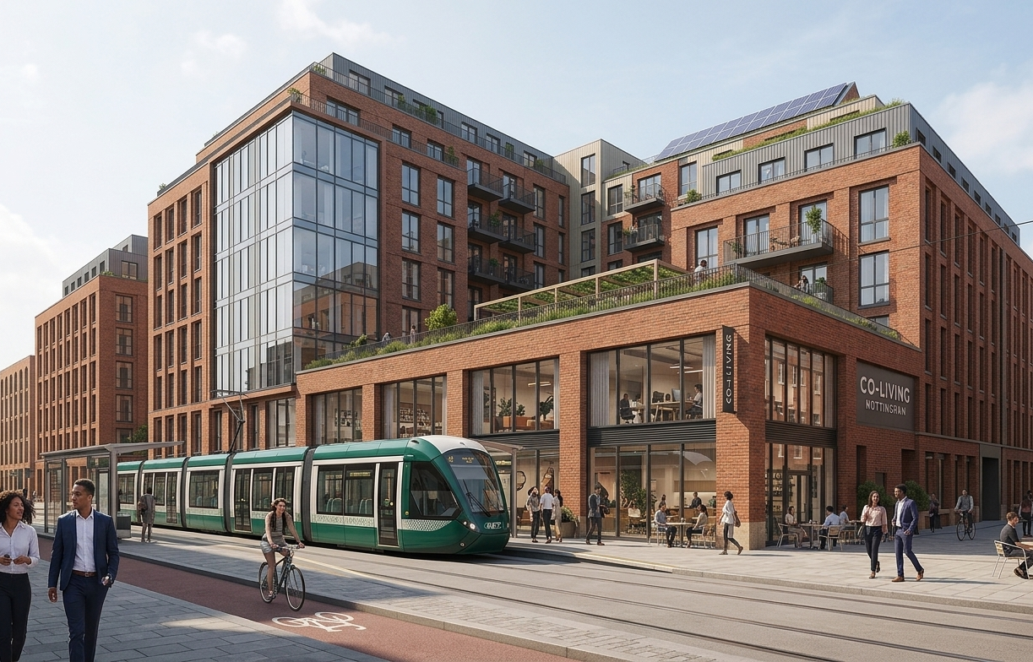
For illustrative purposes only

Planning Obligations and Viability

  - Each case will be considered on its own merits. However, the council will generally seek to secure financial contributions through negotiation of a legal agreement under Section 106 of the Town and Country Planning Act 1990. Where a Planning Obligation is entered, then it will need to be completed prior to the granting of planning consent. Further details can be found on the council’s S106 webpage including annually revised costs.

  - If an applicant considers there are viability issues due to the level of contributions being sought, or due to NDSS compliance under Policy DE1 rendering the scheme undeliverable, they will be required to submit a robust viability assessment. Such assessments will be independently examined before the scale and nature of any reduction or deviation is agreed.

  - The following are the starting point for Planning Obligations for new co-living schemes:

Planning Obligation | Details
Management Plan | A Management Plan is required and will normally be secured by condition and/or planning obligation, depending on the nature and scale of the development. This is to ensure that occupants of the development adhere to standards that prevent noise, disturbance, or nuisance to neighbouring properties. It should provide an established point of contact for nearby residents to report disturbances caused by occupants and mandates the maintenance of cleanliness and tidiness on the site. The plan should require the owner to manage the site effectively, including staffing designated offices 24/7 throughout the year and managing the accommodation. It should outline procedures for managing behaviour, providing contact numbers for residents, and detailing security measures such as CCTV monitoring and regular security patrols. Additionally, the plan should address cleaning and refuse collection to ensure the site remains clean and litter-free.
Education | Co-living developments are not aimed at families and as such there should not be a need for additional primary or secondary school places. However, it will be for the developer to clearly set out that the scheme is not expected to meet family needs now or in the future. Without this justification then it will be assumed that for apartments of 2 or more bedroom apartments that contributions towards education improvements may be required.
Open Space* | Open Space requirements should be agreed in line with The Provision of Open Space in New Residential and Commercial Development Supplementary Planning Document. Sole occupancy rooms will work on the assumption of one occupant per room for open space contributions.
Affordable Housing contributions* | Co-living developments are generally regarded as falling within the sui generis planning use class. In line with the Nottingham LAPP policies that promote the delivery of a balanced housing mix and support affordable housing provision, developments that create new residential units are expected to contribute towards affordable housing where thresholds are met. While co-living accommodation typically consists of self-contained studio units including sleeping space, seating, en-suite bathroom facilities, and a small kitchen or kitchenette. These units are considered residential in nature and should therefore be subject to affordable housing policies.  Therefore, Nottingham City council will seek S106 Affordable Housing Contributions in line with normal residential policy requirements.  Affordable housing requirements should be agreed in line with ACS Policy 19: Developer Contributions, LAPP Policy IN4: Developer Contributions and Policy HO3: Affordable Housing.
Employment and Training contributions* | In line with ACS Policy 19: Developer Contributions and LAPP Policy IN4: Developer Contributions and  Policy EE4: Local Employment and Training Opportunities
Other contributions agreed on a case-by-case basis but could include improvements to public transport, flood mitigation, improvement to highways or street scene etc. | In line with ACS Policy 19: Developer Contributions and LAPP Policy IN4: Developer Contributions
* these contributions can be calculated using the council’s S106 Estimator.

Pre-application Advice

  - Developers and applicants are advised to consult the Development Management Team at the City Council prior to submitting planning applications for new co-living developments to discuss any additional likely requirements given the unique type of development.

  - Please contact Development Management by emailing planning@nottinghamcity.gov.uk.


For illustrative purposes only

Glossary

Amenity Standards: Criteria for the quality and usability of living spaces, including private and communal areas.

Affordable Housing Contributions: Funding and planning efforts to increase the supply of homes for rent or sale at prices accessible to those whose needs are not met by the market.

Build to rent (BTR): Purpose-built housing designed for rent rather than sale, typically offering longer tenancies (e.g., three years or more) and managed by a single landlord.

Cluster flat / shared unit: A type of private unit consisting of individual private bedrooms with kitchen, living, and bathroom facilities shared only among the occupants of that same flat. A cluster flat exceeding eight bedrooms will not be recognised as a single private unit for the purposes of amenity calculations, space standards, or planning obligations (see Private unit).

Co-living: Purpose-built, professionally managed residential accommodation classified as sui generis, comprising a mix of private units (studios or shared cluster flats) together with extensive shared communal facilities, typically aimed at young professionals, graduates, or key workers.

Communal amenity space: Shared kitchens, lounges, workspaces, gyms, etc.

Flexible Tenancies: Rental agreements that offer varying lengths of stay, typically ranging from 3 to 12 months.

Houses in Multiple Occupation (HMOs): Generally shared houses of 3 or more persons living in 2 or more separate households but subject to a more precise definition within the Housing Act 2004.

Large-scale shared living accommodation: Non‑self‑contained accommodation which provides private rooms alongside shared communal spaces and facilities. This type of accommodation does not constitute self‑contained dwellings (use class C3), HMOs, student accommodation, hotels, or other residential institutions. Tenancies should be for a minimum of 3 months.

Note: For the purposes of assessing internal space standards and residential amenity, private units within large-scale shared living accommodation which, as a matter of fact and degree, meet the established functional tests of a dwelling will be treated as dwellings (see 4.23), notwithstanding that they are not fully self-contained and do not fall within use class C3.

Local Plan: Nottingham’s Core Strategy (2014) (ACS) and Land & Planning Policies Document (2020) (LAPP).

Nationally Described Space Standards (NDSS): Guidelines for the minimum size of new homes.

NPPF / NPPG: National Planning Policy Framework & National Planning Practice Guidance.

Private unit: An individual element of residential accommodation intended for the exclusive use of a single resident or household, forming the primary private living space within a development, regardless of whether it is fully self‑contained.

Purpose-Built Student Accommodation (PBSA): Accommodation designed and used solely for the occupation by students.

Planning Obligation (S106): A legal agreement entered into under section 106 of the Town and Country Planning Act 1990 to mitigate the impacts of a development proposal.

Studio room: A private unit occupied by one or two persons containing its own private en-suite bathroom and cooking facilities, with no sharing of kitchen or bathroom with residents from other units.

Sui Generis: A unique use of a property that does not fall into a prescribed use class.

Town and Country Planning (Use Classes) Order 1987 (as amended): A classification system for different types of property use in planning law.

Appendix A: Evidence and Precedent

This annex sets out the evidence and reasoning that has underpinned the development of these guidelines, with particular reference to the recommended parameters for private unit size and internal communal amenity provision.
1. Comparative approaches adopted by other authorities
Review of adopted and emerging policy indicates that local authorities have generally coalesced around three broad approaches to space standards for co‑living developments.
  - London, Chelmsford and Watford: lower minimum private room sizes and indoor amenities
The London Plan permits private co‑living rooms as small as 18 sqm (generally capped at 27 sqm), subject to substantial communal provision, tiered by scheme size, and location in areas of very high public transport accessibility. Communal internal amenity is expected at 4 sqm per resident for schemes up to 100 residents, reducing to 3 sqm and then 2 sqm per resident as scheme size increases. This approach is explicitly justified by exceptional land values and density pressures unique to London.
Both Chelmsford and Watford adopt a closely aligned approach, explicitly referencing the London Large‑Scale Purpose‑Built Shared Living Guidance. In these authorities, private rooms of 18–27 sqm are accepted in principle, with strong emphasis on the quantity, distribution and functionality of communal kitchens, dining areas, lounges and workspaces. In Watford, 4 sqm per resident of internal communal amenity is the stated minimum starting point, with a tiered reduction accepted for larger schemes; Chelmsford similarly relies on London benchmarks. In all cases, policy wording makes clear that 18 sqm is an absolute minimum, with smaller rooms only acceptable where communal facilities are demonstrably sufficient in practice.
1.2 Leeds and Bath: NDSS-aligned total space with flexible distribution
A second approach, exemplified by Leeds and Bath & North East Somerset, retains the NDSS one‑person standard (36–37 sqm) as a meaningful reference point, but allows this to be achieved through a combination of private & communal space, assessed on an aggregated basis.
Under this model, private units may fall below NDSS on their own, but the combined amount of private, indoor communal and (where relevant) outdoor amenity space is expected to broadly align with NDSS‑equivalent levels. In Leeds, the assessment does not apply separate minimum standards for private unit size and communal amenity space. Instead, proposals are assessed on an aggregated basis, with the combined provision of private and internal communal space expected to broadly meet or exceed the NDSS benchmark of 36–37 sqm for a one‑person dwelling, subject to the communal space being sufficiently generous, accessible and well distributed in practice.
Bath’s position statement similarly requires that co‑living schemes deliver an aggregated level of amenity equivalent to conventional residential standards and explicitly identifies 25 sqm as a minimum private studio size for single occupancy, with exceptions permitted only where exceptional communal provision is demonstrated. This approach places significant weight on overall living conditions and avoids endorsing very small private units by default.
Notably, this approach does not support private units that are materially below NDSS‑aligned totals, nor does it assume that communal amenity invariably reduces overall space needs; instead, it treats aggregation as a mechanism for assessment rather than justification in itself.
1.3 Birmingham and Brighton & Hove: a defined minimum private unit size
A third group of authorities, including Birmingham, and Brighton & Hove, and Bristol, adopts a more precautionary and quality‑led approach, identifying a clear minimum private unit size alongside quantified expectations for communal amenity provision. There have been some differences in how this has been approached:
- Birmingham applies a 25 sqm minimum private unit size for sole‑occupancy co‑living accommodation, supported by quantified internal communal amenity standards (generally around 4 sqm per resident, with flexibility by scheme size), with communal kitchens and lounges expected to be generous and well distributed to avoid over‑reliance on shared facilities.
- Brighton & Hove adopts a non‑prescriptive, quality‑led approach, assessing co‑living schemes holistically rather than against fixed numerical standards; sub‑NDSS private units have been accepted where the overall balance of private space, internal communal amenity, layout, daylight and management delivers acceptable living conditions, with 25 sqm functioning as a reference point rather than a formal minimum.
- Bristol sets out the clearest framework: while allowing an absolute minimum of 18 sqm, its draft SPD identifies 25 sqm as the typical private unit size needed to accommodate core domestic functions with dignity, treats smaller units as an exception requiring justification, and applies tiered internal communal amenity standards, starting at 4 sqm per resident for schemes up to 100 residents, with reductions for larger schemes alongside detailed guidance on distribution and access.
2. Evidence on minimum space, usability and wellbeing
In developing these standards, we also reviewed research on space standards and co-living, noting however a very limited number of studies on the latter. The research that exists shows that while there is no single definitive standard for “adequate” space, a growing body of research and post-occupancy evidence indicates that very small private dwellings are associated with poorer functional and wellbeing outcomes. Key findings from design research and housing studies support a cautious approach to very compact private units. Notably, one review article (Ulrich 2025), argued that for 25–30 m² is the observed thresholds for sustained occupancy for single person households. This supports the position taken in the IPG.
3. Evidence from appeals
Recent appeal decisions demonstrate that Inspectors treat co-living space standards as a holistic assessment, rather than a binary application of the NDSS, with outcomes turning on scheme-specific detail.
- In APP/Z4310/W/22/3293838 (Liverpool), a scheme of 236 studios mostly around 22 sqm was dismissed, as the scale and distribution of communal facilities—large kitchens serving over 40 studios on some floors, with some amenity publicly accessible or bookable—were found insufficient to mitigate the small private units, resulting in unsatisfactory living conditions.
- Conversely, in APP/N4720/W/23/3334127 and APP/N4720/Y/24/3336966 (Leeds), schemes with private units below NDSS were allowed where extensive, centrally located communal spaces meant the aggregated internal space exceeded NDSS-equivalent levels (i.e. the minimum cumulative amenity and unit sizes was 38.4 sqm), leading the Inspector to conclude that acceptable living conditions were achieved.
- Similarly, in APP/Q1445/W/23/3321177 (Brighton & Hove), sub-NDSS studios were accepted within a large scheme due to the presence of kitchens and lounges on each floor (with each shared between a small number of studio units), additional communal facilities and a comprehensive management regime.
Taken together, these decisions demonstrate that Inspectors do not endorse very small private units in isolation, but assess whether the scale, quality and distribution of communal space genuinely compensates for reduced private space, with schemes failing where private units fall into the low-20 sqm range without sufficient, accessible and well-distributed shared amenity.
4. Evidence from other schemes and design review
We also reviewed precedent from ten other non-London schemes, including both completed developments and schemes with planning permission. This analysis highlighted the limitations of relying on average unit sizes, instead reinforcing the importance of minimum unit sizes in determining day-to-day living conditions. Minimum unit sizes ranged from 17 sqm to 29.5 sqm, with average internal amenity provision between 1.7 sqm and 8.1 sqm per bed, reflecting the emerging and varied nature of the typology. While this variation limits the value of identifying a single benchmark, the review provided important reassurance on deliverability, demonstrating that the standards proposed in this IPG are achievable in practice.
As shown in Appendix B, we explored this through design of a demonstration studio that meet the recommended space requirements. This also provide assurance that the recommended approach is technically deliverable.
5. Commentary
Taken together, the evidence reviewed in Sections 1 to 4 demonstrates a clear national trajectory towards greater definition and precaution in co-living space standards, particularly outside London. While the London-derived approach is well-established, it is underpinned by exceptional metropolitan conditions—including severe housing affordability pressures, a more common culture of housing sharing, and a denser urban context —that are not directly comparable to the Nottingham context. For this reason, both London policy and London-centric precedent are afforded limited weight in informing these guidelines.

The second, NDSS-aligned aggregated approach used in Leeds and Bath usefully frames co-living as a holistic balance between private and communal provision and accords with Inspector reasoning that space standards should not be applied mechanistically. However, this approach fails to reflect the principle that shared accommodation requires less space per occupant, resulting in housing requirements that are broadly equivalent to NDSS one‑bed units despite fundamental differences in housing typology.
By contrast, the defined minimum private unit size approach adopted by Birmingham, Brighton & Hove and Bristol is most closely aligned with the full body of evidence. This approach reflects research on space, usability and wellbeing which consistently indicates that very small private dwellings are associated with poorer functional and wellbeing outcomes, even where shared amenity is provided. It also mirrors Inspector conclusions which do not endorse very small private units in isolation, but instead assess whether communal provision genuinely enhances living conditions rather than compensating for inadequate private space.
The review of other non-London schemes further reinforces this position. While the wide variation observed across precedent schemes reflects the emerging nature of the typology, it provides important reassurance on deliverability, demonstrating that schemes meeting higher minimum private unit expectations alongside defined communal provision have been successfully delivered or approved in cities with comparable characteristics to Nottingham, notably Sheffield, Birmingham and Leeds.
In light of this evidence, Nottingham City Council considers the Birmingham-style model—establishing a clear minimum private unit size alongside proportionate and quantified communal amenity requirements—to be the most appropriate and robust comparable basis for this guidance. This approach ensures that residents can meet the essential requirements of day-to-day domestic life within their private units, even where communal spaces are used intermittently, while allowing communal amenity to enhance quality, sociability and resilience in a manner that is consistent with appeal precedent, research evidence, and demonstrably achievable in practice.
However, some elements of the London approach have been drawn upon, in particular in relation to the tiering of indoor communal amenity space. This recognises that larger developments can share facilities more efficiently, meaning a slightly lower amount of space per resident can still provide a good overall level of amenity.

Appendix B: Illustrative Designs

The illustrative layouts show on the next page show compact minimum 25 m² studios can function effectively when well designed. They should, however, be read together with the full guidance, which sets out additional requirements relating to:

- Aggregated amenity space (including minimum total amenity per unit and indoor communal space averages),
- Unit mix expectations, including the need for a balanced mix of studios and cluster flats,
- Accessible unit standards, which require larger footprints and compliance with Part M,
- Communal space distribution, including cluster-level lounges and other shared facilities that support smaller private units.

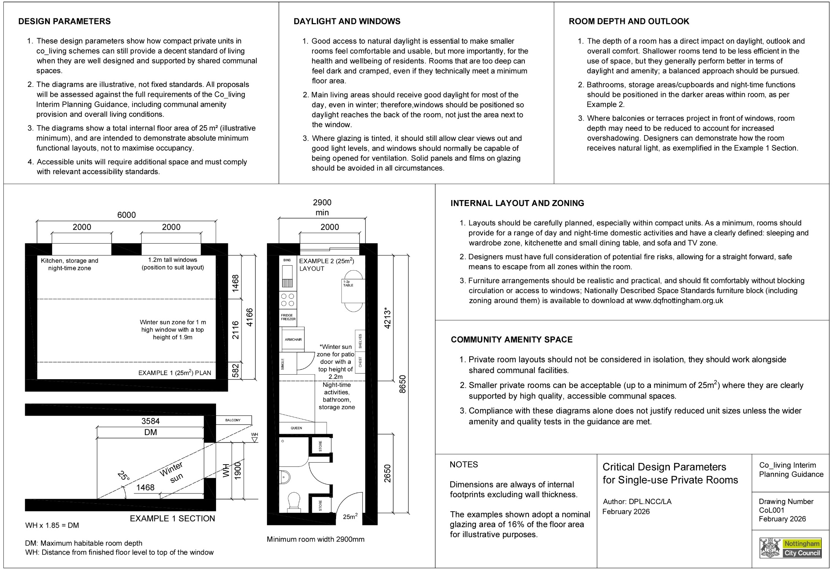
Illustrative Designs

See paragraph 54 of London Borough of Brent v Secretary of State for Levelling Up, Housing and Communities & Anor.
Greater Nottingham and Ashfield Housing Needs Update Final Report Iceni Projects Limited on behalf of The Greater Nottingham Planning Partnership March 2024
Census 2021: RM057 (Household composition by age)
For an overview of this research – see Kearns 2021 for a broad overview of housing space and occupancy standards in the UK. Similarly research on permitted development rights before NDSS requirements, and the impact of lack of space, is also relevant – see 4.3.1and 5.1 in Pieno et al 2024. For a more broad international overview, see Ulrich 2025. For examples of research on co-living in England – see for example Corfe 2019. There also exists a number of descriptive market reports of co-living in England, however these tend to mostly be an overview of what is occurring – see for example the Knight Frank 2024 coliving report, and Lichfield’s reporting on this – not research into what is appropriate in terms of standards and policy.
The schemes reviewed were Queens Road (Nottingham), Hive‑Central (Sheffield), Headrow House (Leeds), Zinc Works (Bristol), Oppidan Life (Manchester), Union (Manchester), Scotland Street (Sheffield), Enterprise Point (Brighton), and Richmond House (Birmingham).

