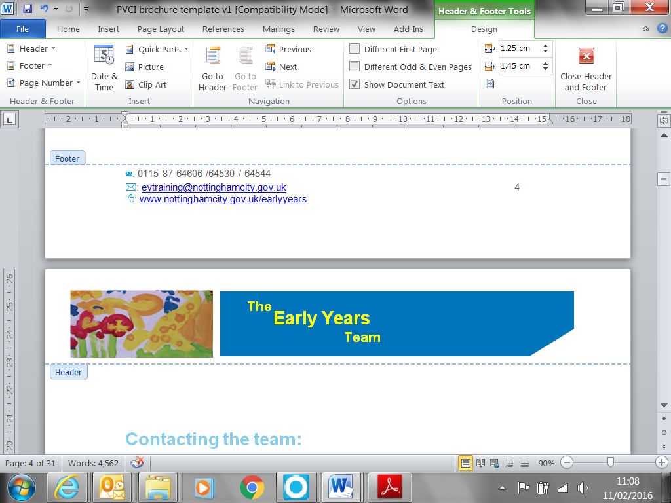

Behaviour Toolkit

Contents
What is Behaviour | P1
Why does behaviour happen | P1
Ages and Stages | P2
How can we identify why a child is displaying a certain behaviour | P3
Helping children understand and communicate their feelings | P4
How to promote positive behaviour | P5
Special Educational Needs and Disabilities (SEND) and behaviour | P6
Practical ideas to support behaviour management as it happens | P7
How to support children with specific behaviours:  Biting  Hitting, Kicking and Throwing | P8  P9
What to remember when supporting children’s behaviour | P11
How can we take care of ourselves and each other when supporting children’s behaviour | P11
Resources and Templates | P12
Behaviour Observation Record (ABC) | P13
All About Me | P14
Targeted Support Plan | P15
Individual Provision Map | P16

What is Behaviour?
Behaviour is defined as the way that someone or something acts in a particular situation or under certain conditions, this can be for both adults and children. At times the behaviours displayed by a child or young person may cause concern to the practitioners supporting them or to their parents. These behaviours may be challenging to deal with or cause injury to the child displaying them or others around them.
These types of behaviours include:
- Tantrums
- kicking and hitting
- Breaking or throwing things
- Biting people and objects
- Screaming and shouting
Why does behaviour happen?
There are many reasons a child may display one or more these behaviours, these could be:
- A child’s direct experience – the child may have had these behaviours done to them

- Curiosity – children are naturally curious, this is how they learn, encourage children to explore and experiment. Support with the boundaries
- Imagination – children will imitate what they see or hear
- Sense of self – children don’t always see things from other people’s point of view so could be unkind or unfair without meaning to, avoid telling the child off but help them understand other people’s views
- Independence – support children to make their own decisions and allow them to do things for themselves
- Seeking Attention – if the child only gets attention when they only display negative behaviour and when they are good, they are ignored then they will continue to carry out the negative and the good behaviour will become less – reinforce good behaviour
- Anger and frustration – this could be reflected in anti-social ways such as tearing, throwing or physical violence against others. Young children are not able to control strong emotions
- Boredom – if the environment doesn’t meet their learning needs children will make up their own play and this can come across as very challenging behaviour
- Testing how far they can go - this is part of a child growing up – be consistent and know your limits – call on help from another colleague and remove yourself not the child from the situation
- Unrealistic demands – some children are not physically or emotionally capable of the behaviour expected of them. treat children as individuals
- Unaware of and not use to boundaries of behaviour – home life may be very different from nursery life. Talk to parents share experiences
- Child not used to doing as they are told, again don’t send mixed messages – work with parents
- Tiredness or illness can change the child’s behaviour – check in with parents and colleagues
- Anxiety or fear – change in behaviour is usually a symptom of emotional upset – check out with parents how the child has been at home or if they have had a good weekend/evening/morning
- A new child in setting who needs time to get used to the different smells, the different sounds, and voices, the room layout, the colours

Ages and Stages
It is also important to consider the child’s age and stage of development when thinking about behaviour and before implementing any behaviour management support. Below are some examples of typical age-related expectations

By the age of 2 years old most children

  - Have no awareness of safety
  - Can be possessive of people and objects that are special to them
  - Need instructions repeated
  - May not like to wait for their needs to be met

By 3 years of age most children

  - Can show resistance to being told what to do
  - Likes to show independence
  - Can have sudden changes in the way they behave without knowing why
  - Can usually wait for their needs to be met

By 5 years of age most children

  - Know and understand when their behaviour is unacceptable
  - May still needs adults to intervene during disagreements with their peers
  - Can at times be overactive
  - May still need support to regulate their emotions

How can we identify why a child is displaying certain behaviours?
By observing children and spending time with them we can begin to recognise how the child displays their feelings and what might be triggering them to behave in a certain way.
Using the ‘who, what, when, where, and how” method - When did the biting occur? Who was involved? Where did it happen? What happened before or after? How was the situation handled?
An Antecedent Behaviour Consequence (ABC) chart may help practitioners identify when an incident may occur and put measures in place to reduce or eliminate it. A template can be found in the appendices. This could include changing routines to ensure children are able to free flow around the setting or have plenty of physical time before asking them to focus on a task or activity. Where you know children all like the same toy try having multiple of the same resource.
By taking time to complete and analysing these tools you may find that you change your perception of what is really happening, i.e. you see exactly what is happening, and not what you thought was happening.
If there are several behaviours, recording and observing can help to establish priorities and what we might need to tackle first. Observing can also help us plan what interventions the child might need to help them through this period and help decide what has been successful.
All about me forms are a good way of having information about the child’s likes and dislikes and what may trigger their challenging behaviours. Using these can help ensure all practitioners working with the child are aware of things that may cause behaviour. An example can be found at the end of this toolkit.

Helping children understand and communicate their feelings
For many children the first feelings they will experience are ‘Happy’, ‘Sad’, ‘Scared’, ‘Anger’. By spending time with children and observing their body language, facial features and behaviours you will begin to recognise which emotion the child is expressing. You can then support the child by labelling these feelings for them.
“Joseph, I know you are feeling sad” or “Kinza I can see that you are feeling happy about the bikes being out today”
You could share books with the child or play games with puppets who are displaying different emotions and feelings or mirrors to experiment acting out different emotions through facial expressions.
Once children are aware of what emotions they are feeling, we can then support children to communicate these feelings.
For some children this will be verbally, and they will be able to explain to you why they feel a certain way for example “I am angry because I want that car” or “I am sad because Joel pushed me’
For children who are not able to express verbally we need to offer things such as emotion cards or emotion faces for them to show us how they feel.
Once children have the understanding and can communicate their feelings some behaviours may reduce or stop.

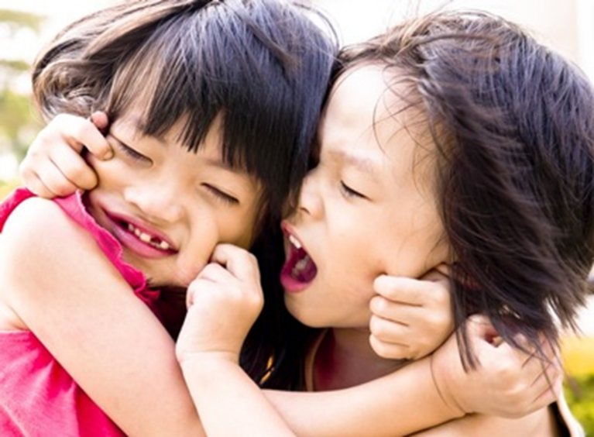

How to promote positive behaviour
- Have clear routines to help children understand what is happening

- Ensure the environment offers developmentally appropriate activities

- Create a calm space with low lights, cushions and blankets for children to access when they begin to become overwhelmed or upset

- Ensure children have opportunities to be physical this might help burn excess energy

- Ensure children have adequate access to fresh air

- Ensure practitioners are clear on the settings approach to children's behaviour

- Have clear expectations for everyone's behaviour in your setting

- Model the behaviour you want to see

- Praise the desired behaviours

- Ensuring practitioners are aware of and consistently using the same strategies to guide children's behaviour

- Use consistent language

- Have consistent boundaries and always follow these through – i.e. if you do not want children to run inside don’t encourage running games as this will lead to confusion

- Give children time to process what is being asked of them

- Offer children choices

- Give appropriate rewards

- Give children the tools to communicate

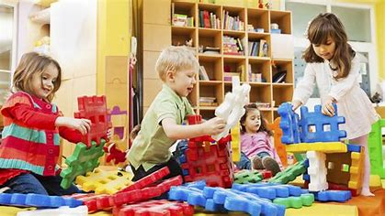

Special Educational Needs and Disabilities (SEND) and behaviour
Children with some specific medical conditions may be more likely to display certain behaviours. For example, a child with learning difficulty may become frustrated easily and frequently, they may find it harder to concentrate and understand what is expected of them and find it more difficult to deal with their emotions.

Children with visual impairments, hearing impairment or physical impairment will need different systems to communicate their needs in order to avoid feelings of anxiety, frustration and rage, which could trigger undesirable behaviour.

Children with additional needs may not be able to respond in the same way and behaviour that causes problems may escalate and become persistent. Although children with some conditions and disabilities are at increased risk of developing behaviours it is important for practitioners to recognise that it is not a certainty for all children with the same diagnosis, for example not all children with an autism diagnosis will display head banging or chewing behaviours.

All of the strategies for promoting positive behaviour can be used for all children however for children with addition needs it is important to remember that they may need additional processing time and may need tasks or instructions broken down into smaller steps or stages to support them to understand. They may also need to revisit these steps more frequently to help them embed them.

Using visual aids such as objects of references or photo cards while using clear, literal language may also support the child understand and help reduce feelings of anxiety, stress, frustration or worry.

Sensory circuits and fidget toys can support children regulate their sensory processing systems supporting children to feel calm, alert and ready to engage with learning.



Practical ideas to support behaviour management as it happens

Challenging behaviour can be difficult to manage; below are some positive and effective ways you can do to support children to learn self-control and manage challenging behaviours
- Learn to recognise the child’s triggers

- Set realistic goals and next steps to prevent frustration
- Where possible, ignore or give minimal attention when the behaviours occur (unless injurious or dangerous) find what motivates the child and use this to engage the child
- Use distraction techniques as an alternative to demands, for example if the child is outside, say, “Let’s go and play with this inside” rather than, “Go in inside”
- If a child is displaying injurious or dangerous behaviours, you may need to clear the area around them to keep everyone safe. Keep words to a minimum at this stage, sometimes by trying to talk a child down we can fuel the situation
- Give the child space to calm down, for some children they may need to be taken out of the initial environment either to another room or outside
- Once the child is feeling calm, follow up by offering and practising strategies to help them manage their emotions more appropriately, such as ‘finger breathing’, ‘soldier marching ‘or going to their quiet space etc
- Praise the smallest achievement
- Be consistent and ensure all practitioners use the same language and techniques
- Keep language simple and relevant to the child’s stage of development – i.e. hand down, feet down – back up with sign or gestures if this is relevant
- Don’t turn the situation into a game
- Talk to the parent – does the child present like this at home, what strategies do they implement can these be replicated in the setting

For some children implementing the above strategies will be enough to help then regulate and reduce or stop the behaviours but for some children we may need to consider specialist support through referrals to local authority or health services.

How to support children with specific behaviours
In this next section we will look at some specific behaviours many practitioners report they struggle with.
Biting
Biting is a very common developmental behaviour. Despite this, it can be one of the most difficult behaviours for early years practitioners and parents and carers to deal with.
Children bite for a range of different reasons; they may have delayed communication and language skills and cannot express their needs or wants so will communicate by biting. At times biting can also be a result of excitement but the child may not have the language or self-control skills to express this, so it results in them biting.
Practitioners can support this by
- Supporting children to build on their skills, use the language they would if they could such as ‘Harry’s turn’
- Modelling turn taking with appropriate language – start this with just the child and as they develop the skills, increase the number of children involved in the activity
- Using visuals and gestures to show children what you are saying to them and to build on their understanding - these can include photographs of the routine, emotion faces, signs and symbols
- Being consistent with how you deal with the biting and the language you use and ensure that all practitioners do the same. You may also want to share these with parents.
The child may feel overwhelmed by the environment or what is happening around them. They could also be experimenting to see what reaction they receive, or they could be coping or imitating if they have been bitten. Biting is often used as a way of expressing frustration or stress from situations the child cannot understand or due to new life events such as a new baby or death in the family.
Practitioners can support by
- Helping children to self-regulate – naming their emotions and letting them know it is okay to feel upset, angry or excited
- Providing a calm, quiet space children can go to – dark dens or cosy corners with lots of cushions, throws and calming lights
- Giving children warnings before changes – this can support children's understanding and decrease their feelings of being overwhelmed or fearful and also lessen their frustrations of their favourite activity coming to an end
- Allowing Children need time to settle into environments and get used to new situations and people – this could be child coming into your setting for the first time or a child moving from the baby room into the toddler room with a new routine, a different layout and different people
- Children will often imitate actions they have seen or had done to them. For example, if parents or carers use biting as a game, the child may imitate this not understanding that this hurts especially as children get older and stronger what might seem an innocent game with a 2yr old can lead to serious harm or injury when the child does this at the age of 10. So, it is important that we don’t give mixed messages to children and young people about biting. Ensure you work with parents/carers and reenforce this message to them
- Children will experiment to get reactions, so we need to ensure we are consistent with our management of biting – ensure all practitioners use the same language – ‘no biting, biting hurts’ and then give attention to the child or person that is hurt. Use a firm tone but do not shout or prolong the interaction with the child or young person that has bitten
- When we notice the signs that the child might be biting to gain attention distract them with an activity or a new toy. If a biting incident occurs remain calm tell them, ‘No biting’ and redirect your focus to the child that has been bitten
The child could be teething or suffering from discomfort in their mouth. The child may not be stimulated enough and require more physical activities to occupy them. Sometimes biting can be linked to a need for sensory input or oral stimulation.
Practitioners can support by
- Sign posting parents to dental and health professionals
- Providing a range of sensory play experience and building these into the daily routine.
- Providing alternative objects such as chewy tubes, teething toys, drinking through straws or a sports bottle, blowing bubbles or eating crunchy snacks.
- Deep pressure massage soothing – this is where you apply gentle but firm pressure to the jaw area – this could be done while singing a body awareness song
Biting is a quick and easy way to get attention, express feelings, relieve tension and explore the world.
Hitting, Kicking and Throwing
As with biting hitting, kicking and throwing can be typical child development behaviours and are often referred to as temper tantrums. This usually starts at around the age of 18 months old. As a child reaches the age of 4 years old we would expect these behaviours to be much less frequent as the child is more able to make sense of themselves and the world around them.

A child may hit, kick or throw for many reasons including
- Not having the communication and language skills to tell you what they want or how they are feeling
- They could be frustrated, scared or trying to gain attention
- They could be experimenting to gain a reaction
- They may imitate what they have seen, this could include things observed from video games or tv programmes.
- Children who have been victims of Domestic violence may also copy behaviours they have seen or experienced.
- The child may not understand the correct use of toy or object so will throw it in frustration
- The child may have a sensory need and may do these behaviours to gain sensory feedback such as the sounds of the hitting or the different sounds the objects being thrown make when they hit the floor or wall.

Practitioners can support by

- Giving children the tools to communicate and express their feelings – visuals prompts, emotion/feelings cards
- Name the feelings the child may have ‘I know you are angry that Lily took your toy’ so they understand
- Naming the action, we want children to do ‘hands down, no hitting’ or ‘feet down, no kicking’ ‘we use kind hands’
- Ensure the language we use is consistent and used across the setting.
- Share the language and strategies that you are using with parents, so the child is receiving that consistent message
- Using a physical gesture alongside our language to help the child understand – this could be placing a flat hand on their arm while gently pressing down and at the same time we say ‘Hands down’
- Having clear and consistent routines in place so children know what to expect this will reduce feelings of anxiety or fear
- Use visuals to support understanding of the routine - time tables or now and next boards.
- Give warnings and prepare children before a change – some children may need a countdown
- Consider if our routine meets the needs of the child– if they do not have access to a garden at home are they having enough physical time.
- Offer children safe alternatives such as throwing a ball into a hoop or basket or a balloon to hit at
- Ensure the environment offers a safe space for children to access such as a cosy area or dark den
- Reward children for doing the behaviours we want to see – use their interests to do this
- Consider if the activities on offer are too easy or too hard for the child and adjust accordingly
- Where possible intervene before the behaviour happens and re direct the child

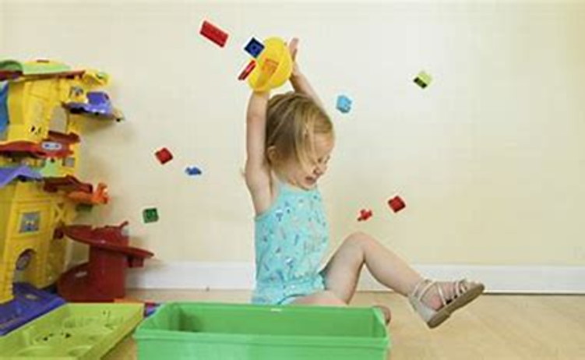

What to remember when supporting children’s behaviour

- We are helping children to manage their behaviour; we are not punishing them.
- It won’t always work.
- Be consistent and mean what you say.
- Remain calm.
- Get down to the child’s level to make eye contact.
- Ensure you share the strategies you are using with others
- The child may not be enjoying the behaviour any more than you are.
- Praise and reward desired behaviour.
- Things often get worse before they get better.
- Change takes time
- Take care of your self and each other

How can we take care of ourselves and each other when supporting children’s behaviour

Supporting behaviour is challenging, we need to remember to take care of our selves and each other suggestion of how to do this can be found below
- Take turns in supporting children throughout the day – just because you are the 1-1 doesn’t mean other can’t support – this can actually be good for children
- Ensure you share how you are feeling if you feel overwhelmed or can feel your self-becoming flustered ask for help
- Go for a walk in your lunch or reading a book something to take your mind from work
- Leave work at the door when you go home
- Have a staff wellbeing policy
- Give practitioners the opportunity to talk about themselves during supervisions or check ins
- Check in with practitioners throughout the day
- Reflect on what you can do as a team to support each other
- Provide practitioners with CPD opportunities

Resources and Templates
The next section contains a range of useful websites and templates practitioners may find useful in identifying and supporting children’s behaviour
Behaviour Vodcasts – These vodcasts aim to provide useful tips and strategies to support practitioners understand why behaviours may happen and what they can put in place to help reduce or prevent these behaviours occurring.
Hitting, kicking and throwing https://youtu.be/EKwDj0qI0oM
Biting and spitting https://youtu.be/-IpbuqwaKD4
Inclusive Environment Audit - This Inclusive environment audit is designed to help you to look at the provision and practice to promote inclusion and positive behaviour within your setting ADD LINK
Practitioner Wellbeing and support
Early Years - Nottingham City Council
Help for early years providers : Early years practitioner wellbeing support (education.gov.uk)
Early years staff wellbeing: a resource for managers and teams | Anna Freud
Practitioner Wellbeing: useful information and resources - Foundation Years
ABC Behaviour chart – P13
ABC charts can be used to record behavioural concerns. • 'A' stands for antecedents, that is, what happens immediately before the behavioural outburst and can include any triggers, signs of distress or environmental information. • 'B' refers to the behaviour itself and is a description of what actually happened during the outburst or what the behaviour 'looked' like. • 'C' refers to the consequences of the behaviour, or what happened immediately after the behaviour and can include information about other people's responses to the behaviour and the eventual outcome for the person. It can also be a good idea to keep track of where and when the behaviour occurred to help in identifying any patterns.
All about Me – P14
All about me forms help practitioners understand a child and their needs so that personalised support for the child can be planned and based around the child’s, likes and dislikes and what they may need support with. They can also be used to support transitions.
Targeted Support Plans and Individual Provision Maps – P15&16
Both of these documents can be used to plan individual structured activities and routines to support a child’s emerging or additional needs following the graduated approach of assess plan, do and review. These documents should also include the parents’ voice.

Behaviour Observation Record (ABC Chart)
Date, place and time of incident | Antecedent  What happened before? | Behaviour  Exact description of what the child did | Consequence  What happened after? What did the adult do? What did the child do? | Notes

All About Me
Hello, my name is _______________
My birthday is _________________

Things I like:

Things I don’t like:

When I am upset, I will:

You can help calm me by:

Things I am good at:

Things I need help with:

(Photo)

Targeted Support Plan Strategies and Activities
Name: DOB: Start date of plan:
Childs area to develop | Strategies for staff to implement | Specific activities to involve child | Review after 6-8 weeks
Comments:

Child’s Name |  | D.O. B |  |  | IPM Ref & IPM Date
Name of Setting |  | Key Person |  |  |  | 1:1 SUPPORT |  | EVERYDAY SUPPORT
Areas of Strength and Interests |  |  |  | Areas of Need
Targets/Expected Outcomes |  | How these will be achieved |  |  | Additional strategies that will support
Individual Provision Map

Childs attendance | Monday | Tuesday | Wednesday | Thursday | Friday
Session and Support needs
Activities where the child may need support:
Additional Information:
Ideas for at home:

