**APPLICATION FOR PAVEMENT CAFÉ LICENCE**

**INTRODUCTION**

Nottingham city centre has much to offer by way of its superb high quality public realm. A compact central area, extensive pedestrianised streets and a cosmopolitan ‘buzz’ make it highly attractive for outdoor seating use. We can’t guarantee fine weather all the time of course, but don’t let that put you off, visitors to Nottingham love being outside, as much as they do undercover!

The purpose of this guide is to highlight the standards and requirements expected of pavement café operations and to guide those wishing to apply for a pavement café licence (“the Licence”) through the process.

The guide is produced in two main sections.

* General Requirements
* Application forms and Contact Details

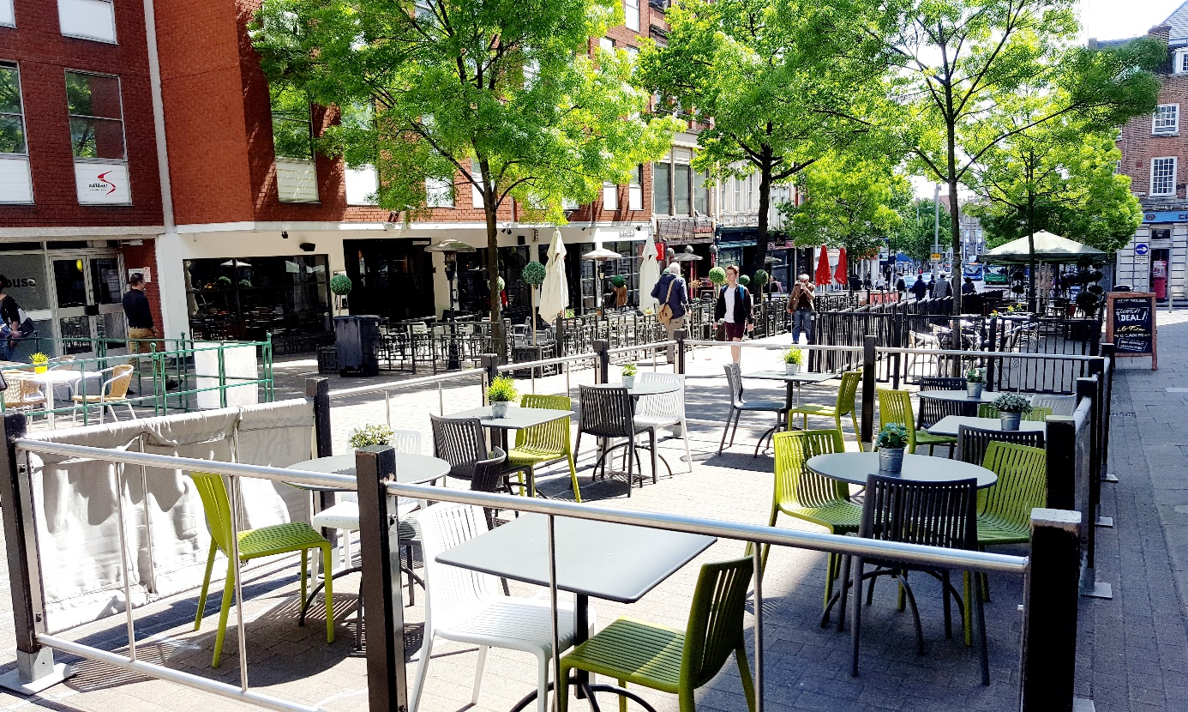

**General Requirements**

**Introduction**

Pavement cafés may be sited on the public highway and are authorised by the Licence which, if granted, lasts for up to 1 year, and further renewal applications can be made before the Licence expires. Seated areas that are not on highway and sited on privately owned land i.e. to the rear of buildings or other courtyard areas do not require a (pavement café) Licence. However, other permissions/authority or other restrictions may apply. It is advisable to check beforehand.

It will not normally be necessary to obtain planning permission, in addition to the Licence, provided the main premises from which it is proposed that the pavement café area will operate (“the Premises”) have either A3 or A4 use. However, planning permission will be necessary if any permanent fixtures are proposed that constitute development.

For applicants wishing to apply for a Licence, it is advisable to discuss your proposals with Nottingham City Council (“the Council”) prior to submission, as some locations/proposals may not be suitable. Completed applications containing all the relevant information will normally take approximately 1 month to be considered. This includes a statutory notice period of 14 days, during which time objections to the application can be made. If objections are made, the Council will try to assist in attempts to deal with these, however it should be noted that if concerns cannot be addressed the application may be refused.

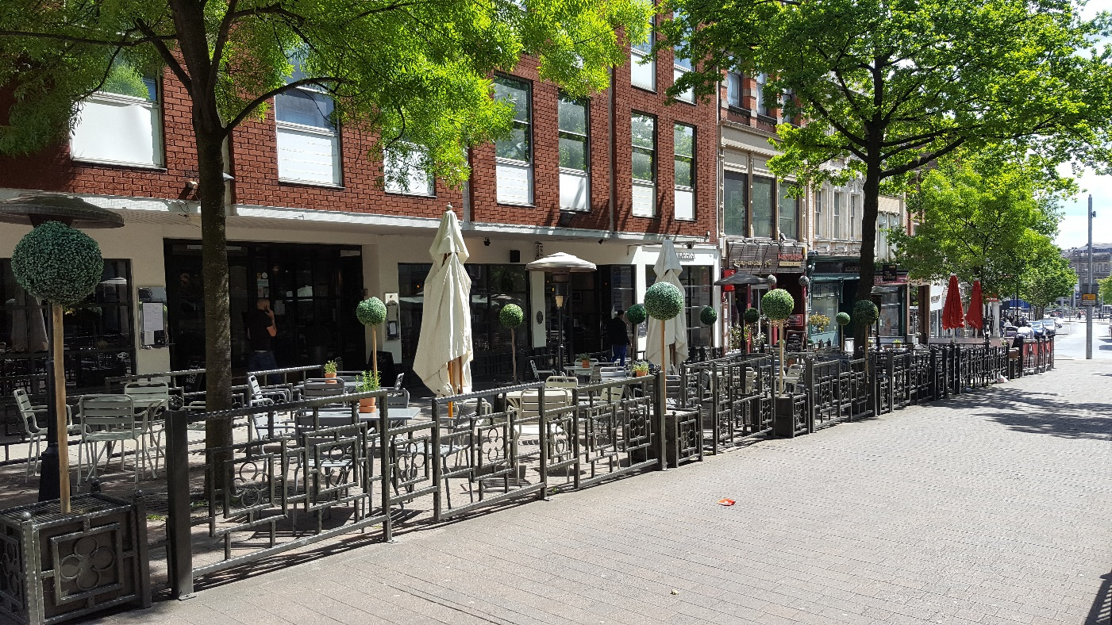

**Suitable Areas and Local Restrictions**

Most locations on the public highway can accommodate a pavement café area. However, there are several areas where access is restricted, where other obstructions or other uses are permitted or where pedestrian routes would be unsafe.

While this guide is primarily aimed at Nottingham city centre, it is applicable across the Council administrative area.

The map below highlights some areas in Nottingham city centre where restrictions apply, and pavement café areas cannot be accommodated. There may be other areas of the city centre, and will be locations across the Council’s administrative area, where pavement café areas would not be suitable.

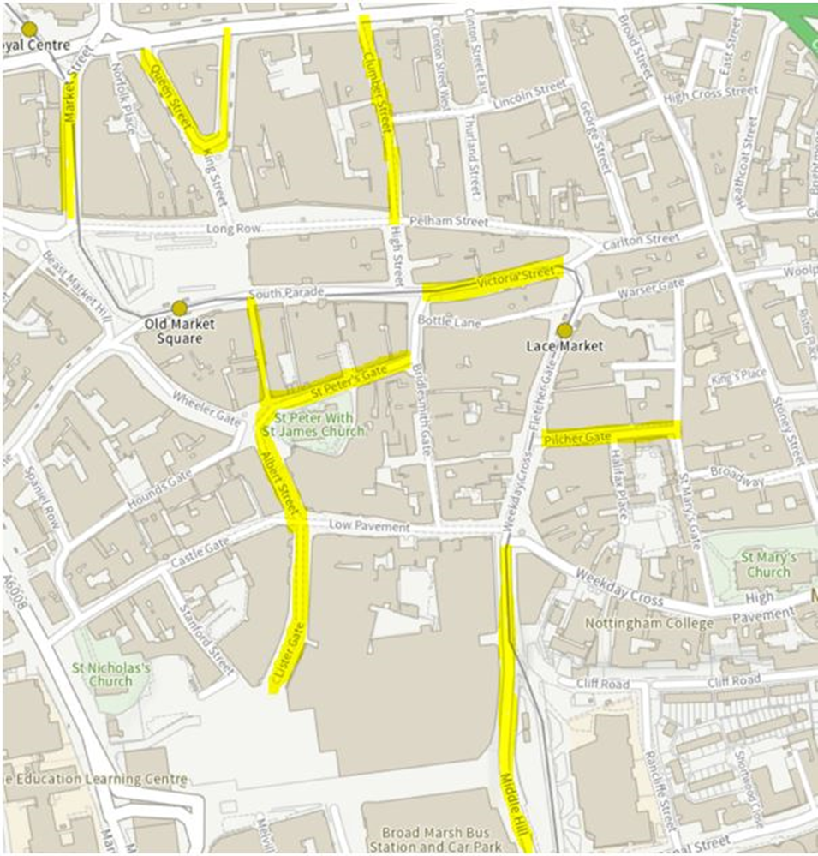

On public highway in the vicinity of the Old Market Square pavement café areas may only be permitted on Long Row to the north side of the Old Market Square on the main area from the edge of the Long Row arcade to the edge of the delivery access road (highlighted yellow on the plan below).

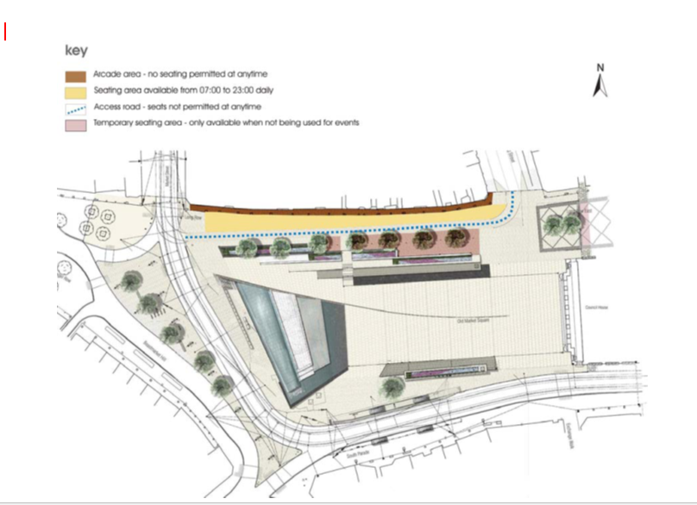

In the areas where pavement café areas can be accommodated each application has to be considered on its own merits. The Council reserves the right to refuse a pavement café application if it considers the application is inappropriate or rescind a Licence in accordance with the terms of the Licence if, for example, the location becomes unsuitable for outdoor pavement café use.

**Size and Layout**

Pavement café areas will normally be situated parallel to and in line with the frontage of the Premises leaving a 2-metre clear gap between the Premises and the area authorised by a Licence (“the Licensed Area”). Where suitable recesses in the building line exist or where the pedestrian desire line is away from the building frontage, the Licensed Area may be located adjacent to the Premises. If the proposed Licensed Area fronts adjacent or other properties, prior consent from the owners/occupiers of those properties will be required.

The Licensed Area must take into account other needs and uses in the vicinity – for example pedestrian crossings, loading bays and street furniture. A minimum distance of 0.5 metres must be kept clear of the kerb line of regularly trafficked routes.

Consideration to size and layout must be given to allow customers with disabilities to access and move around within the Licensed Area.

All emergency exits and routes from buildings and those associated with the highway must be kept clear at all times.

**Means of Enclosure**

All pavement café areas when in use are to be enclosed with barriers to demarcate the Licensed Area and to reduce the risk of accidents to both seated customers and other pavement users (“the Barrier”). When not in use, or outside of the times the Licensed Area is authorised by the Licence (“the Licensed Period”), the Barrier must be removed. The only exception will be where planning permission has been granted for the Barrier to be affixed to the highway and the Barrier is so affixed in accordance with the planning permission.

Materials for the Barrier need to be selected on the basis that they are strong and robust and would withstand collapse if accidentally stumbled into. However, as the Barrier needs to be portable the materials should also be lightweight.

The design of the Barrier must compliment the character of the surrounding area and, in some specific locations including the vicinity of Old Market Square and Hockley, the Council will require a particular specification to be met reflecting the special character of these areas.

The Barrier must be solid horizontally and vertically, with the upper and lower rails set at 1000 mm and 100 mm above ground level respectively or be in accordance with other specifications agreed by the Council. Rope barriers are not suitable. Applicants are advised to discuss their proposals with the Council.

Planters can be used as part of the means of enclosure, where agreed by the Council, but must be removed outside of the Licensed Period. In certain circumstances existing street railings or other suitable items of furniture may be utilised as a part of the Barrier, but only where this is agreed by the Council.

**Furniture and Equipment**

Furniture to be used within the Licensed Area must comply with the conditions of the Licence and be of a high-quality uniform style and suitable for outside use. Plastic garden furniture and/or picnic tables will not be permitted.

Incidental items including menu boards, portable gas heaters and signs also need to be approved by the Council and form part of the conditions of the Licence. Cooking equipment and BBQ’s will not be permitted.

Where umbrellas are used these must be a non-reflective fabric type. Umbrellas must be positioned to avoid impairing any vehicle sight lines and must not overhang the edge of the Licensed Area. They must be suitably secured and balanced to withstand reasonable winds. Only advertisements (on any furniture, other items or the Barriers) which have the express consent of the Local Planning Authority will be allowed.

All items contained within the Licensed Area must be portable enough to be brought in at the end of the Licensed Period of each day that the Licence applies, or to be moved quickly in the event of an emergency/other reason specified in the Licence.

**Environmental and Other Requirements**

In certain parts of the city centre the quality of air from traffic fumes makes it inappropriate to site pavement café area and the Council will not issue a Licence under such conditions. In other areas, consideration does need to be given to the proximity of bus stops and taxi ranks, not only from the aspect of air quality but also taking into account movement clusters of vehicles and people.

It will be the responsibility of the person granted permission by the Council and named in the Licence (“the Licence Holder”) to keep the Licensed Area free of all litter during the hours of operation, including that blown into the Licensed Area. The Licence Holder will also be responsible for the removal of any litter in a 5-metre radius of the Licensed Area.

The License Holder must ensure compliance with the relevant liquor licensing (where applicable), food safety and toilet requirements. Further advice should be sought from the relevant Council departments in relation to these other requirements at the time of or prior to application.

**General Conditions of the Licence**

The power to grant a Licence is contained in PART 1 of the Business & Planning Act 2020: Pavement licences.

The Licence may be applied for directly by the proposed Licence Holder or via an agent. However, the Licence will only be granted to a named individual who is either the owner and or occupier of the Premises or is otherwise associated with the owner and or occupier of the Premises (either as an employee or in any other capacity).

The charge for a new Licence is £360.

The following represents a summary of some of the general conditions of the Licence:

The Licence Holder must notify the Licensing Manager of the Council in writing of any change of their address/ownership within 14 days of the change.

If the Licence Holder ceases to be associated with the Premises during the term of a Licence the Licence will no longer be valid. If a pavement café area is still required a new Licence application must be submitted and the pavement café area cannot be used unless and until a Licence has been granted in the name of the new Licence Holder.

Any proposed changes to the Licence, including replacement furniture, must be applied for by the Licence Holder in advance, and authorised by the Council in writing before any change is made. However, any proposed change to the Licensed Period will be treated as a new application and will need to be accompanied by a new Licence fee (£360).

Within the Licensed Area only persons who are seated will be able to consume food and drink, and that food and drink must be purchased from the Premises.

The consumption of alcohol will only be permitted in the Licensed Area where it was purchased in the Premises in accordance with the applicable Premises Licence issued under the Licensing Act 2003 and consumed in the Licensed Area in accordance with the terms of that Premises Licence.

The Licence Holder will be required to hold a valid Public Liability Insurance policy to a value of £5 million cover for the Licensed Area (“the Policy”) and must provide a copy of the Policy with their application and ensure that the Policy and the current receipts for premium payments and confirmation of the annual renewal of the Policy are retained in the Premises at all times and that they shall be made available for inspection by an officer of the Council and or the Police immediately upon request.

The Licence will have a Licensed Period where the use of the Licensed Area is generally authorised from 9.00 am to 11.00 pm to take into account delivery access times for the city centre and Policing requirements. Outside of the Licensed Period (with the exception of the Barrier if it has planning permission and complies with that permission) all items must be removed from the highway, even if the Premises has longer opening hours.

A Licence will be granted for up to 1 year. If a Licence Holder would like to continue to use the Licensed Area after the period, the Licence was granted for a renewal application for the Licence must be received **before** the Licence expires and must be accompanied by the Policy. If the renewal application is received in time, is accompanied by the Policy and there are no other changes proposed to the Licence the annual renewal charge is £185.

A Boards must be located in accordance with the Council’s A Board guidance. This will ordinarily mean that A Boards must be positioned against the building line of the Premises and should **not** be placed within the Licensed Area –. A copy of the Council’s A Board guidance is available on request.

Where CCTV equipment is provided it must be installed and operated in accordance with Police recommendations.

In the event of non-compliance with any of the terms and conditions of the Licence, the Council reserves the right to immediately rescind the Licence and consider enforcement action in respect of any unauthorised items left on the highway. This could include the removal of unauthorised items by the Council in some circumstances, or possibly prosecution for obstruction.

**APPLICATION FOR A PAVEMENT LICENCE UNDER**

**BUSINESS AND PLANNING ACT 2020**

**This application form must be completed in full and legibly.**

A Pavement Licence is a temporary agreement to place “street furniture” on the

highway for the consumption of food and drink.

The grant of a Pavement Licence is subject to “standard and national conditions”

which can be found at [Guidance: pavement licences (outdoor seating) - GOV.UK](https://www.gov.uk/government/publications/pavement-licences-guidance)

[(www.gov.uk)](https://www.gov.uk/government/publications/pavement-licences-guidance)

Where the applicant is not the owner of premises, written confirmation of consent to

use a Pavement Licence in respect of the Premises from the property owner(s), or,

freeholder(s), or managing agent is required.

Applicants must provide a Location Plan (to scale of 1:200) detailing the premises (“the

Premises”) and the adjacent area of highway sought to be licenced under a Pavement

Licence highlighted in red (including dimensions), listing the name of the highway to be used,

and detailing the layout of furniture. Images of the Street Furniture should also be submitted.

**Please note that there are several Public Spaces Protection Orders (PSPOs) that**

**ban the consumption of alcohol in public which apply in Nottingham and which ban**

**the consumption of alcohol in a public place in the area designated by that Order.**

**‘Public Place’ includes highway. The prohibition on the consumption of alcohol does**

**not apply to a place where facilities or activities relating to the sale or consumption of**

**alcohol are at the relevant time permitted by virtue of a Pavement Licence issued**

**under the Business and Planning Act 2020. Copies of PSPOs which apply in**

**Nottingham can be found on Nottingham City Council’s website.**

**DETAILS OF APPLICANT:**

**FULL NAME:**

**ADDRESS:**

**POSTCODE:**

**TELEPHONE No:**

**EMAIL:**

**DETAILS OF THE PREMISES:**

**PREMISES NAME:**

**ADDRESS:**

**POSTCODE:**

**TELEPHONE No.**

**DETAILS OF OWNER OF THE PREMISES:**

**OWNERS NAME:**

**ADDRESS:**

**POSTCODE:**

**TELEPHONE No.**

**EMAIL:**

**DETAILS OF HIGHWAY TO BE USED FOR PROPOSED PAVEMENT LICENCE:**

**NAME OF HIGHWAY (ROAD NAME):**

**BRIEF DETAILS OF THE NATURE OF THE BUSINESS**

**PLEASE INSERT:**

**DO YOU INTEND THAT YOUR CUSTOMERS WILL CONSUME ALCOHOL IN THE**

**HIGHWAY?**

**YES/NO?**

**No alcohol shall be consumed within an area licensed by a Pavement Licence unless**

**a premises licence as defined by the Licensing Act 2003 (or relevant subsequent**

**legislation) has been issued by the Licensing Authority in relation to the premises**

**which that Pavement Licence is in respect of, the alcohol is purchased from those**

**premises and the consumption is in accordance with that premises licence.**

**DETAILS OF STREET FURNITURE PROPOSED (INSERT NUMBER OF ITEMS):**

**TABLES**

**COUNTERS**

**UMBRELLAS**

**BARRIERS**

**CHAIRS**

**BENCHES**

**HEATERS**

**PLANTS**

**PROPOSED TIMINGS FOR USE OF OUTDOOR AREA (24 HOUR CLOCK FORMAT)**

**MONDAY FROM TO**

**TUESDAY FROM TO**

**WEDNESDAY FROM TO**

**THURSDAY FROM TO**

**FRIDAY FROM TO**

**SATURDAY FROM TO**

**SUNDAY FROM TO**

**CHECK LIST:**

**The following additional information must be submitted with your application form**

**(please “tick” each box to confirm that you have enclosed the following additional**

**information with your application):**

**The completed Pavement Licence Application Form:**

**Fee: £360 Renewal £185:**

**The Location Plan (scale 1:200) showing the name of the highway, the proposed**

**area applied for (including dimensions), and the positions of the**

**street furniture to be placed within the proposed area applied for:**

**Photographic images of the proposed Street Furniture:**

**Proof of Owner’s Consent or Lease Holders Consent:**

**Proof of Public Liability Insurance (to a minimum value of £5,000,000):**

**Copy of the A4 Notice placed at the Premises:**

**Please note that should you fail to provide all the items listed below then**

**your application will be deemed “void” and returned to you.**

**Privacy Notice**

We will use the information provided by you for processing a Highways Amenities

Licence on your behalf. The basis under which the Council uses personal data for this

purpose is that this is necessary for the performance of a task carried out in the public

interest by the Council or in the exercise of official authority associated with the

Business & Planning Act 2020

You are not obliged by statute or by contract, to provide the information that is

requested here, however if you require a licence then we will need to process your

data for this purpose.

The information that you have provided will be kept for the length of the licence + 6

additional years.

The information provided by you may also be used for the purpose of any other

function carried out by the Council. Information about these functions and the legal

basis on which information is used for them can be found at

<http://documents.nottinghamcity.gov.uk/download/5939>

The Data Controller is Nottingham City Council, Loxley House Station Street

Nottingham NG2 3NG

The Data Protection Officer is Naomi Matthews. You can contact the data protection

officer at the above address or at [data.protectionofficer@nottinghamcity.gov.uk](mailto:data.protectionofficer@nottinghamcity.gov.uk)

The new data protection law known as the General Data Protection Regulation

provides for the following rights as prescribed by the legislation:

• A right to request a copy of your information

• A right to request rectification of inaccurate personal data

• A right to request erasure of your data known as ‘the right to be

forgotten’.

• A right to in certain circumstances to request restriction of processing

• A right in certain circumstances to request portability of your data to

another provider

• A right to object to processing of data in certain circumstances

• A right regarding automated decision-making including profiling

Please note that if you are unhappy with a decision regarding the handling of your

data you have the right to complain to the Information Commissioners Office at

Wycliffe House Water Lane Wilmslow, Cheshire SK95AF and see the

Information Commissioners website at <https://ico.org.uk/your-data-matters/>

For more information about these rights please refer to our detailed privacy

statement at <https://www.nottinghamcity.gov.uk/privacy-statement>

**PLEASE NOW COMPLETE THE DECLARATION BELOW**

**Declaration**

**I, the undersigned, hereby declare that the information contained in this**

**application is true and accurate to the best of my knowledge.**

**I confirm I have read the General Data Protection Regulation 2016 (GDPR) /**

**Data Protection Act 2018 (DPA) - Privacy Notice above.**

**Signature of Applicant: _____________________________ Date: _______________**

Please submit all details to:

Highway Network Management

1st Floor

Loxley House

Station Street

Nottingham

NG2 3NG

For any queries, please contact Clair Thurman 0115 8764602, or email [Highway.Management@nottinghamcity.gov.uk](mailto:Highway.Management@nottinghamcity.gov.uk)

**CONTACT DETAILS**

General Information

In the first instance please contact Highway Network Management on 0115 8765406

Application forms should be completed and submitted with payment and enclosures detailed to:

Highway Network Management

1st Floor

Loxley House

Station Street

Nottingham

NG2 3NG

Further useful information may be obtained from:

**Change of Use**

Planning Services – [development.management@nottinghamcity.gov.uk](mailto:development.management@nottinghamcity.gov.uk)

Telephone: 0115 8764447

**Nottinghamshire Constabulary**

The Chief Constable

Nottinghamshire Police

Central Police Station

Byron House

Maid Marian Way

Nottingham

NG1 6HS

Telephone: 101 x 3180973

**Email:**  [city.licensing@nottinghamshire.pnn.police.uk](mailto:city.licensing@nottinghamshire.pnn.police.uk)

Nottingham City Council

Commercial & Operations

Licensing

Central Police Station

Byron House

Maid Marian Way

Nottingham

NG1 6HS

Telephone: 0115 9156571

Email: [general.licensing@nottinghamcity.gov.uk](mailto:general.licensing@nottinghamcity.gov.uk)

**GENERAL INFORMATION**

**Location Plan**

The application process takes approximately 28 days from the receipt of a complete application.

Please supply an A4 plan clearly outlining the premises and the location of the proposed Licensed Area. Suggested scales are 1:1250/1:500 the location plan may be included as part of a larger site plan.

**Site Plan**

Please supply 1 copy of a site plan showing the following information. Suggested scales are 1:1250/1:500

* Access points
* Building lines
* Boundaries
* Kerbs
* Dimensions of seating area
* Table and chair arrangement
* Other furniture/items layout
* Plan and elevation (1:50) of barriers/enclosure

**Payment**

Costs are £360 (or £185 for renewal) and you can make payment by card over the phone.

**Insurance**

Please supply evidence of £5 million Public Liability Insurance Cover.

**Details of Furniture, Means of Enclosure and Other Proposed Items**

|  |
| --- |
| **Details of Proposed Street Furniture** |
| **1. Please give brief description, suppliers and technical details where appropriate of proposed furniture.** |

|  |
| --- |
| **Details of Proposed Barriers** |
| **1. Please give brief description, suppliers and technical details where appropriate of proposed barriers.** |

|  |
| --- |
| **Details of any other items to be included in pavement seated area** |
| **1. Please give a brief description, suppliers and technical details where appropriate of proposal** |

**General Guidance in Relation to Smoke Free Legislation**

With the introduction of the new smoking legislation from July 2007, customers can not smoke inside the Premises; however, these customers will be able to smoke within the pavement café area (the Licensed Area).

If you are a Licence Holder or are applying for a Licence, the following guidelines will apply: -

* Pavement café areas are exclusively for the use of paying customers who must be seated for the consumption of food and drink. The same principle will apply to smokers, in that the Licensed Area is for the use of paying customers and they must be seated.
* Those customers who are seated within the Licensed Area and who chose to smoke will not be in breach of the smoke free legislation i.e.: it will not be an offence for them to smoke.
* As the Licence Holder, it will be at your discretion as to whether you designate either all or any part of the Licensed Area as ‘smoking’/non-smoking’. Where you make such designations, you must manage these areas accordingly, and in accordance with the terms of the Licence (eg: litter/butt free).
* If you are considering alternative means of providing authorised area(s) for customers to smoke eg: gazebo or external covered area (which are not located on the highway), these are structures and are subject to normal planning and/or building regulations.

**APPLICATION FOR A PAVEMENT LICENCE UNDER BUSINESS AND PLANNING ACT 2020**

**This application form must be completed in full and legibly.**

A Pavement Licence is a temporary agreement to place “street furniture” on the highway for the consumption of food and drink.

The grant of a Pavement Licence is subject to “standard and national conditions” which can be found at [Guidance: pavement licences (outdoor seating) - GOV.UK (www.gov.uk)](https://www.gov.uk/government/publications/pavement-licences-draft-guidance/draft-guidance-pavement-licences-outdoor-seating-proposal)

Where the applicant is not the owner of premises, written confirmation of consent to use a Pavement Licence in respect of the Premises from the property owner(s), or, freeholder(s), or managing agent is required.

|  |  |
| --- | --- |
| Applicants must provide a Location Plan (to scale of 1:200) detailing the premises (“the Premises”) and the adjacent area of highway sought to be licenced under a Pavement Licence highlighted in red (including dimensions), listing the name of the highway to be used, and detailing the layout of furniture. Images of the Street Furniture should also be submitted.  **Please note that there are a number of Public Spaces Protection Orders (PSPOs) that ban the consumption of alcohol in public which apply in Nottingham, and which ban the consumption of alcohol in a public place in the area designated by that Order. ‘Public Place’ includes highway. The prohibition on the consumption of alcohol does not apply to a place where facilities or activities relating to the sale or consumption of alcohol are at the relevant time permitted by virtue of a Pavement Licence issued under the Business and Planning Act 2020. Copies of PSPOs which apply in Nottingham can be found on Nottingham City Council’s website.** | |
|  | |
|  |  |
|  |  |
|  |  |
|  |  |
| **DETAILS OF APPLICANT:** | |
| **FULL NAME:** | |
| **ADDRESS:** | |
| **POSTCODE:**  **TELEPHONE No:**  **EMAIL:** | |
| **DETAILS OF THE PREMISES:**  **PREMISES NAME:**  **ADDRESS:**  **POSTCODE:**  **TELEPHONE No.**  **DETAILS OF OWNER OF THE PREMISES:**  **OWNERS NAME:**  **ADDRESS:**  **POSTCODE:**  **TELEPHONE No.**  **EMAIL:**  **DETAILS OF HIGHWAY TO BE USED FOR PROPOSED PAVEMENT LICENCE:**  **NAME OF HIGHWAY (ROAD NAME):**  **BRIEF DETAILS OF THE NATURE OF THE BUSINESS**  **PLEASE INSERT:**  **DO YOU INTEND THAT YOUR CUSTOMERS WILL CONSUME ALCOHOL IN THE HIGHWAY?**  **YES/NO?**  **No alcohol shall be consumed within an area licensed by a Pavement Licence unless a premises licence as defined by the Licensing Act 2003 (or relevant subsequent legislation) has been issued by the Licensing Authority in relation to the premises which that Pavement Licence is in respect of, the alcohol is purchased from those premises and the consumption is in accordance with that premises licence.**  **DETAILS OF STREET FURNITURE PROPOSED (INSERT NUMBER OF ITEMS):**  **TABLES** | |
|  | |
| **COUNTERS**  **UMBRELLAS**  **BARRIERS**  **CHAIRS**  **BENCHES**  **HEATERS**  **PLANTS**  **PROPOSED TIMINGS FOR USE OF OUTDOOR AREA (24 HOUR CLOCK FORMAT)**  **MONDAY FROM TO**  **TUESDAY FROM TO**  **WEDNESDAY FROM TO**  **THURSDAY FROM TO**  **FRIDAY FROM TO**  **SATURDAY FROM TO**  **SUNDAY FROM TO** | |
|  | |

|  |
| --- |
| **CHECK LIST:**  **The following additional information must be submitted with your application form (please “tick” each box to confirm that you have enclosed the following additional information with your application):** |
| **The completed Pavement Licence**   * **Application Form:** * **Fee: £360 Renewal £185** |
| * **The Location Plan (scale 1:200) showing the name of the highway, the proposed area applied for (including dimensions), and the positions of the**   **street furniture to be placed within the proposed area applied for:** |
| * **Photographic images of the proposed Street Furniture** |
| * **Proof of Owner’s Consent or Lease Holders Consent** |
| * **Proof of Public Liability Insurance (to a minimum value of £5,000,000):** |
| * **Copy of the A4 Notice placed at the Premises:** |

**Please note that should you fail to provide all the items listed below then your application will be deemed “void” and returned to you.**

**Privacy Notice**

We will use the information provided by you for processing a Highways Amenities Licence on your behalf.  The basis under which the Council uses personal data for this purpose is that this is necessary for the performance of a task carried out in the public interest by the Council or in the exercise of official authority associated with the Business & Planning Act 2020

You are not obliged by statute or by contract, to provide the information that is requested here, however if you require a licence then we will need to process your data for this purpose.

The information that you have provided will be kept for the length of the licence + 6 additional years.

The information provided by you may also be used for the purpose of any other function carried out by the Council.  Information about these functions and the legal basis on which information is used for them can be found at <http://documents.nottinghamcity.gov.uk/download/5939> .

The Data Controller is Nottingham City Council, Loxley House Station Street Nottingham NG23NG

The Data Protection Officer is Naomi Matthews. You can contact the data protection officer at the above address or at [data.protectionofficer@nottinghamcity.gov.uk](mailto:data.protectionofficer@nottinghamcity.gov.uk) .

The new data protection law known as the General Data Protection Regulation provides for the following rights as prescribed by the legislation:

* A right to request a copy of your information
* A right to request rectification of inaccurate personal data
* A right to request erasure of your data known as ‘the right to be forgotten’
* A right to in certain circumstances to request restriction of processing
* A right in certain circumstances to request portability of your data to another provider
* A right to object to processing of data in certain circumstances
* A right regarding automated decision-making including profiling

Please note that if you are unhappy with a decision regarding the handling of your data you have the right to complain to the Information Commissioners Office at Wycliffe House Water Lane Wilmslow, Cheshire SK95AF and also see the Information Commissioners website at <https://ico.org.uk/your-data-matters/>

For more information about these rights please refer to our detailed privacy statement at <https://www.nottinghamcity.gov.uk/privacy-statement> .

**PLEASE NOW COMPLETE THE DECLARATION BELOW**

**Declaration**

**I, the undersigned, hereby declare that the information contained in this application is true and accurate to the best of my knowledge.**

**I confirm I have read the General Data Protection Regulation 2016 (GDPR) / Data Protection Act 2018 (DPA) - Privacy Notice above.**

**Signature of Applicant: _____________________________ Date: _______________**

|  |
| --- |
| Please submit all details to:  Highway Network Management  1st Floor  Loxley House  Station Street  Nottingham  NG2 3NG  For any queries, please contact Clair Thurman 0115 8764602, or email [Highway.Management@nottinghamcity.gov.uk](mailto:Highway.Management@nottinghamcity.gov.uk) |