



**Nottingham City Council**

**UK Shared Prosperity Fund**

Shop Front Improvement and Vacant Premises Grant

2023-2025

Applicant Guidance Notes



August 2023

1. **Introduction**

The Shop Front Improvement and Vacant Premises Grant is available to independent retail businesses and property owners in Nottingham to improve their shop front or to bring vacant premises back into use. The objective of the grant scheme is to support traders and the local economy as well as improving the retail environment for shoppers, residents and visitors.

The Scheme provides a maximum of 50% towards the total cost of the project in the form of grant up to a maximum of £5,000 for shop front improvements and £10,000 for vacant premises.

1. **Aim of the grant**

The Shop Front Improvement and Vacant Premises Grant has been created using monies from the UK Shared Prosperity Fund with the aim of:

* improving the appearance of shop fronts and high streets to increase trade and footfall
* reducing the number of vacant shop units by assisting tenants and property owners to improve the function and appearance of empty shops in order to bring them back into use.

The grant supports 2 separate activities:

|  |  |  |  |
| --- | --- | --- | --- |
| **Activity** | **Maximum grant available** | **Match funding required** | **Area available** |
| Improving shop fronts | £5,000 | 50% of total project cost | Nottingham City Centre, Alfreton Road (nos. 1-194), Bulwell, Clifton, Sherwood |
| Improving vacant shop premises | £10,000 | 50% of total project cost | Nottingham City Centre |

In both cases works may include internal and external refurbishment.

**NOTE: Businesses can apply for a shop front improvement grant or a vacant premises improvement grant. You cannot apply for both.**

1. **Who can apply for the grant?**

The grant is available to independent retail businesses and landlords in Nottingham city centre (as defined by the map at Appendix 1) and the neighbourhood shopping districts of Bulwell, Clifton, Sherwood and Alfreton Road. Applicant businesses must have been trading for a minimum of 6 months.

To qualify for grant funding an applicant must satisfy the following criteria:

* **Shop front improvements**
  + Traders must have a lease agreement with a minimum of 12 months remaining to apply for the grant
  + Traders must have been trading for a minimum of 6 months
* **Vacant premises**
  + The applicant must be the leaseholder or freeholder of the property. Leaseholders must have a lease agreement with a minimum of 12 months remaining.
  + Leaseholders must have been trading for a minimum of 6 months
  + The property must be vacant at the time of the application
* The property must have a ground floor and street facing frontage
* The property must be located in the city centre or one of the 4 designated neighbourhood shopping districts
* The applicant must be able to match fund the grant by a minimum of 50% from other sources
* The applicant must have a business bank account
* The applicant must be eligible for funding under the Subsidy Control Act 2022
* Only one application will be accepted per property

The following types of retail business are ineligible to apply for the grant:

* Pawn brokers/money shops, adult/private shops, betting shops, vape shops, shops licensed to sell alcohol for consumption off the premises**,** national chain stores.

**The scheme will not support works that have already been undertaken or any works which are started prior to a formal offer of grant funding being made.**

1. **How much grant can be applied for?**

The maximum grant for shop front improvements is £5,000. This covers 50% of the eligible project cost (excluding VAT) for eligible businesses

The maximum grant for vacant premises is £10,000. This covers 50% of the eligible project cost (excluding VAT) for eligible businesses

Grants are discretionary and subject to the availability of funds

1. **Application process**

Applicants are required to submit the following:

• Completed application form - this contains basic contact details, justification for your project and a cost breakdown

* Quotes for the proposed works from supplier(s) - you need to provide a single quote from recognised suppliers/contractors for each item being purchased or for the whole works being undertaken

• Confirmation of approvals such as planning permission and building regulations, if required

• Proof of ownership/lease – You will need to provide proof of property ownership or a copy of the lease agreement

• If a leaseholder, signed agreement by the property owner agreeing to the works if property owners consent is required

* A business bank account will be required as the grant payment will be made directly into the applicant’s business bank account.  
  The business bank account must be the commercial trading account in the name of the applying business. All purchases must be made via the business account and all grant payments will be made to the same business account. Personal or current accounts are not eligible.

Grant applications will be assessed by Nottingham City Council which has the final decision for which there is no appeal process.

Successful applicants will need to enter into a contract agreement with Nottingham City Council before any work is undertaken or items and equipment purchased. It is not possible to claim the grant towards costs incurred before the date of the grant approval.

The grant is paid in arrears, therefore successful applicants will need to pay the total project cost in full and provide payment evidence through business bank account statements before the grant is paid.

1. **Do I require planning approval/consents?**

Most alterations to shop fronts and vacant premises will require permission under the Planning Acts, Advertisement Regulations or both. Work carried out without consent may result in enforcement action or prosecution.

Planning permission is required for works that involve a material change to the external appearance of premises. Such works include alterations to the fascia, the windows or the doorway, changes to the materials used or the installation of blinds/awnings or security shutters.

We suggest that you refer to Nottingham City Council’s Design Quality Framework for guidance on design good practice. This can be found at <www.dqfnottingham.org.uk>

Advertisement consent is required for the display of certain types of signs in particular locations, notably illuminated signage.

Applicants will need to provide evidence that all required permissions have been obtained where they are required.

Please note that it can take approximately eight weeks to determine a planning application, advertisement consent or other statutory consent. This consideration should be built into the project timescale.

If you are unsure what permissions are required a free of charge pre-planning application query can be made by contacting our Planning Team at [planning@nottinghamcity.gov.uk](mailto:planning@nottinghamcity.gov.uk) or 0115 8764447.

If more in-depth advice on the details of a scheme and the likelihood of permission being granted is required a paid pre-application enquiry would be needed

1. **Eligible grant uses**

Not all the improvement works that you may want to do will be eligible for a grant.

There must be a clear difference between the existing shop front and the new shop front to demonstrate that the grant can make a noticeable/significant improvement to the retail property and street scene. The grant will not support general maintenance work or rebranding.

The grant can contribute towards the following improvements:

• New shop front (subject to planning permission)  
• Re-painting of shop front in a suitable colour  
• Rendering and painting of building  
• New signage (subject to planning permission)  
• External lighting (subject to planning permission)  
• Alterations to doors and level entry to improve access  
• Replacement gutter and downpipes  
• Awnings and canopies  
• Internal security grilles

1. **Ineligible grant uses**

The grant scheme will not fund the following:

* Lighting within window displays
* Professional fees associated with the development and delivery of the project, including planning application fees, advertising consent fees and advisory services.
* Window display equipment
* Repointing, repair and cleansing of external stonework and brickwork above fascia level
* Repair of external stonework and brickwork
* General repairs and maintenance
* Repair and reinstatement of guttering and down-pipes
* Externally mounted security features (shutters and CCTV cameras)
* The purchase of machinery or equipment
* Improvements undertaken solely to allow compliance with legislation (e.g. Disability Discrimination Act requirements)
* Works to the upper floors or basement (i.e. works not at street level)
* Works to residential properties
* Works to industrial premises or offices.

1. **Application and approval process**

The Grant Scheme operates a rolling, two-stage application process, with applicants required to submit an Expression of Interest and then a Full Application before a final decision on funding is made.

1. **Expression of Interest**  
   The first stage of the application process involves the submission of an Expression of Interest by the property owner. This is a ‘light touch’ form that asks for basic details about the vacant property and the intended improvements.

**NOTE** -at the Expression of Interest stage you are asked to provide estimated costs for the work you want to undertake. Quotes from suppliers are only required at full application stage.

1. **Eligibility Assessment**  
   Following the receipt of an Expression of Interest, an Eligibility Assessment is carried out to determine whether the proposal meets all of the essential criteria for the Scheme.

It should be noted that the decision of Nottingham City Council on the eligibility of all Expressions of Interest is final.

1. **Full Application**  
   If the proposal meets all of the key eligibility criteria, the applicant is then asked to complete a Full Application. This asks for further details on the proposed improvement works, including evidence of obtaining competitive quotes and of obtaining necessary permissions, if applicable, for the works to be carried out. At this stage, the applicant will also need to outline proposals for occupying the vacant property.

The documents required at full application stage are:

• A completed application form – This contains basic contact details, justification for your project and a cost breakdown

• Schedule of Works – full details of the improvement works that you intend to carry out should be provided in the application form

• Proof of ownership/lease – You will need to provide proof of property ownership or a copy of the lease agreement.

• Details of your business bank account will be required as the grant payment will be made directly into the applicant’s business bank account.  
The business bank account must be the commercial trading account in the name of the applying business. All purchases must be made via the business account and all grant payments will be made to the same business account. Personal or current accounts are not eligible.

• Cost estimates including quotes and fees. You need to provide a single quote from recognised suppliers/contractors for each item being purchased or for the whole works being undertaken.

1. **Appraisal**Following the receipt of a Full Application, a comprehensive appraisal of the proposal is undertaken. This involves an assessment of how the proposals meet the aims of the grant. The Appraisal Panel is composed of Nottingham City Council Economic Development Officers and draws upon further input as required by the application, for example this could include Nottingham City Council Planning or Health & Safety Officers or the marketing agent for the property.

Feedback will be provided on any unsuitable proposals, including potential ways to improve the applicant’s case for funding. An offer of grant funding may be subject to specific terms and conditions in relation to the works to be carried out.

As with the Expression of Interest, the decision of the Appraisal Panel on all Full Applications for funding is final.

A decision will usually be made within three weeks of receiving the completed application with all supporting information in place.

We reserve the right not to approve a grant if:

• The business has outstanding debts payable to Nottingham City Council

• The business has a poor food hygiene rating of 2 or below out of 5

• The business or its activities would bring the Council into disrepute or negatively impact on the Council’s reputation in any way

• There are conflicts of interest resulting from the relationship between the business and supplier

1. **Grant offer**Following the approval of funding by Nottingham City Council we will issue a Grant Agreement to the successful applicant. This may include the attachment of specific conditions relating to the grant.

It should be noted that works must not commence until all necessary planning permission, advertisement consent and building regulations approvals are in place. The approval of a grant funding application does not guarantee the outcome of any other statutory processes that are required.

The full application, appraisal and approval process is shown diagrammatically at Appendix 3.

1. **Grant payment**

You will be expected to pay for all refurbishment works. We will reimburse you on submission of your Grant Claim, only on the agreed funding and suppliers, as outlined in your Grant Agreement and with all payment evidence. This includes:

1. Completed grant claim form
2. Supplier invoice(s) showing a detailed breakdown of costs
3. Business bank account statement clearly showing payment to the supplier(s)

**Paying your supplier(s)**You must use a payment method that evidences the payment to your suppliers, i.e. **DO NOT MAKE CASH PAYMENTS**. If you pay by cheque you must take a photocopy of the cheque before you pass it on to the supplier, this will enable us to cross reference the cheque number to your bank account.

Payments by debit card and bank transfer, clearly stating the supplier name, are the preferred methods, as they provide us with the required evidence. No cash transactions will be accepted as evidence of payment.

**IMPORTANT**

* No claims will be paid for activity carried out and paid for prior to the issue of the Grant Offer Letter.
* Grant claims will only be paid to reimburse you of works carried out by the approved suppliers. If you change your supplier you will need to submit a new quote and get prior approval from us. We reserve the right to reject any claims for works carried out by non-approved suppliers
* No claims will be paid where supplier payments were made by cash, by a third party or by cheque (with no photocopy evidence).

1. **Contacts for further information and advice**

For further information about the Shop Front Improvements and Vacant Premises Grant please contact David Kelly, Economic Projects Officer.

Email: [david.kelly@nottinghamcity.gov.uk](mailto:david.kelly@nottinghamcity.gov.uk)

Telephone: 0115 876 4271

Other useful contacts within Nottingham City Council are:

**Planning Services**

Telephone: 0115 876 4447

Email: [planning@nottinghamcity.gov.uk](mailto:planning@nottinghamcity.gov.uk)

**Building Control**

Telephone: 0115 876 4028

Email: [building.control@nottinghamcity.gov.uk](mailto:building.control@nottinghamcity.gov.uk)

**Appendix 1: City Centre Map**

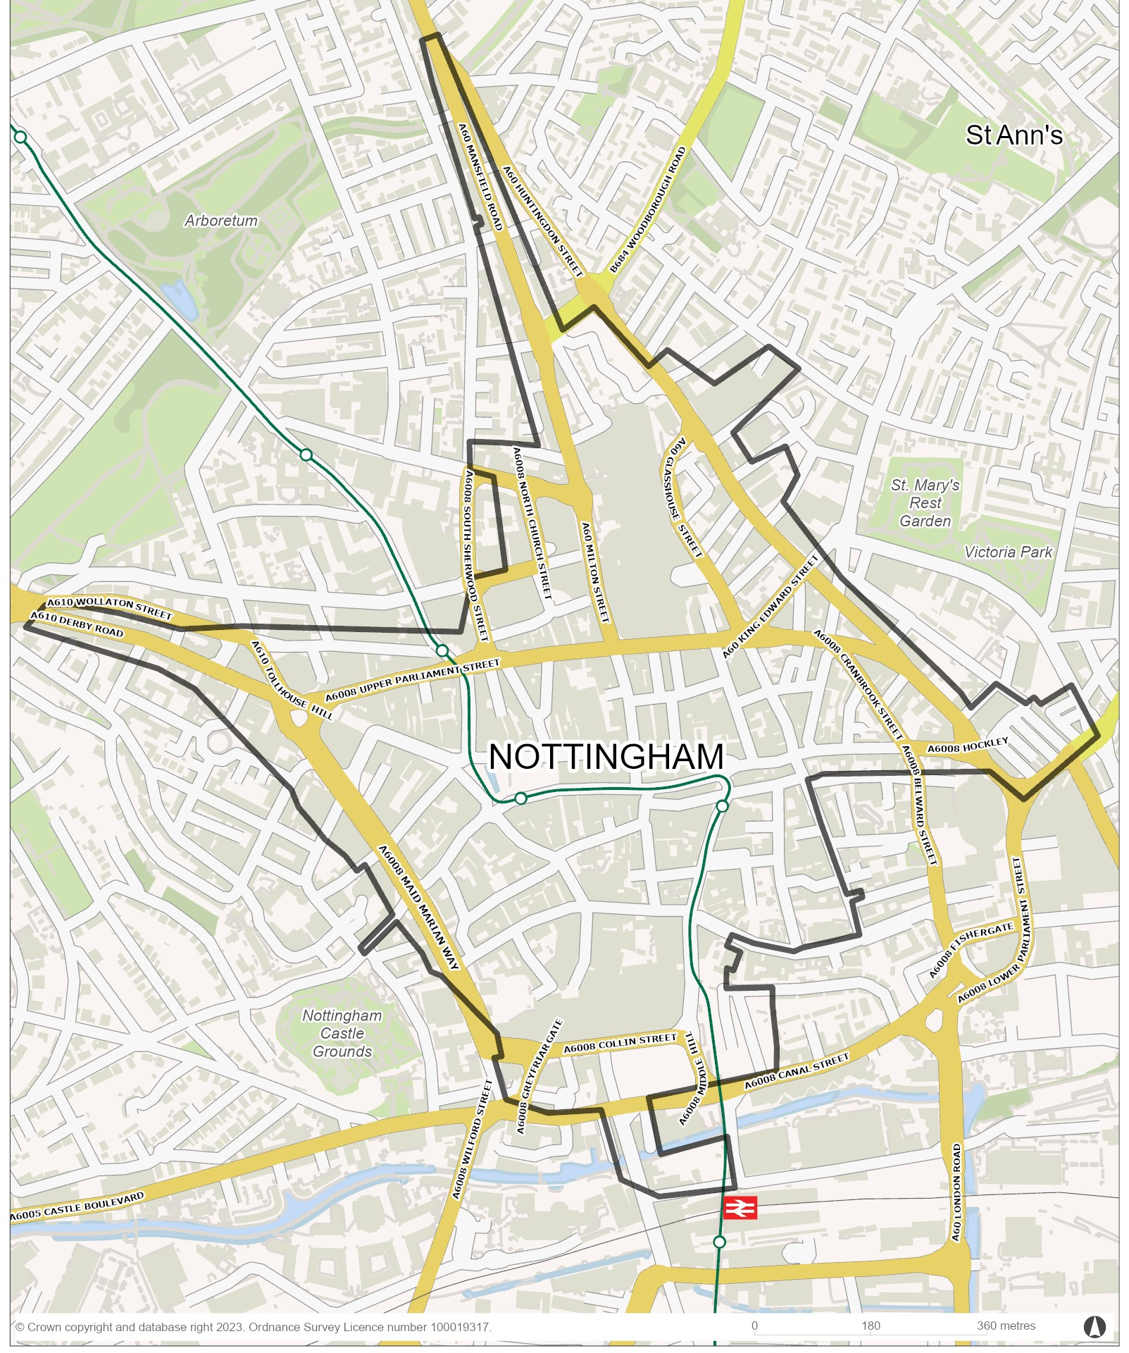

**Appendix 2: City Centre Streets**

|  |
| --- |
| Adams Walk |
| Albert Street |
| Albion Street |
| Alfreton Road |
| Angel Alley |
| Angel Row |
| Bank Place |
| Bath Street |
| Beastmarket Hill |
| Beck Street |
| Belward Street |
| Bluecoat Close |
| Bluecoat Street |
| Boston Street |
| Bottle Lane |
| Bridlesmith Gate |
| Bridlesmith Walk |
| Brightmoor Street |
| Broad Street |
| Broadway |
| Bromley Place |
| Brook Street |
| Burton Street |
| Byard Lane |
| Cairns Street |
| Canal Street |
| Cannon Court |
| Carlton Street |
| Carrington Street |
| Castle Gate |
| Castle Place |
| Chapel Bar |
| Chatham Street |
| Cheapside |
| Clare Street |
| Clarendon Street |
| Cliff Road |
| Clinton Street East |
| Clinton Street West |
| Clumber Street |
| Collin Street |
| Convent Street |
| Cranbrook Street |
| Curzon Place |
| Derby Road |
| Derby Street |
| East Circus Street |
| East Street |
| Eldon Chambers |
| Exchange Arcade |
| Exchange Walk |
| Fletcher Gate |
| Flying Horse Walk |
| Forman Street |
| Freckingham Street |
| Friar Lane |
| Frogmore Street |
| Fulforth Street |
| Garners Hill |
| Gedling Street |
| George Street |
| Glasshouse Street |
| Goldsmith Street |
| Goose Gate |
| Great Freeman Street |
| Greyfriar Gate |
| Greyhound Street |
| Halifax Place |
| Hanley Street |
| Heathcoat Street |
| High Cross Street |
| High Pavement |
| High Street |
| Hockley |
| Hounds Gate |
| Howard Street |
| Huntingdon Street |
| Hurts Yard |
| Kayes Walk |
| Kent Street |
| King Edward Street |
| King Street |
| Kings Place |
| Kings Walk |
| Kippis Street |
| Lace Market Square |
| Lennox Street |
| Lincoln Street |
| Lister Gate |
| Lister Gate Square Broad Marsh Centre |
| Long Row |
| Low Pavement |
| Lower Parliament St |
| Maid Marian Way |
| Major Street |
| Mansfield Road |
| Manvers Street |
| Market Street |
| Maypole Yard |
| Melville Street |
| Middle Hill |
| Middle Pavement |
| Milton Street |
| Mount Street |
| Nelson Street |
| Newcastle Chambers |
| Newcastle Street |
| Nile Street |
| Norfolk Place |
| North Church Street |
| North Circus Street |
| Old Lenton Street |
| Old Market Square |
| Old Street |
| Packers Place |
| Park Row |
| Parliament Terrace |
| Peachey Street |
| Peck Lane |
| Peel Street |
| Pelham Street |
| Pepper Street |
| Perth Street |
| Pilcher Gate |
| Plumptre Street |
| Poultry |
| Poultry Arcade |
| Poynton Street |
| Queen Street |
| Rancliffe Street |
| Rick Street |
| Sampsons Yard |
| Shakespeare Street |
| Sneinton Market Avenues  A, B, C, D, E, F |
| St James's Street |
| St Marks Street |
| St Marys Gate |
| St Marys Place |
| St Nicholas Street |
| St Peters Church Walk |
| St Peters Gate |
| St Peters Square |
| Stanford Street |
| Station Street |
| Stoney Street |
| Stretton Street |
| Sussex Street |
| Theatre Square |
| Thurland Street |
| Tokenhouse Yard |
| Tollhouse Hill |
| Trinity Square |
| Trinity Walk |
| Truswell Yard |
| Union Road |
| Upper College Street |
| Upper Parliament St |
| Vernon Street |
| Victoria Centre |
| Victoria Street |
| Warser Gate |
| Weekday Cross |
| West End Arcade |
| Western Street |
| Wheeler Gate |
| Wing Walk |
| Wollaton Street |
| Woodborough Road |
| Woolpack Lane |
| York Street |

|  |
| --- |
|  |

**Appendix 3: Eligible Retail Property by Class Descriptor**

**•** Commercial, Retail, Shop / Showroom

• Commercial, Retail, Restaurant / Cafeteria

• Commercial, Retail, Retail Service Agent

• Commercial, Retail, Other Licensed Premise / Vendor

• Commercial, Retail, Public House / Bar / Nightclub

• Commercial, Hotels, Boarding and Guest Houses, Hotel / Motel

• Commercial, Leisure, Amusements

• Commercial, Leisure, Bingo Hall / Cinema / Conference / Exhibition Centre / Theatre / Concert Hall

• Commercial, Leisure, Indoor / Outdoor Leisure / Sporting Activity/ Centre

• Commercial, Leisure, Library

• Commercial, Leisure, Museum / Gallery

**Appendix 4: Application, Appraisal and Approval Process**

**8. Grant Payment**

Grant paid by BACS into applicant’s business bank account

**7. Grant Claim**

Grant claim form, contractor invoices and payment evidence submitted to Nottingham City Council

**6. Grant Offer**

If the application is approved a Grant Agreement is issued. The Agreement must be signed and returned before any work is started or costs incurred

**3**. **Full Application**

Submit completed application form with quote, planning consent (if applicable) and lease/ownership details to <ukspfgrants@nottingham.gov.uk>

If

1. **Expression of Interest**

Applicant completes and submits an Expression of Interest (EoI) form to [ukspfgrants@nottinghamcity.gov.uk](mailto:ukspfgrants@nottinghamcity.gov.uk)

**5. Application Decision**Application submitted to grant panel for a decision

**4. Appraisal**

Appraisal of application undertaken within 10 working days of receipt

**2. Eligibility Assessment**Eligibility assessment of EoI undertaken within 5 working days of receipt