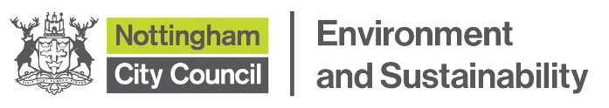
MEDIA RELEASE
Date: 25 September 2026 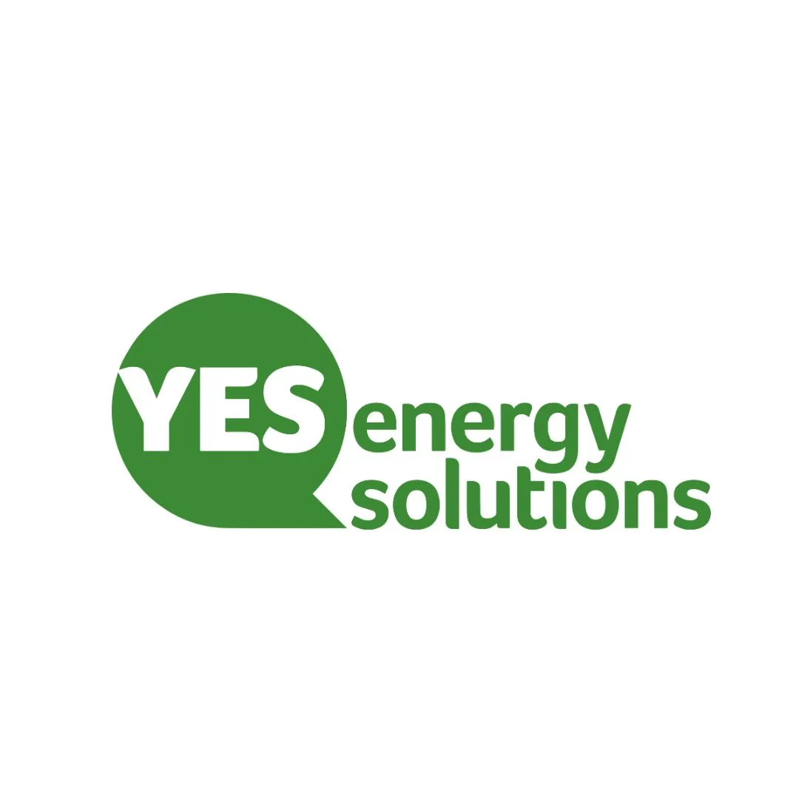
Call-out for community Groups to ‘win’ a free solar panel installation
Free solar panels are being offered to Nottingham based community groups in an initiative which could cut their fuel bills significantly.
Nottingham City Community centres are being invited to take part in a ‘competition’ to win the installation on their building worth up to £60k – at a time when rising energy prices are often a major part of their running costs.
The solar panels are being offered to a local community group or centre with a building and roof suitable for a solar panel installation. The installation is being offered by YES Energy Solutions as part of their Warm Homes Local Grant contract with Nottingham City Council (NCC).
This money may be used on one project or divided between separate groups depending on applications.
YES Energy Solutions operate as Community Interest Company and as part of their Social Value commitment to the communities of Nottingham City, they are looking to invest in the free installation of Solar PV to a suitable community building. To ensure they find a suitable community group to support they are asking for applications from across the city of Nottingham to apply.
Applications will be assessed against their ability to demonstrate clear and measurable benefit to the local Nottingham community, both now and in the future. Funding is intended for community-focused organisations.
The solar panels will be installed in the New Year and will help reduce energy bills for the community centre.
To be in with a chance of having the solar panels installed on your community building, applicants should send in a maximum of 300 words on how and why they meet the criteria (below) and why they feel they are deserving of the funding.
  - The successful entry must own the building or have leaseholders’ permission
  - Have a roof suitable for Solar PV – this can be assessed if the application is shortlisted
  - Explain how the project/initiative supports disadvantaged members of the community, such as supporting with fuel poverty
  - Must have a community space to facilitate community events, and gatherings
  - Must be in the current city council boundary

For more information on the competition and the terms and conditions please visit the link for more information: Greener Housing - Nottingham City Council
Through the Warm Homes Local Grant (WHLG) funding, which runs until 2028, NCC aims to support around 400 homes, helping residents who are in, or at risk of, fuel poverty by reducing energy bills and improving comfort and wellbeing. The social value part of the contract aims to offer wider support to communities across the city – for example by brining the Energy Advice Van to events such as the Beach in the City over summer to offer 1-1 energy Advice.
Emma Williams, Delivery Manager at YES Energy Solutions, said:
“Our partnership with Nottingham City Council over the past three years has demonstrated the power of working together with a shared purpose. As we look ahead, we are excited to see how our Community Interest (CIC) investment can strengthen communities and deliver meaningful benefits for residents across Nottingham”
Councillor Sam Lux, Executive Member for Climate, Energy and Nature at Nottingham City Council, said:
“The twin crises of cost of living and climate change mean there has never been a more critical time to expand renewables.
Nottingham City Council is forging ahead with its nationally leading decarbonisation agenda and will never turn down an opportunity like this to support our communities.
This project will make a long-lasting difference for the successful applicant and we couldn’t be happier to work with our trusted partner, YES Energy Solutions.”
YES Energy Solutions will design and install a solar array and possible battery (depending on suitability) for the community centre building. The solar asset will be transferred to the property owner following installation and will therefore be wholly owned by the building owner.
ENDS
Notes to editors:
- NCC secured £7.4 million of Warm Homes Government funding to support low-income homeowners and private renters in the city to upgrade and retrofit their homes with a range of free energy efficiency measures. These include insulation, solar panels, batteries and air source heat pumps.
- The WHLG scheme, announced by the Department for Energy Security and Net Zero (DESNZ), is being administered by the Midlands Net Zero Hub (MNZH) and will run until March 2028.

