**CAMHS Service Plan 2023 – 2024**

1. **Introduction**

The aim of this Service Plan is to outline how Nottingham City Targeted Children & Adolescent Mental Health service (CAMHS) will deliver services for children and young people to improve their emotional and mental health wellbeing.

Nationally, there has been a gradual rise in the number of children and young people with a mental health disorder. Research and copious amount of evidence highlights the negative impact mental health issues can have on children and young people’s development and wellbeing. Mental health problems in young people can result in lower educational attainment… and are strongly associated with behaviours that pose a risk to their health” (DHSC 2015). Evidence also highlights the long term impact if these issue are not addressed. Half of all long-term adult mental health disorders are established by age 14 and three quarters by the age of 24 (Kessler, 2005), this highlights the importance of effective mental health services.

It is estimated that 8718 children in Nottingham City have a diagnosable mental health disorder at any one time. Nottingham City Council (NCC) is committed to improving the emotional and mental health wellbeing of children and young people. Children’s emotional and mental health is a key strategic priority within NCC’s local partnership plan (Nottingham City Children and Young People’s Plan 2021 – 2024). *‘Good mental and emotional wellbeing underpins so much of our lives. We will ensure that children, young people, parents and carers are able to access the help they need to meet their mental health needs’* (Nottingham City Children and Young People’s Plan 2021 – 2024).

***Our Vision:***

A city where every child can enjoy their childhood in a warm and supportive environment, free from poverty and safe from harm; a city where every child grows up to achieve their full potential.

***Our Values:***

1. Children and young people are at the heart of all that we do
2. We will ensure that children, young people and families can access the right help at the right time.
3. We will work with, not do to, children, young people and families.
4. We will listen to, and act on, the views of children, young people and communities

**Children, young people and families in Nottingham will be**:

* Heard and Included
* Happy and Healthy
* Safe and Supported
* Learning and Achieving

1. **Demographics**

Nottingham ranked as the 11th most deprived Local Authority out of 317 in 2019. The Index of Multiple Deprivation (IMD) shows, 39% of Nottingham’s 0-17 year olds live in Lower Super Output Areas (LSOAs), that are in the highest decile of national depravation, the most deprived 10% of areas nationally. Data from the Department of Works and Pensions, evidencing children in low income families, shows that 25% of 0-15 in Nottingham live in low income families, locally defined as those who live in household’s dependent on out-of-work benefits, compared to 19% nationally.

Nottingham is a very diverse City, 42.7% of the population are of Black, Asian and Minority Ethnic background, higher than the England average of 26.5%. The 0-17 years’ population of Nottingham is 65972 of which 28894 are aged 10-17, (2021census). From the 2011 census to 2021 census, there has been a 6% increase in the 0-17 population, (62,457 in 2011, 65,909 in 2021). Some of the population growth has been made up of young people from newer and emerging communities, which has required a different focus and level of understanding in terms of their mental health needs and behaviour.

1. **Structure and Governance**

As part of Early Help and the wider Children’s Integrated Services (CIS), CAHMS will be subject to the same governance, reporting and scrutiny arrangements.

Update reports from CAMHS will be shared quarterly with the Nottingham Children’s Partnership Board. The partnership board work together to deliver a joint approach to improving outcomes for children, young people and families and oversees the development and implementation of the Nottingham’s Children and Young People’s Plan.

Annual updates will be shared with the Health and Wellbeing board, who bring together key local leaders to improve the health and wellbeing of the population of Nottingham and reduce health inequalities. The Board is Chaired by NCC Portfolio holder for Health and vice chair appointed from Nottinghamshire Integrated Care Board.

CAMHS Performance will also be monitored monthly at the CIS Oversight & Assurance Day chaired by the Corporate Director for People.

CAMHS will also produce performance and data reports in line with the requirements of schedule 6 in the agreed contract.

***Fig1. CAMHS Management Structure (2023/24 after completion of recruitment)***

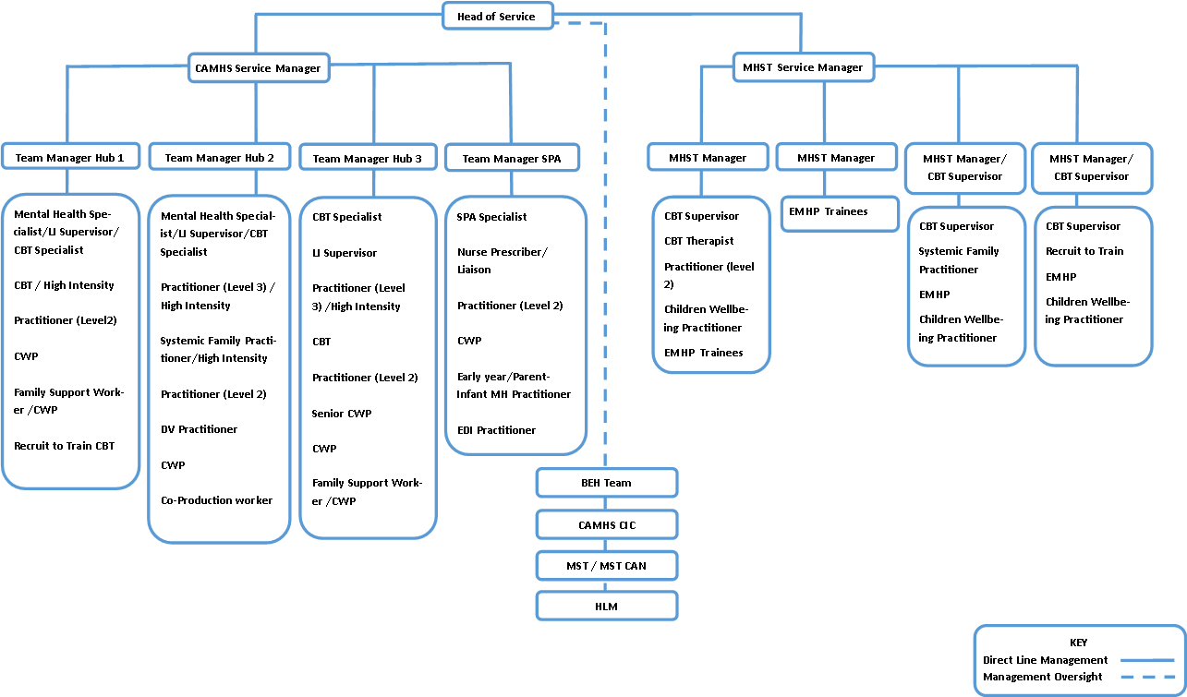

1. **Partnership & Funding Arrangements**

***Table 1: Financial contribution to CAMHS***

|  |  |  |  |
| --- | --- | --- | --- |
| **Partner** | **21/22** | **22/23** | **23/24** |
| **NCC** | 547,591.00 | N/A | N/A |
| **Public Health** | N/A | 677,522.00 | 445,035.00 |
| **Integrated Care Board** | 921,303.00 | 1,098,221.00 | 1,330,708.00 |
| **TOTAL** | **1,468,894.00** | **1,775,743.00** | **1,775,743.00** |

1. **Service Development**

CIS are currently working through an extensive transformation and improvement programme. The review and development of CAMHS sits alongside this process. As a service area, CAMHS has grown over the last few years and continues to do so with the addition of Mental Health Support Teams (MHST) and the Behaviour and Emotional Mental Health team (BEH). CAMHS also provides management oversight and support for Healthy Little Minds, Multi Systemic Therapy (MST) team, MST CAN and CAMHS Children in Care team.

The recruitment of a Head of Service will provide CAHMS with a dedicated senior manager, to manage what will be a transformative period for the service over the next 12 months to two years. The role will provide the strategic oversight and senior management link across all the services noted. It will also enable CAMHS to have a dedicated senior manager to strengthen CAMHS engagement at a strategic level with partners.

The SPA remains a priority service area for CAMHS. The service sits alongside the City’s Multi Agency Safeguarding Hub and manages all the referrals for the Nottingham City. There are clear protocols in place to ensure that referrals are processed quickly and effectively and children and young people are signposted to the right support for them depending on their needs.

The role of the SPA has increased exponentially, as referrals continue to grow, the team are working to full capacity. Development within that area of the service will see the addition of a:

* Team Manager
* Nurse Prescriber/Liaison
* Children Wellbeing practitioner (CWP) x 2
* Early year/Parent-Infant MH Practitioner
* Practitioner (Level 2)

The additional of these new roles will transform the SPA’s service offer and strengthen a much-needed health element, whilst increasing resilience in terms of specialist availability. The new roles will enable CAMHS to significantly increase its offer of a comprehensive early intervention service. The Nurse prescriber/Liaison role in particular will be crucial in working across Nottingham Health Care Trust and NCC regarding medication reviews, health checks, providing practice guidance and consultation around unexplained medical illness and liaison with healthcare providers.

This additional specialist role will allow for both an operational and clinical specialist and avoid drawing from the generic CAMHS team to provide SPA cover. The additional specialist will also support with quality assurance by authorising assessments and supervising clinical work on SPA.

CAMHS will also be able to reduce waiting times for children and young people, increase access to the service and deliver life-span provision at the point of referral. CAMHS has an excellent early intervention model of delivery that has previously been considered exemplary. Extending the resources within the service will enable CAMHS to build on their early intervention model and fully embed the Thrive model within the service.

The High Intensity roles that are being added to the service will increase the provision for high intensity therapeutic work in line with Improving Access to Psychological Therapies (IAPT). Increasing access to Cognitive Behaviour Therapy (CBT), Interpersonal Psychotherapy for Adolescents, Systemic Family Practice (SFP), Parent therapists and Eye Movement Desensitisation and Reprocessing, also requires additional supervision for CWPs and high intensity posts. This will be provided by the additional supervisors. The supervisors will ensure practitioners are accessing evidenced-based clinical supervision and ensure a progression pathway within the service for our low and high intensity staff. The supervisors will also be able to offer interventions.

CAMHS has an excellent track record of coproduction and participation with children and young people and has previously worked with Young Minds and other partnership agencies to embed participation within the service and to ensure children and young people have a say in service design and delivery and a voice in decisions that impact them. The CAMHS newsletter, your voice campaign, attendance at events (festivals) have all enable CAHMS to increase public awareness of the service CAMHS and supported the services drive to reduce stigma around mental health. We will strengthen this area of work with the coproduction worker developing an ongoing programme of participation events for 23/24 and establishing a stakeholder group comprising of children and young people.

**Service Delivery Key Objectives**

The Key objectives within the service plan builds on the target areas outlined in Nottingham and Nottinghamshire Joint Local Transformation Plan for Children and Young People’s Emotional Well-Being and Mental Health 2016 -2023 (September 2022 Refresh), and is informed by the Nottingham City Joint Strategic Needs Assessment 2022 (Emotional and mental health needs of children and young people aged 0 – 25 years)

|  |  |  |  |  |
| --- | --- | --- | --- | --- |
| **Objective** | **Actions** | **Required outcomes** | **Lead** | **End Dates** |
| Embed new structure | * Recruit to all vacant roles * Implement induction and training package to support new recruits * Work with CIS Integrated Workforce Development Team to identify ongoing training and development for all staff * Work the Workforce Development Team to develop the Early Help learning academy | * Strengthened leadership team * Stabilised our workforce * Development of a workforce that represents the diversity of the City * Enhanced service delivery * Increased senior level oversight across CAMHS/MHST/ BEH * Evidence of staff progression & retention | HoS & Service manager | Oct 2023 (Q3) |
| Develop the SPA function with CAMHS and wider CIS | * Recruit to all vacant roles * Implement induction and training package to support new recruits * Work with CIS to strengthen SPA integration / intervention at the front door and to look at opportunities to pool resources to strengthen service resilience | * Greater resilience across the SPA team * An appropriate allocated workforce (capacity and skill, experience, qualifications mix) to meet demand and presenting need * Delivery of early interventions at the point of referral * Reduction in waiting times and access to interventions * Closer working with MASH/Front door | Service manager | Oct 2023 (Q3) |
| Strengthen Early Intervention | * Provide a comprehensive service with focus on early years (0-5): * Recruit to Early Years post and CWP * Review all provision across age range and address training needs * Strengthen online offer * Continue to raise awareness of mental health issue regarding children and young people * Purchase Silver Cloud | * Delivery of early interventions at the point of referral * Active pathway between Healthy Little Minds and CAMHS * Increased provision for 0-5s * Update CAMHS section in CIS menu of service * Work with Early Help to ensure a presence in Family Hubs * All staff trained in use of Silver Cloud * Improved parental support and consultation * Increase access to self-help materials to support children, young people and families * Increase virtual offers of support through social media presence (Podcast, YouTube clips, Instagram, video calls) | Service manager & Team managers | Jan 2024 (Q4) |
| Strengthen Evidence based work | * Increase percentage of staff able to deliver evidence based work * Increase the offer of SFP & CBT available * Increase access to clinical supervision * Improvement on paired data (ROMS) | * Clinically indicated and evidence based interventions delivered to children and young people based on need and presentation (right support at the right time) * Regular clinical supervision routinely delivered by supervisors * ROMs moved to online forms/Availability of electronic ROMs (increases fidelity and completion) * Digital offer embedded to supplement service provision * Progression & retention * Ensure ongoing commitment to offer training opportunities through recruit to train | Service manager & Team managers | Jan 2024 (Q4) |
| Coproduction / Participation | * Strengthen coproduction work with young people * Develop opportunities for young people’s participation * Develop programme of participation events for 23/24 * Establish a stakeholder group comprising of CYP | * Feedback from young people informing service development/delivery * Access to events/activities to support mental health wellbeing * Development of a programme of participation events for 23/24 * Development of a stakeholder group comprising of children and young people * Development of opportunities for young people to support service planning, delivery and recruitment * Work with the Research, Engagement and Consultation Team to ensure Participation activities align with wider NCC Children and Young People Participation Strategy, 2021-2025 | Team managers | Jan 2024 (Q4) |
| Embed the Thrive model of working | * Work with ICB on the Community and Targeted CAMHS project to embed Thrive approach across the service/s * Deliver Thrive model training across the service * Ensure ongoing support for staff to ensure practice is embedded in service. | * An agreed vision and service model in place * SPA delivering fully in Getting Advice and Getting Help quadrants, through signposting and intervention at point of referral. * Completed training of workforce * Service delivery within Thrive parameters and reporting requirements | Service manager & Team managers | Mar 2024 (Q4) |
| Embed KPIs and develop Quality Assurance and reporting framework | * Work with Analysis & Insight and ICB to consolidate reporting framework to align with contract * Ensure data is being used to inform practice and service delivery and development * Ensure dip-testing and Quality Assurance process in place | * Production of a quarterly performance report to align with contract requirements * Timely data reporting * Regular dip-testing being undertaken by managers and specialist * Action and improvement plan implemented for any areas identified for improvement/development (practice or service) | HoS & Service manager | Sept 2023 (Q2) |
| Strengthen partnership work | * Develop working relationship with community & voluntary service providers * Work with ICB to support the development of children’s mental health services across the City * Work with Early Help colleagues to inform Early Help Strategy | * Attendance at partnership meetings supporting mental health services/development * networking/liaison/consultation with Healthy Families Teams, Family Hubs and strategic partners * Presence in Family hubs, implementation of Whole Family working, development of Early Help Strategy | HoS, Service manager & Team managers | Sept 2023 (Q2) |

**Name -**

**Title -**

**Organisation –** Nottingham City Targeted CAMHS

**Signature -**

**Date -**

**………………………………………..**

**Name -**

**Title -**

**Organisation –** Nottinghamshire Integrated Care Board

**Signature -**

**Date -**