Topic | Image/Media | Text to go with the post
Safer Sleep over Christmas | https://www.youtube.com/watch?v=suoccf8D1ns  This is the URL for the Youtube video to be added as the link preview  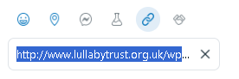  So that the image will display on the post like this:  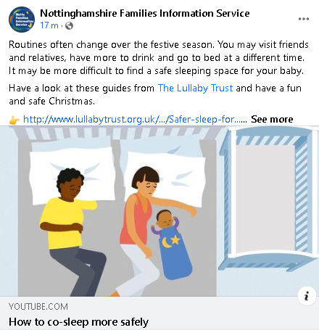 | Routines often change over the festive season. You may visit friends and relatives, have more to drink and go to bed at a different time. It may be more difficult to find a safe sleeping space for your baby.  Have a look at these guides from @lullabytrust and have a fun and safe Christmas.  www.lullabytrust.org.uk/wp-content/uploads/Safer-sleep-for-emergency-situations.pdf  www.lullabytrust.org.uk/wp-content/uploads/Safer-sleep-in-winter-resource.pdf  #BestStartNotts  #lullabytrust

