Title: |  | First Name(s): |  | Surname:
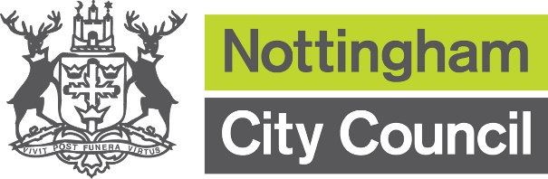
APPLICATION FOR
FREE SCHOOL MEALS
Your Details (Parent/Legal Guardian):

Date of Birth: |  | National Insurance or NAS (National Asylum Support) Number: |  |  |  |  |  |  |  |  |  | Relationship to your child(ren):
Your Address:
Postcode:
Contact Number: |  | Email Address:
Please confirm if you have Parental Responsibility
Yes |  | No
Your Partners Details and Contact Information:

Title: |  | First Name(s): |  | Surname:
Date of Birth: |  | National Insurance or NAS (National Asylum Support) Number: |  |  |  |  |  |  |  |  |  | Relationship to your child(ren):

Your Children’s Details:
Please include in the boxes below details of all dependent children who are living with you and are in attendance at school or nursery and please also confirm if the nursery children are full or part time.

First Name(s): | Surname: | Gender: | Date of Birth: | Name of School:

The qualifying benefits to be eligible to receive free school meals are:

• Universal Credit (provided you have an annual net earned income of no more than £7,400, as assessed by earnings from up to three of your most recent assessment periods)
• Income Support
• Income-based Jobseeker’s Allowance
• Income-related Employment and Support Allowance
• Support under Part VI of the Immigration and Asylum Act 1999
• The guarantee element of Pension Credit
• Child Tax Credit (provided you’re not also entitled to Working Tax Credit and have an annual gross income of no more than £16,190)
• Working Tax Credit run-on – paid for four weeks after you stop qualifying for Working Tax Credit

Declaration to be signed by ALL applicants

I understand that my entitlement to free school meals and/or school clothing allowance will continue only as long as I am in receipt of qualifying benefits. I will immediately inform the Pupil Benefits Team if my entitlement to qualifying benefits end and/or the contact details for myself and/or my child/ren change. I understand that if I do not inform you of a change to my circumstances and my child/ren continue to receive free school meals or school clothing allowance I will have to repay the amount in full.

I declare that all of the information provided on this form and associated documents is complete and true and I authorise Nottingham City Council to take such steps as they consider necessary to verify the information provided.

I understand that you must protect the public funds that you handle and that you may use the information provided to prevent and detect fraud. You may also share this information with other organisations that handle public funds. I understand that to give false information may lead to prosecution.

Claimant: |  | Partner:
Signed: |  | Signed
Date: |  | Date:

Once you have completed the application return the form via email to: pupil.benefits@nottinghamcity.gov.uk

