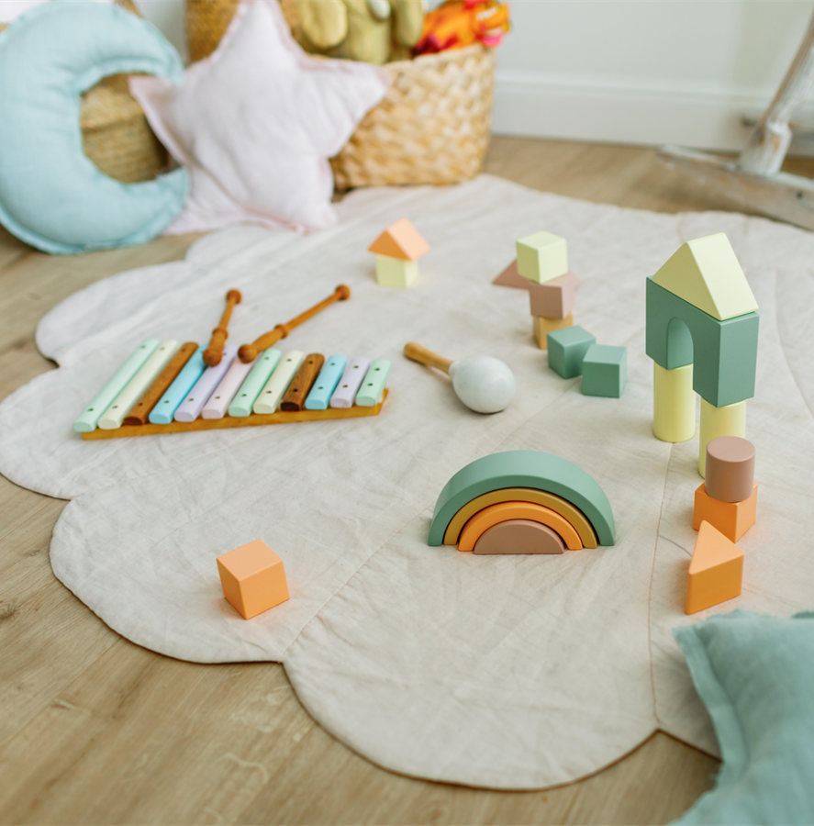
Early Years

Inclusive Environment Toolkit

This toolkit has been designed to help in reviewing your provision and ensuring it promotes an inclusive environment for all children and their families. When completing the audit settings should consider each of the statements and make a judgement as to if the practice is securely in place (S), Partly in place (P) or a Development area (D). Settings should use the comments section to note what they have in place already that meets the statement or what needs to be planned or implemented in the future.

Area for Consideration – Leadership and Management | S | P | D | Comments
Leaders and managers understand their Statutory duties under the SEND Code of Practice and the Equality Act. Policies and Procedures are implemented in line with statutory requirements
Policies and Procedures are reviewed and evaluated regularly
Clear safeguarding arrangements are in place and practitioners complete ongoing training
There is a clear admission and induction process for all children and parents
There are effective key person systems in place
The setting has a named SENCO who is clear on their role and responsibilities and works with all practitioners in the setting to ensure there is clear support for children with SEND
Leaders and Managers ensure practitioners are aware of their responsibilities is relation to supporting progress for all children
There is a clear SEND offer available, Parents and children with SEND are welcomed and engaged
The setting has clear transition plans in place for all children and work with parents and other settings to ensure this is a smooth process for all children
Accurate records and data are kept

The setting actively works with other agencies to support the identification of SEND and children’s ongoing needs
Communication with parents enables them to contribute to the shaping of the quality of support and the provision in a variety of ways
Children’s attendance is monitored and where appropriate supported
The setting is aware of and use wider resources to support children with SEND – including support from EYFS SEND Workers, tools on the Early Years Equality and Inclusion website
The setting has knowledge of referral routes for children both within the Local Authority and also wider agencies (NSPT, SALT, Paediatrician, Community nursing)
The setting access and utilise additional funding such as SENIF, HLN and DAF to support SEND in the provision
The setting has knowledge of the process for requesting an EHC Assessment
(S – Securely in place, P – Partly in place, D -Development Area)
Area for Consideration – Teaching and Learning | S | P | D | Comments
Practitioners have access to on going CPD opportunities to enable them to fully support children
Practitioners greet children by name – where there is EAL practitioners offer a greeting in home language
Observation and assessment systems are used to effectively support identification of any barriers to learning
Parents/carers are fully involved in discussions on identification and assessment of needs
Activities challenge children and are appropriate for the child’s stage of development
Practitioners have aspirations for all children and use their knowledge of what the children know and what they want them to learn next
Children are offered choices

Practitioners differentiate activities and break learning down into small steps (Targeted Support Plans, Individual Provision Maps)

Practitioners use a range of assessment tools to show small steps of progress for all children (Birth to 5, Development Matters, DFE SEND Assessment, Autism Progression Framework)
Routines are clear, flexible and adaptable

There are defined areas of learning – (Mathematics’, Literacy, Role play, Construction)
Visual prompts and/or objects of reference are used to support children’s understanding (Now and Next boards, visual timetables)
Children have access to adapted resources
There are sensory resources available in all areas
Practitioners use sign and gesture to support children’s learning and understanding
The outdoor environment gives children the opportunity to practise and develop their physical skills

Resources are accessible to the children
Resources are recognisable to children, but activities also offer new experiences for them
All areas of the setting are accessible to all children
Both indoor and outdoor environments promote the characteristics of effective learning i.e. encourage risk taking and promote curiosity and imagination

Children are given time to explore different learning opportunities and given time to revisit and embed the skills they learn

All children have a voice
(S – Securely in place, P – Partly in place, D – Development area)
Area for Consideration – Quality of Provision | S | P | D | Comments
Children have access to a cosy quiet space – carpeted area with cushions, pop up tent, dark den
Room décor supports children with sensory needs
Background noise is at a low level and purposeful I.e. is music playing throughout the session needed
Lighting considers sensory needs i.e. flashing fairy lights
The furniture is adaptable to accommodate specialist equipment
Resources are in a good state of repair
There is comfortable seating for adults supporting children
The room layout allows children space to explore and provides easy access for specialist equipment - i.e. wheelchairs
The environment supports children with sensory impairments
A wide selection of books and images are available that promote equality, diversity and inclusion
The setting celebrates all cultural events
Children and their families are represented throughout the environment - Books and resources reflect both the local community and the wider world
(S – Securely in place, P – Partly in place, D – Development area)
Following completion of this toolkit if you require any further support, please contact EYFSSEND@nottinghamcity.gov.uk

