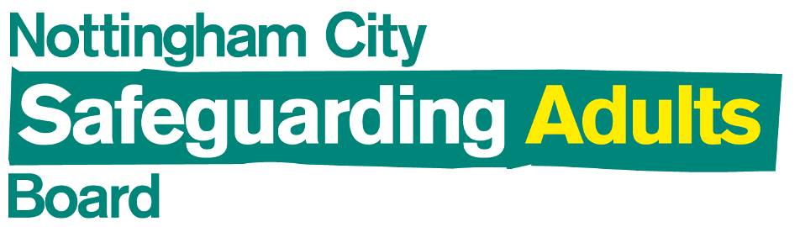

**Annual Report**

**2017/18**

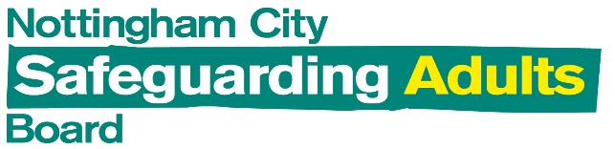

**Foreword by the Independent Chair /Executive Summary**

This Annual Report is a valuable read. At a time when organisations and many citizens are under increasing pressure, the Board continues to seek assurance that Safeguarding adults arrangements in Nottingham City are effective.

Amidst the challenges of shrinking budgets and growing demand for services, the Board has this year been assured that Safeguarding adults remains a priority across the partnership; and furthermore, some innovative ways of working are being developed. This good practice is testament to the systems, training, and commitment of our combined workforce – but we can always do better! Read on to find out more…

**Let’s look at the facts**

This report contains performance data (see Section 2) showing the level, type and source of referrals to Adult Social Care. The overarching message is that this is consistent with previous years.

1. **Level of referrals:** The data shows a stable level of safeguarding referrals and enquiries. With an increase or decrease in referrals we can not be sure if that reflects occurrence or awareness and practice. But the percentage of referrals which meet the criteria for a Section 42 enquiry has actually dropped. Prior to April 2016 it was 75%-80% but it is now down to 55%-60%. A ‘Making Safeguarding Personal’ approach continues to be led by ASC – working with citizens to remove or manage risks and not putting them through unhelpful processes. When asked, nearly all citizens said the safeguarding outcomes they desired had been fully or partially met.
2. **Referral sources:** The majority of safeguarding referrals which met the criteria for a Section 42 enquiry came from either the NHS or the private and voluntary sector. This is due to robust safeguarding leadership, procedures and training programmes. Additionally, providers commissioned by the Council or NHS are contractually required to have safeguarding procedures and training, monitored by the commissioners, which explain their positive awareness in relation to safeguarding.
3. **Types of referrals:** Domestic Abuse, Modern Slavery, Self-Neglect, and Sexual Exploitation are all now recorded as separate types of abuse. Nonetheless, the profile of abuse over the previous three years has not changed significantly. The most common type of abuse remains Neglect/Acts of Omission**.** The majority of referrals have a recorded source of Private/Voluntary, so it is likely that this refers to abuse which has taken place in a care home or domiciliary home care service. In line with previous years, Financial/Material abuse and Physical abuse also make up a significant proportion of referrals.

**What is being done?**

This report is full of case studies and best practice (see Section 3) showing innovation happening on the ground to help protect citizens. A few highlights include:

1. **Publicity and promotion:** Locally developed posters are now available in care settings and ‘Top Tips’ for staff are raising awareness of safeguarding amongst staff and people living in or visiting care homes.
2. **Community Protection:** This year, the City Safeguarding Team has undertaken effective partnership working with the Community Protection Team - making contact with socially excluded citizens and sharing intelligence about local offenders who may target vulnerable adults. This support has been invaluable to the Safeguarding Team in supporting citizens to remain safe from harm and crime in their own homes.
3. **Early Intervention:** The Adult Safeguarding Quality Assurance Team are holding monthly Quality Information Sharing Meetings regarding regulated providers. When early indicators show that quality is dipping the Team call Early Intervention meetings with the provider to raise their concerns. This has led to Care Homes either improving or progressing into a formal procedure more quickly.
4. **Prevention:** The CCG continued to fund the Early Intervention Practitioner (EIP) nursing post to help identify and support nursing homes that are not reaching or maintaining adequate standards. This has led to provider services being more aware of their safeguarding responsibilities and how to carry them out.
5. **Community Hubs:** Adult Social Care have developed Community Together Surgeries to offer local citizens the opportunity to get face-to-face advice, information and signposting. The model is a strengths based, preventative model of support which connects people to support and resources in their local community in order to reduce social isolation, increase activity and the development of robust informal networks. This innovative work is leading to better outcomes for citizens.
6. **Joint working:** The Mental Health Triage car is a joint Police and Health initiative which responds to potential mental health incidents reported into the Police. The service is designed to prevent harm to both the subject and the public. In 2017 the triage car dealt with an average of 11 incidents per day, or over 4000 per year. This means that right from the very first interaction with services, our citizens are getting a joined up response to address their needs.
7. **Learning from Experience:** the SAR subgroup is proactively seeking out complex cases for multi-agency review to help identify learning and improve outcomes in our work.

**What more needs to be done?**

It has been heartening to see how adult Safeguarding remains at the heart of our partnership. Increasingly in local organisations Equality Impact Assessments now require a Safeguarding Assessment to be made as part of any budget reduction decision.

The Quality Assurance subgroup has been developing a replacement to the Safeguarding Adults Assurance Framework (SAAF), which works well within the NHS but is not fit-for-purpose for all partners to follow. We need a system to provide assurance and scrutiny without imposing a one-size-fits all approach. Any solution needs to encourage partners to challenge each other and hold each other to account.

Continued training and learning across all partners remains essential. The most recent Safeguarding Adults Reviews emphasised the need for professional curiosity in all our work, alertness to coercion and control and forms of modern slavery. The Board aims to further share best practice and build the resources on the Board’s website.

**Should I read the full Annual Report?**

This Annual Report is really rich in case studies and insight. Whilst our context remains one of austerity and pressure on services, there are so many examples of good work leading to better outcomes for our citizens. We need to remain committed and continue to build on these strengths.

The full report can be found [here](https://www.nottinghamcity.gov.uk/health-and-social-care/adult-social-care/adult-safeguarding/about-nottingham-city-safeguarding-adults-board/). Read it, be informed, be inspired, help us to do even better next year. Thank you. **Malcolm Dillon, Independent Chair, Safeguarding Adults Board**

#### Contents

Introduction p. 5

Local Context p. 5

Board Structure p. 6

How is the work of the Board delivered? p. 7

Performance Information p. 8

Performance against the Board Annual Plan p. 17

Strategic Priority 1 – Prevention p. 17

Partner Contributions to Priority 1 p. 18

Strategic Priority 2 – Assurance p. 32

Partner Contributions to Priority 2 p. 34

Strategic Priority 3 – Making Safeguarding Personal p. 45

Partner Contributions to Priority 3 p. 46

Strategic Priority 4 – Safeguarding Performance and Capacity p. 52

Partner Contributions to Priority 4 p. 55

Looking forward to 2017/18 p. 60

1 Introduction

* + 1. The Care Act 2014 stipulates that the Safeguarding Adults Board (SAB) ‘must publish an annual report detailing what the SAB has done during the year to achieve its main objective and implement its strategic plan, and what each member has done to implement the strategy as well as detailing the findings of any safeguarding adults reviews and subsequent action’.[1]
    2. This report therefore provides an overview of what Nottingham City Safeguarding Adults Board has done during 2017/18 to achieve its main objective - to assure itself regarding the adult safeguarding arrangements in Nottingham City.
    3. The report begins by setting the scene with a brief overview of the local demographic context in Nottingham. The next section describes the function of the Safeguarding Board, the membership and the governance structure. The main body of the report takes each of the Board’s four strategic priorities in its annual plan for 2017/18 (which can be found [here](http://www.nottinghamcity.gov.uk/health-and-social-care/adult-social-care/adult-safeguarding/about-nottingham-city-safeguarding-adults-board/)) and reports on progress against these. Partner agencies’ descriptions of the contributions they have made towards the Board’s strategic priorities are included at the end of each section, including some illustrative case examples. The report concludes by looking forward to the work planned for 2018/19.

# Local Context[2]

* + 1. Nottingham has an estimated population of [**329,200**](http://www.nottinghaminsight.org.uk/people/population/) people, having risen by 4,400 since 2016 (Office for National Statistics, mid-year estimate 2017).
    2. The 2011 Census shows 35% of the Nottingham population as being from BME groups; an increase from 19% in 2001.
    3. Looking at the detailed ethnic groups, in those Census figures, those showing the biggest increases were Other White (2.5% to 5.1%), Mixed - White and Black Caribbean (2% to 4%), Black African (0.5% to 3.2%), and Pakistani (3.6% to 5.5%).  The largest groups other than White British are now Other White (5.1%) – which will include large numbers of people from Poland - and Pakistani (5.5%)
    4. Nottingham is the **eighth** most deprived district of 326 districts in the country ([Indices of Deprivation](http://www.nottinghaminsight.org.uk/research-areas/key-facts-about-nottingham/) Office for National Statistics): 34% of children and 25% of people aged 60 and over live in areas described as affected by income deprivation. Out of the seven, separate ‘domains’ that make up the Index of Multiple Deprivation, **Health and Disability** is the domain in which Nottingham performs worst.
    5. Nottingham has a relatively young age-structure: 50% of the population are aged under 30, 11.5% of the population are over 65 years old.
    6. Despite the relatively young age structure, Nottingham has a higher than average rate of people with a limiting long-term illness or disability: 18% of the population have a long term activity-limiting illness or disability. 7.7% of the population aged 16-64 were claiming Incapacity Benefit, Severe Disablement Allowance or Employment and Support Allowance in November 2017, compared with 5.6% nationally.

# The Board Structure

* + 1. **What is the Safeguarding Adults Board?**
    2. The Care Act (2014) made it a statutory requirement for each local authority to set up a Safeguarding Adults Board (SAB). The main objective of a SAB is to assure itself that local safeguarding arrangements and partners act to help and protect adults in its area who meet the criteria, also defined in the Care Act.
    3. The criteria are that safeguarding duties apply to an adult who:
* has needs for care and support (whether or not the local authority is meeting any of those needs)
* is experiencing, or at risk of, abuse or neglect
* as a result of those care and support needs is unable to protect themselves from either the risk of, or the experience of abuse or neglect
  + 1. The adult’s care and support needs should arise from, or be related to a physical or mental impairment or illness; however, they do not need to meet the minimum eligibility criteria as set out in chapter 14 of the Care and Support Guidance, issued under the Care Act 2014[3]. Abuse and neglect includes: Physical abuse, Domestic violence, Sexual abuse, Psychological abuse, Financial or material abuse, Modern Slavery, Discriminatory abuse, Organisational abuse, Neglect and acts of omission, Self-neglect
    2. **Who sits on the Board?**
    3. The Board has representation from the following organisations:
* Nottingham City Council Adult Social Care (ASC) & Public Health
* Nottingham City Council Community Protection
* Nottinghamshire Police
* NHS Nottingham City Clinical Commissioning Group (CCG)
* National Probation Service, Nottinghamshire
* DLNR Community Rehabilitation Company (DLNR CRC)
* Nottinghamshire Fire and Rescue Service (NFRS)
* East Midlands Ambulance Service (EMAS)
* Nottinghamshire Healthcare NHS Foundation Trust (NHCFT)
* Nottingham CityCare Partnership (CityCare)
* Nottingham University Hospitals NHS Trust (NUH)
* Vulnerable Adults Provider Network (VAPN)
* HMP Nottingham
  + 1. In addition, Nottingham City Council’s Lead Member for safeguarding adults is a participating observer on the Board. In practice, this means routinely attending meetings and receiving all written reports.
    2. All Board papers are sent to the Crime and Drugs partnership, and a representative is invited to attend meetings where cross cutting issues are on the agenda.
    3. The Board has an Independent Chair, Malcolm Dillon. The Board meets quarterly. The Board is supported by a full time Board Manager, and 0.5 FTE Business Support Officer.
    4. The Board Manager left for a promotion in December 2018 and for the remainder of this year the Board continued to operate without a Board Manager, though it is hoped to recruit during 2018-9. The absence of a Board Manager for this part of the year has had an inevitable impact on the delivery of some parts of the annual plan.

# 1.4 How is the work of the Board delivered?

* + 1. The Board has a Business Management Group (BMG), which drives the main business of the Board. The BMG is responsible for co-ordinating the business of the NCSAB to enable the Board to focus on strategic decision-making, and is responsible for managing the implementation of Board decisions, ensuring work is appropriately delegated to subgroups.
    2. The Board has three subgroups.
    3. **The Quality Assurance Subgroup** is responsible for supporting the NCSAB in its assurance responsibilities by collecting evidence on behalf of the Board in regard to the quality of local Safeguarding Adults interventions and the performance of agencies in carrying out their safeguarding responsibilities. This includes a focus on the principles of Making Safeguarding Personal.
    4. **The Safeguarding Adults Review (SAR) Subgroup** is responsible for ensuring that agencies and individuals learn lessons to improve the way in which they work, both individually and collectively, to safeguard and promote the welfare of vulnerable adults. The SAR subgroup seeks to regularly develop SAR processes in line with The Care Act 2014, local and national best practice.
    5. **The Training, Learning & Improvement Subgroup** aims are: to be assured that the organisations working with adults at risk understand what their workforce need to know in terms of their safeguarding responsibilities, and that the workforce is competent in carrying out these responsibilities; to promote learning and improvement opportunities that respond to Safeguarding Adults Reviews, audits and other work of the Board and their partner agencies and that this leads to improved practice and better outcomes for adults at risk; to act as a vehicle for disseminating safeguarding messages into the workforce and to review the effectiveness of multi-agency learning and improvement activities, including training, in order to safeguard and promote the welfare of adults at risk.
    6. The Governance Structure is represented by the diagram on the following page



**Business Management Group**

Chair – NCSAB Independent Chair

Nottingham City CCG

NCC Adult Social Care

Nottinghamshire Police

Subgroup Chairs

**Training, Learning & Improvement Subgroup**

Nottinghamshire Healthcare NHS Trust

CityCare Partnership

NCC Adult Social Care

NCC Communications

Nottingham University Hospitals NHS Trust

NCVS

Metropolitan Housing

**Quality Assurance Subgroup**

Nottingham City CCG

NCC Adult Social Care

Nottinghamshire Police

CityCare Partnership

Nottingham University Hospitals NHS Trust

Nottinghamshire Healthcare NHS Trust

Vulnerable Adults Provider Network

NCC Analysis & Insight

**Safeguarding Adult Review Subgroup**

Nottingham City CCG

NCC Adult Social Care

Nottinghamshire Police CityCare Partnership

Nottingham University Hospitals NHS Trust

Nottinghamshire Healthcare NHS Trust

* + 1. The Quality Assurance Subgroup is chaired by the Director of Nursing and Allied Health Professionals at Nottingham CityCare Partnership.
    2. The Training, Learning and Improvement subgroup was established in its own right in 2017/18, having previously been joint with the Nottingham City Safeguarding Children’s Board. It was initially chaired by the Principal Social Worker, ASC Training, Development and Quality Assurance until her maternity leave and will be chaired by the Safeguarding Lead Named Nurse from Nottinghamshire Healthcare Trust in 2018/19.
    3. The SAR subgroup has been chaired by the Safeguarding Practitioner at NHS Nottingham City Clinical Commissioning Group, who is now in the role of Designated Nurse, Adult Safeguarding, Greater Nottingham Clinical Commissioning Partnership.

2. Performance Information

* + 1. The following report has been prepared by the Senior Performance Analyst in Nottingham City Council, who is a member of the Quality Assurance Subgroup. The information is drawn from the Adult Social Care information systems but reflects work undertaken by the range of partner organisations who are represented on the Board. Over time, it is intended that greater use can be made of the information held by other organisations as well.
    2. Before considering the data contained within this section, please note that Nottingham City Council changed the IT system that they used to record Adult Social Care data within the time period this data covers: the new system went live in August 2016. A consequence of this was that data in both July 2016 and August 2016 is not fully complete due to issues with data migration onto the new system. This does not mean that citizens were not safe because of this data issue; however, some data for these months is not available to be included in this section or should be noted with this data issue in mind.
    3. The number of referrals received by Adults Safeguarding recorded a slight upward trend between quarter 4 in 2016/17 and quarter 3 in 2017/18 (see chart 1). Despite this upward trend, there has been no statistically significant increase in the number of safeguarding referrals received. Please keep in mind that quarter 2 of 2016/17 shows a drop in the number of safeguarding referrals received due to data migration issues rather than a drop in actual numbers and should be disregarded from any trend analysis.

**Chart 1 – Number of Referrals Received**

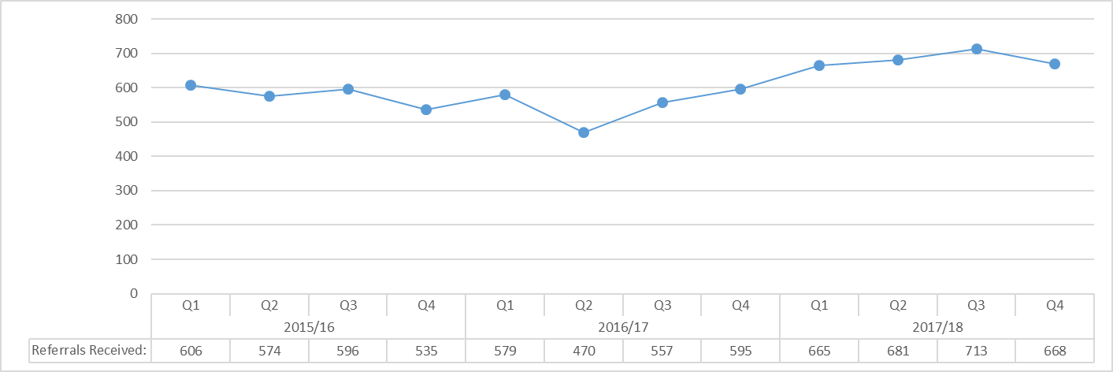

* + 1. In this report, a Section 42 referral is defined as a safeguarding referral which meets the three criteria in the Care Act Guidance (as in Paragraph 1.3.3 above). The number of Section 42 referrals received which met the criteria for a Section 42 enquiry (see chart 2) follows a similar pattern to that of all safeguarding referrals received in 2017/18 (see chart 1). There is a slight upward trend seen between quarter 4 in 2016/17 and quarter 3 in 2017/18, but once again, the increase is not statistically significant. Additionally, examination of monthly data for all safeguarding referrals and those which met the criteria for a Section 42 enquiry shows no statistically significant difference in any month (which can sometimes be masked by quarterly performance data).
    2. Once again, there is evidence of quarter 2 in 2016-17 displaying a pronounced drop in volume when compared to other quarters; however, the reason for this is the same as for the total number of safeguarding referrals received and will be a common factor in all ‘over time’ charts shown in this report.
    3. **Chart 2 – Number of Referrals Received which became Section 42 Enquiries**

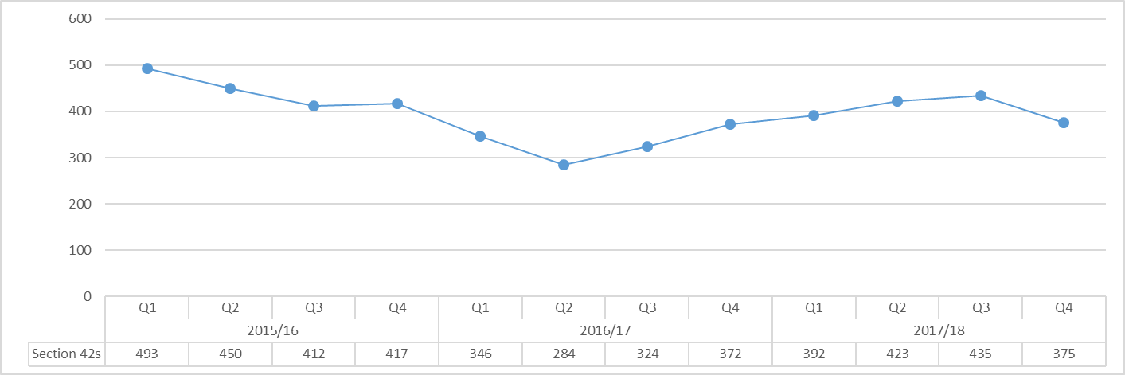

* + 1. The number of Section 42 enquiries gradually increased in 2017-18 when compared to the previous year (22.5% increase, 299 additional Section 42 enquiries); this was consistent with the increase in the number of all safeguarding referrals (23.9% increase, 526 additional safeguarding referrals). Nonetheless, this gradual increase is not statistically significant.
    2. Chart 3 shows the number of Adult Safeguarding referrals received by Adult Social Care broken down by those that met the criteria for a Section 42 enquiry and those that did not. The percentage of Adult Safeguarding referrals that met the criteria for a Section 42 enquiry was around 75%-80% prior to April 2016. With the implementation of the Care Act in April 2015 came a significant amount of additional training provided to social care staff, which led to a better understanding of exactly what constitutes cause for a Section 42 enquiry. With the bedding in of Care Act implementation, this percentage dropped to between 55%-60% and has remained at this level. Since the introduction of the new Adult Social Care system in August 2016, the percentage of Adult Safeguarding referrals in to Adult Social Care that met the criteria for a Section 42 enquiry has remained similar.
    3. **Chart 3 – Section 42 Enquiries & Non Section 42 Enquiries**

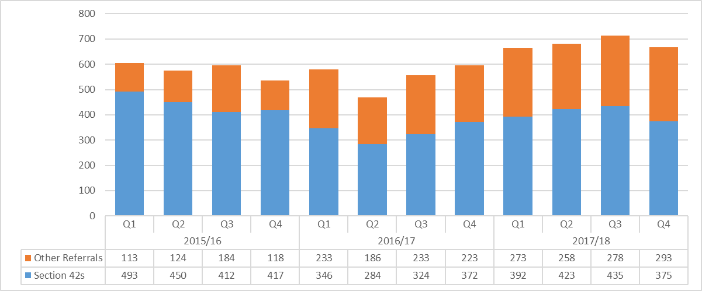

* + 1. Examining the source of those Adult Safeguarding referrals that met the criteria for a Section 42 enquiry (see chart 4) revealed that the trend over the last two years has not changed significantly. Similarly to the entirety of 2016/17, quarter 1 of 2017/18 saw a slight change in the number of Section 42 enquiries arising from some sources, with the private sector or voluntary sector contributing a higher percentage in this quarter than in any other. In general, the majority of Adult Safeguarding referrals which met the criteria for a Section 42 enquiry came from either the NHS or the private and voluntary sector. The key reason for this, specifically within the NHS, is due to robust adult safeguarding leadership, procedures and training programmes. Additionally, providers with contracts commissioned by the Council or NHS are contractually required to have safeguarding procedures and training, which are monitored by the commissioners, which should explain their positive awareness in relation to adult safeguarding. The number of Adult Safeguarding referrals which met the criteria for a Section 42 enquiry from ‘other’ sources contributed to a larger proportion in some months than in others (notably quarter 3 of 2017/18, 26.9%). Nonetheless, a breakdown of the ‘other’ category did not reveal any one referral source which made a significant contribution to the total number of Adult Safeguarding referrals in to Adult Social Care which met the criteria for a Section 42 enquiry.
    2. **Chart 4 – Volume of Section 42 Enquiries by Source of Referral**

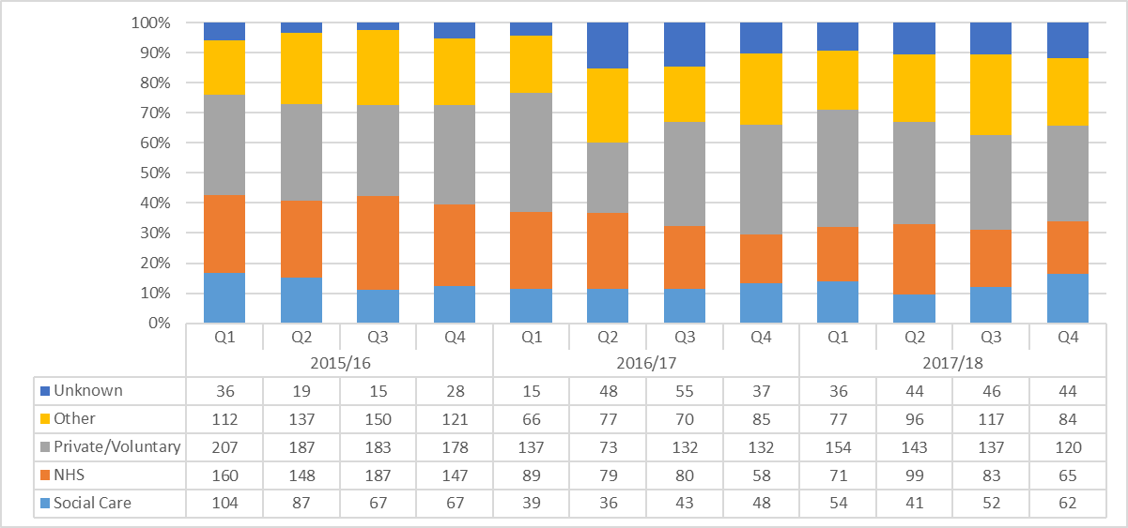

* + 1. The different types of alleged abuse have slightly changed since the implementation of the Care Act, with Domestic Abuse, Modern Slavery, Self-Neglect, and Sexual Exploitation all now recorded as separate types of abuse. This change came into effect in quarter 1 of 2015/16. Chart 5 shows that the main effect of this change to the alleged abuse categories is that Domestic Abuse can now be separated from the various abuse types these referrals used to be recorded as. Nonetheless, the profile of abuse over the previous three years has not changed significantly. Domestic Abuse, however, has recorded a reduction since it was first introduced as a separate category; this reduction started in April 2016. There is currently no proven rationale to explain this reduction.
    2. The most common type of alleged abuse is Neglect/Acts of Omission**;** this pattern has not changed over the three year period covered. As the majority of referrals which feed into this alleged abuse type have a recorded source of Private/Voluntary, it is likely that this refers to alleged abuse which has taken place in a care home or domiciliary home care service; such that the most common type of alleged abuse linked to these services is Neglect/Acts of Omission. Other types of alleged abuse that make up a large proportion of safeguarding referrals are Financial/Material abuse and Physical abuse, again this pattern has not changed significantly throughout the period this report covers.
    3. **Chart 5 – Volume of Section 42 Enquiries by Alleged Abuse Type**

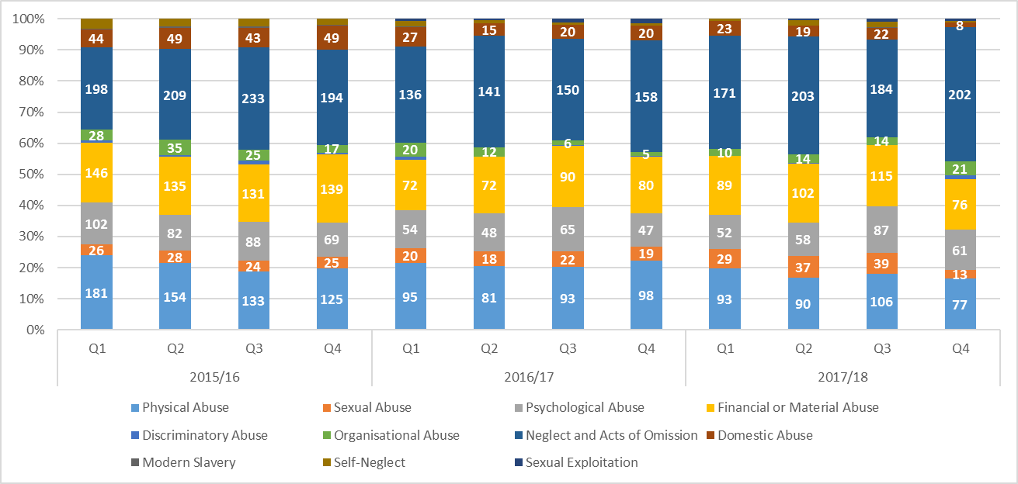

* + 1. The relationship of the alleged perpetrator saw a change in recording over the previous three years. Chart 6 shows a significant reduction in Section 42 enquiries where the alleged perpetrator was recorded as someone in a private/voluntary setting (-89.2% reduction, 100 fewer Section 42 enquiries, Q2 2016/17 compared to Q1 2016/17). At the same time there was a significant increase in Section 42 enquiries where the alleged perpetrator was recorded as someone working for Social Care (229.6% increase, 62 additional Section 42 enquiries). Analysis of these trends has revealed that this pattern is purely attributable to a change in how this data is recorded; such that, the relationship options available in the new IT system within Adult Social Care are different to those available in the old IT system, where there is no direct or logical comparison between the two figures.
    2. Additionally, since the change in recording, the percentage of Section 42 enquiries with a perpetrator relationship of ‘other’ saw a slight increase in the last three quarters of 2017/18. Analysis of this category reveals that quite a large proportion are recorded as an unknown relationship and as such this is something that Adult Social Care managers will address.
    3. **Chart 6 – Volume of Section 42 Enquiries by Perpetrator Relationship**

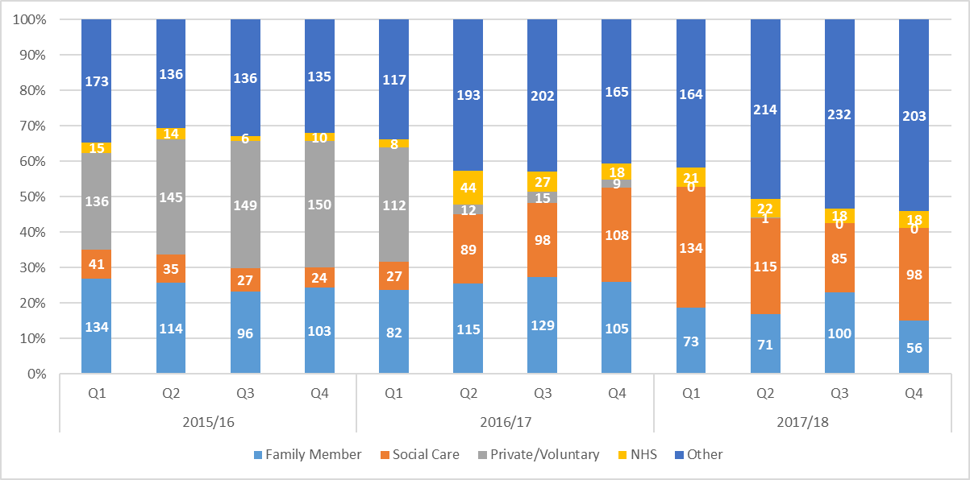

* + 1. When examining the location of alleged abuse, the slight increase in the ‘other’ category seen in the last two quarters of 2016/17 continues into 2017/18 (see chart 7). This trend is mainly due to an increase in the number of Section 42 enquiries where the location of abuse has been recorded as either ‘Unknown’ or ‘Blank’. In some cases, this can be expected as the alerter may not have been informed of where the alleged abuse took place; however, this will be highlighted in the Adult Social Care Safeguarding Training programme to ensure that colleagues are aware to aim to identify the location of abuse wherever possible. Aside from this, there is no significant change in the location of abuse over the last three years of data, with the majority of events taking place either in the citizen’s own home or in a care home; both of which are places where the majority of referred events are most likely to take place.
    2. **Chart 7 – Volume of Section 42 Enquiries by Location of Alleged Abuse**

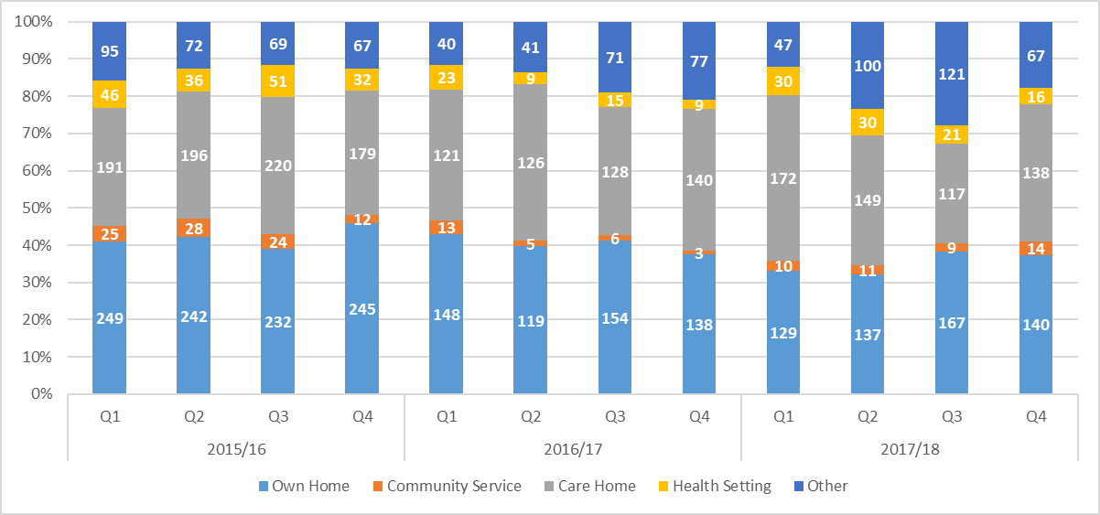

* + 1. As with referrals to Adult Social Care in general, citizens recorded to be of Asian ethnicity, specifically those of Chinese of Other Asian backgrounds, were under-represented within Section 42 enquiries when compared to the ethnic makeup of Nottingham City. This may be partly attributable to the demographic breakdown of the community, such that there are a higher proportion of younger people of Asian ethnicity in Nottingham City. Nonetheless, the number of Section 42 enquiries made for vulnerable adults from this ethnic category has increased slightly throughout 2017/18 (50% increase in 2017/18 compared to 2016/17, 22 additional enquiries), with a reduction in the proportion of citizens with an unknown ethnicity reducing over the same period (9.8% in 2016/17, 8.4% in 2017/18). It is important to note, however, that further analysis of the Asian/Asian British category shows that the increase in Section 42 enquiries is due to an increase in citizens of Pakistani ethnicity, with the level of Section 42 enquiries for other Asian ethnicities remaining at a similar level to that of previous years. It is encouraging to see a reduction in the proportion of unknown ethnicity recorded, this will continue to be monitored to see if any trends develop.
    2. **Chart 8 – Volume of Section 42 Enquiries by Ethnicity of Vulnerable Adult**

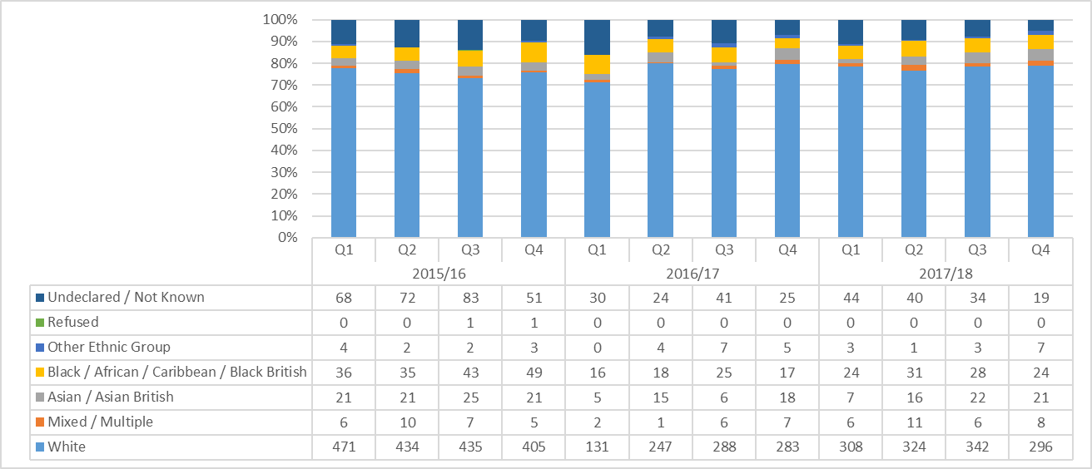

* + 1. Analysis of other key demographics revealed that there has been no significant change in relation to age range or gender over the last three years. Vulnerable adults over the age of 65 account for around 60%-65% of Adult Safeguarding referrals into Adult Social Care which met the criteria for a Section 42 enquiry, with citizens aged between 75 and 94 contributing the highest proportion within this age category (61.5% 2017/18). The gender of vulnerable adults continues to show a 60% female to 40% male split; this is consistent with what has been recorded over the last three years.
    2. Linking the above into the type of alleged abuse that took place shows that for female citizens, physical, sexual, and psychological abuse are more prevalent in the younger age groups (53%, 279 Section 42 enquiries, ages 18-70), with neglect the key abuse type for citizens aged over 71 years (56.5%, 342 Section 42 enquiries). Also, financial abuse is more prevalent in the 51-90 age range, accounting for 76.6% of all Section 42 enquiries for this type of abuse (144 referrals, see chart 11). Chart 12 shows an almost identical pattern in relation to male citizens with a Section 42 enquiry, albeit with the additional caveat that male citizens are more likely to suffer financial abuse than their female counterparts (accounting for 16.6% of all Section 42 enquiries for females compared to 21% for males).
    3. **Chart 9 – Volume of Section 42 Enquiries by Age**

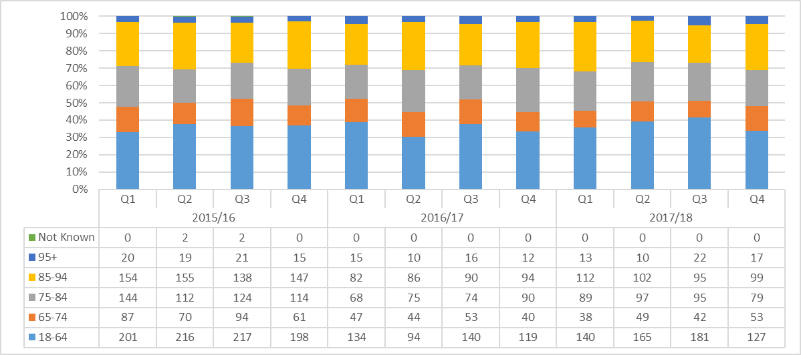

* + 1. **Chart 10 – Volume of Section 42 Enquiries by Gender**

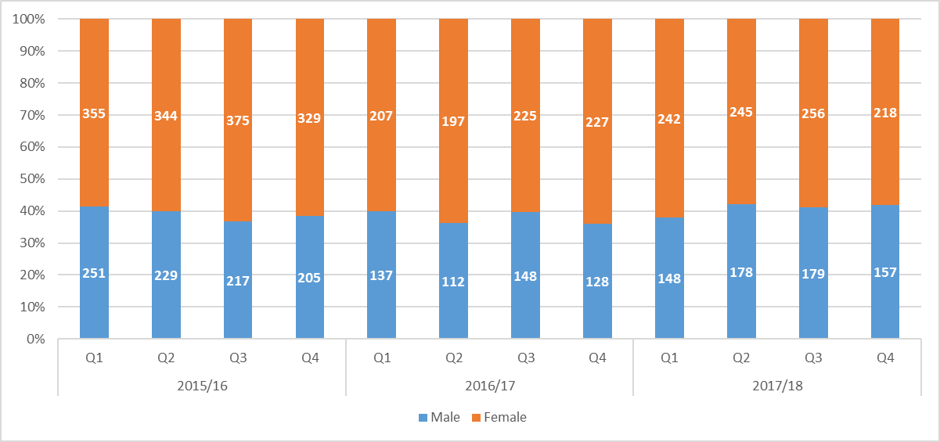

* + 1. **Chart 11 – Female Abuse Type by Age Group 2017/18**

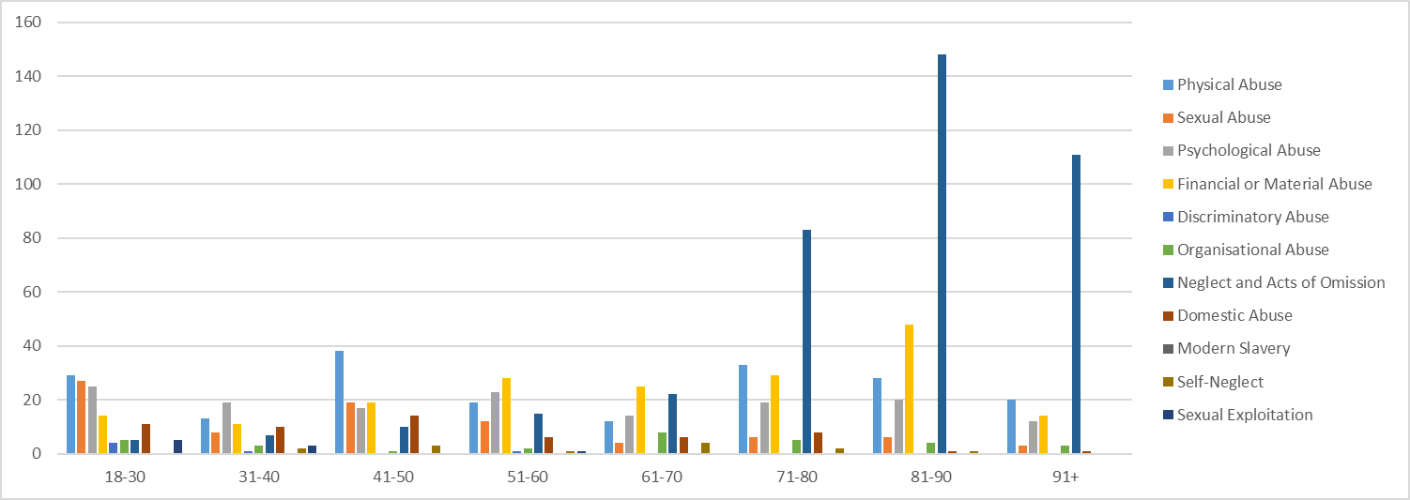

* + 1. **Chart 12 – Male Abuse Type by Age Group 2017/18**

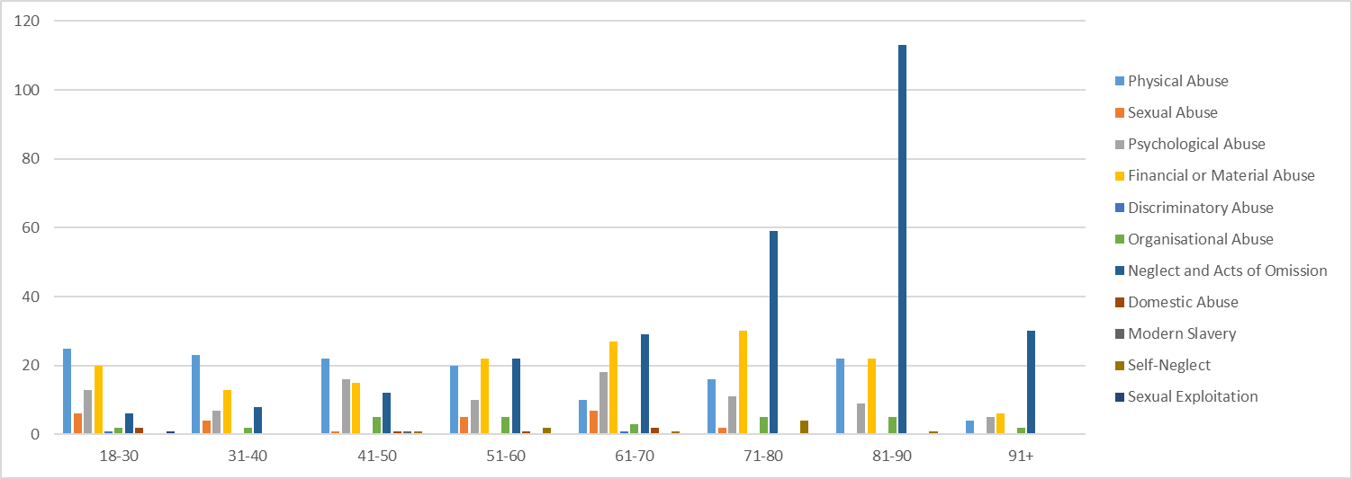

* + 1. Improved accuracy in the recording of Primary Support Reason (PSR) led to an increase in the number of vulnerable adults recorded with a PSR of either Physical or Mental Health in quarter 2 of 2016/17. This improved recording is due to the new Adult Social Care recording system implemented at the time, which now ensures that a PSR is entered if the citizen requires intervention from Adult Social Care (something the old system did not). This has led to fewer vulnerable adults having no PSR recorded, although this does still happen as some vulnerable adults will not be receiving a social care service, and therefore no mandatory PSR will be requested by the system. Following the change in system in 2016/17 quarter 2, the trend remains consistent throughout the rest of 2016/17 and 2017/18, such that vulnerable adults with a PSR of Physical and Mental Health account for the majority of referrals (54.9%, 890 referrals, see chart 13).
    2. 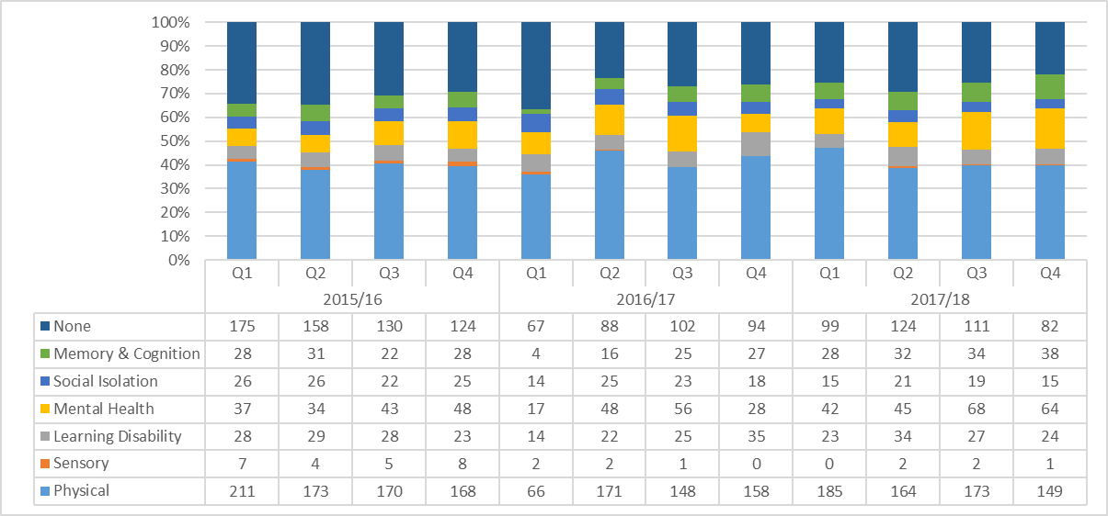**Chart 13 – Volume of Section 42 Enquiries by Primary Support Reason**
    3. With the implementation of the Care Act and its commitment to Making Safeguarding Personal, a focus on working to achieve citizens’ desired outcomes, as established by Adult Social Care, is at the forefront for all partners within safeguarding. In 2016/17, 94.0% of citizens had their specified outcomes either fully or partially met, and this figure has increased to around 97.0% in 2017/18. The outcomes requested by the citizen were usually key in what the safeguarding enquiry was attempting to achieve (e.g. speak to the alleged perpetrator or ensure that the vulnerable adult was checked up on more often). For those vulnerable adults who did not have their outcomes met a large proportion were alleged victims of financial abuse.

3 Performance Against the NCSAB Annual Plan

3.1 Strategic Priority 1: Prevention

* + 1. **That the workforce in Nottingham is aware of their safeguarding responsibilities and they know how to enable people to stay safe from harm through appreciating their concerns and promoting their independence**
    2. The Board Independent Chair and Business Manager met with lead officers from each Board organisation to seek assurance on their arrangements for this; feedback on the meetings was provided to each organisation. Overall the Chair and Board Manager were assured that organisations were striving successfully to ensure that their workforce were aware of their safeguarding responsibilities and were assisting in the partnership approach to enabling people to stay safe and promote their independence. This has to be a continuing, dynamic process for organisations. The Chair and Board Manager remarked on the very different levels of scrutiny by external bodies that there were for different organisations on the Board. This emphasised both the importance of internal assurance processes and challenge by partners on the Board.
    3. The Head of Adult Safeguarding and Quality Assurance in ASC has met with particular individual organisations to ensure there is understanding and agreement about what should be referred and what further steps they could take themselves to assist in promoting safety and independence in some situations. The Board’s aim is for as much preventative and proactive work as possible to be undertaken without immediately passing on possible concerns to ASC. This work is continuing in 2018/19.
    4. The Board is developing the information available on the website [here](http://www.nottinghamcity.gov.uk/health-and-social-care/adult-social-care/adult-safeguarding/learning-and-improvement/useful-resources-and-links/); the aim is for it to become a place people would expect to go to find information about good practice. So, for example, we have put there the national guidance on Financial Abuse and Scams and locally developed Top Tips for front line staff visiting care homes and people in their own homes.

|  |
| --- |
| **Excerpt from: Top Tips for front line staff visiting care homes**  When you visit a particular resident, take the opportunity to consider the home more broadly:   * -  What does the home look, sound, smell & feel like? * -  How do the other residents seem? Are they engaged in activities? What happens at meal times? * -  Are staff, including the manager, visible, approachable & purposeful? * -  How do the staff engage with the residents? Are call bells responded to promptly or do they ring repeatedly? * -  Is visiting encouraged? * -  Are complaints & advocacy encouraged (e.g. can you see posters explaining how to contact safeguarding, CQC)? * -  **Would you like a friend or family member to live here?** * -  Be alert to the risk of complacency about poor care. * - **Talk to the adult** who you are visiting and ask for their views: consider their **wellbeing** in the broadest sense.   The full list of Top Tips when visiting care homes and adults in their own home are [here](https://www.nottinghamcity.gov.uk/health-and-social-care/adult-social-care/adult-safeguarding/learning-and-improvement/useful-resources-and-links/) |

**3.2.1 The Board develops a better understanding of the impact of social isolation on people in Nottingham and implications for prevention work in adult safeguarding**

* + 1. ASC in Nottingham has been one of the national pilot areas for social isolation initiatives: the team are information gathering through supervision and data collection in order to measure if Social Isolation is a strong indicator in susceptibility to abuse.
    2. The Board received a ‘think piece’ from the Association of Directors of Adult Social Services that stimulated awareness of the links between social isolation and adult safeguarding.
    3. The outcomes of the local and national pilots are being reviewed nationally and the Board will consider the implications for Nottingham in 2018/19.
  1. Partner Descriptions of their Contributions to Strategic Priority 1
     1. **NHS Nottingham City Clinical Commissioning Group**

The CCG has worked towards the Prevention objective by continuing to fund the Early Intervention Practitioner (EIP) nursing post following the external evaluation of the project. Their role is to help identify and support nursing homes in the city that are not reaching or maintaining adequate care and wellbeing standards for residents.

The safeguarding team have carried out a number of safeguarding quality visits to GP Surgeries and the main health providers across the city. At all of these visits the training and governance arrangements are reviewed by the CCG and recommendations and support are offered by the team to ensure that the services are aware of their safeguarding responsibilities and how to carry them out.This is reinforced by the GP leads meetings which are held quarterly along with a bi monthly Safeguarding Newsletter.

The CCG continues to identify patients that are 100% continuing health care (CHC) funded and meet the criteria for a Court of Protection application to ensure that any restrictions and restraints that are required in order to deliver the care they need are in the patient’s best interest and are authorised by the courts. The pilot has now been incorporated into the new community contract service specification for CHC. The CCG continues to work closely with Nottingham City Council colleagues on complex joint funded Court of Protection cases.

* + 1. **Nottingham City Council - Adult Social Care**

**Strengthening Partnerships Operationally**

This year, the City Safeguarding Team, responsible for the majority of Safeguarding Enquiries undertaken in the City, instigated and embedded strong, effective partnership working with the Community Protection Team (based elsewhere in the Council). The Safeguarding Team utilise the support from the Community Protection Officers on a weekly basis (minimum of 3 times a week) in work such as joint visits, making contact with socially excluded citizens (who often only frequent their properties at evenings and weekends) and sharing intelligence about local offenders who may target vulnerable adults. This support has been invaluable to the Safeguarding Team in supporting citizens to remain safe from harm and crime in their own homes.

|  |
| --- |
| **Case Study**  P was taken advantage of financially by his neighbours and also local members of the community would force their way in to his property and exploit him. P wished to remain in his own home, which meant the ongoing risk was very difficult to remove. The Safeguarding Social Worker created a Protection Plan where the Community Protection Service played a significant role in providing ongoing monitoring and deterring further exploitation through a raised uniformed presence in the local vicinity. The property was also made more secure and there were no further incidents reported at home. An ongoing risk remained that P would be targeted while out and about, however, Officers agreed to proactively approach P if they saw P in Nottingham city centre, which has also worked as a protective factor.  Traditionally, without this level of support from Community Protection, the ‘safest’ options would be for P to move from the property and community that P loved, with no guarantee that the exploitation would not occur again due to P’s visible vulnerability. A successful outcome has been achieved though partnership working. |

**Social Isolation:** Tackling social Isolation is a key Strategic Priority for Adult Social Care through our ‘Better Lives, Better Outcomes’ programme. The more connected and engaged citizens are in their local community with neighbours, social contacts and local service, the more this improves health and wellbeing. It is well established that isolated, vulnerable citizens will be at a higher risk of crime and exploitation. The following case study illustrates what Adult Social Care are doing to reduce vulnerability;

**Case study; Community Hubs**

Our Community Together Surgery (CTS) is in the Aspley area of Nottingham City and has been operational since early December 2017.  The purpose of the CTS is to offer the opportunity for local citizens including carers to get face to face advice, information, signposting and a Care Act compliant assessment (where needed).  The CTS model is a strengths based, preventative model of support which connects people to resources in their local community and to other local people in order to reduce social isolation, increase activity and the development of robust informal networks.  Outcomes for citizens in other areas where this model of support has been delivered over several years include: increased confidence & self-esteem, improved health & wellbeing and maintenance of positive informal support networks.  Our CTS has been co-produced and delivered with local people and local services.  Skilled and experienced Care practitioners facilitate the CTS.  Colleagues from partner organisations co-facilitate the CTS and these include colleagues from our Community Together Service, the Community Activator Team, Evoke and the Carers’ Trust.

We plan to jointly deliver a CTS with stakeholders in each Nottingham locality by the end of 2019.  The CTS in each area will be co-produced and co-delivered and will be responsive to the needs of the local community.

**Social Isolation National research;** The City Safeguarding Team are now participating in the national ADASS Safeguarding, Prevention and Social Isolation Evaluation project. The team are information gathering through supervision and data collection in order to measure if Social Isolation is a strong indicator in susceptibility to abuse. The findings will be reviewed once thematic issues begin to emerge and will contribute to the ADASS research.

**Early Intervention** The Adult Safeguarding Quality Assurance Team are responsible for chairing and coordinating Adult Safeguarding Investigations in regulated services, namely Care homes and homecare provider services. In 2017the team implemented a system of calling Early Intervention meetings when concerns had been raised in the monthly Quality Information Sharing Meeting regarding regulated providers who are showing **early** indicators of dipping quality. In the period April 2017 – March 2018, 16 individual care homes were subject to Early Intervention Meetings, which usually entails 2 – 4 meetings. The ASQA Team going forward will monitor the number of Care Homes that either improved following this intervention, or progressed into a formal procedure.

|  |
| --- |
| **Case Study**  The Early Intervention process was implemented following a number of safeguarding referrals and general concerns raised by a whistle blower. Also, a focussed CQC (Care Quality Commission) Inspection identified a range of concerns within the ‘safe, effective and well led’ category.  An initial meeting included the CQC, Early Intervention Practitioner, along with the Provider, Safeguarding social workers and Contract Team representatives.  The Provider was keen to engage and the view was that the service had lost touch with current good practice, evolving their own approaches that at times were unsafe and did not respect citizens’ rights. As a small care provider, external support was required to address the problems in this service. The Early Intervention Practitioner undertook targeted support with the provider, and progress was reviewed via Early Intervention Meetings.  This was extremely successful and the service exited the EI process after 5 months, which included 4 months of improvement and a final month to measure sustainability. This was a great example of working through the Early Intervention approach. |

**Training and Development**

Adult Safeguarding continues to deliver this to our Adult Social Care Assessment and Provision colleagues, covering Foundation, Record Keeping, Chairing & Co-ordinating meetings, Effective Information Gathering, Risk Management, and other procedural training. A key development in 17/18 has been the proactive involvement of the Adult Safeguarding Trainer and City Safeguarding Team in working with both trainee and newly qualified Social Workers. This ensures that Adult Safeguarding is embedded at the forefront of developing Social Workers and has included members of the Safeguarding Team delivering presentations to University students about safeguarding and MSP and the Adult Safeguarding Trainer mentoring and supporting trainee and newly qualified Social Workers who are on placement or who have recently joined the council.

**Deputyship Team**

The Adult Social Care Deputyship Team is responsible for managing the finances and assets of over 260 citizens who lack the Mental Capacity to do this themselves, and would otherwise be vulnerable to financial exploitation. A further preventative step was taken in 2017, and in collaboration with ‘Cifas’, all citizens are now registered under their ‘Protective Registration for the Vulnerable’ scheme. This minimises on-line and credit fraud, which citizens, despite being under Deputyship Orders, may still be highly susceptible to, in particular when they remain living in the community.

Cifas is a not-for-profit association who work to prevent financial abuse and internal fraud. They provide a shared database with over 300 public and private organisations to prevent fraud i.e. if someone tries to take out credit or an account, and the registered organisation checks the Cifas database and if the client appears, they will contact Cifas, who will contact the team to check if it is a known / approved transaction and decline it if not.

**Future Learning**

In this period of austerity and pressure on public services, Adult Social Care will continue to lead and collaborate to provide training and development opportunities to promote Adult Safeguarding. This is through the personal commitment of colleagues where traditionally courses would have been commissioned and resourced. The rich experience of the Safeguarding specialists in Adult Social Care has been shared this year including delivering Every Colleague Matters training to external partners in relation to Making Safeguarding Personal and providing a briefing to the Care Homes Forum. The City Safeguarding Team regularly welcome colleagues from across the partnership to shadow work in the team, and this has been especially beneficial for student nurses. The cross-partnership commitment to ongoing learning has been reciprocal and we have welcomed colleagues from Community Protection and NHS CCG Medicines Management to brief our staff in workshops.

* + 1. **Nottingham City Council – Commissioning**

The Contracting Team carry out annual quality monitoring visits to all residential homes in the City (CCG carry out monitoring visits to nursing homes). A Quality Monitoring Framework is completed. The framework has four sections, one of which covers Safeguarding. The outcomes expected are:

* Appropriate safeguarding policies and procedures are in place to ensure the safety of citizens.
* Relevant information on safeguarding is made available to citizens, relatives and/or Carers
* Communication practices in place to keep staff, citizens and carers up to date on relevant issues
* Staff have been through appropriate process to ensure they are suitable to work in this area.
* Staff are appropriately trained to safeguard citizens

The Officer carrying out the visit will look for evidence to ensure the provider is meeting all the above outcomes.

All visits are RAG rated – any home scoring an overall Red is required to complete an action plan which is then monitored by the Contracting team until such time as the action plan can be ‘signed off’.

* + 1. **Nottingham City Council – Community Protection**

Nottingham City Council’s Community Protection Directorate consists of a variety of functions including the following:

* Regulation and compliance functions (Environmental Health, Trading Standards, Food Safety, Taxi Licensing, Anti-Social Behaviour)
* Community Protection uniformed services that consist of over 100 officers responsible for providing visible reassurance to citizens, enforcing public realm breaches and are increasingly dealing with vulnerable individuals with a variety of complex needs, particularly in respect of homelessness and substance misuse
* The Community Cohesion and Safety Service, focuses on hate crime, Prevent, counter-extremism, asylum seekers and refugees, Syrian Resettlement Programme, modern slavery, and community safety.

**Homelessness Prevention Strategy**

In terms of change within the organisation, the Homelessness Prevention Strategy has been developed under the framework of the Homelessness Reduction Act 2017. The strategy commits to a continuation of the “No Second Night Out” policy, the introduction of “No First Night Out” and by the end of 2018 we aim to have no family based in bed and breakfast as temporary accommodation. The strategy aims to build on strong partnerships between the public, voluntary and private sector in order to protect vulnerable people from sleeping rough. Throughout the year CPOs have been assisting other agencies such as Framework and Social Care in carrying out welfare checks on rough sleepers. In part this is due to lack of funding elsewhere but also due to the fact CPOs are consistently coming across people with complex needs and have built trust with many of these. A large percentage of homeless people have mental health problems so it is incredibly important for officers to consider the correct referrals. Whether that is accessing Emmanuel House or being assessed by the street triage car, officers spend a very large percentage of their time ensuring the safety of vulnerable, complex people and ensuring that their needs are being met.

Community Protection has funded a pilot of the Street Engagement Team (SET) which has been developed to encourage and support people who beg and street homeless people to access the Nottingham Recovery Network (NRN) for treatment and recovery interventions relating to substance misuse. SET comprises staff from Nottingham Recovery Network (NRN) Triage, Clean Slate (a specialist substance misuse service for offenders) and the Rough Sleeper Street Outreach Team. On evening outreach the SET is accompanied by a Community Protection Officer.

|  |
| --- |
| **Modern Slavery Pathways Project**  The Community Cohesion Service was successful in applying for funding (182K) from the Home Office to pilot a support programme for victims of modern slavery.  The funding supports 2.5 posts in the Council, 0.5 posts in the voluntary sector and some funding to support the programme, the pilot concluding on the 31st March 2019.    The project originated from a review undertaken by the Home Office that established a number of weaknesses in the National Referral Mechanism (NRM) for victims of modern slavery.  Key to these was a lack of oversight of individuals once their NRM support package ended and some evidence of victims returning to slavery.  Local evidence also suggested reluctance among victims to enter the scheme.  The Home Office invitation to bid talked of support for integration into communities, thereby reducing the likelihood of individuals being further victimised.  The Nottingham pilot aims to offer a tailored package of support to victims at the end of NRM, ideally by starting to engage with victims whilst still in NRM safe houses, to have a package on offer when the NRM package finishes, to help re-empower victims into housing and employment and to build a life in local communities and ensure health needs are met.  The project will also use this intervention to collect information about the experience of victims and a better understanding of the barriers to integration, that will inform the development of future practice.  Under our proposal we have committed to support up to 34 victims, a figure that reflects the number of referrals made locally into the scheme and we have the support of County colleagues in delivering this.  In addition to supporting those taking up the NRM, it is hoped that an improved pathway will increase the take up of NRM leading to both better support for victims and reduction in opportunities for those exploiting others.  The project also supports the City’s aspiration to be a slavery-free City. |

The Director of Community Protection is responsible for producing and revising Nottingham City Council’s Modern Slavery Statement - due in September 2018 and published on the Authority’s website.

* + 1. **Nottingham CityCare Partnership**

**Preventative and early intervention strategies**

Prevention forms a significant part of CityCare’s Safeguarding Adults strategic work plan and as such all of our training, Standard Operating Procedures, pathways and guidance have a focus on early intervention approaches to Safeguarding Adults.

The CityCare QUIF meets monthly, and is a forum where good practice and concerns in care homes/domiciliary homecare agencies are discussed. Information gathered from this is shared with the Local Authority and we in turn, receive information from the Local Authority. An Early Intervention Practitioner attends regularly and provides feedback, offers advice and supports the sharing of information to the Local Authority QUIF. This helps to ensure that our clinical staff are in a good position to support our care home colleagues in partnership with the Local Authority and the CCG.

|  |
| --- |
| **Self-care pilot**  Care coordinators at CityCare are involved with a pilot supporting self-care/social prescribing. This aims to enable socially isolated patients to take ownership of their own health conditions and wider needs by working holistically with them to look at broader social, emotional and practical needs, as opposed to focusing on their health issue in isolation. The NHS England trained self-care champions have now started work on phase two of the pilot, which involves them meeting all referred patients face to face initially, either in clinics or in their own homes, and completing a holistic assessment which focuses on what matters most to them. The hope is that this process will support and encourage engagement with health services, and improve access to local non-clinical services, such as third sector sources of support. Patients will be coached to develop individual plans and set realistic goals to help them achieve this, and their progress will be reviewed and fed back to the MDT via the Care Coordinators. A meeting is planned with the Care Coordinators involved in this pilot to look at safeguarding issues and Making Safeguarding Personal that may be identified as part of this process. |

CityCare works in partnership with other agencies when there are safeguarding concerns. We support Local Authority Safeguarding Adult Enquiries, and regularly take part in strategy meetings when appropriate. For example, recent involvement in a complex case with issues around the adult’s mental capacity, social and health needs and safeguarding concerns relating to family members acting as carers. We work in partnership with the Local Authority, NUH and other health partners.

The CityCare Safeguarding Champions Network meets quarterly and provides a vital role in promoting, cascading and embedding key safeguarding messages throughout the organisation. Recent topics have included focus sessions on Making Safeguarding Personal, Record Keeping, hoarding and Self-Neglect, and Modern Slavery. All sessions utilise a Think Family Approach and are accessed by clinical staff who work with children and adults.

Safeguarding Adults case supervision is available to clinical staff on a one to one basis or in a group setting. This allows clinical staff to have protected time to discuss, and reflect on safeguarding cases on a quarterly basis and enables robust case management plans before crisis is reached. The Safeguarding Service also offers a duty service, which staff can access Monday to Friday 9-5 on an as-needed basis for complex case advice.

Level 2 Safeguarding Adults training is included in the CityCare mandatory training programme for all clinical staff. Non-clinical staff complete an introduction to Safeguarding Adults at Level 1 as part of their mandatory training. Current compliance for level 2 is 91%, level 1 compliance is at 89%.

PREVENT training also forms part of all staff’s mandatory training, and looks at adults and young people with vulnerabilities to exploitation and focuses on action to take to identify concerns and intervene early. Current compliance is 93%.

MCA (Mental Capacity Act) training is also mandatory and can be completed either by e-learning or attendance at bespoke workshops, which apply theory to practical scenarios.

Within the last year, following audit, the Safeguarding Service has reviewed and changed the mandatory training offered to staff, to improve staff compliance and meet organisational needs. During this year, based on feedback from evaluations, the training has been adapted as part of an ongoing process to ensure the training is relevant for staff. We know that our new programme of training which entails a full day of all safeguarding training (to include Safeguarding Adults, Domestic Abuse and Safeguarding Children) for staff to attend every three years has improved compliance significantly and has been received well by staff. At the last dip-test into evaluations, 100% of staff stated that they knew how to make a Safeguarding referral and where to seek advice should they encounter safeguarding concerns.

|  |
| --- |
| **Bitesize**  We are also offering “bitesize” workshops which focus on complex issues such as working with non-engagement and self-neglect; honour based abuse, and making safeguarding referrals, alongside factsheets which offer guidance around these issues, and other key safeguarding topics such as person centred practice in safeguarding, Making Safeguarding Personal, record keeping and talking to adults about concerns. This aims to provide our staff with a toolkit of resources to support them when they encounter safeguarding concerns. |

All of our Safeguarding training encourages staff to be professionally curious and discuss identified concerns with adults as soon as possible.

The Safeguarding Service are currently in the process of planning an audit to evaluate the effectiveness of the changes to the training programme, we will also be auditing the impact of the Bitesize workshops as a whole, which will enable us to plan future learning.

CityCare training packages are accessed by other agencies when necessary.

The Safeguarding Adults service also audits all advice calls received on a monthly basis. This helps to quality assure advice calls and identify emerging themes. The themes identified are used to inform our safeguarding champions’ sessions and the Bitesize workshop focus – for example, the work done recently on self-neglect and Making Safeguarding Personal - has been partly steered by this. Most recently, the audit identified a rise in calls relating to Financial abuse, so the next Champions session will include a focus on this and the role that Making Safeguarding Personal can play in supporting adults to have positive outcomes in these situations.

CityCare completes a quarterly report on MCA and DoLS (Deprivation of Liberty Safeguards) to the CCG. Quarterly PREVENT returns are shared with the CCG Designated Nurse for Safeguarding.

* + 1. **Nottinghamshire Fire and Rescue Service**

The role of the Fire and Rescue Service has changed over the last thirty years. The number of fires has decreased in Nottinghamshire from around 30,000 per year in the 1990’s to around 10,000 per year today. This decrease has been the result of changes to the service which has shifted from responding to demand to focussing on prevention.

The decrease in the demand for the service has resulted in changes in the way that the workforce are utilised, with staff spending less time responding to incidents and with more capacity to support prevention and improving community wellbeing.

The Fire and Rescue Service is a trusted profession which has respect across all age groups and in a diverse range of communities. Sometimes this means that Nottinghamshire Fire and Rescue Service (NFRS) can gain access and a rapport with households deemed as ‘hard to engage’ by other services.

**Home Visits**

Every year NFRS completes over 3000 home visits with a focus on vulnerable groups such as the over 65’s or disabled people. The Service’s newly established Safe and Well visits, that will begin in June 2018, are a good example of our dedication and commitment to early intervention and prevention. It is envisaged that, through our interactions with people in their homes, and with the necessary additional awareness training, firefighters will be able to identify and act upon a significantly wider range of risks. Not only fire risks, but those that predispose people to a number of health and wellbeing issues that can significantly reduce life expectancy and/or quality of life as well as leaving them at risk from abuse and neglect.

To minimise dependency on external services, reduce the need for crisis interventions, and the cost that this incurs, as well as ensuring a better outcome for the individual, identifying those at risk and intervening early is crucial. In 2018 the Service seconded an Occupational Therapist (OT) from Nottinghamshire Healthcare NHS Foundation Trust into the Prevention Team. The secondment has been extremely positive and the OT is firmly embedded within the team. The OT is managing their own caseload and contributing to many different work streams and training opportunities within Prevention and the wider Service. Whilst the Team can see the tangible difference this is making to people’s lives - reduction in fire risk, reduced need for additional referrals and visits, support offered in timely manner - it is hard to assign a monetary value to this work. Therefore a student from the University of Nottingham will be joining the team to evaluate this secondment. In addition to the clinical responsibilities, the OT has strengthened links with healthcare colleagues and promoted the fire service agenda to clinical colleagues. The manager of the Prevention Team is now submitting a paper to Senior Management in order to get this secondment extended for a further three years.

To ensure the organisation learns from fire fatalities and serious incidents, NFRS review incidents. Following the fatality of a service user with care and support needs who smoked while on an air-flow mattress, the Service has been working closely with Health Trusts, providers and other partner organisations to raise awareness of this issue. This work has resulted in procedural change, improved and more robust referral pathways, training and a much greater awareness around the issue.

There has been significant investment in training this year with the Service utilising a variety of methods; e-learning, actor workshops and direct engagement. The training has included topics such as dementia, domestic abuse, self neglect, modern slavery and drug and alcohol addiction to ensure we are meeting the needs and communicating effectively with our most vulnerable groups.

NFRS is one of the founding members of the newly established “Greater Notts High Impact User Group”. This group is made up of colleagues from the Police Control Room, EMAS, Long Term Alcohol Conditions Team and Mental Health teams.   The aim being all Emergency Services can bring repeat callers into this meeting to be identified and offered support to reduce their risk/vulnerability and potentially reduce the number of calls.

* + 1. **Nottinghamshire Healthcare NHS Trust**

The Associate Director for Safeguarding and Social work is a key member of the SAB and members of the corporate safeguarding team ensure the Trust is represented on all the local safeguarding board subgroups.

In terms of prevention work, the key focus areas for the Trust include:

**Domestic violence**: The Trust’s DV subgroup has focussed on the use of routine enquiry, which will lead to earlier interventions when an adult is experiencing or at risk of domestic violence. A new DV training package has been developed to further enhance understanding in this challenging area.

In November 2017 the Trust made an active contribution to the 16 Days Of Activism campaign co-ordinated by Equation. This included a number of events, displays and the wearing of white ribbons by senior male managers. This coming November, we aim to develop this with a domestic violence conference for staff and partner agencies to launch the 16 Days Of Activism 2018.

**Communications:** The safeguarding team continue to run a number of events throughout the year. From January 2018 there has been a monthly focus on different safeguarding topics, including MSP, eating disorders, ‘was not brought’ and self-neglect. The safeguarding team has continued to develop posters for both staff and service users and their families. These now comprise: Care Act awareness; MSP; where to seek help if you are experiencing abuse.

**Research and development**

The Trust has completed a research project in partnership with the University of Nottingham aimed at improving the sexual safety of patients which had been identified by the CQC as an area for improvement at a national level. Funding has been secured to develop this work further and it is hoped that we will be able to make a national contribution to the prevention of this emerging risk.

**The Independent Inquiry into Child Sexual Abuse:** This year the Trust has continued to be represented at the Strategic Management Group meetings to ensure a proactive response. The Trust continues to play a key role in the Inquiry locally by supporting survivors via the survivors group, ensuring appropriate services are in place for survivors and supporting the multi-agency partnership in the preparation of information for survivors.

Internally, we have worked on ensuring that staff are kept up to date with the progress of the Inquiry and we have provided assurance around our current safeguarding policies and processes. A suite of leaflets for staff and service users related to historic abuse disclosures can be found on our website.

**Learning and improvement:** The Trust has a specialised safeguarding training team who deliver safeguarding training across the Trust. Training is reviewed on an annual basis and specific areas of need are identified and addressed as necessary. Evaluations of training (by both attendees and observers) are consistently high. The Named Nurse for Safeguarding continues to lead this work in line with her statutory responsibilities. During 2017/18 the Trust has developed a safeguarding leadership programme for senior clinical leaders, led by the Safeguarding Clinical Lead and this will be launched in 2018/19.

* + 1. **Nottingham University Hospitals NHS Trust**

Nottingham University Hospitals ensures that the safety and wellbeing of adults at risk is at the core of everything it does.

The trust is mainly a referring agency when abuse or neglect is identified, with a team of safeguarding specialists available for staff to contact for support. The trust specifically employs two safeguarding/domestic abuse workers to provide initial urgent interventions when a disclosure of domestic abuse is made.

Primary prevention of abuse sits within the role of all clinical teams within the trust. They continue to work with partnership agencies on a daily basis, identifying individual risks and planning a multi-agency approach to allow people to live a life as free as possible from abuse, considering the rights of individuals to make unwise decisions about their own welfare.

Staff receive annual mandatory safeguarding update training. This continues to be a face-to face interactive session allowing staff to ask questions. This session receives very positive feedback. In 2017-18, the team focused on the PREVENT agenda, with the training identifying vulnerabilities similar to domestic abuse, child sexual exploitation and other forms of abusive relationships. In 2018-19 the trust has committed to delivering ‘Think Family’ safeguarding training, focusing on modern slavery, specifically focussing on why individuals do not disclose abuse and actions staff need to take in the event that concerns arise.

* + 1. **Nottinghamshire Police**

The Head of Public Protection attended the Making Safeguarding Personal workshop in February 2018 and is now the force lead for ‘vulnerability’.

The force Vulnerability Policy (document PS 158) was updated in April 2018 and now reflects Working Together and Making Safeguarding Personal guidance. This policy provides staff guidance on safeguarding vulnerable people under the headline of “Know it, Spot it, Stop it!”

The force has embarked on a refreshed Vulnerability Training program for all front line staff providing practical guidance on safeguarding. This program commenced in January 2018 and will be delivered during 2018-2019.

Public Protection has recruited new staff employed to prevent victimisation and reassure vulnerable people. These include:

* safeguarding officers for domestic abuse
* Honour Based Abuse (HBA) safeguarding officers and
* A Working Together team in the County and City MASH designed to provide more efficient safeguarding, information sharing and joint working.

The HBA safeguarding officers supported 87 cases in 2017/18. This is compared to 9 identified cases in 2013/14.

The Police and Crime Plan 2018 states the Police and Crime Commissioner (PCC) will:

* Invest in and co-commission a new ISVA and CHISVA support service for victims and survivors of sexual abuse;
* Work with health partners to drive forward improvements to therapeutic support for sexual violence victims and survivors;
* Work with partners to invest in new facilities for the adult Sexual Assault Referral Centre (SARC).

In delivering this plan, the PCC has funded new ISVA services across Nottinghamshire, which commenced on 1st July 2018.

The Mental Health Triage car is a joint Police and Health initiative with an input of 5 staff from the Police. This car responds to potential mental health incidents reported into the Police. The service is designed to prevent harm to both the subject and the public. In 2017 the triage car dealt with an average of 11 incidents per day, or over 4000 per year. They completed 998 mental health assessments in 2017 or 2.73 per day

The Public Protection Notice (PPN) is a referral mechanism where front line officers can highlight concerns for adults who may be at risk. The referrals are considered by the MASH (Multi Agency Safeguarding Hub) and decisions are made to share information, commence Police/Social Care investigations or requiring interventions/prevention plans from other strategic or third sector partners. This PPN transformed in July 2018, into a consolidated Domestic Abuse PPN.

The increase in PPN submissions (shown below) highlights the increased awareness and identification of safeguarding concerns by front line officers responding to Police reports.



* + 1. **Derbyshire, Leicestershire, Nottinghamshire & Rutland Community Rehabilitation Company**

Derbyshire, Leicestershire, Nottinghamshire & Rutland Community Rehabilitation Company (DLNR CRC) is responsible for the supervision of low and medium risk of harm adult offenders, the provision of a range of rehabilitative interventions for CRC and National Probation Service (NPS) cases and the delivery of ‘Through the Gate’ (TTG) services in Resettlement Prisons. This work involves working with adult offenders who are both perpetrators of abusive behaviour and individuals who present with multiple vulnerabilities.

DLNR CRC are experienced in risk assessment and managing safeguarding risks on all levels. We also deliver a range of interventions to respond to specific needs both directly and in partnership. These include specific interventions to address alcohol misuse, substance misuse, homelessness and employment and training opportunities as well as interventions that address themes such as domestic abuse, anger management and general offending behaviour. We also have distinct approaches in working with female service users and young adults.

Safeguarding is a key statutory function of DLNR CRC. Risk assessment and risk management is one of its key activities, driving all its activities with service users. Safeguarding considerations are considered within assessment and risk management plans at all stages. DLNR CRC use specialist risk assessment tools such as OASyS and SARA (Domestic abuse) to support defensive decision making across all areas of risk. All operational staff are trained in safeguarding as part of their core training and DLNR CRC has a competency framework to ensure that all cases are allocated to appropriately trained staff on the basis of identified risk and need.

In addition to specific safeguarding adults and domestic abuse training, DLNR CRC have recently rolled out training for its frontline staff to support trauma-informed practice across the caseload.

**Work with perpetrators;** DLNR CRC work with a significant number of cases that are perpetrators of domestic abuse. All our case managers are specifically trained for this work and we also deliver two programmes dependent upon risk and need. These programmes are called Building Better Relationships Programme and Safer Choices respectively. In all this work we also employ partner link workers to provide support to victims of abuse through linking them with local specialist agencies.

In Nottingham, DLNR CRC has worked with the Police and the Police & Crime Commissioner to provide Independent Domestic Violence Advocate support to partners of serial domestic abusers who are managed within the Integrated Offender Management Scheme.

**Work with those at risk of domestic abuse;** DLNR CRC are a key participating partner in local MARAC arrangements. We have established protocols for the exchange of information to support decision-making and also attend all MARACs with listed cases.

**Supporting Women**

DLNR CRC also commission women’s specific services with local women’s specialist agencies. This includes commissioning services with Nottingham Women’s Centre. These services are designed to support female service users by increasing their sense of autonomy and resilience (Change Programme) as well as through specific modules focusing on ‘Healthy emotions’, Healthy Relationships and Positive Parenting.

DLNR CRC recognise that men can also be at risk of domestic abuse and that abuse can also occur in other contexts and across other vulnerabilities. DLNR CRC is committed to working with its Adult Social Care, substance misuse, housing and health partners from both the statutory and voluntary sector to support a joined up approach to prevent and reduce the escalation of abuse and to respond to the impact of these behaviours in individual service users’ lives.

* + 1. **National Probation Service Nottinghamshire**

The National Probation Service has issued Guidance to all staff outlining their responsibilities in respect of safeguarding. Alongside this there is a requirement for all staff to complete both an on-line introductory module in Adult Safeguarding, followed by one day face-to-face training. This training is mandatory and for all grades of staff in the organisation. Completion of both elements forms part of their annual performance review.

As part of a national organisation, the NPS Nottinghamshire has responsibility for many offenders who may be held in prisons in other areas of the United Kingdom; this means that to work effectively in a multi-agency forum we often engage with adult safeguarding services in other parts of the country. This often entails the completion of care assessments in custody, for cases due to return to Nottingham and Nottinghamshire. National guidance in respect of the 2014 Care Act has been developed and as a consequence of this guidance it is now increasingly possible to secure pre-release assessment and care plans for Nottingham resident prisoners detained out of Nottinghamshire.

* + 1. **NCVS (Nottingham Community and Voluntary Services) and the Vulnerable Adults Provider Network (VAPN)**

Between May and October 2017, 93 people undertook safeguarding training through NCVS. The training courses held specifically for adult safeguarding were as follows:

|  |  |  |  |
| --- | --- | --- | --- |
| May 2017 | Introduction to Safeguarding Adults – Rape Crisis | 26 attendees | 2 organisations |
| May 2017 | Introduction to Safeguarding Adults – Myotonic Dystrophy Support Group | 12 attendees | 1 organisation |
| June 2017 | Introduction to Safeguarding Adults | 15 attendees | 9 organisations |
| July 2017 | Introduction to Safeguarding Adults | 10 attendees | 7 organisations |
| September 2017 | Introduction to Safeguarding Adults | 17 attendees | 10 organisations |
| October 2017 | Introduction to Safeguarding Adults for Small Groups | 20 attendees | 14 organisations |

Training planned between November to Spring 2018 did not take place due to lower attendance numbers. Further training is planned to take place over the 18-19 year.

1. Strategic Priority 2 Assurance

**4.1.1 Assurance that learning from SARs – Safeguarding Adults Reviews - and other serious incidents is embedded across the partnership, to achieve continuous improvement of local safeguarding arrangements**

* + 1. Three SARs were completed in 2016/17 and the Executive Summary of the last one – Adults C and D - was published in 2017/18. All the Executive Summaries are available [Here](https://www.nottinghamcity.gov.uk/health-and-social-care/adult-social-care/adult-safeguarding/learning-and-improvement/learning-from-practice/) and they and their recommendations were described in detail in the Annual Report for 2016/2017.
    2. The SAR subgroup has received assurance from each relevant organisation that the recommendations and plans arising from the three SARs completed in 2016/17 have been implemented. Where these had not been fully implemented, organisations have been given time for completion and assurance has subsequently been obtained. By the end of 2017/8, all recommendations and plans for individual organisations have been implemented.
    3. The Regional Manager from the Care Quality Commission attended the Business Management Group to provide assurance to the Board that his organisation had fulfilled all the requirements arising from the Autumn Grange SAR.
    4. Partner organisations used a variety of methods to embed learning. The TLI subgroup has been scoping available resources to continue to assist learning on the themes from the SARs and this work will continue in 2018/19. Stand-out themes where awareness and good practice need to continue to be addressed are: Modern Slavery, Coercion and Control and Professional Curiosity.
    5. The Board reviewed the processes that operate when any organisation identifies a situation that might fit the criteria to undertake a SAR. Revised SAR processes were developed by a working group and have been agreed by the Board and by the County SAB. As well as clarifying stages and roles, the aim was to strengthen decision-making and ensure that the review process would be proportional to the learning expected to be achieved.
    6. In 2017/18 no new referrals were made from any agency for a particular case or set of circumstances to be reviewed as to whether it met the Care Act criteria for undertaking a SAR. So no new SARs were undertaken in 2017/18.
    7. The Board Manager met regularly with colleagues responsible for Domestic Homicide Reviews and Children’s Serious Case Reviews to ensure mutual learning was applied. As a result of learning from a DHR, work is in progress to provide guidance to staff on working with adults who self-neglect and do not engage with services and this will be brought to the Board for consideration in 2018/19.

**Learning from practice**

The SAR Subgroup developed the ‘Complex Case Multi-agency Review Referral Guidance’ which enables single agencies to seek the support of the SAR subgroup on cases that have involved other agencies and there is relevant multi-agency learning but it does not meet the criteria for a SAR. Themes for these reviews are identified by the SAR subgroup using local intelligence or by using the themes identified in the East Midlands Safeguarding Adult Network (EMSAN) report of a thematic review of Safeguarding Adult Reviews within the East Midlands. The Complex Case Reviews reflect the principles outlined in SAR processes, namely that the purpose of the reviews is not to apportion blame, but to identify learning, good practice and to improve practice and outcomes. The SAR subgroup will be piloting this process through 2018-2019.

Learning from good practice examples is also sought from partner agencies as the subgroup acknowledge that good practice is an important method of learning and this should be identified and shared accordingly.

* + 1. **Assurance that safeguarding arrangements in the City are effective, person centred and outcome focussed**
    2. The Quality Assurance subgroup has developed an action plan to ensure the QA Framework provides evidence to the Board of the impact of safeguarding work in the City and promotes a focus on outcomes. They receive regular data reports and analyse any changes or new significant information.
    3. The Quality Assurance Subgroup surveyed Board organisations to learn what ‘early intervention’ they were undertaking; they found that there was a range of useful early intervention happening but there was not a strong evidence base to inform future developments. The subgroup will undertake further work in 2018/19 to gather more assurance in this area.
    4. The QA and SAR subgroups surveyed the application of DoLS (Deprivation of Liberty Safeguards) and concluded that there was a risk, particularly in care homes, that staff were not adequately trained to know when to refer for this. The Board notified CQC (the Care Quality Commission) and NHS and Local Authority commissioners of this conclusion. The Board were also informed of the prioritisation process being used by the Local Authority in reviewing DoLS that were in place, as this Local Authority like others was finding that the resources available did not match the statutory requirements.
    5. **T**he Quality Assurance subgroup has been developing a replacement to the Safeguarding Adults Assurance Framework (SAAF) that has been in use in the NHS and had been used in the past by other organisations to provide assurance to the Board about their arrangements. Work on producing a format that can provide assurance and identify areas for development, but is fit for purpose for all organisations, will continue in 2018/19. As in much of the Board’s work, the aim is to achieve an approach that has the support of both the Nottingham and Nottinghamshire SABs.
  1. Partner Descriptions of their Contributions to Strategic Priority 2
     1. **NHS Nottingham City Clinical Commissioning Group**

On the 18th May 2017 the CCG ran a Safeguarding Adults and MCA conference for the GPs across the city and county. This received a presentation from the Chair of NCSAB where the learning from City & County SARs (Safeguarding Adults Reviews) and DHRs (Domestic Homicide Reviews) was shared with primary care practitioners. The event was very well attended by GPs and as well as the main presenters there were also a number of solicitors who sat amongst the delegates to give support and to encourage debate and discussions during the case study sessions.

The evaluation evidenced that the local information in relation to the SARs and DHRs was welcomed by the delegates. Delegates were contacted 6 weeks post event and this evidenced that the knowledge and confidence in relation to MCA & DoLS had improved immediately after the event and there was also evidence that this was retained and used to influence change within the GP practices.

The safeguarding Newsletter is used to share learning from SARs with GP practices along with any other national or legislative information that would impact on the safeguarding responsibilities in primary care or the CCG.

The CCG Safeguarding Team completes a biannual report for the CCG Quality Improvement Committee (QIC) identifying how we are meeting our statutory duties as well as identifying and escalating any potential safeguarding risks for the CCG and/or the Nottingham City population. These reports are then scrutinised by the QIC membership and shared with the CCG Governing Body.

During 2017/18 the CCG participated in the pilot and evaluation of a web-based IT Safeguarding Assurance Tool (SAT) which has been used to provide assurance to NHSE and the Board. The tool includes self-assessment against a number of areas, provision of evidence in support of the self-assessment ratings and action plans where there are areas for further improvement.

* + 1. **Nottingham City Council - Adult Social Care**

**Provider Investigations;** The NCC Adult Safeguarding Quality Assurance Team is responsible for chairing and coordinating Adult Safeguarding Investigations in regulated services, namely care homes and homecare provider services. This specialist team was created to ensure that regulated services in Nottingham City deliver the appropriate standards of care to some of our most vulnerable and socially excluded citizens. The team intervene where allegations of abuse or neglect are affecting, or likely to affect, more than one resident or service user. The team adhere to the NCC/NCCG Provider Investigation procedure and also oversee home closures under the provider failure procedure. In 2017/18 eleven individual Care Homes in Nottingham City were subject to this formal procedure. During this timescale, 3 of these interventions resulted in termination of contract and subsequent closure.

**Lessons Learned**

It is standard practice for a Lessons Learned event to take place following any Provider Investigation, Home closure or significant incident. Five such multi agency sessions were held in 17/18 and the learning from such sessions will feed into a review of several procedures in 2018/19. Citizen feedback plays a vital component of the sessions, and is fed in via the Age UK Advocacy service who provide support during formal proceedings.

**Quality Assurance**

Case file audits and Data Analysis are core business within Adult Social Care to provide assurance that we are satisfied that Safeguarding practice is timely and of a good quality. Audit findings are analysed by the Adult Safeguarding trainer who takes appropriate action to rectify and resolve practice or process issues that emerge thematically. This year we have also implemented a ‘Deep Dive’ audit of the City Safeguarding team’s work. Investigation reports from all team members were audited by the Team Manager and Head of Safeguarding. The outcome of the audits indicated that the specialist team was delivering a high standard of work with a strong MSP focus. This audit will now be repeated annually.

**Case study**

A recent example of the effectiveness of this approach was when thematic issues emerged in one particular team following analysis of several audits. As a consequence, the Specialist Co-ordinators from our Adult Safeguarding Quality Assurance Team linked in with that team on a regular basis to support Decision making and Risk assessment. There has now been a significant improvement in the team performance and proactivity in seeking advice and discussion about Safeguarding cases with the Specialist co-ordinators*.*

**Achieving Desired Outcomes**

In line with the principles of Making Safeguarding Personal and ensuring when we work with citizens that we determine the outcomes they would like to achieve following a Safeguarding enquiry, we record this information in the citizen’s records so data can be collected. We continue to maintain a good performance in this area. In 2017/18:

* 1,033 citizens were asked to define their outcomes, this is 84.4% of all citizens worked with.
* 907 citizens had their outcomes fully or partially met, this is 97.1% of all citizens who expressed a desired outcome

Outcome measurement is audited to ensure that there is qualitative evidence of determining and achieving outcomes, and that this has not merely become a ‘box ticking’ exercise.

* + 1. **Nottingham City Council - Commissioning**

Providers are expected to ensure all workers are appropriately trained in safeguarding with regular refresher training taking place. Safeguarding should be a standing agenda item at team meetings and supervisions.

Providers need to have a copy of the Nottingham and Nottinghamshire safeguarding policy, Procedure and Guidance available to staff. Their own safeguarding policies should make reference to the local policy.

Information on safeguarding should be made available and is accessible to citizens and other key partners with relevant posters with contact numbers on display.

Robust recruitment processes must be followed including with relevant DBS checks in place.

Copies of training matrix and minutes of meetings and supervisions are looked at as part of the monitoring visit.

Providers are expected to keep a record of all safeguarding referrals and the outcomes.

* + 1. **Nottingham City Council – Community Protection**

**Safeguarding Training – Across the Generations**

Community Cohesion Service has initiated safeguarding training with key voluntary sector groups over recent years which has been delivered by recognised safeguarding trainers. There have been repeated requests for training particularly from small community sector organisations

Examples of VCS organisations that have received the training are as follows:

* Faith organisations in partnership with Near Neighbours
* Ending Gang and Youth Violence/ Girls Women and Violence network
* Modern Slavery network

**Safer Housing – Housing Licensing**

Community Protection is responsible for the regulation of private rented housing under the provisions of the Housing Act 2004. Safe, warm housing is vital to individual wellbeing. The service not only ensures that landlords maintain adequate and legal housing but also ensures that people who may be vulnerable are effectively and appropriately engaged and as required refer them into adult safeguarding pathways. The opportunity to engage potentially vulnerable adults in their homes by staff trained in safeguarding awareness represents a considerable contribution to managing risk to adults in the city.

**Community Cohesion**

The Community Cohesion service works to engage and understand the needs of Nottingham’s diverse communities of place, origin, faith, interest, religion and identity. Through its work to support community networks the service is able to track and monitor issues as they arise and provide signposting, advice and support to groups in the city that may otherwise struggle to access services.

Key areas of focus for the service are communities at risk of modern slavery, extremism, violence and hate crime as well as those new communities that are furthest removed from services such as the Roma community. The service aims to foster trust with at risk and hard to hear communities so that their capability to access the services they need, including safeguarding provision, is enhanced. This work forms an important component of the City Council’s commitment to equalities. The service has worked especially on modern slavery as this poses a particular risk in adult safeguarding terms. The service has coordinated the training of over 600 individuals from the statutory and voluntary sectors in identifying and reporting modern slavery and labour abuse.

The service is also responsible for the resettlement of Syrian and other vulnerable refugees under its Vulnerable Persons Resettlement Scheme funded by central government. This service includes casework, language support, integration initiatives and employment support to adults and their families who are identified as vulnerable by the UNHCR outside of the United Kingdom.

Community Cohesion is accountable for the Prevent delivery plan and the General Duty under the Counter -Terrorism Act 2015, with overall responsibility resting with the Corporate Director of Adults and Children’s Department. The Head of Cohesion also chairs the countywide Prevent Steering Group with Channel arrangements being administered by the Youth Justice Service. Nottingham remains a tier three authority in terms of risk (the lowest category).

* + 1. **Nottingham CityCare Partnership**

CityCare’s Serious Incident Review Group (SIRG) uses a standardised framework to implement, monitor and review learning from serious incidents.

SARs learning is embedded through training, safeguarding updates (local and national safeguarding updates given at supervision or champions sessions). The Safeguarding Service also has a Safeguarding section on the CityCare Intranet, where learning, guidance and resources are available for staff to access at any time.

CityCare’s Champions also play a key role in cascading information and learning to their teams, as they are in the valuable position where they can give relevant information tailored to the particular needs of their team.

The Safeguarding Service also attends staff forums such as the Nurses Forum and Allied Health Professionals Forums where they can share key messages with clinical staff.

As mentioned previously, the Safeguarding Service completes an ongoing audit of all advice calls relating to adult safeguarding. This provides us with quantitative and qualitative data from which we can elicit themes and be responsive in terms of future learning analysis. Analysis over time demonstrates that staff are becoming more responsive to issues such as Making Safeguarding Personal and the MCA.

The Local Authority keeps data relating to the number of safeguarding referrals received from CityCare, but CityCare do not currently hold data on referrals made by staff.

Data is also kept relating to Safeguarding training which demonstrates that compliance within the organisation is currently high, and the evaluations demonstrate that staff (100%) leave the training with the knowledge to recognise and respond to safeguarding concerns and how to seek advice and address concerns that they encounter.

We are currently in the process of completing a deep dive audit into MCA recording in records, expecting results to be reported back at the end of June 2018 ready for analysis. However, a recent record keeping audit demonstrated that recording of MCA in records has improved significantly. Data was collected from seventeen services between July 2017 and March 2018, and where mental capacity was identified as being an issue, 80.6% of records had carried out a stage one assessment – this is an increase from 67.9% the previous year. It was also identified that where a stage two assessment has identified that the person did not have the capacity to make the decision, a Best Interests decision had been made in 83.3% of cases, which has increased from 65% the previous year.

The CityCare Quality and Safety Group quality assure Safeguarding Adults processes, and they in turn report to the CityCare Board.

All policies and processes relating to adults at risk are informed and led by national policy, legislation and guidance, such as the Care Act (2014), Making Safeguarding Personal and the Mental Capacity Act (2005).

* + 1. **Nottinghamshire Fire and Rescue Service**

As mentioned in last year’s report, the Service has a Serious Event Review Group established to review fire fatalities and serious incidents for adults at risk and children. Demonstrating commitment from the top of the organisation, the Deputy Chief Fire Officer is Chair of this group. The Service both learns from incidents and works with partner agencies to raise awareness around issues arising.

The Service’s Safeguarding lead sits on a national Safeguarding forum aligned to the National Fire Chiefs Council. This forum meets quarterly with the aim of providing peer support to strengthen and improve Safeguarding practices in Fire Services nationally. This group has developed a Safeguarding Self Assessment Guidance; whilst still in draft form the Service has planned to undertake this assessment in July 2018 to gain a greater insight into areas needed for improvement and development.

NFRS employees are asked to inform the Service’s Safeguarding team following every Safeguarding referral made. This allows the team to record and quality assure referrals, be aware of the type of incidents staff are coming across (ensuring training is appropriate) and also have an awareness of the volume of referrals being made into the safeguarding teams.

**CHARLIE**

Through national SARS and partnership working with other fire services NFRS have done a lot of research in profiling our most at risk groups. This has led to the development of the CHARLIE profile, which is an acronym for all of the issues that we believe put individuals at an increased risk of dying in a fire. These stand for; Care and Support Needs, Hoarding, Alcohol issues, Reduced mobility, Lives Alone, Inappropriate use of electrics and Elderly. The profile of CHARLIE features in many of NFRS’s prevention campaigns, raising awareness both internally and externally.

To gain further assurances for internal safeguarding practises and improve NFRS’s relationship with the city safeguarding, a safeguarding lead from NFRS spends half the day per week with the City Team. This has helped improve inter-agency relations, facilitated training opportunities and strengthened referral pathways.

* + 1. **Nottinghamshire Healthcare NHS Trust**

There is a safeguarding strategy available Trustwide which underpins both adult and child safeguarding. This is an integral part of the quality of service provided and is overseen via the Trustwide Safeguarding Strategic Group and assurance is further provided quarterly to the Trust Board. Our Safeguarding Strategy is strengthened by the Trustwide Think Family Safeguarding Strategy which aims to improve outcomes for children and adults and forms the basis for all our safeguarding training. This is further reinforced by the Trustwide Domestic Violence and Training Strategies.

Safeguarding remains a priority for the Trust and all Equality Impact Assessments now include a specific requirement to address the potential safeguarding implications of the proposed change.

The Trust has an established system for learning from incidents, with the learning being shared both divisionally and trust wide. Areas identified as requiring improvement are monitored to ensure completion and the embedding of new practice.

The learning and areas of good practice identified from multi-agency reviews are shared across the Trust via briefings which can used by teams or individually, twitter and the staff intranet. This year has seen the establishment of a safeguarding link practitioners network which has provided another targeted method of sharing safeguarding learning and information. The safeguarding training team continually update the training to ensure that learning from reviews is included in the training packages. Additionally, this year we have once again run our Lessons Learned seminars, which cover the themes from recent reviews: we have identified domestic violence and abuse as the overarching theme for these sessions this year.

|  |
| --- |
| **QI**  In order to ensure that learning is embedded across the Trust, we have recently introduced the framing of action plans into Quality Improvement Plans and our QI plans are revised on a regular basis to reflect accomplishments, changing priorities and the impact of lessons learned and changing priorities. We are also reviewing our practice across the Trust against the thematic SAR reports from London and the East Midlands and hope to be able to report on this next year. |

The Trust believes that effective monitoring and management of our activities are key to measuring our performance in order to be continually assured that we are delivering safe, efficient, high quality service and Making Safeguarding Personal to our clients, patients and service users. We continue to develop our performance information reporting to provide a statistical analysis on how the Trust has been complying with safeguarding duties over the year and highlights good areas of practice, trends and themes and key areas for future developments. We are continually seeking to improve the reliability of our data and to further extend our datasets across a number key of areas and recording systems.

We have a robust governance system which covers divisional assurance up to the Trust Board. Corporately, safeguarding assurance is provided annually via our annual report to the Trust’s Board of Directors. Over the last 12 months, the corporate safeguarding team has worked hard to strengthen links with governance colleagues, particularly in the areas of serious incidents, allegations against staff and inquests. Work is underway to review the themes from serious case reviews against human factors (the understanding of interactions among humans and other elements of a system to optimise human wellbeing and overall system performance) to identify the most common issues and it is intended that this work will be developed to encourage a trust wide focus on the key themes.

This year has seen the introduction of a Compliance Framework which can be used by individual services to measure their safeguarding compliance against the CQC standards for safeguarding. This has begun to be used across both divisions, supported by the safeguarding divisional teams. If areas of improvement are identified, a quality improvement plan is developed and monitored by the corporate safeguarding leads. Initial feedback is that this is a useful tool for staff to use to reflect on the quality of their safeguarding practice.

This year the safeguarding supervision framework has been introduced to ensure that all relevant staff are receiving appropriate safeguarding supervision. The revised system includes a central database which collates data around the level of compliance with this requirement. The framework is being independently evaluated by the University of Nottingham and we will report on the outcomes next year.

The Trust continues to review and update compliance using the Safeguarding Adults Assurance Framework (SAAF) to ensure safeguarding arrangements remain robust. This has included the appointment of a new Named Nurse for Safeguarding and the creation of a Clinical Lead for Safeguarding who have joint responsibility for ensuring the key statutory responsibilities (e.g. supervision and training) are discharged.

In February 2018 the CCG (Clinical Commissioning Group) undertook a safeguarding quality assurance visit. The outcome was positive in all respects and provided significant assurance that the safety and welfare of children and adults is a priority within the organisation.

* + 1. **Nottingham University Hospitals NHS Trust**

The trust is fully engaged with the Safeguarding Adults Board and has appropriate representation at the board itself and sub-groups. The adult safeguarding team have membership on the Quality Assurance, SAR and training Sub-groups of the NCSAB.

The Trust has an effective governance structure which adult safeguarding sits within. Incident and risk trends are monitored closely.

The Trust has an Executive lead for Safeguarding – the Chief Nurse. NUH has a Safeguarding Adults Committee, Chaired by the named doctor for adult safeguarding. Safeguarding is reported six monthly to the Quality Assurance Subgroup of the Trust Board and the Trust Board receive a safeguarding report annually.

NUH reports to Commissioners quarterly, safeguarding is a standing item on the agenda for the Quality Scrutiny panel.

The Safeguarding Adults Assurance framework (SAAF) was updated and submitted to commissioners in March 2018. There are 22 areas of assessment relevant to providers and NUH is complaint in all areas and is excelling in 14 of these areas, especially in relation to workforce.

|  |
| --- |
| **Benchmarking**  The trust completes an annual audit of safeguarding knowledge and practice across the organisation (Essence of Care Benchmark). This audit is completed in all clinical areas between November and December. Results of this are used to guide safeguarding training for the following financial year. It also provides detail to the safeguarding team about potential knowledge gaps in specific clinical areas and focus additional resources and training accordingly.  The results for 2017/18 are below.  **Results**  185 areas scored:  98 (52.9%) scored GOLD  78 (42.1%) scored GREEN  9 (4.8%) scored RED  **95% of ALL areas scored Green/Gold**  Summary  In the Adult areas, six of ten indicators of best practice were achieved by at least 90% of departments. |

**Safeguarding Adult Internal Audit- Follow up report**

In 2016/17 there was an internal audit of safeguarding adults where significant assurance was obtained. In October 2017 a follow up report was received by the executive lead for Safeguarding which confirmed that all actions identified in the Internal Audit carried out in October and November 2016 were complete.

**Clinical Commissioning Group Annual Safeguarding Visit- October 2017**

In October 2017 representatives from Nottinghamshire County and Nottingham City CCG visited NUH. They were accompanied by the Chair of the Nottinghamshire Safeguarding Adults Board. This visit was positive.

NUH employs its own safeguarding adults team who provide advice, support and initial interventions within the hospital setting when safeguarding concerns are raised. The team is led by the Head of Safeguarding.

The team provide assurance that referrals leaving the agency are necessary with good quality monitoring of staff safeguarding knowledge/practice. The initial interventions put in place also focus on stopping abuse when it is identified.

Learning from SARs and DHRs is disseminated to clinical teams as required and changes to policies, procedures and care pathways are undertaken accordingly. The trust safeguarding team are fully engaged in the review process

* + 1. **Nottinghamshire Police**

Nottinghamshire Police is fully committed to the statutory requirements of the Care Act 2014 and its statutory guidance and provides consistent attendance at both City and County Safeguarding Adults Boards and the associated subgroups, including SAR.

Our dedicated ‘Audit and Compliance’ Detective Chief Inspector has specific responsibility for SAR and DHR (Domestic Homicide Review) attendance and gathering of organisational learning.

There is a new robust process introduced in 2017, where identified learning from reviews are now recorded on the Police ‘4Action’ database where audit and scrutiny can be provided for organisational learning. A monthly monitoring and update process is in place, led by the Head of Public Protection.

Organisational Learning is externally reviewed by the HMICFRS (Her Majesty’s Inspectorate of Constabulary and Fire and Rescue Service) in their annual PEEL effectiveness inspection.

Additional audit of organisational learning is provided by the DHR ALIG.

Public Protection Senior management are fully aware of the SAR reporting process and requirement.

The East Midlands Special Operations Unit Regional Review Unit provides professional and independent reviews for DHR and SAR reports.

In 2017/2018, Nottinghamshire Police were involved in 15 separate DHRs or SARs.

* + 1. **East Midlands Ambulance Service**

Across the EMAS region both LSAB’s and commissioners seek reassurance from EMAS that they meet safeguarding adults’ responsibilities and improve outcomes for their patients. EMAS complete one Safeguarding Adult Assurance Framework (SAAF) and provide this to their commissioners. During 2017 EMAS completed a SAAF that focussed on the following areas

* Partnership and collaborative working
* Safeguarding adults at risk
* Training and staff development
* Patient Safety initiatives
* Implementation of the Mental Capacity Act and Deprivation of Liberty Safeguards
* Making Safeguarding Personal

Thank you for your ongoing commitment and hard work on behalf EMAS. You have clear priorities for strengthening and building on the work and structures already in place across a wide geographical area. (SAAF 2017)

A follow up visit was completed by commissioners in November 2017 to provide an update on work completed since the visit in 2016. A presentation was provided to commissioners during the assurance visit, which was well received. The Commissioners recognised that EMAS continued to engage with the safeguarding adults agenda and that there is ongoing work to drive the agenda forward. They recognised the safeguarding workbook as a first class resource and made EMAS aware that it had been praised by partnership agencies. Commissioners were reassured by the figures provided on the visit and the development of a new referral process.

EMAS have received requests to participate in 51 statutory reviews this year and have completed trawls and chronologies for all of these. This is a decrease of one in comparison to 2016-2017.

|  |  |  |  |
| --- | --- | --- | --- |
| 2017-2018 requests | Active request | Closed | Total |
| Domestic Homicide Review | 9 | 1 | 10 |
| Safeguarding Adults Review | 8 | 6 | 14 |
| Serious Case Review | 14 | 12 | 26 |
| Fatal Fire Review | 1 | 0 | 1 |
| Total | 42 | 8 | 50 |

The team continue to work on a number of cases that remain open, as the process has not yet been completed. There are also 15 reviews from 2016-2017 and three cases from 2015-2016 that have not completed their process yet. Learning that has been identified during 2017-2018 can be seen below. Learning included:

* Completion of referral for unknown pregnancy
  + Case study in an e-news bulletin
  + Update to Safeguarding children and young person policy
  + Update to safeguarding training
* Referrals not raised when other agencies on scene.
  + Individual learning for crews
  + Information include within safeguarding training
* Missed opportunity to raise referrals for patients who have self-neglected/neglected and passed away.
  + Individual learning for staff.

Learning that EMAS have disseminated regarding SCRs, SARs and DHRs relates to cases from 2016-2017 as well as 2015-2016 due to the process ending during 2017-2018. The case studies have been shared with the following learning:

* Comprehensive completion of Patient report forms
* Ensuring that patient report forms are complete for mother and baby on maternity call outs
* Safeguarding referrals for unknown pregnancy
* Recognition of domestic violence in same sex couples

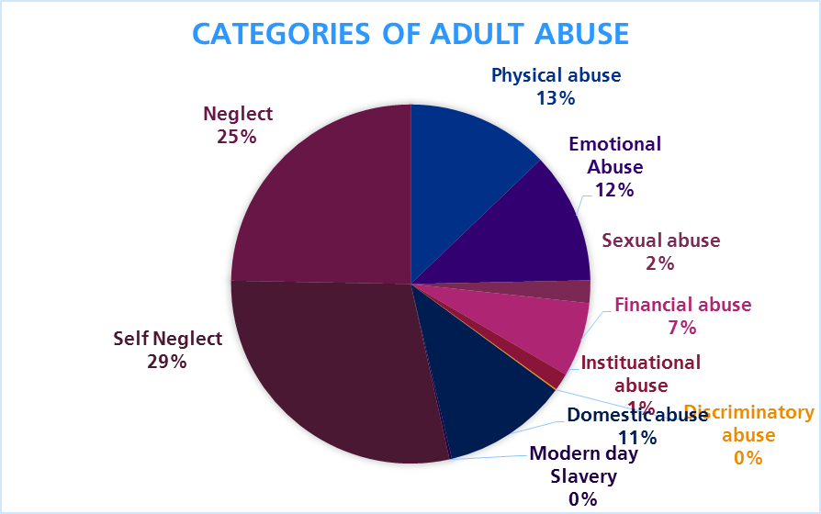

* + 1. **HMP Nottingham**

HMP Nottingham sends a representative to the NCSAB. Any SARs are shared with the health provider. The establishment Safeguarding Board (see below) documents discussions and actions made in relation to the identification and safeguarding of vulnerable men. Good information sharing systems are in place between the establishment, healthcare and partners. Prison staff are trained in self harm and suicide prevention and both the prison and health induction process support the identification of potential vulnerabilities and safeguarding issues. Health providers have good information sharing with external agencies.

* + 1. **Derbyshire, Leicestershire, Nottinghamshire & Rutland Community Rehabilitation Company**

DLNR CRC does not have the functionality to specifically track data relating to Adult safeguarding. However, DLNR has quality assurance mechanisms to support the maintenance of effective practice standards. All team managers within DLNR CRC attend ‘Quality Days’ on a monthly basis during which case records are sampled and quality assured. Such Quality Assurance days, whatever the specific theme, will always include scrutiny of case management with regard to safeguarding practice. Individual findings are fed back to case managers, and general themes are fed into the work of the organisation’s Quality Improvement Group (QUIG).

The QUIG collate the findings from these Quality Assurance days, and combines them with any relevant findings from internal and external audits, HMIP Reports, Serious Further Offence Reviews, Serious Case Reviews, Safeguarding Adults Reviews and Domestic Homicide Reviews. A centrally managed Organisational Improvement Plan then assigns actions to specific working groups for senior managers to implement.

DLNR CRC also have an Internal Audit team who undertake themed audits across DLNR. This includes audits with a specific focus on Safeguarding practice. DLNR CRC are also subject to audits through HMPPS contract management team and HMIP.

* + 1. **National Probation Service Nottinghamshire**

The NPS is committed to safeguarding adults at risk and to managing individuals who pose a risk of harm or exploitation to others. As a national organisation, practice change and learning are often complex to implement and assure.

The National Probation Service is divided into 8 divisions, Nottinghamshire forming part of the Midlands division. This division is broken down into 8 clusters, all of which include more than one Safeguarding Adults Board.

In part, because of differential learning and actions across the country, the NPS Midlands division has developed a division wide vulnerabilities forum / development group. One of the functions of this group is to identify learning themes from a range of statutory reviews - Domestic Homicide Reviews, Safeguarding Adults Reviews, Serious Case Reviews, and internal Prison and Probation reviews (Prisons and Probation Ombudsman, and Serious Further Offences). These lessons will be circulated divisionally, and if changes have been suggested these will be fed to the national group overseeing that area of work for consideration of national process changes.

More generally the National Probation Service is responsible for the supervision and management of adults - both those who are presenting needs in respect of safeguarding and those who are posing safeguarding risks to others. Work with such offenders is often complex and demanding, in many situations outcomes require judicial decision making at Parole Board level. A consequence of this is that governance and oversight of the management of safeguarding issues is often a fully documented and whole organisation function.

* 1. Strategic Priority 3: Making Safeguarding Personal
     1. **The Board is assured of strong multi-agency commitment to MSP across the partnership. The principles of MSP are embedded in local safeguarding practice and make safeguarding person-centred and outcome focussed**
     2. The Board’s Quality Assurance Framework emphasises the need for the Board to receive intelligence about what people who experience safeguarding services have to say about the process.
     3. The QA subgroup has explored various ways in which to engage with citizens and capture their experiences of safeguarding, and the Making Safeguarding Personal approach – though there has continued to be a view that understanding and applying MSP continues to need development.
     4. In order to address this, members of the QA subgroup facilitated a further briefing session on MSP as part of the Every Colleague Matters event. This was attended by 25 people: from Nottingham City Council (13), Private, Voluntary and Independent sector organisations (10), Schools (2). Feedback collated by the Every Colleagues Matters team was good with 43% rating the session as excellent and 52% rating it as good and 5% average.
     5. Getting independent feedback on how people receiving services have experienced safeguarding involvement is not easy. But ASC asked one of their training consultants to undertake a telephone survey to find how people had experienced safeguarding interventions in Nottingham. This found the qualitative feedback was of benefit and indicated that those citizens who wished to feedback said on the whole that they were ‘listened to’ and they were happy ‘with the end result’. This is described in more detail in the ASC contribution below.
     6. The QA subgroup sought assurance that partners are asking citizens about what their desired outcomes are, as part of making a referral to ASC. All partners were asked to make this a mandatory referral question and the QA subgroup has reviewed implementation of this*.*
     7. Through the EMSAN (East Midlands Safeguarding Adults Network), outcome based measures have been agreed and all Local Authorities in the region are now using these, enabling some comparison in terms of whether outcomes are met across the region. This comparative position is produced twice yearly. ADASS have just published their own outcomes framework, which EMSAN has contributed to, but the output has been a set of slightly different outcome measures. In EMSAN we have decided not to pilot the new ADASS Framework in 18/19 as it may change again at the end of the pilot, but the likelihood is that we would want to adopt it in its final form in 19/20.

|  |
| --- |
| **MSP Good Practice**  The Association of Directors of Social Services (ADASS) published useful guidance on the application of good practice in Making Safeguarding Personal and some Board members attended a local workshop. As a result, the Board will in 2018/19 hear and discuss local good practice cases, invite contributions to the Board from the local Independent Advocacy providers and check with Board members how they have personally assisted the development of MSP in their organisations.  <https://www.local.gov.uk/topics/social-care-health-and-integration/adult-social-care/making-safeguarding-personal/resources> |

* 1. Partner Descriptions of their Contributions to Strategic Priority 3
     1. **NHS Nottingham City Clinical Commissioning Group**

The CCG has continued to support the board with the delivery of MSP training as part of the local authority Every Colleague Matters events.

MSP is not explicitly mentioned in the NHS Standard Contract 2017/2018. However, the Safeguarding Adult Lead and CCG Quality team have addressed this by including MSP in the service specification for the larger Nottingham City health providers.

All CCG staff receive Safeguarding Adults training, with the vast majority having been trained to level 1 as we are not a patient facing organisation. The training currently does not include MSP but the six principles of adult safeguarding are currently included and staff are made aware that safeguarding adults is about empowering individuals, having a proportionate response and the need to work in partnership. Going forward, MSP will be included in the training as a specific item.

* + 1. **Nottingham City Council - Adult Social Care**

**MSP and Safeguarding Practice**

MSP is the ‘golden thread’ throughout the Adult Social Care Safeguarding Training programme. We gather evidence of MSP both through data analysis and audit. In the City Safeguarding Team, (who undertake the bulk of Safeguarding enquiries) we have set up a MSP specialist group and undertaken work which has included devising letters to provide citizens with information about Safeguarding at the beginning of the Enquiry, promoting Advocacy, and developing Mental Capacity Assessment skills in the team to ensure people’s voices are heard.

|  |
| --- |
| **Safeguarding Case Study MSP example**  M was an elderly citizen with a learning disability, living with their partner. There had been multiple safeguarding referrals regarding non-engagement with care input, which placed the citizen at risk. M needed full assistance with personal care, mobility, and refused to cooperate with a continence management regime, which had severely exacerbated a skin infection on their legs. M and the partner had a history of declining home care, district nurse visits and medical support –The East Midlands Ambulance Service had raised concerns regarding recurrent call outs, and a number due to falls as M was mobilising without appropriate support. M was admitted to hospital with severely infected legs and due to concerns re M’s ability to manage at home; they were encouraged to remain in hospital while the situation was reviewed. M’s partner attempted to remove M from the hospital and legal measures had to be put in place to ensure M remained in hospital and could not leave or be removed.  A Best Interest meeting in accordance with the Mental Capacity Act was held re M’s future care and accommodation. Concerns were expressed by M’s advocate about safety at home, however M expressed a clear wish to remain living at home their partner. A Best Interest decision was made to increase the care package at home along with M being encouraged to attend a day centre to reduce social isolation. M was discharged and the Safeguarding Social Worker continued to undertake visits to M and their partner to build a relationship with the couple and work through the issues regarding accepting a care package. A good working relationship was established which enabled a collaborative approach with M and their partner to ensure that M’s stated wishes were respected but that the citizen remained healthy and safe.  M’s case was kept open for an extended period of time of over 12 months to ensure the care package remained stable, day centre attendance commenced and regular multi agency review meetings were held.  This case amply demonstrates that MSP requires the practitioner to look beyond the immediate issues that concern professionals. Positive risk taking, and working at P’s pace delivered a successful outcome and consequently reduced the number of crises and pressure on emergency services. |

**Strengths based approach; Domestic abuse**

Last year Adult Social Care was one of only 4 pilot sites for the National Women’s Aid England / Home Office project ‘Change that Lasts’. Our City Safeguarding Team and Duty team colleagues are now ‘ Trusted Professionals’. The aims of the programme were to facilitate earlier intervention and increase opportunities for survivors to get the help they need. Survivors have paid testament to the importance of a trusted relationship with an individual professional in facilitating change for them. The aims of the role includeempowering survivors to draw and build upon their individual strengths and resources.

The approach taken by Women’s Aid aligns strongly with Making Safeguarding Personal, which has enhanced the skills of our practitioners.

This pilot has been successful, with 78% of participants reporting an increased ability to understand warning signs of coercive controlin abusive relationships and 91% reporting a better understanding of the needsof survivors of domestic abuse.

Our partnership with National Women’s Aid has continued and has included Adult Safeguarding practitioners shadowing colleagues at the Nottingham Women’s Centre, thus increasing knowledge and understanding between both organisations to ensure the best possible outcomes are achieved for survivors.

**Citizen Feedback** We continue to participate in the East Midlands Safeguarding Adults Network (EMSAN) project through conducting a short MSP focussed questionnaire with citizens who have participated in a Safeguarding Enquiry. This is undertaken through a telephone call with the citizen or nominated individual following the Safeguarding intervention. Although the response rate is not very high, the qualitative feedback is of benefit and indicates that those citizens who wished to feedback said on the whole that they were ‘listened to’ and they were happy ‘with the end result’.

In the latest sample, out of 33 citizens /advocates contacted, the following feedback was gathered;

* 75% felt they had been listened to during conversations and meetings with people about helping them feel safe
* 84% felt happy with the end result of what people did to try and keep them safe
* 78% felt satisfied that the outcomes they wanted had been achieved at the end of the Safeguarding interventions
  + 1. **Nottingham CityCare Partnership**

When staff contact the safeguarding service for advice and supervision, they are asked what the adult’s views are and what outcomes they want. If they have not explored this, then they are asked their rationale for this and if appropriate, are asked to go back and have this discussion with the adult concerned.

The referral template created by the Safeguarding service for referrals into the Local Authority also specifically asks for the adult’s wishes and feelings. We have factsheets and guidance available on our intranet, which provides staff with a toolkit of resources to assist them in ensuring that safeguarding interventions are person-centred.

We have been working with a gentleman who lives in a residential home and receives care and support from community Nursing for chronic leg ulcers. He has a mental health condition which impacts on his capacity to make decisions around receiving dressings for his legs and a history of long term self-neglect. Whilst he does not have capacity to weigh up and use information provided to him to enable him to make informed choices around his care, he is able to express his preferences in that he does not want to move from the home, he cannot tolerate his dressings being done daily and cannot cope when he feels rushed to receive care. The Nurses have worked in partnership with the gentleman concerned, the GP and the residential home to provide him with care whilst respecting his wishes and feelings so that he can receive person led care. They have two hour protected time slots so that Nurses can provide him with the time he needs to allow him the best opportunity to receive care and treatment. Whilst this is a complex case, the management of his care has taken into account his preferred outcomes whilst also managing to provide him with the care he needs which has so far managed to prevent deterioration of his leg ulcers and enabled him to remain at the care home.

|  |
| --- |
| **Case Example**  Another recent case example relates to an isolated gentleman receiving care from community nursing who disclosed long standing financial abuse from a friend. He had been giving her large quantities of money every week for many years, but as he had numerous health problems, he felt very worried about losing the friendship and did not want to take further action, as he felt this would further increase his isolation. He had been advised against accessing any support from social care from the friend, which also meant that he was living in squalor due to his mobility issues. Following discussion with him, and time taken to explore his reasoning and allay some of his concerns without pressure, he began to recognise that social care involvement may make positive change in his life, and felt supported to go ahead with social care input for further exploration of some of the issues that had been raised. |

**Citizen feedback**

We have found it difficult to engage with adults around their safeguarding experiences. However, we work with a partnership approach with other agencies around engagement and feedback in line with the principles of MSP, and are aware that Healthwatch have been doing recent work around adults’ experiences of safeguarding. We await their feedback and recommendations around this issue.

We have an engagement event planned in June 2018, where we will be meeting with members of the Patient Experience Group (PEG) and Healthwatch to focus on MSP. The plan is to share the work that CityCare has been doing in relation to MSP and get feedback from the members. We also hope to discuss topics such as social isolation and how this can fit with MSP. This will undoubtedly inform our future work plans around further embedding MSP within the organisation. When CityCare receive feedback, complaints or compliments from citizens, this information/learning is shared with us via the public engagement team.

**Staff involvement**

MSP underpins our safeguarding training, where there is a focus on supporting staff to clearly communicate safeguarding concerns to adults, with the aim of promoting the adult’s ability to feel empowered to work in partnership when discussing concerns and preferred outcomes. Information relating to MSP is also given to staff in their takeaway workbook and factsheets and resources are available to staff online.

Staff have been involved in the creation of the factsheets and resources supporting MSP and statements of concern via a working group, and resources around these and self-neglect have been shared with the Safeguarding Champions Network for their feedback. This has helped the Safeguarding service at CityCare to ensure that the information and learning staff receive are evidence based and relevant to inform their clinical practice. The resources have been received very positively by teams so far, in particular the self-neglect guidance which offers staff support in analysis of risk when working with adults who have complexities which can impact on their ability to accept or access healthcare, social care or making other personal choices.

CityCare Safeguarding Adults has developed a framework of documents and guidance for clinical staff underpinned by MSP, and collaborate with NCSAB and the Local Authority in any awareness raising projects, for example the recent posters produced. CityCare is also represented at the Quality Assurance Sub-Group.

**Embedding MSP into safeguarding practice**

CityCare has a strong commitment to MSP, and all Safeguarding training, Standard Operating Procedures, pathways and templates have a focus on MSP so that responses to safeguarding concerns are person-led and outcome focussed. MCA training also focuses on the rights of the adults.

CityCare Safeguarding Adults duty advice template is built around a framework supporting discussion and reflection for staff which is underpinned by MSP. The Safeguarding Adults referral template also requires staff to have considered the adult’s wishes and feelings relating to the concern and their desired outcomes from the local authority.

Staff have resource toolkits to support them with MSP, self-neglect and unwise decisions, and statements of concern.

* + 1. **Nottinghamshire Fire and Rescue Service**

NFRS completes a citizen survey bi-annually. This forms a large part of workstreams going forward in order to learn lessons and improve practice.

NFRS is committed to establishing a person-centred approach that in turn helps to embed MSP principles. To this end, the Seconded OT and Student OTs have been working on a variety of projects, training exercises and internal guides to help improve these principles internally. Please see below summary of a case study written by the OT highlighting the value of their partnership with NFRS:

**Case Example**

Between January and March 2018 the OT accompanied a member of the Prevention Team on a HSC visit with a 92-year-old lady who had been referred by a member of the Prevention team following a number of cooking-related fire calls. Thankfully the lady had been lucky and had been un-injured by the previous fires, however, there were serious concerns for her safety. The OT undertook Functional Assessments and a Montreal Cognitive Assessment, which identified a significant degree of cognitive impairment. The OT has since liaised with family members who were unaware of the extent of their relative’s issues and was able to support them in applying for an Attendance Allowance and Lasting Power of Attorney. The OT also made referrals for a social care assessment (the lady is now in receipt of a care package) and to secondary mental health services. At the time of writing no further incidents relating to this lady have been reported to the Service and she has been enabled to continue living in her own home as she wished*.*

* + 1. **Nottinghamshire Healthcare NHS Trust**

The Associate Director for Safeguarding and Social Work has worked with the local authority on the development of a pathway for the addressing of s.42 enquiries.

There is evidence of Service User engagement and consultations throughout the Trust. The corporate safeguarding team have worked with the volunteering leads to review the recommendations from the Lampard Report (2015) to ensure that the Trust is compliant with its recommendations and to review the Volunteering Policy. There is now an identified safeguarding lead to work with the volunteering service, including around issues arising from DBS checks for volunteer applicants.

Making Safeguarding Personal has continued to be a focus across the Trust, including the development of a poster to assist service users in self-referrals and a leaflet (using Somerset Symbols) for service users who have a learning disability and are experiencing domestic violence.

MSP continues to be a focus in all our safeguarding training and our revised clinical package delivers clear messages on this area, clearly linked with the expectation that all our staff will Think Family. As we develop new adult safeguarding training, MSP will continue to feature heavily so that staff strengthen their knowledge and skills for future practice. The complexities around MSP and domestic violence are explored in our newly developed domestic violence training package.

Aside of our strategic trustwide work, our divisional safeguarding teams continue to focus on and challenge staff around MSP when giving safeguarding advice. It is our ambition to be able to monitor our MSP effectiveness via our performance reporting framework.

* + 1. **Nottingham University Hospitals NHS Trust**

Making Safeguarding Personal is a core principle of adult safeguarding at Nottingham University Hospitals NHS Trust. All non-urgent safeguarding referrals are passed through the trust team for quality assurance, specifically focussing on MSP and the outcomes the individual would like as a result of a referral. The NUH safeguarding referral form contains a mandatory MSP section that requires completion prior to the referral being processed.

The trust continues to monitor safeguarding and mental capacity knowledge through its annual Essence of Care benchmark audit.

MSP values continue to be delivered in annual training plans, in combination with theories relating to coercion/control, fear and the reasons why individuals may not disclose and choose to remain in harmful relationships. NUH staff are taught to assess safeguarding risk and respond accordingly.

* + 1. **Nottinghamshire Police**

In addition to the MSP assurance contained in paragraph 3.39, Nottinghamshire Police consider a victim centred approach, from initial contact to conclusion.

On initial contact, the Control Room conducts an immediate vulnerability assessment and this dictates the speed of response to the call for service. As a result, police response is directly in correlation with victim need.

As mentioned in paragraph 3.39, front line responders now have increased awareness and training of their safeguarding responsibilities under the vulnerability policy and headline of ‘Know it, Spot it, Stop it’.

The Public Protection Notices (PPN) highlight concerns and safeguarding requirements to partnership agencies thought the MASH.

The mental health triage car enables the Police and Health to work together and prevent people suffering from mental health entering the criminal justice pathway, instead leading them to mental health support.

Investigation teams, particularly within the Public Protection Department, work more with a victim focussed ethos and less on criminal justice outcomes. The Police, more than ever, invest resources into safeguarding and prevention, particularly within the MASH and MARAC processes.

Safeguarding is not restricted to Public Protection matters. Nottinghamshire Police’s fraud department work in partnership with the banking sector in order to protect and prevent vulnerable people being subject of organised fraud. Organised criminal activity is highlighted via Suspicious Activity Reports (SARS). Additionally, a new protocol introduced in 2017 allows banks to report vulnerable people who present at branches, potentially subject to fraud crimes in progress. Enhanced and rapid response to such incidents protects and safeguards these adults from extensive financial loss.

The force has an extensive victim/survivor feedback department. Historically, this department has conducted daily victim satisfaction surveys from victims/survivors of domestic abuse. In 2017, these surveys expanded their data set to include non-cooperative victims, designed to increase our knowledge and learning.

The yearly report for 2017-2018 was drafted in August 2018 and reported:

97% of DA victims were satisfied with the initial contact with the Police.

92% of DA victims were satisfied on the action taken by the Police.

96% of DA victims were satisfied how they were treated by the Police.

Furthermore, in 2018, we have commenced victim satisfaction surveys from victims of rape and people subject to ‘Claire’s Law’ – the process of ‘right to know – right to ask’ in relation to people at risk of DA perpetrators.

* + 1. **HMP Nottingham**

HMP Nottingham holds a weekly safeguarding board comprising of attendees from across prison functions. Any individual working in the establishment can make a referral. This allows for the implementation of support plans for individuals with specific safeguarding needs, the sharing of useful information about how to support individuals with operational staff and the coordination of actions to safeguard the individual and reduce vulnerability.

* + 1. **Derbyshire, Leicestershire, Nottinghamshire & Rutland Community Rehabilitation Company**

DLNR CRC has tried to implement consideration for the service user perspective across our service delivery which would include its safeguarding work. This includes

* Full involvement in assessing and planning
* Service User bi-annual survey
* Service User council
* Peer mentoring scheme
* Co-design and co-delivery of interventions
* Progression route into employment with us where appropriate

Our approach to service user involvement extends to encouraging and enabling our service users to engage in other services’ involvement/participation systems, including adult safeguarding.

* + 1. **National Probation Service Nottinghamshire**

This is an area of work that has been locally identified as an area for improvement - it has been noted that the NPS National Safeguarding Adults Practice Guidance does not identify MSP. Face to face training does not specifically reference or address the importance of this aspect of practice. Therefore, it has been fed back to the trainers and policy section that these omissions are felt to weaken the impact and relevance of the information and training – it is hoped that revisions of both practice guidance and training will reflect this issue going forward.

Locally there are plans to develop MSP in briefings for all teams, and it will be included in a forthcoming “learning lessons” bulletin which will be issued divisionally to all staff.

Strategic Priority 4: Safeguarding Performance and Capacity

* + 1. **Assurance that suitable sustainable arrangements are in place to achieve continuous learning and improvement across the adult safeguarding partnership**
    2. In their contributions to this Report, agencies describe the learning and improvement that they implement in their own organisations; the reach and effectiveness of this was a focus for assurance in the visits to each agency which the Board Chair and Manager undertook during the year and arrangements were generally found to be very satisfactory.
    3. The Training, Learning and Improvement (TLI) subgroup was established in 2017/18, with the intention of implementing the Learning and Improvement strategy agreed in 2016/7. This was a newly established adult safeguarding subgroup, no longer in a joint group with children’s safeguarding. This was also the first year in which the Board no longer had a funded post responsible for training development or delivery as the budget made available to the Board would no longer provide for this. So the TLI subgroup has been seen as an important group to bring together best practice and resources for training and development across all City organisations. It also has a communication and engagement role as this is a central part of ensuring that the workforce is competent to carry out its safeguarding responsibilities and that learning from reviews is disseminated.Unfortunately, with the departure of the subgroup Chair for maternity leave during the year, combined with the departure of the vice chair through promotion, and the vacancy in the Board Manager post, the work of this subgroup has been very limited. Board member organisations remain committed to contributing expertise and training and learning resources to this group so it is expected that it will start work again in 2018/19.
    4. In the past, the Training Officer post had a significant role in defining standards that organisations should meet in their adult safeguarding training and assuring the Board that standards were being met. The continuing work by the QA subgroup on how to replace the Safeguarding Adults Assurance Framework is giving consideration to how this assurance can be provided without the Training Officer resource.
    5. An area of concern has been and continues to be the provision of training for and in the Voluntary and Community Sector (VCS). Commissioned VCS organisations train their staff as required by contracts e.g. from the Local Authority and NHS, and Nottingham Community and Voluntary Services (NCVS) organised some training courses during the year, but the Board agreed there has been a risk through shortfall in this area, particularly for smaller VCS organisations. This has been increased as the previously free and recommended online training provided by SCIE (the national Social Care Institute for Excellence) introduced a charge for each participant. An aim for 2018/19 is for the TLI subgroup to identify resources that could be of use by other organisations and increase the offer on the Board’s website.
    6. **Assurance that members of the public are aware of Adult Safeguarding, what to look out for, how to refer.**
    7. During the year the Board commissioned Healthwatch Nottingham and Nottinghamshire to undertake a survey with community groups to understand people’s awareness of adult safeguarding and what and how to refer if they are concerned. Healthwatch were asked to undertake the survey with a wide range of different groups in the City. This survey was commissioned jointly with Nottinghamshire SAB and will report to the Board in June 2018.
    8. Before the Board Manager left, she started work on communications and engagement processes in place that could be used to develop public awareness, but this has paused while there has been a vacancy. It was agreed to strengthen connections with PoHwer, the commissioned advocacy provider, and they will bring their experience in the field of safeguarding adults to the Board in 2018/19.
    9. **Assurance that there are effective methods for communication with Nottingham citizens and the workforce**
    10. The new web pages specifically for the Board were launched during 2017/8. These are hosted within the City Council website and accessible to all. They give headline priority to anyone who may be wanting to refer an adult at risk. Beyond that there are: information about the Board, including its Strategic and Annual Plans and Annual Reports; the local Safeguarding Adults procedures and guidance; and a section for Learning and Improvement, which includes summary reports from recent SARs and other useful links and resources. These pages have been welcomed for their value and clarity and it is intended to continue to develop the information available there during 2018/9 through the TLI subgroup and the Board Manager post when filled.
    11. Two posters were developed and circulated during the year. The first was aimed at the general public and has been widely circulated through member organisations and in public settings, with the question: ‘Are you, or someone you know, being harmed or neglected?’ and contact details. The second was designed specifically for care homes, with the question: ‘Are you happy with the quality of care in this care home?’ and contact details; care homes are required to display these. Though it will be difficult to assess the impact of them, the comments about them have been very positive and in 2018/19 the PDF format of these will continue to be used in digital displays and in other forms of communication such as newsletters.
    12. **A shared view about the Board’s financial requirements, and 2018/19 budget for Board administration and management agreed in principle.**
    13. Funding partners – the City Council, NHS Nottingham City Clinical Commissioning Group, and Nottinghamshire Police – agreed to maintain existing budget contributions in 2018/19 for the NCSAB. This gives funding for the same resources as in 2017/18 - an Independent Chair (three days a month), the full time Board Manager and 0.5 Business Support Officer, with a small amount of funding for additional expenditure, such as the production of the posters. It does not provide funding for an independent author for a SAR, if it were decided one were needed, but there was no need for this in 2017/8 and the funding partners have agreed they will manage that need should it be required in 2018/19.
    14. The Board Manager post was vacant from December to the end of this financial year but the subgroups and Board continued to operate; this was evidence of how much the Board works as a result of the dedication and goodwill of staff from partner organisations, particularly those involved in subgroups. But those involved found that communication across and beyond the Board’s arrangements and achievement of tasks inevitably suffered without a Board Manager in place.
    15. **Ensure the Board operating model is fit for purpose to enable it to respond to national and local strategic drivers and priorities**
    16. The SAB Constitution was reviewed and a new Constitution was agreed by the Board in 2017/18. It is built round Care Act expectations, defines the role of the Board and its constituent organisations and states what is expected of all Board members. It defines the particular roles and responsibilities of the three funding partners (the City Council, NHS Nottingham City Clinical Commissioning Group and Nottinghamshire Police). It contains the Terms of Reference for the three subgroups. It will be subject to regular review.
    17. A Complaints Policy was added, so there is clarity in the event of any complaints specifically about the Board and its officers rather than a partner agency. This was shared with regional colleagues as none had yet developed one. So far, there has been no need to make use of it locally.
    18. **Ensure the Board’s work is aligned with the work of other strategic Boards across the City.**
    19. As a result of meetings that the Board Chair and Board Manager held with colleagues from various organisations, including Public Health and the Crime and Disorder Partnership (CDP), a series of assurance reports concerning adult safeguarding were presented to the Business Management Group and made available to the Board, and this will continue on a usually annual basis. These provide assurance about safeguarding awareness and have concerned Strategic Housing, Suicide Reduction, Prevent, Female Genital Mutilation and DSVA. Additionally, the City Council’s Community Protection have joined the Board and this creates a stronger link with the CDP and its business, including modern slavery. Board members are asked to act as champions of the work of the NCSAB in their roles on other Boards.
    20. The Board Manager has an important role in maintaining connections, awareness and action with other Boards in the City as well as local, regional and national safeguarding interests; the Manager attends EMSAN, the regional East Midlands Safeguarding Adults Network – which is chaired by the DASS (Director of Adults Social Services) for Nottingham.
    21. The Independent Chair meets regularly with the Independent Chairs of the NCSCB and the Nottinghamshire SAB and they also meet with the Nottinghamshire Coroner. He attends the regional Chairs network, and Nottinghamshire Strategic Chairs network (chaired by the Police & Crime Commissioner).
    22. The Board receives regular reports regarding Operation Equinox, the overarching investigation into allegations of historical child abuse in care settings in Nottingham and Nottinghamshire. The Strategic Management Group have developed a Victim and Survivor Support Strategy on behalf of both Councils and the Board has promoted awareness of available services through its partner organisations.
  1. Partner Descriptions of their Contributions Toward Strategic Priority 4
     1. The Board has been well attended by Partner agencies. The table below shows the cumulative attendance record of partner agencies.

|  |  |  |  |  |  |  |  |  |  |  |
| --- | --- | --- | --- | --- | --- | --- | --- | --- | --- | --- |
| **Name** | **Possible** | **Actual** | **Sent Rep** | **Agency Total** |  | **Name** | **Possible** | **Actual** | **Sent Rep** | **Agency Total** |
| **Independent Chair** | 4 | 4 |  | 4:4 | **East Midlands Ambulance Service** | 4 | 3 |  | 3: 4 |
| **Nottingham City Council Director for Adult Social Services (DASS)** | 4 | 3 | 1: 4 | 4:4 | **NCC - Head of Safeguarding & Quality Assurance (Adults)** | 4 | 4 |  | 4: 4 |
| **CCG - Director**  **CCG - Corporate Medical Director** | 4 | 4 |  | 4: 4 | **Vulnerable Adults Provider Network representative** | 4 | 3 |  | 3: 4 |
| *1* | *1* |  | **HMP Nottingham** | 4 | 1 |  | 1:4 |
| **Nottingham University Hospitals NHS Trust** | 4 | 3 | 1 | 4: 4 | **Notts Fire & Rescue – Engagement & Partnerships Officer** | 4 | 1 |  | 1: 4 |
| **Police – Head of Public Protection** | 4 | 4 |  | 4: 4 | **Nottinghamshire Healthcare NHS Trust – Associate Director Safeguarding & Social Care** | 4 | 4 |  | 4: 4 |
| **CityCare Partnership – Director of Nursing & Allied Health Professionals** | 4 | 4 | 3 | 4: 4 | **Board Manager** | 3 | 3 |  | 3: 3 |
| **National Probation Service - Deputy Head of Nottinghamshire** | 4 | 2 |  | 2: 4 | **DLNR Community Rehab Company – Regional Manager** | 4 | 1 | 2 | 3: 4 |

* + 1. The City Council’s Lead Member with responsibility for safeguarding adults is a participating observer of the Board. He receives all Board papers, and attended one meeting in 2017/18.
    2. **NHS Nottingham City Clinical Commissioning Group**

The CCG continues to be well represented throughout the board subgroups and has provided the Chair of the Safeguarding Adults Reviews Subgroup. We are well represented at Board level and continue to make a financial contribution to the board as one of the funding statutory agencies.

* + 1. **Nottingham City Council - Adult Social Care**

**Board Participation**

Adult Social Care are committed to supporting the work of the Board and commit both financially as a statutory funding partner and through participation. The Director for Adult Social Caresits on the Board andis also the serving DASS Safeguarding Lead for the national Association of Directors of Adult Social Services (ADASS) and the chair of the East Midlands Safeguarding Adults Network (EMSAN). This brings the benefits to the Board of both escalating issues to a regional and national level and sharing developments and expertise gleaned from these positions

The Head of Adult Safeguarding and Quality Assurance sits on the Board, Business Management Group and the SAR subgroup. The Team Manager for Adult Safeguarding and Quality Assurance sits on the Quality Assurance subgroup.

**Engagement Strategy**

In 2018 the Team Manager from the City Safeguarding Team presented a MSP case study of good practice to the Safeguarding Adults subgroup and the Board. This was welcomed positively and Adult Social Care intend in 2018 to continue to bring the ‘citizens voice’ to the partnership through similar exercises.

**Lion Community Directory**

Nottingham City Council launched ‘Lion’ in 2017, an online community directory which enables citizens to connect to appropriate resources in their local community. We have ensured that the Board publicity is promoted on the website to ensure that citizens who would otherwise not come into contact with traditional services are aware of how to report concerns.

* + 1. **Nottingham CityCare Partnership**

CityCare’s Director of Quality and Safety and Nursing and Allied Health Professionals attends Board meetings and cascades information to CityCare colleagues. CityCare are also members of the Safeguarding Adults Review Sub Group and the Quality Assurance Sub Group. This helps to ensure that we actively participate in learning and improvement.

Any Board requests for information for SAR panel are responded to in a timely manner, and CityCare staff work in partnership with our colleagues in the Local Authority. Training includes learning from SARs which helps to make safeguarding relevant and ensure learning is embedded and continuous.

CityCare have supported the distribution of posters created by the board for the general public, advising how to report or get advice should they identify a safeguarding concern in a care home or in the community.

* + 1. **Nottinghamshire Healthcare NHS Trust**

Nottinghamshire Healthcare Trust safeguarding team has completed the fourth year of a five year plan to effect quality improvements in safeguarding across the Trust. We have three key priorities:

1. To demonstrate Nottinghamshire Healthcare has a strong integrated and sustainable culture of both safeguarding leadership and strategic and operational working across the Trust.
2. To demonstrate that we are assured that safeguarding is everyone’s responsibility and are able to evidence that we are making a difference.
3. To demonstrate that we are assured that learning and improvement is raising awareness and quality of safeguarding practice and ensure that training, procedures and guidance support improvements in safeguarding children and adults.

All three link to the local safeguarding boards’ priorities to ensure that we continue to support the work of the local adult and children boards.

* + 1. **Nottingham University Hospitals NHS Trust**

NUH is a fully engaged member of the board and appropriately represented on the safeguarding board and its subgroups. This membership drives the safeguarding priorities that the organisation sets on an annual basis, specifically learning gained from incidents, SAR process and national guidance/learning.

The NUH safeguarding strategy and work-plan is aligned to that of the Local Safeguarding boards.

Feedback from the safeguarding boards is a standing agenda item on the NUH safeguarding adults committee.

The trust has posters and information available for the public identifying adult safeguarding and signposting where to get support. Detailed information is available for staff across the organisation utilising actions cards, posters, screensavers and an intranet site.

As a large well-respected organisation at the heart of the local community, communication and engagement with the trust’s patients, visitors and staff is fundamental to the daily operations of Nottingham University Hospitals NHS Trust. Keeping adults at risk safe is at the centre of the organisation’s values.

* + 1. **Nottinghamshire Fire and Rescue Service**

NFRS have a strong following on social media as well as robust links with local and national media in order to highlight and broadcast important safety messages to members of the public. These channels have been utilised to promote Adult safeguarding; what to look for and the local pathways in place for referrals.

* + 1. **Nottinghamshire Police**

Nottinghamshire Police is fully committed to the statutory requirements of the Care Act 2014 and its statutory guidance and provides consistent attendance at both City and County Safeguarding Adults Boards and the associated subgroups. This is primarily provided by the Head of Public Protection, the ‘Audit and Compliance’ Detective Chief Inspector or our ‘Adults’ DCI.

Nottinghamshire Police have a dedicated Public Protection webpage on the force’s Intranet. This provides a corporate reference library to its workforce for all matters in public protection. This includes vulnerability and safeguarding policy and procedures.

The 2018 Police and Crime Commissioner plan outlines his strategic direction to the force and is accessible to the public. This public document includes the PCC’s commitment to

* Invest in and co-commission a new ISVA and CHISVA support service for victims and survivors of sexual abuse;
* Work with health partners to drive forward improvements to therapeutic support for sexual violence victims and survivors;
* Work with partners to invest in new facilities for the adult Sexual Assault Referral Centre (SARC).

Although challenging through these times of austerity, Nottinghamshire Police is committed to contributing to the financial requirements of the Adult Safeguarding Boards.

* + 1. **East Midlands Ambulance Service**

EMAS recognise that they must continue to be vigilant about the evolving safeguarding agenda and ensuring that staff are kept updated and informed.

EMAS safeguarding team produce regular communications for staff on a variety of topics across the safeguarding agenda as well as contribute to campaigns from other teams. The aim of the communication strategy is to raise awareness of safeguarding and promote the role of the ambulance service in protecting children and adults. The communications campaign aims to raise awareness of safeguarding and the role of all trust staff and continues to drive home the message that safeguarding is “Everybody’s business”. It will build on work carried out over the last eight years by the safeguarding team, emphasising the importance that safeguarding plays in the patient journey and the recognition of the impact that safeguarding and the associated agendas have on ensuring good patient outcomes.

The campaign aims to educate all staff about safeguarding and the associated agendas, incorporating recognition of national promotion days and makes them relevant to EMAS staff. The communication strategy also includes regular learning from SCRs, DHRs and SARs.

EMAS continue to be vigilant about the evolving safeguarding agenda, locally and nationally. They ensure that staff are able to recognise and act on safeguarding concerns appropriately and effectively, sharing relevant information in the best interests of children and adults atrisk. Numerous communication pathways are utilised to ensure wide dispersal of knowledge and to improve access for staff, this includes, payslips, E news articles and case studies, clinical bulletins, station posters, and desktop bulletins.

The communication strategy for 2017-2018 included

* National Carers week
* Learning disability awareness week
* Anti-Slavery Day
* Safeguarding Week
* International day of zero tolerance of FGM
* National CSE Day
* Domestic violence awareness month.
  + 1. **HMP Nottingham**

HMP Nottingham contributes to the work of the Board through attendance at Board meetings.

* + 1. **Derbyshire, Leicestershire, Nottinghamshire & Rutland Community Rehabilitation Company**

DLNR CRC now has a Safeguarding Adults lead and will meet its obligations with safeguarding adults through regular attendance at the Safeguarding Adult Board, fulfilling duties of Safeguarding Adult Reviews in relevant cases and providing a SPOC to support targeted engagement with learning and development sub groups.

* + 1. **National Probation Service Nottinghamshire**

Attendance at Safeguarding Adults Boards is a core strategic responsibility of Heads or Deputy Heads of National Probation Service Clusters across England and Wales. In Nottingham and Nottinghamshire, Board membership rests with the Deputy Head. Contributions are also made to Board Subgroups as required.

* + 1. **NCVS (Nottingham Community and Voluntary Services) and the Vulnerable Adults Provider Network (VAPN)**

NCVS has promoted the resources from the SAB including the recent poster campaign. We have shared updates to guidance and referral forms through the NCVS e-bulletin and through updates to network members.

The Vulnerable Adults Provider Network (VAPN) meets bi monthly and is a forum for voluntary and community organisations. The meeting agenda includes a standing item to feedback from the SAB meetings and into the Board via the VCS Representative. A new VCS Rep has now been appointed.

The VAPN was previously funded by the CCG and the Local Authority until March 2018 but this funding has now ceased. The VAPN will nevertheless continue to actively promote key safeguarding messages and provide training opportunities in partnership with an experience external trainer.

1. Looking forward into 2018/19
   * 1. The areas of work to be carried forward into 2018/19 are:

* Reviewing the outcomes from the national pilot sites on social isolation and safeguarding and seeing how we can learn from them
* Looking at how well the ‘Top Tips’ have worked in practice
* Considering how partner agencies can assist in mitigating risks arising from reduced reviewing by ASC
* Developing self assessment and other Board safeguarding assurance processes
* Learning from ‘complex cases’ as well as SARs and ensuring learning from recent SARs has been implemented
* Developing the ‘offer’ of information and training materials from the Board, particularly for the Voluntary and Community Sector
* Promoting MSP across the partnership
* Increasing engagement with advocacy providers and people who have experienced services
* Working with the outcomes of the Healthwatch survey and continuing to promote awareness of adult safeguarding and how to refer concerns
* Consulting on revised Policy and Procedures, jointly with the County
* Working with the Safeguarding Children’s Board and its Strategic Management Group addressing ‘emerging themes’ of concern for young people and younger adults
* ASC is working with key partners on early intervention before necessarily referring to adult safeguarding
  + 1. The NCSAB is looking forward to working on these and more, and its plan for 2018/19 can be found [here](https://www.nottinghamcity.gov.uk/health-and-social-care/adult-social-care/adult-safeguarding/about-nottingham-city-safeguarding-adults-board/).

1. <https://www.gov.uk/government/publications/care-act-statutory-guidance/care-and-support-statutory-guidance>
2. This section is taken from the demographic chapter at <http://www.nottinghaminsight.org.uk/>
3. <https://www.gov.uk/government/publications/care-act-statutory-guidance/care-and-support-statutory-guidance>