The Wheels on the Bus | Twinkle, Twinkle Little Star
Twinkle, Twinkle Chocolate Bar | Here is a Beehive

Baa, Baa Black Sheep | 3 Little Men in a Flying Saucer
Tommy Thumb | Incey Wincey Spider

Humpty Dumpty | 2 Little Dickey Birds
This Little Piggy | Jack and Jill

5 Little Ducks | Miss Polly had a Dolly
5 Little Speckled Frogs | Hickory Dickory Dock

I’m a Little Teapot | Hey Diddle Diddle
London Bridge | Mary had a Little Lamb

Row, Row, Row Your Boat | Grand Old Duke of York
Old MacDonald had a Farm | Wind the Bobbin

Old King Cole | Old Mother Hubbard
Polly put the Kettle on | Goosy, Goosy Gander

Little Jack Horner | Little Miss Muffet
Pop goes the Weasel | Ring of Roses

Sing a Song of Sixpence | 3 Blind Mice
Pat-a-Cake | Heads, Shoulders ….

10 Green Bottles | Ding Dong Bell
The Farmer’s in his Den | 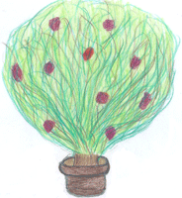  The Mulberry Bush

Jelly on a Plate | If You’re Happy and You Know it
Peek-a-Boo | t

