

Admission Arrangements 2026/27

**Bluecoat Bentinck Primary Academy**

The Archway Learning Trust (herby referred to as the Trust) in liaison the Department for Education and Nottingham City Local Authority supports Bluecoat Bentinck Primary Academy. Bluecoat Bentinck Primary Academy offers primary education from age 3 – 11. The Academy is distinctively inclusive, and it is clear about its ethos welcoming children from many different backgrounds.

The Trust, which is its own admission authority, has responsibility to ensure that the admission arrangements comply with the School Admissions Code and School Admissions Appeal Code, and is implemented objectively and fairly.

**How to apply:**

Admission to Bluecoat Bentinck Primary Academy is carried out as part of the home authority co-ordinated admission arrangements. The deadline for applications for those children applying for a reception place starting September 2026 is **15th January 2026** by completing ‘School Common Application Form’ via your home local authority. Notification of school allocation will be made by the home local authority on National Offer Day. For September 2026 entry, the National Offer Day is **16th April 2026.**

For In-year admissions, please contact the Academy on 0115 9151566 or complete the relevant In-Year application form available on the academy website [www.bluecoatbentinck.co.uk](http://www.bluecoatbentinck.co.uk) under the **Prospective Parents > How to Apply** tab.

**Admission to schools outside the normal year group:**

Bluecoat Bentinck Primary Academy will normally admit children to primary education at the beginning of the school year in which they reach the age of 5. Parents have the right to defer admission until the term in which their children become 5 years of age or start school on a part-time basis for a selected period of time or until the point of reaching statutory school age (statutory school age is the term after the child’s fifth birthday), if you are considering deferring admission or wish to discuss your child starting on a part-time basis for a selected period of time please contact the Academy to discuss the reasons why with the Head Teacher.

Bluecoat Bentinck Primary Academy will consider requests for admission outside the normal year group and take account of the circumstances of each case. Requests must be made in writing as a supplement to the local authority application and be sent to the Archway Learning Trust c/o Bluecoat Bentinck Primary Academy F.A.O the Head Teacher. All requests to educate a child outside their normal year group must include evidence of the child’s circumstances from a relevant professional detailing the child’s educational need which makes education outside the normal age group necessary. Parents must consider the impact of a child being educated with children of a different age both within primary school and at transition to secondary school where admissions outside the cohort cannot be guaranteed.

**Admission Arrangements:**

Bluecoat Bentinck Primary Academy has a planned admission number of **30** places in Year R (Reception year).

**Consideration of applications:**

The Trust will consider all applications for places. Where fewer applications are received than places available, the Trust will offer places to all those who have applied.

Children, who have an Education, Health and Care Plan (EHCP), naming Bluecoat Bentinck Academy, will be admitted first, followed by looked after and previously looked after children. This will reduce the number of reserved places available for other applicants on a pro rata basis.

**Oversubscription criteria:**

*(see notes on page 4 for definitions):*

After the admission of students with a statutory right to a place at the Academy through an Education, Health and Care Plan (EHCP), naming Bluecoat Bentinck Primary Academy in their plan, the criteria will be applied in the order in which they are set out below.

1. Please will first be allocated to 1looked after children or children who were previously looked after but immediately after being looked after became subject to an adoption, child arrangements, or special guardianship order including children who were previously in state care outside of England and who ceased to be in state care as a result of being adopted.
2. Places will then be allocated to children who, live within the 2catchment area, and who have a 3sibling on roll at Bluecoat Bentinck Academy at the time of application and admission.
3. Places will then be allocated to other children who at the closing date for applications, live within the 2catchment area.
4. Places will then be allocated to children who live outside the 2catchment area, and who have a 3sibling on roll at Bluecoat Bentinck Academy at the time of application and admission.
5. Places will then be allocated to children who live outside the catchment area.

In the event of oversubscription **within any criterion** the following criteria will apply in this order:

1. The nearness of the child’s home to Bluecoat Bentinck Primary Academy
2. If such a measure is identical to the nearest metre for two or more children and there are insufficient places available for both or all of them, the remaining place/s will be awarded by random allocation using lots drawn by a person independent of the Trust.

*Distance will be measured in a straight line (i.e. as the crow flies) from a point at the child’s main home to a point at Bluecoat Bentinck Primary Academy, Alfreton Road, Nottingham, NG7 4AA using a computerised geographical information system.

**In-Year Admissions:**

Applications for places after the usual entry point (e.g., after Reception) should be made directly to the academy. If places are available and there is no waiting list, unless there is prejudice determined an offer will be made to the applicant. If there are more applicants than available places in the relevant year group, the oversubscription criteria will apply. In the event of oversubscription, parents/carers whose application is unsuccessful have the right to appeal to an independent appeal panel, and their child's name will be placed on a waiting list.

Applications can be submitted via the Bluecoat Bentinck Academy website or by contacting the academy directly. Parents/carers will be notified of the application outcome within 15 school days of submission.

**Waiting list:**

In accordance with the Nottingham City Secondary Co-ordinated Admissions Scheme, when the number of applications received during the normal admissions round exceeds the number of available places in Reception the Nottingham City Local Authority will maintain a waiting list in conjunction with the Trust from the offer day until the start of the academic year. After that, the Trust will manage the waiting list until 31st December 2026.

Children will automatically be added to the waiting list for a place if they were refused entry and their application was ranked above the secondary where they were offered a place. Where the academy was ranked lower than the secondary where they were offered a place, Parents/Carers must make a written request to the LA for their child’s name to be added to the waiting list.

For in-year applications, if the Trust receives more applications than available places, a waiting list will be maintained until the end of the term in which the application was received. If places become available in any year, they will be allocated to children on the waiting list in accordance with the oversubscription criteria.

**Arrangements for appeals panels:**

Where a parent/carer has been refused a place for their child at Bluecoat Bentinck Academy, they have the right to appeal to an independent appeal panel. The appeal process will be in accordance with the School Admission Appeals Code published by the Department for Education. The decision of the appeal panel will be made in line with the School Admission Appeals Code and is binding on all parties.

Appeals should be submitted to the Independent Appeals Clerk, c/o Bluecoat Bentinck Primary Academy, Alfreton Road, Nottingham, NG7 4AA, within 20 school days of the refusal. Information on the timetable for the appeals process is on our website [www.bluecoatbentinck.co.uk](http://www.bluecoatbentinck.co.uk) under **Prospective Parents > Appeals.**

Notwithstanding these arrangements, the Secretary of State may direct the Trust to admit a named student to the Academy upon application from any Local Authority. Before doing so, the Secretary of State will consult with the Trust.

**General:**

**Late Applications:**

The Local Authority and the Trust may be willing to accept applications which are received late but before **5:00pm** on **10th February 2026** for good reason, for example:

* a family returning from abroad;
* a lone parent/carer who has been ill for some time;
* a family moving into Nottingham City from another area; or
* other exceptional circumstances.

Each case will be treated on its merits. All other late applications that are received after the Nottingham City Council deadline date will be dealt with after the national offer day.

**Infant class size (England) regulations 2012:**

Infant classes (those where the majority of children will reach the age of 5, 6 or 7 during the school year) must not contain more than 30 students with a single teacher. Additional children can only be admitted under limited exceptional circumstances. These children will remain as an ‘excepted student’ for the time they are in an infant class or until class numbers fall back to the current infant class size limit.

**Fair access protocol:**

The 2009 School Admissions Code required all local authorities to establish in-year fair access protocols to ensure that access to education is secured quickly for children who have no education place, and to ensure that all schools and academies in an area admit their fair share of vulnerable and challenging children and young people. The code requires that all educational settings and academies must participate in their local authority’s protocol in order to ensure that unplaced children are offered a place at a suitable educational setting as quickly as possible. This includes admitting children above the published admission number to schools and academies that are already full. Bluecoat Bentinck Primary Academy and the Trust will participate fully in the Nottingham City Council’s fair access protocol.

**Notes:**

**1. Children in Public Care –** A looked after or previously looked after child is:

(a) in the care of a local authority or being provided with accommodation by a local authority in the exercise of their social services functions in accordance with section 22(1) of the Children Act 1989, at the time of making an application to a school.

(b) or a child who has been *adopted, placed under a **special guardianship order, or subject to a ***child arrangements order after being in care. This also extends to children who are considered to have been in state care outside of England if they were in the care of, or accommodated by, a public authority, a religious organisation, or any other care provider whose primary purpose is to benefit society.

*an adoption order refers to an order under the Adoption Act 1976 (see section 12, adoption orders), as well as children adopted under the Adoption and Children’s Act 2002 (see section 46, adoption orders).

**Section 14A of the Children Act 1989 defines a ‘special guardianship order’ as an order appointing one or more individuals to be a child’s special guardian (or special guardians).

***child arrangements orders are defined in Section 8 of the Children Act 1989, as amended by Section 12 of the Children and Families Act 2014. Child arrangements orders replace residence orders and any residence order in force prior to 22 April 2014 is deemed to be a child arrangements order.

2. **Children living in the catchment area –** are children residing in a defined geographical area, which the Academy serves. Details of the academy’s defined catchment area can be found in appendix 1 (see page 5) and on the Nottingham City Council website.

<https://geoserver.nottinghamcity.gov.uk/primarycatchment/>.

A child will be considered ‘living in the catchment area’ if the child’s permanent place of residence which is deemed to be the residential property at which the child normally and habitually resides with the person or persons having parental responsibility for the child at the time of completion of the application form is within the catchment area designated for the academy. If a child’s parents live at separate addresses the child’s permanent place of residence will be whichever of the two addresses the child permanently spends at least 3 school nights i.e. Sunday, Monday, Tuesday, Wednesday or Thursday each week. Addresses of other relatives or friends will not be considered as the place of residence even when the child stays there for all or part of the week. Proof of permanent residence (minimum 12 months tenancy agreement from the date of application in the case of rented accommodation) and other evidence from the court regarding parental responsibilities in these matters may be required. Where a child is resident at two addresses for an equal amount of time, the child’s permanent place of residence will be the address shown on the child benefit letter.

**3. Sibling -** The term sibling includes:

- a brother or sister who share the same parents;

- a half-brother or half-sister, where two children share one common parent, living at the same address;

- a stepbrother or stepsister, who are related by a parent’s marriage or civil partnership, living at the same address,

- adopted or fostered children or children living at the same address under the terms of a child arrangements or special guardianship order.

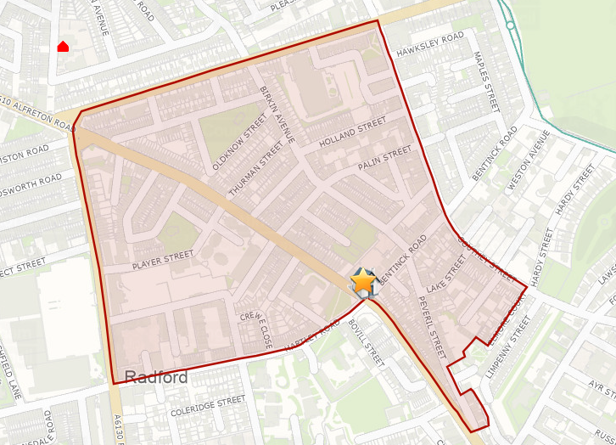Appendix 1:

*The yellow start indicates the location of Bluecoat Bentinck Academy, the area within the red lines depicts the catchment area.*