Nottingham City Council
Nottingham Core Affordable Housing Viability Assessment
Final Report

Three Dragons



August 2009

1 INTRODUCTION

Background to the Study
- A consortium of the local authorities in the Nottingham Core Housing Market Area commissioned Three Dragons to undertake a study which examined, “…… the potential impact on development viability of revised planning-led affordable housing targets, thresholds and tenure splits for each authority” (extract from the Study Brief).

- The local authorities in the Nottingham Core Housing Market Area are Ashfield District Council (Hucknall part only), Broxtowe Borough Council, Erewash Borough Council, Gedling Borough Council, Nottingham City Council and Rushcliffe Borough Council.

- The Study Brief provides a further explanation of the relationship between this study and the development of policy at the local level, stating that:

“The Nottingham Core authorities are fully committed to increasing the delivery of affordable housing through a planning-led process, but they recognise Planning Policy Statement 3 (PPS3) requires a viability assessment to be undertaken before making major policy changes, and want to be confident that viability issues do not threaten implementation of these policies. Regional Housing Group funding has been obtained so that the authorities can carry out a comprehensive viability assessment, which will enable them to set specific and deliverable affordable housing targets. These targets may be fed through policy into each authority’s Local Development Framework (LDF), housing strategy and the East Midlands Regional Spatial and Housing Strategies.”

- This report relates to the specific circumstances of Nottingham City Council.

Progress in Delivering Affordable Housing
- To place the report into context, we set out below in Table 1.1 recent delivery rates for affordable housing in the City.
Financial year |  | All completions | Affordable as % of completions
 | Total | Gross | Gross
1996-97* | 133 | 395 | 33.7
1997-98* | 53 | 375 | 14.1
1998-99* | 100 | 413 | 24.2
1999-2000 | 139 | 471 | 29.5
2000-01 | 83 | 380 | 21.8
2001-02 | 154 | 1,143 | 13.5
2002-03 | 97 | 822 | 11.8
2003-04 | 146 | 1,128 | 12.9
2004-05 | 77 | 1,249 | 6.2
2005-06 | 120 | 1,380 | 8.7
2006-07 | 12 | 1,528 | 0.8
2007-08 | 154 | 1,292 | 11.9

- The table shows a varying delivery rate with an average of 16% per annum for the period 1996-7 to 2006-7.

Need for Affordable Housing
- The Nottingham Core HMA was published by B. Line Housing Information and Three Dragons in May 2007. The report calculates housing need estimates using the ‘Bramley model’ which has been considered as “potentially one of the most robust methods that could be used at regional, HMA and local levels.”
- The following table indicates that there is an annual need for 203 affordable houses in Nottingham and this equates to about 20% of the planned new housing supply.

Table 1.2: Final Housing Need Figures for Nottingham
Net Annual Need | LA Planned Annual New Supply | Need as a % of New Supply
203 | 1,000 | 20.3%
Source: Adapted from Nottingham Core Strategic Housing Market Assessment, B. Line Housing Information and Three Dragons, May 2007.
- It is suggested that a target of 27% of the affordable housing in Nottingham should be Intermediate Housing marketed at 70% of the open market entry level price. Lower proportions of open market entry level price are illustrated, but not recommended because it is likely that this would create financial difficulties for Registered Social Landlords to develop. Ultimately, local circumstances will also determine the levels.
- Our report is not intended to deal with the issue of affordable housing need in any detail. However, we note that the Strategic Housing Market Assessment estimates need for affordable housing at around 20% of the total supply. This figure is significantly lower than the need identified in other authorities in the Nottingham Core Housing Market Area.

Policy context - national
- This study focuses on the percentage of affordable housing sought on mixed tenure sites and the size of site from above which affordable housing is sought (the site size threshold). National planning policy, set out in PPS3 makes clear that local authorities, in setting policies for site size thresholds and the percentage of affordable housing sought, must consider development economics and should not promote policies which would make development unviable.
PPS3: Housing (November 2006) states that:
“In Local Development Documents, Local Planning Authorities should:
Set out the range of circumstances in which affordable housing will be required. The national indicative minimum site size threshold is 15 dwellings. However, Local Planning Authorities can set lower minimum thresholds, where viable and practicable, including in rural areas. This could include setting different proportions of affordable housing to be sought for a series of site-size thresholds over the plan area. Local Planning Authorities will need to undertake an informed assessment of the economic viability of any thresholds and proportions of affordable housing proposed, including their likely impact upon overall levels of housing delivery and creating mixed communities”. (Para 29)
- The companion guide to PPS3 provides a further indication of the approach which Government believes local planning authorities should take in planning for affordable housing. Paragraph 10 of the document states:
“Effective use of planning obligations to deliver affordable housing requires good negotiation skills, ambitious but realistic affordable housing targets and thresholds given site viability, funding ‘cascade’ agreements in case grant is not provided, and use of an agreement that secures standards.” (our emphasis)

Policy context – East Midlands Region
- The East Midlands Regional Plan was published in March 2009. It has identified that 20,000 dwellings should be provided in Nottingham for the period 2006 to 2026, giving an annual average figure of 1,000 dwellings per annum (dpa) for the period.
- Policy 14 of the Regional Plan requires 17,100 (30%) affordable dwellings to be provided in the Nottingham Core HMA. If the same ratio is applied to Nottingham City, this would equate to about 300 affordable dwellings per annum, between 2006 and 2026 which would be in excess of the level of need identified in the SHMA (at 200 per annum).

Policy context – Nottingham City Council
- Nottingham City Council’s Local Plan Review (2005) includes one saved policy regarding affordable housing. Policy H5 seeks a proportion of affordable housing on housing sites above the threshold of one hectare or 25 dwelling. Where affordable housing is appropriate but not desirable a commuted sum will be sought for provision elsewhere. The policy justification states that on eligible sites, 20% of the development will be sought for affordable housing.
- As a result of the proposed changes to the Regional Spatial Strategy, in response to more recent government guidance and the newly adopted Regional Plan, Nottingham is working on an aligned Core Strategy with the five other local authorities that make up the Nottingham Core Housing Market Area (Ashfield District Council, Broxtowe Borough Council, Gedling Borough Council, Nottingham City Council and Erewash District Council) - as recommended by central government.

Research undertaken
- There were four main strands to the research undertaken to complete this study:
- Discussions with a project group of officers from the commissioning authorities which informed the structure of the research approach;
- Analysis of information held by the authority, including that which described the profile of land supply;
- Use of the Three Dragons Toolkit to analyse scheme viability (and described in detail in subsequent chapters of this report);
- A workshop held with developers, land owners, their agents and representatives from a selection of Registered Social Landlords active in the district. A full note of the workshop is shown in Appendix 1.

Structure of the report
- The remainder of the report uses the following structure:
- Chapter 2 explains the methodology we have followed in, first, identifying sub markets and, second, undertaking the analysis of development economics. We explain that this is based on residual value principles;
- Chapter 3 provides analysis of residual values generated across a range of different development scenarios (including alternative percentages and mixes of affordable housing) for a notional 1 hectare site.
- Chapter 4 considers options for site size thresholds. It reviews national policy and the potential future land supply and the relative importance of small sites. The chapter considers practical issues about on-site provision of affordable housing on small sites and the circumstances in which collection of a financial contribution might be appropriate (and the principles by which such contributions should be assessed);
- Chapter 5 identifies a number of case study sites (generally small sites which are currently in use), that represent examples of site types found in the authority. For each site type, there is an analysis of the residual value of the sites and compares this with their existing use value.
- Chapter 6 summarises the evidence collected through the research and provides a set of policy options.

2 METHODOLOGY

Introduction
- In this chapter we explain the methodology we have followed in, first, identifying sub markets (which are based on areas with strong similarities in terms of house prices) and, second, undertaking the analysis of development economics. The chapter explains the concept of a residual value approach and the relationship between residual values and existing/alternative use values.

Viability – starting points
- We use a residual development appraisal model to assess development viability. This mimics the approach of virtually all developers when purchasing land. This model assumes that the value of the site will be the difference between what the scheme generates and what it costs to develop. The model can take into account the impact on scheme residual value of affordable housing and other s106 contributions.
- Figure 2.1 below shows diagrammatically the underlying principles of the approach. Scheme costs are deducted from scheme revenue to arrive at a gross residual value. Scheme costs assume a profit margin to the developer and the ‘build costs’ as shown in the diagram include such items as professional fees, finance costs, marketing fees and any overheads borne by the development company.
- The gross residual value is the starting point for negotiations about the level and scope of s106 contribution. The contribution will normally be greatest in the form of affordable housing but other s106 items will also reduce the gross residual value of the site. Once the s106 contributions have been deducted, this leaves a net residual value.

Figure 2.1 Theory of the Section 106 Process

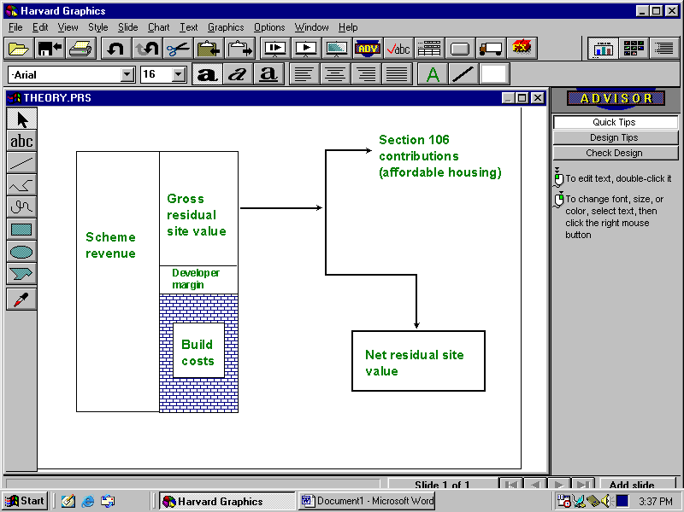
- Calculating what is likely to be the value of a site given a specific planning permission, is only one factor in deciding what is viable.
- A site is extremely unlikely to proceed where the costs of a proposed scheme exceed the revenue. But simply having a positive residual value will not guarantee that development happens. The existing use value of the site, or indeed a realistic alternative use value for a site (e.g. commercial) will also play a role in the mind of the land owner in bringing the site forward and thus is a factor in deciding whether a site is likely to be brought forward for housing.
- Figure 2.2 shows how this operates in theory. Residual value falls as the proportion of affordable housing increases. At some point (here ‘b’), alternative use value (or existing use value whichever is higher) will be equal to scheme value. If there is a reasonable return to the land owner at point ‘b’ (i.e ‘b’ reflects best possible current use value (alternative or existing) and there is a sufficient return, then the scheme will come forward. At point ‘c’, affordable housing will make the site unviable. At ‘a’ the scheme should be viable with affordable housing. The diagram does not assume grant. Grant should be used to ‘lever out’ sites from their existing or best alternative uses.
Figure 2.2 Affordable housing and alternative use value

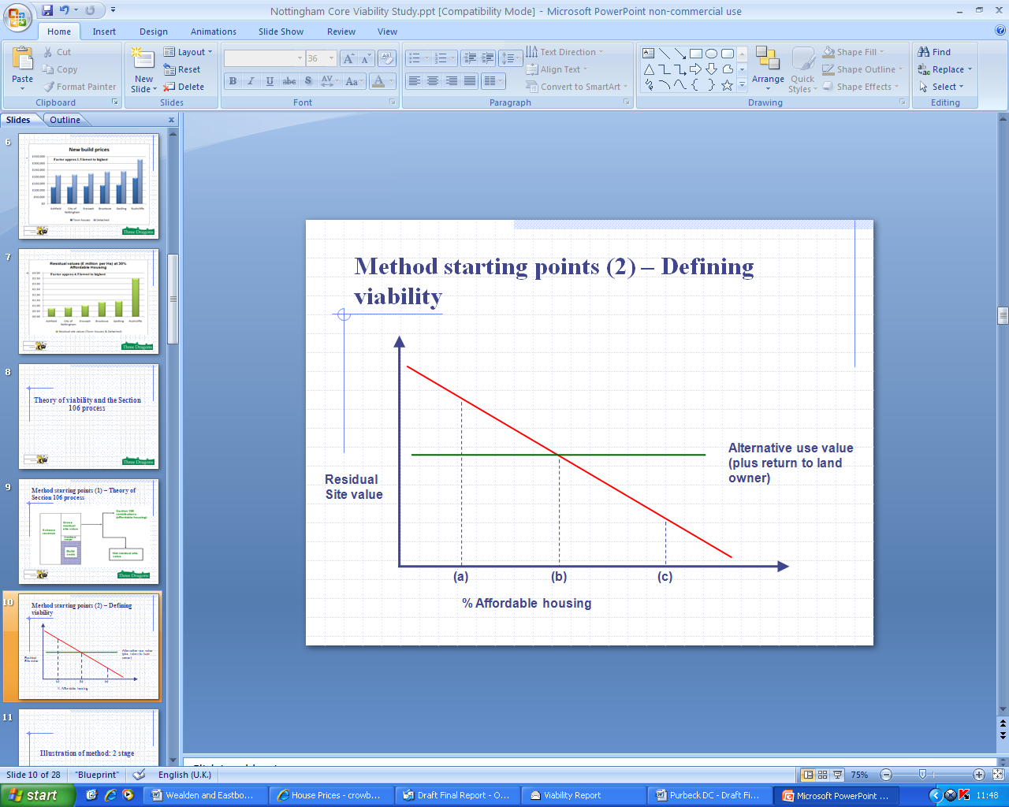

- The analysis we have undertaken uses a Three Dragons Viability model. The model is explained in more detail in Appendix 2, which includes a description of the key assumptions used.

3 HIGH LEVEL TESTING

Introduction
- This chapter of the report considers viability for mixed tenure residential development for a number of different proportions and types of affordable housing. The analysis is based on a notional 1 hectare site and has been undertaken for a series of sub markets that have been identified. The residual value shown will be the same whether the site is greenfield or on previously used land. The chapter explains this and explores the relationship between the residual value for the scenarios tested and existing/alternative use values.

Market value areas
- Variation in house prices will have a significant impact on development economics and the impact of affordable housing on scheme viability.
- We undertook a broad analysis of house prices in Nottingham using HM Land Registry data to identify the sub markets. These sub markets have been developed from smaller geographical areas which were developed for the Strategic Housing Market Assessment. The house prices which relate to the sub markets provide the basis for a set of indicative new build values as at December 2008. Table 3.1 below sets out the sub markets in Nottingham developed for the study. The SHMA areas are shown in the map below.
Table 3.1 Viability sub markets in the Nottingham City area

Sub Markets | Locations
Nottingham Prime | Park and Standard Hill
Southern Suburban | Wilford and Silverdale
Southern Suburban | Clifton Village, Fabis Drive
Suburban Nottingham | Wollaton
Suburban Nottingham | Mapperley Park South, Carrington, Sherwood Rise
Suburban Nottingham | Rise Park
Suburban Nottingham | Dunkirk, Hillside and Old Lenton
Suburban Nottingham | Arnold - Mapperley
Sherwood and Hyson Green | Sherwood
Sherwood and Hyson Green | Chalfont Drive - Aspley Lane
Sherwood and Hyson Green | Hyson Green & Bobbers Mill
Bakersfield and Forest Fields | Bakersfield
Bakersfield and Forest Fields | Forest Fields
Lower value Nottingham | Sneinton
Lower value Nottingham | St Ann's
Lower value Nottingham | Bestwood Park
Lower value Nottingham | Radford
Lower value Nottingham | Clifton
Lower value Nottingham | Lenton Abbey
Lower value Nottingham | Bulwell
Lower value Nottingham | Meadows
Outer Estates | Broxtowe
Outer Estates | Aspley
Outer Estates | Bells Lane
Outer Estates | Bestwood Estate

Source: Market value areas as agreed between Three Dragons and Nottingham CC

Map 3.1 Viability sub markets in the Nottingham City area

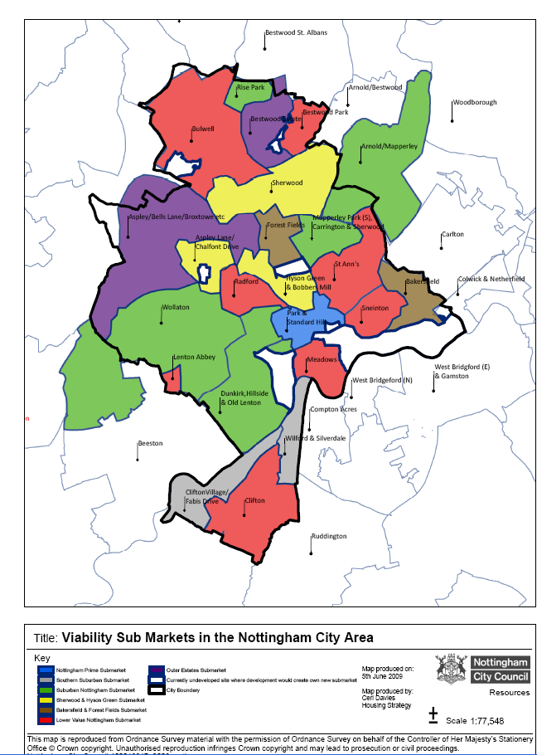

Testing assumptions (notional one hectare site)
- For the viability testing, we defined a number of development mix scenarios, using a range of assumptions agreed with the Council. The scenarios were based on an analysis of typical development mixes and were discussed at the stakeholder workshop.
- The development mixes were as follows:
- 30 dph: including 10% 2 Bed flats; 10% 2 bed terraces; 15% 3 bed terraces; 20% 3 bed semis; 25% 3 bed detached; 15% 4 bed detached; 5% 5 bed detached
- 40 dph: including 5% 1 bed flats; 15% 2 bed flats; 15% 2 bed terraces; 15% 3 bed terraces; 20% 3 bed semis; 20% 3 bed detached; 10% 4 bed detached;
- 50 dph: including 10% 1 bed flats; 20% 2 bed flats; 20% 2 bed terraces; 15% 3 bed terraces; 15% 3 bed semis; 15% 3 bed detached; 5% 4 bed detached;
- 80 dph: including 20% 1 bed flats; 30% 2 bed flats; 30% 2 bed terraces and 20% 3 bed terraces;
- 250 dph: including 50% 1 bed flats; 50% 2 bed flats.
- We calculated residual scheme values for each of these (base mix) scenarios in line with a further set of tenure assumptions. These were 10%; 15%; 20%; 25%; 30%; 35% and 40% affordable housing. These were tested at 70% Social Rent and 30% New Build HomeBuy in each case. For the New Build HomeBuy, the share purchase was assumed to be 50%. All the assumptions were agreed with the authority. Unless stated, testing was carried out assuming nil grant.

Other s106 contributions
- For the modelling we have undertaken (and unless shown otherwise) we have assumed that other planning obligations have a total cost of £7,000 per unit.

Results: residual values for a notional one hectare site
- This section looks at a range of development mixes and densities. It shows the impacts of increasing the percentage of affordable housing on residual site values. The full set of results is shown in Appendix 3.

Low density housing (30 dph)
- Figure 3.1 shows low density housing (30dph) and the residual values for each of the market value areas outlined in Section 3.
Figure 3.1 Low density housing (30 dph) – Residual value in £s million
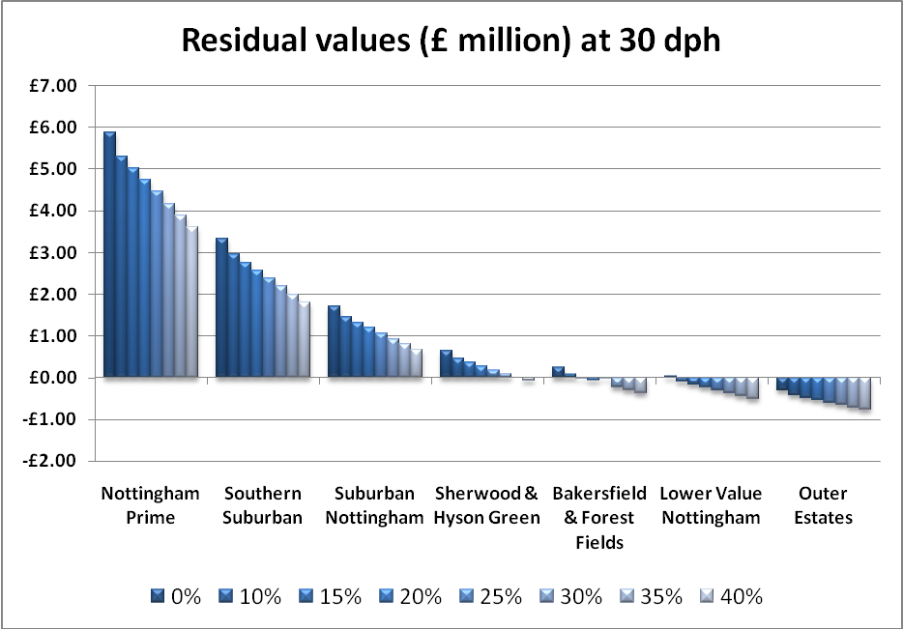
- Figure 3.1 shows a range of residual values for the sub markets across the City. It is immediately apparent that the City has a wide range of sub markets. Residual values at 20% affordable housing range from £4.74 million per hectare in Nottingham Prime to minus £0.53 million per hectare in the Outer Estates.
- The chart shows a range of values across the settlements with Nottingham Prime and the Southern Suburban providing the highest residual values. Suburban Nottingham, including a wider range of suburban locations such as Wollaton and Mapperley, provide reasonably robust residual values (£1.2 million per hectare at 20% affordable housing). There is then a range of locations, in particular Lower Value Nottingham (including for example Sneinton, St Ann’s and the Meadows) where residual values are either marginal or negative.
- In the weaker sub markets, the £7,000 per unit (other Section 106 obligation) hits residual values particularly hard and this is case for all the density scenarios tested below.
- The range in values has potentially important implications for policy making. With the scenarios tested (Figure 3.1), a significantly higher value (£3.61m versus minus £0.31m) is generated in the Nottingham Prime sub market at 40% affordable housing than in the Outer Estates at 100% market housing;
- We note that (and this applies to subsequent analysis – Figures 3.2 to 3.5) that development appears either marginal or non viable for housing in Lower Value Nottingham and the Outer Estates. In practice, we know that schemes have been developed in these locations and we attribute this to a combination of factors; these include very low or nil affordable housing contributions, nil (other) s106 contributions, potentially lower development costs than we have assumed here and development within the ‘hotter spots’ of these (weaker) sub markets. High quality development within weaker housing markets can also help to make affordable housing possible.

Lower density housing (40 dph)
- Figure 3.2 shows lower density housing (40 dph) and the residual values for each of the market value areas.
Figure 3.2 Lower density housing (40 dph) – Residual value in £s million
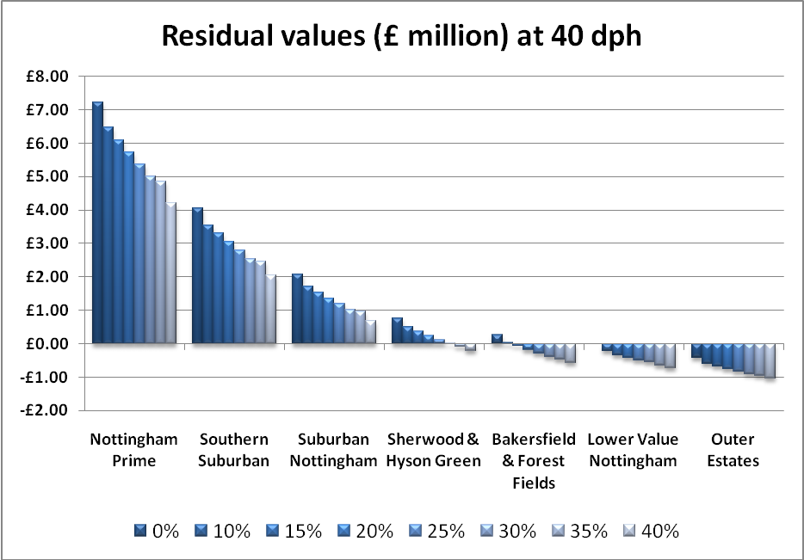

- Consistent with the 30 dph scenario, a range of both positive and negative land values is shown, although with even more significant negative scheme values now beginning to be seen in the lower value sub markets.
- The impact of increased density varies between market areas and at different levels of affordable housing. Increases in residual value occur with increased density (30 dph to 40 dph) in the top three sub market areas (Nottingham Prime, Southern Suburban and Suburban Nottingham) at all affordable housing targets tested (i.e up to 40%). However in the lowest three sub market areas (Bakersfield & Forest Fields, Lower Value Nottingham and Outer Estates), the 30 dph scenario produces a higher residual value at all affordable housing targets tested. In Sherwood and Hyson Green, the 40 dph scenario produces a higher residual (versus the 30 dph scenario) up to 15% affordable housing. Thereafter (20% to 40% affordable housing), the lower density (30 dph) scenario gives a higher residual.

50 dph scheme
- Figure 3.3 shows residual values for a (50 dph) scheme and the residual values for each of the market value areas outlined earlier.
Figure 3.3 Medium density housing (50 dph) – Residual value in £s million
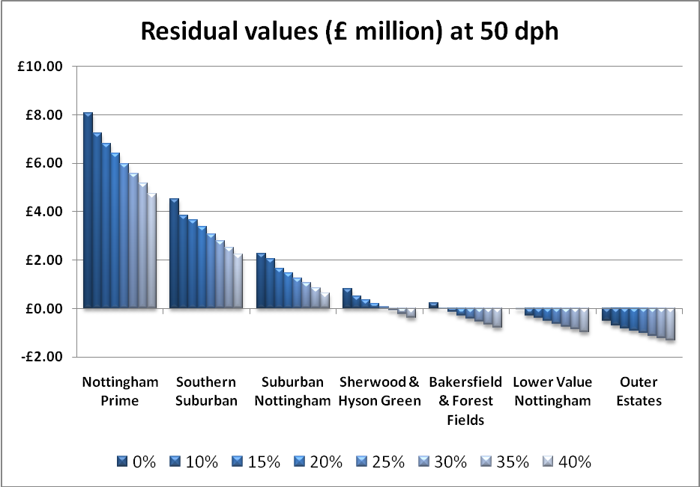
- The results for the 50 dph scenario underline the conclusion that increasing density does not necessarily increase residual value.
- As previously, this conclusion depends on location. 50 dph produces a higher residuals in Nottingham Prime and Southern Suburban at all percentages of affordable housing. In Suburban Nottingham, the 50 dph scenario produces the highest residual (versus 30 dph and 40 dph) up to 30% affordable housing. However in the lowest three value locations (Bakersfield & Forest Fields, Lower Value Nottingham and Outer Estates), a 50 dph scheme is likely to produce the lowest residuals at all scenarios tested.
- Several scenarios show negative residual values at 50 dph. The Outer Estates are particularly noticeable here.

80 dph scheme
- Figure 3.5 shows residual values for a (80 dph) scheme and the residual values for each of the sub markets.
Figure 3.5 Higher density housing (80 dph) – Residual value in £s million
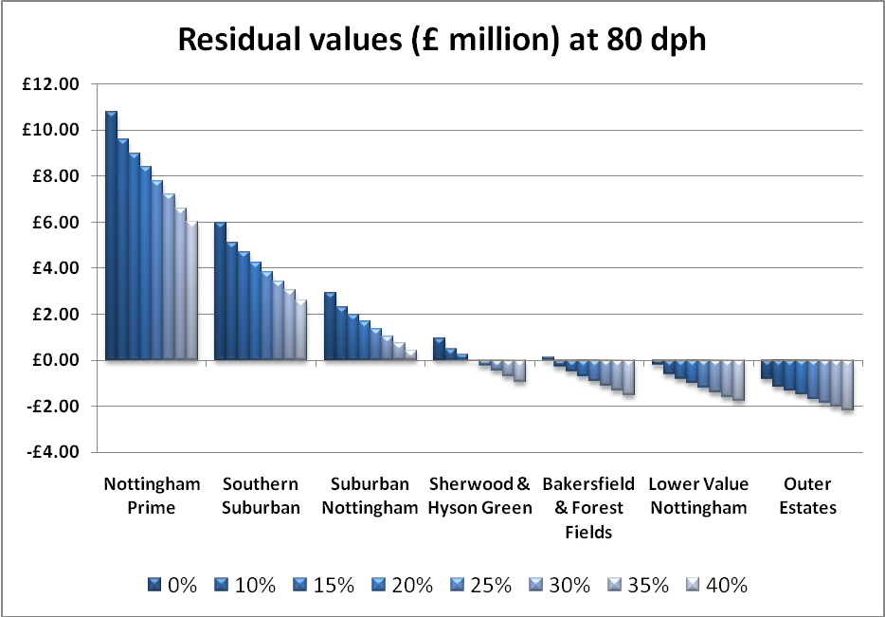
- The 80 dph scenario includes a significantly higher proportion of apartments – 50% of the scheme is assumed to be flats.
- The impacts of the development mix and density on residual is largely twofold. Versus other lower density scenarios the impact is generally to enhance residuals at lower proportions of affordable housing and in higher value locations, and, on the other hand, to make schemes in weaker sub markets even less viable at relatively modest proportions of affordable housing.
- It can be seen (Figure 3.5) that in the weakest two sub markets,Lower Value Nottingham and Outer Estates, housing development looks marginal both with and without affordable housing. We emphasize here that the £7,000 per unit other Section 106 planning gain package amounts (at 80 dph) to some £560,000 which goes a considerable way towards explaining the apparent non viability of this type of development in these weaker market areas.
250 dph scheme
- Figure 3.6 shows residual values for a (250 dph) scheme and the residual values for each of the sub markets. This type of development (high density apartments has not been unusual in the city during the past few years although has mainly, we understand, been restricted to the city centre). We show here other sub markets for completeness..
Figure 3.6 Higher density apartment scheme (250 dph) – Residual value in £s million
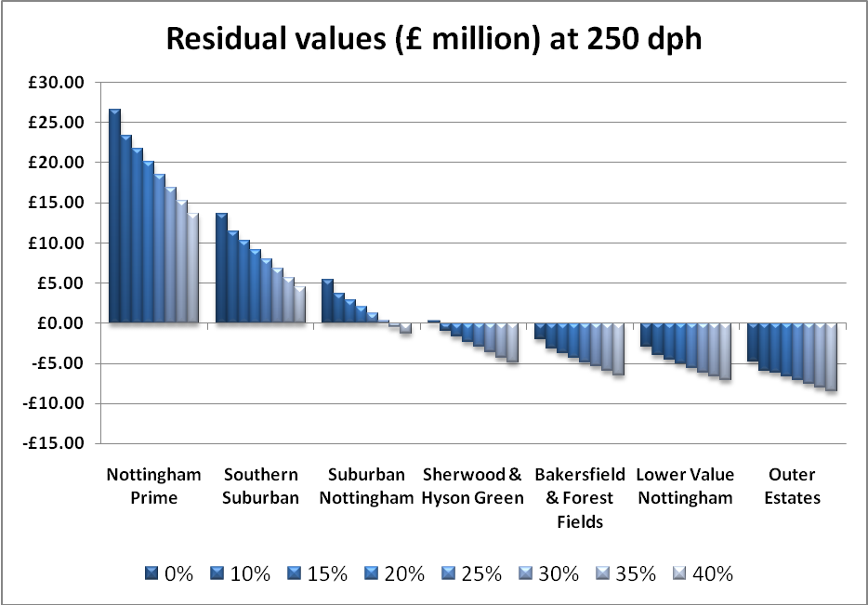
- Figure 3.6 shows very clearly the impacts of density and development location. The chart shows that residual values are dramatically higher at the lowest propotions of affordable housing in the highest value locations (Nottingham Prime and Southern Suburban).
- However, the chart also shows a substantial number of locations where this type of development looks to be unviable.
- This does not mean that the Council should not seek affordable housing from developer contributions without grant in site specific instances as there will be cases where this type of high density development creates its own ‘market’; the ‘city living’ experience has proven this with relatively healthy selling prices being achieved.
- What it does mean however is that where schemes (probably smaller schemes) reflect largely local prices in the weaker sub markets, then normally it will be difficult to deliver affordable housing without grant.
Impacts of potential grant funding
- The availability of public subsidy (in the form of grant) can have a significant impact on scheme viability. Grant given to the affordable housing providers enables them to pay more for affordable housing units, thus increasing overall scheme revenue and therefore the residual value of a mixed tenure scheme. There are two main sources of grant which may be available: from the Homes and Communities Agency and/or the local authority (for example using money collected from development in the form of a commuted sum, through a s106 agreement).
- We have assumed grant of £50,000 per Social Rented unit and £25,000 per New Build HomeBuy unit.
- For our testing, we have tested the impact of grant on residual values for a 1 Ha site at 50 dph for a selection of locations. The results are shown in Table 3.2.
- Table 3.2 (and indeed Tables 3.3 and 3.4 below) look at a selection of sub markets across the full range of all sub markets in the City. The selection allows for conclusions to be made about the wider impacts of grant across the city.
Table 3.2 Comparison of impact of grant versus on residual values (at 50 dph): Residual Value (£s million per hectare); 70% Social Rent: 30% Shared Ownership
50 Dph | Nottingham Prime |  | Suburban Nottingham |  | Bakersfield & Forest Fields |  | Lower Value Nottingham |  | Outer Estates
 | No grant | Grant | No grant | Grant | No grant | Grant | No grant | Grant | No grant | Grant
0% AH | £8.07 | N/A | £2.28 | N/A | £0.23 | N/A | -£0.04 | N/A | -£0.51 | N/A
10% AH | £7.24 | £7.45 | £2.05 | £2.26 | -£0.02 | £0.19 | -£0.28 | -£0.07 | -£0.70 | -£0.49
15% AH | £6.82 | £7.13 | £1.67 | £1.98 | -£0.14 | £0.17 | -£0.40 | -£0.09 | - £0.81 | -£0.50
20% AH | £6.41 | £6.84 | £1.47 | £1.90 | -£0.28 | £0.15 | -£0.51 | -£0.08 | - £0.91 | -£0.48
25% AH | £5.99 | £6.52 | £1.26 | £1.79 | -£0.41 | £0.12 | -£0.63 | -£0.10 | - £1.02 | -£0.59
30% AH | £5.57 | £6.21 | £1.06 | £1.70 | -£0.53 | £0.11 | -£0.75 | -£0.11 | - £1.12 | -£0.59
35% AH | £5.16 | £5.90 | £0.86 | £1.60 | -£0.66 | £0.08 | -£0.86 | -£0.12 | - £1.22 | -£0.60
40% AH | £4.74 | £5.59 | £0.65 | £1.50 | -£0.78 | £0.07 | -£0.98 | -£0.13 | - £1.31 | -£0.69

- Table 3.2 shows that grant will enhance site viability. In Nottingham City, grant will be particularly important in helping to deliver affordable housing as there are several sub markets where viability is a very real challenge. In these weaker market locations (and indeed for ‘colder’ spots within the higher value sub markets), the Council should, we think, look to support the delivery of affordable housing through grant.
- As a general rule, the introduction of grant has a greater proportionate impact in the weaker sub markets. However, it will be noted (Table 3.2) that in the lowest two sub markets, grant, at the levels tested, still fails to generate a positive residual value for all the affordable housing scenarios tested. Under certain circumstances it will either be necessary to exempt sites from any other (than affordable housing) Section 106 contributions or increase the levels of grant above the assumed levels here (£50,000 and £25,000 for Social Rent and Shared Ownership respectively. In some cases it will be necessary to both increase grant levels and make sites exempt from other Section 106 contributions. For this purpose we would expect an individual site viability assessment to be carried out.
- As we have proposed in related reports for the Nottingham Core authorities, grant should be focused on the weaker sub market areas. Nottingham has several strong sub markets where grant will not normally be necessary.
Impacts of increasing the proportion of Intermediate housing within the affordable element
- In the previous section we considered the impact of grant on scheme viability. Where grant is not available to support schemes (or is not sufficient on its own), scheme viability can be (further) enhanced by increasing the percentage of intermediate affordable housing. We have tested all scenarios thus far assuming the relevant affordable element is split 70% Social Rent and 30% Shared Ownership. Here we test a 50%:50% split in the affordable element.
Table 3.3 Site values (£ million per hectare) for a 50 dph scheme comparing 50% Social Rent and 50% Shared Ownership without grant versus grant option (70% Social Rent and 30% Shared Ownership)
50 Dph | Nottingham Prime |  | Suburban Nottingham |  | Bakersfield & Forest Fields |  | Lower Value Nottingham |  | Outer Estates
 | No grant (50%:50%) | Grant | No grant (50%:50%) | Grant | No grant (50%:50%) | Grant | No grant (50%:50%) | Grant | No grant (50%:50%) | Grant
0% AH | £8.07 | N/A | £2.28 | N/A | £0.23 | N/A | -£0.04 | N/A | -£0.51 | N/A
10% AH | £7.43 | £7.45 | £1.96 | £2.26 | £0.04 | £0.19 | -£0.23 | -£0.07 | -£0.67 | -£0.49
15% AH | £7.12 | £7.13 | £1.80 | £1.98 | -£0.06 | £0.17 | -£0.32 | -£0.09 | - £0.75 | -£0.50
20% AH | £6.80 | £6.84 | £1.65 | £1.90 | -£0.16 | £0.15 | -£0.41 | -£0.08 | - £0.83 | -£0.48
25% AH | £6.48 | £6.52 | £1.49 | £1.79 | -£0.26 | £0.12 | -£0.50 | -£0.10 | - £0.91 | -£0.59
30% AH | £6.16 | £6.21 | £1.33 | £1.70 | -£0.37 | £0.11 | -£0.60 | -£0.11 | - £0.98 | -£0.59
35% AH | £5.84 | £5.90 | £1.18 | £1.60 | -£0.47 | £0.08 | -£0.68 | -£0.12 | - £1.07 | -£0.60
40% AH | £5.14 | £5.59 | £1.02 | £1.50 | -£0.57 | £0.07 | -£0.78 | -£0.13 | - £1.15 | -£0.69

- Table 3.3 shows the residual values with a 50%:50% split in the affordable element. In all locations, this does not however show a higher residual value compared to the ‘with grant’ scenario, although Nottingham Prime, the ‘trade-off’ position is very close; in other words, going for a 50%:50% split in the affordable element produces a similar result to a scheme with grant (at the levels tested).

- In middle markets (example here Bakersfield and Forest Fields), the grant produces a substantially higher residual value than the scenario assuming a 50%:50% split.

- The main reason for these outcomes lies in the role played by Shared Ownership in the appraisals. In high value areas, switching tenure (an 80%:20% split to a 50%;50% split in the affordable tenure) will have much more dramatic impact than in a low value area, since revenue to the developer is based on a higher affordable housing payment, based in turn on higher house prices.

Market sensitivity testing

- Given the volatility of the current housing market, we have looked a situation where house prices are 10% higher and 10% lower than the levels assumed in our main testing based at December 2008.

- Table 3.4 shows residual values for a 50 dph scheme with house prices increased and decreased by 10%. This is not a reflection of any particular forecast of how the market will perform, but aims to show the sensitivity of residual values to changes in house prices.

Table 3.4 Residual values (£ million per hectare) for a 50 dph scheme with prices 10% higher and lower than the baseline. No grant; 70% Social Rent: 30% Shared Ownership

Prices up10% | 0% | 10% | 20% | 30% | 40%
Nottingham Prime | £9.35 | £8.42 | £7.50 | £6.58 | £5.65
Suburban Nottingham | £2.98 | £2.52 | £2.06 | £1.60 | £1.15
Bakersfield & Forest Fields | £0.73 | £0.44 | £0.14 | -£0.15 | -£0.44
Lower Value Nottingham | £0.43 | £0.16 | -£0.11 | -£0.38 | -£0.66
Outer Estates | -£0.09 | -£0.32 | -£0.55 | -£0.79 | -£1.02
Baseline position | 0% | 10% | 20% | 30% | 40%
Nottingham Prime | £8.07 | £7.24 | £6.41 | £4.57 | £4.74
Suburban Nottingham | £2.28 | £2.05 | £1.47 | £1.06 | £0.65
Bakersfield & Forest Fields | £0.23 | -£0.02 | -£0.28 | -£0.53 | -£0.78
Lower Value Nottingham | -£0.04 | -£0.28 | -£0.51 | -£0.75 | -£0.98
Outer Estates | -£0.51 | -£0.70 | -£0.91 | -£1.12 | -£1.31
Prices down10% | 0% | 10% | 20% | 30% | 40%
Nottingham Prime | £6.81 | £6.08 | £5.34 | £3.60 | £3.86
Suburban Nottingham | £1.60 | £1.24 | £0.88 | £0.53 | £0.17
Bakersfield & Forest Fields | -£0.24 | -£0.46 | -£0.68 | -£0.15 | -£1.13
Lower Value Nottingham | -£0.49 | -£0.69 | -£0.90 | -£1.10 | -£1.31
Outer Estates | -£0.91 | -£1.08 | -£1.26 | -£1.42 | -£1.59

- Table 3.4 shows significant variation in residual values depending on the assumption about future price changes. For example in the Nottingham Prime sub market, a 10% increase in house prices will increase residual land value by 44% at a 30% affordable housing target. At the weaker end of the market, a small increase in prices will have an even more dramatic impact. For example, at 20% affordable housing, in Lower Value Nottingham, residuals will quadruple residual values.

- Falling house prices will have a significant impact on land values as could been seen from the table above. However, it can also be seen that in high value areas, residual values remain bouyant even at higher percentages of affordable housing.

Viability on very large sites

- The analysis carried out relates to a notional one hectare site, where it is anticipated that market selling prices will broadly ‘pick up’ the values from surrounding or very local settlements.

- In practice, where very large sites are released (several hundred houses), these sites will have the potential to create their own market, which in many instances will exceed the prices being charged for new housing being on smaller sites.

- The testing of such strategic sites is beyond the scope of this study, as market values and specific infrastructure and abnormal costs need to be established in each instance. We would suggest that these sites are tested by the Council going forward, where affordable housing targets can be set independently of the findings of this study.

Benchmarking results

- There is no specific guidance on the assessment of viability which is published by national government. In Section 2, we set out that we think viability should be judged against return to developer and return to land owner.
- One approach is to take “current” land values for different development uses as a kind of ‘going rate’ and consider residual values achieved for the various scenarios tested against these. Table 3.5 shows residential land values for selected locations within the East Midlands.

Table 3.5 Residential land values regionally

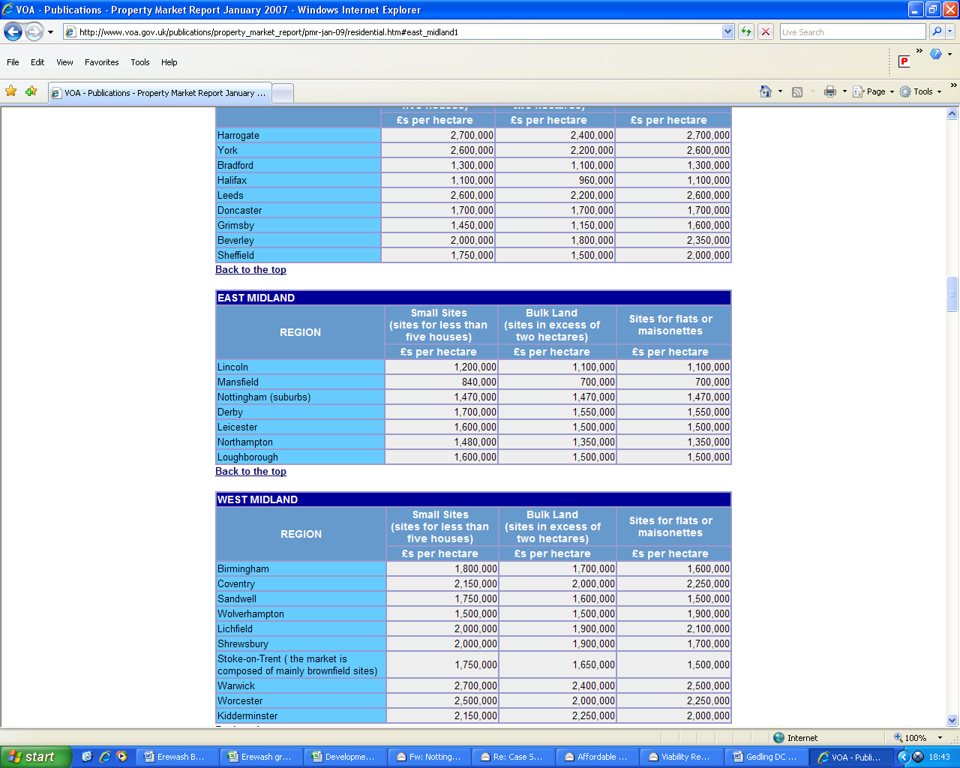

Source: Valuation Office; Property Market Report, January 2009

- The table indicates residential land values ranged from £0.75 million (Mansfield) to £1.47 million (Nottingham suburbs).

- Another benchmark which can be referred to is that of industrial land. Table 3.6 shows values ranging from £250,000 per hectare to £500,000 (Nottingham) per hectare in the latter part of 2008 for Typical sites (Table 3.6)

Table 3.6 East Midlands industrial land values

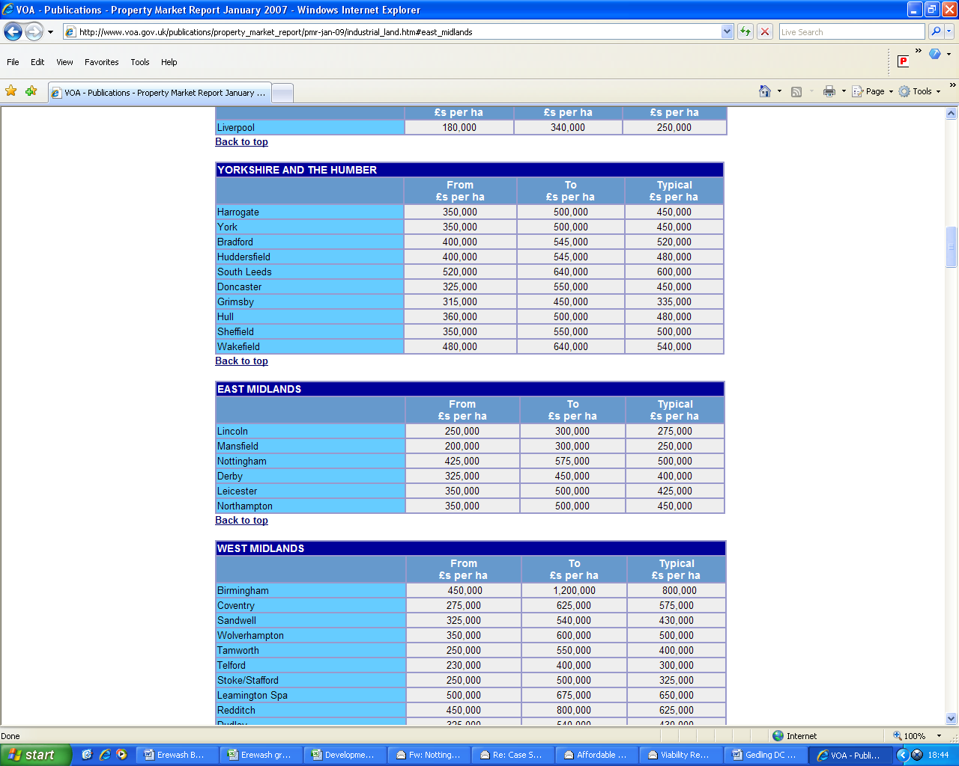

Source: Valuation Office; Property Market Report, January 2009

- The ‘benchmark’ of industrial land value can be important where land, currently in use as industrial land, is being brought forward for residential development or where sites may be developed either for residential or employment use.
4 LAND SUPPLY, SMALL SITES AND USE OF COMMUTED SUMS

Introduction
- This chapter reviews the policy context and options for identifying the size of sites above which affordable housing contributions would be sought, in the national policy context. Policy HOU7 seeks 30% affordable housing on allocated sites and unallocated sites of 0.5ha or 15 dwellings or more. On all other unallocated sites less than 0.5ha or 15 dwellings provision of affordable housing will be encouraged. The chapter provides an assessment of the profile of recent planning consents and the likely relative importance of small sites. It then considers practical issues about on-site provision of affordable housing on small sites and the circumstances in which collection of a financial contribution might be appropriate (and the principles by which such contributions should be assessed).

Purpose of the Analysis
- PPS3 Housing sets out national policy on thresholds and affordable housing and states:
”The national indicative minimum site size threshold is 15 dwellings. However, Local Planning Authorities can set lower minimum thresholds, where viable and practicable, including in rural areas. This could include setting different proportions of affordable housing to be sought for a series of site-size thresholds over the plan area.” (Para 29)
- By reducing site size thresholds and ‘capturing’ more sites from which affordable housing can be sought, an authority can potentially increase the amount of affordable housing delivered through the planning system.
- In this section we examine the impact that varying site size thresholds would have on affordable housing supply. In order to do this we need to examine the likely future site supply profile.

Small sites analysis
- We have analysed data on past permissions to consider how important sites of different sizes are likely to be to the future land supply. The table below shows the results of this exercise. The analysis has considered permissions granted over the three and half years April 2005 to September 2008.

Table 4.1: Proportion of dwellings in different sizes of sites, granted permission between 2005 and 2008
Size of site in dwellings | % of all dwellings
1 - 4 | 7.9%
5 - 9 | 6.8%
10 - 14 | 5.6%
15 - 24 | 9,.8%
25 - 49 | 10.1%
50 - 99 | 19.8%
100 + | 40.0%
 | 100%
Source: Nottingham City Council
Note: Table excludes schemes which are redevelopment/reconfiguration of council built estates
  - The above information indicates that larger sites are of great importance to the overall supply of sites in the City. Schemes of under 15 dwellings (the national indicative minimum threshold) represent about 20% of the total dwellings while schemes of 100 or more dwellings represent 40% of all dwellings.
  - On the face of it and compared with other authorities in the Nottingham Core Market Area, small sites are of limited significance to the City’s land supply. However, this overview may mask important difference between sub-markets in the City. The following table uses the same data as in Table 4.1 and shows the proportion of dwellings in sites of under 15 dwellings.

Table 4.2: Proportion of dwellings in sites of under 15 dwellings (granted permission between 2005 and 2008) by sub market
Sub markets | % dwellings in sites of 15  or fewer dwellings
Nottingham Prime | 11.8%
Southern Suburban | 19.2%
Suburban Nottingham | 60.5%
Sherwood and Hyson Green | 15.6%
Bakersfield and Forest Fields | 35.0%
Lower value Nottingham | 16.8%
Outer Estates | 15.0%

  - The above analysis needs to be treated with caution and individual figures taken as no more than guides to overall trends in each sub market. But as a snapshot, Table 4.2 indicates that the profile of site supply does vary significantly between sub markets.
  - While the overall pattern of site supply may indicate that there is little justification for considering a threshold below 15 dwellings as a city-wide approach, there may be particular areas where a lower threshold may be useful to provide the flexibility to achieve some affordable housing in mixed tenure schemes in these area.

Small sites and management of affordable housing
- We discussed the suitability of small sites for affordable housing at the workshop with the development industry, which included representatives from locally active housing associations.
- The housing associations said that there is no problem, in principle, of providing affordable housing on-site (even if this means there will be as few as one or two affordable homes in the scheme). Whilst some housing associations normally prefer to secure affordable housing in larger ‘blocks’, other associations will take on very small numbers (even single units) of affordable housing.
- Although the number of affordable housing units is not a reason, in itself, to forego an on-site contribution, there may be scheme-specific housing management reasons why it is better to take an off-site contribution (either as units or a commuted sum). Such reasons could include, for instance, high service charges in a flatted block.
- Another reason raised at the workshops for not taking on-site provision on small sites was that of the lack of familiarity amongst developers of small sites about affordable housing. It was agreed that whilst this factor should not exempt developers of small sites from making an affordable housing contribution, the form of the contribution could more realistically be as a commuted sum and not on-site provision. Contributions as a commuted sum were believed to reduce the degree of complexity in scheme negotiations with the local authority and housing and a potential range of other parties and make for a simpler s106 agreement.

Use of commuted sums
- As a general principle, we recognise that seeking on-site provision of affordable housing will be the first priority and that provision of affordable housing on an alternative site or by way of a financial payment in lieu (or commuted sum) should only be used in exceptional circumstances. This position is consistent with national guidance in Paragraph 29 of PPS3 which states:
“In seeking developer contributions, the presumption is that affordable housing will be provided on the application site so that it contributes towards creating a mix of housing. However, where it can be robustly justified, off-site provision or a financial contribution in lieu of on-site provision (of broadly equivalent value) may be accepted as long as the agreed approach contributes to the creation of mixed communities in the local authority area” Para 29.
- Where commuted sums are sought as an alternative to direct on or off-site provision, PPS3 sets out the appropriate principle for assessing financial contributions - that they should be of “broadly equivalent value” (see para set out 29 above). Our approach is that the commuted sum should be equivalent to the ‘developer/landowner contribution’ if the affordable housing was provided on site. One way of calculating this is to take the difference between the residual value of 100% market housing and the residual value of the scheme with the relevant percentage and mix of affordable housing.
- If the ‘equivalence’ principle is adopted, then the decision of the local authority to take a commuted sum will be based on the acceptability or otherwise of on-site provision as a housing and spatial planning solution.
- Any concerns about scheme viability (whatever size of site) should be reflected by providing grant or altering tenure mix, or by a ‘reduced’ affordable housing contribution whether provided on-site, off-site or as a financial contribution. Other planning obligations may also need to be reduced under some circumstances.
- However, if affordable housing is sought from very small sites, in certain circumstances it becomes impractical to achieve on site provision e.g. seeking less than 25% on a scheme of 4 dwellings. There will also be occasions where on-site provision can only deliver a partial contribution towards the proportion of affordable housing sought e.g. 25% affordable housing in a scheme of 5 dwellings would deliver one affordable unit on site (representing 20% of provision). In the latter case, it is possible to devise a formula which mixes on-site provision with a commuted sum to ‘make up the balance’.
- The ‘equivalence principle’ for off-site provision and taking commuted sums was discussed and supported by the development industry workshop. Comment was also made at the workshop that where commuted sums are collected, it is important that the local authority has an effective programme in place to spend the money.

5 CASE STUDY VIABILITY ANALYSIS

Introduction
- The analysis in Chapter 3 provides a good indication of the likely viability of sites in the City. The residual values can be compared with existing use values to establish whether land owners are likely to make a return over and above existing use value, taking into account a developer margin.
- The analysis in Chapter 3 will apply for large as well as small sites (on a pro rata basis). We do not have any evidence to suggest that the economics change significantly between large and small sites. This assumption was accepted at the development industry workshops as has been the case elsewhere where we have run similar workshops.
- It will be noted (Table 3.5) that small sites can achieve higher land values than larger ones, suggesting that the economics of developing smaller sites could actually be more favourable than developing larger ones.
- In theory therefore there is no real need to review in detail viability issues for small sites. However, for the sake of further illustration, and recognising that there may be special circumstances which impact on the viability of some types of smaller sites, it was felt helpful to review the development economics of some illustrative case studies.

Case study sites
- In this section we review a number of case study developments which are examples of small sites for residential development. Figure 5.1 shows the types of schemes granted planning permission during the period 2005 to 2008, with the nature of the existing land use. Here we are measuring the number of schemes of different sizes.
Figure 5.1 Incidence of planning permissions (no of schemes) 2005-2008
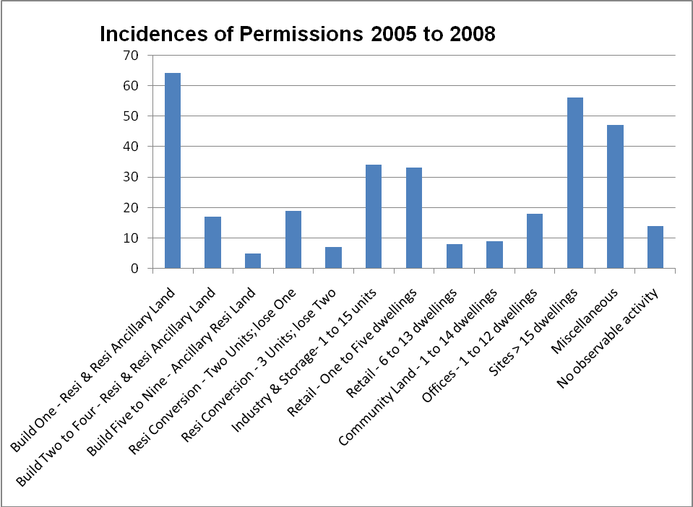

- Figure 5.1 shows a high incidence of permissions for schemes involving the development of one dwelling, mainly from land which is categorised as residential or residential ancillary land (19% of all incidences of planning permission). We assume these permissions relate to garden land or back land. Other significant types of schemes involve the development of two to nine dwellings from the same source of land (7% of all incidences of planning permission).
- There are a number of other types of planning permission for smaller sites. These include new build schemes (one to fifteen dwellings at 10% of all incidences) on industrial and storage land, and developments on retail land (10% of all incidences where one to five dwellings are built), and a range of other schemes emanating from sites previously in leisure use and community land.
- There are a number of schemes which do not fit neatly into any of these categories. These are included as miscellaneous. Permissions for more than 15 dwellings has been categorised separately.
- The data was scrutinised to see if any particular types of sites predominated in any specific locations (according to the sub markets previously identified). It was found that schemes involving the demolition of one dwelling and its replacement with a new build tended mostly to occur in Suburban Nottingham and shop conversions in the middle range sub markets.

- On the basis of the data, we have selected four case studies for further investigation. These are shown in Table 5.1
Table 5.1 Case study sites
Case Study | Number of dwellings | Type of new development | Site Size (Ha) | Resulting density
A | 1 | 1 x 5 bed detached house | 0.05 | 20
B | 2 | 1 x 4 bed detached house;  1 x 5 bed detached house | 0.075 | 27
C | 4 | 2 x 3 bed terraces;  2 x 4 bed detached | 0.1 | 40
D | 10 | - x 2 bed flats;  2 x 2 bed terraces  4 x 3 bed terraces | 0.125 | 80

- For each case study we have undertaken an analysis of residual values for a selection of three sub markets (high, medium and lower value) and at levels of affordable housing from 0%; 10%; 20%; 30% and 40%. All the other assumptions used are the same as for the main analysis described in Chapter 3.
- We have then benchmarked the residual values derived against various potential alternative/existing use values. One comparator is the value of a second hand dwelling which is a relevant comparison where the development includes the demolition of an existing dwelling. We have used the market value of a second hand 4 bed detached dwelling as the comparator for these cases. Our estimate of the ‘average’ market value of one 4 bed detached property for each of the three market value areas we have analysed is as follows:
Southern Suburban: £355,000
Sherwood and Hyson Green: £210,000;
Lower Value Nottingham: £180,000.

Case study A – Develop one detached house on a 0.05 ha site
- The first scenario assumes the development of one five bed detached house. The results, with the affordable housing impacts are shown in Table 5.2:
Table 5.2 Develop one detached house
Case A | 0% | 10% | 20% | 30% | 40%
Southern Suburban | £185,000 | £175,000 | £155,000 | £136,000 | £117,000
 | £3.70 | £3.50 | £3.10 | £2.72 | £2.34
Sherwood and Hyson Green | £41,000 | £34,000 | £26,000 | £18,000 | £10,000
 | £0.82 | £0.68 | £0.52 | £0.36 | £0.20
Lower Value Nottingham | £9,000 | £3,000 | -£2,000 | -£8,000 | -£14,000
 | £0.18 | £0.06 | -£0.04 | -£0.16 | -£0.28

Table shows residual values in a selection of market value areas: the upper figure is the residual value for the scheme and the lower figure is the equivalent residual value per hectare (in £s million)
- Table 5.2 shows residual values at the different proportions of affordable housing. This is a relatively low density assumption, and results are not dissimilar to the High Level testing results at 30 dph. The results are positive for the higher value areas and negative for the lower value ones.
- Where one dwelling of this type is built on, for instance, garden or backland sites, we would expect there to be a substantial uplift in site value, particularly in the stronger sub markets. For sites taken from garden land, this will also be the case although a devaluation to the existing dwelling may also occur.
- As indicated in Figure 5.1, a number of cases involve the replacement of an existing property with a new one. These are not significant (3% of incidences of planning permission). Given the average values we set out in 5.11 above, demolishing an existing dwelling and building a single new five bed detached dwelling and which makes a contribution to affordable housing, looks unlikely to be viable.
- However, in the example used above, it can be seen that the residual value generated without any affordable housing is well below the existing use value. This will partly explain the small number of examples of this development type found in the Borough. It also implies that the circumstances in which a dwelling is brought forward for redevelopment will not be the ‘average’ situation for the market value area. The analysis implies that properties brought forward for redevelopment will be below average values and the new dwellings will be of a higher value than ‘average’ for new properties.
- Versus industrial and storage land value (estimated here at around £500,000 per hectare based on Valuation Office data) we would expect all sites in the Southern Suburban (and Nottingham Prime) sub markets to be viable. In the middle markets, a 20% affordable housing target should not make development unviable, although in the weaker sub markets (in so far that industrial land does not vary significantly in value) we would expect affordable housing to make development unviable above a modest target.

Case study B – Develop two detached houses (one 4 bed and one five) on a 0.075 ha site.
- The viability of developing two detached houses rather than one will depend on the site size and existing use value. There will be some instances where the relationship between existing use value and residual development value is favourable and some where this may not be the case. Table 5.3 shows residual values for the development of two detached houses.
Table 5.3 Develop two detached houses
Case A | 0% | 10% | 20% | 30% | 40%
Southern Suburban | £348,000 | £313,000 | £278,000 | £244,000 | £209,000
 | £4.64 | £4.17 | £3.71 | £3.25 | £2.79
Sherwood and Hyson Green | £65,000 | £52,000 | £37,000 | £24,000 | £9,000
 | £0.87 | £0.69 | £0.49 | £0.32 | £0.12
Lower Value Nottingham | £4,000 | -£6,000 | -£15,000 | -£25,000 | -£35,000
 | £0.53 | -£0.08 | -£0.20 | -£0.33 | -£0.47

Table shows residual values in a selection of market value areas: the upper figure is the residual value for the scheme and the lower figure is the equivalent residual value per hectare (in £s million)
5.20 Similar arguments apply to Case Studies 1 and 2. For infill, backland and garden plots, there will some uplift, although modest at lower affordable housing percentages. However, as previously discussed, schemes involving the demolition of an existing residential dwelling are in most situations unlikely to provide any Section 106 contributions.
5.21 As with residual values for one dwelling, values for a two dwelling scheme of detached housing is likely to generate robust values in the higher value sub markets (here tested Southern Suburban). In the weaker markets (here tested Lower Value Nottingham), residual values are low or negative both on a per hectare and an absolute financial basis.
5.22 The analysis of recent permissions (Figure 5.1) indicates that the development of a site for 2 dwellings including the demolition of an existing dwelling is relatively low in number (5% of all incidences of planning permission). We believe that even replacing one dwelling with two new ones will normally present viability problems, although (see Para 5.16) above, there will instances where ‘normal’ or usual situations do not apply and a relatively low value dwelling can be developed for two new dwellings, providing an affordable housing contribution. These circumstances will need to be looked at by the Council on a site by site basis.
5.23 Similar conclusions apply as for Case Study A in so far as industrial and storage land is considered.

Case study C – Develop four dwellings on a 0.1 ha site
5.24 A number of schemes involve the development of four dwellings. We have modelled a mix of terraces and detached houses.
Table 5.3 Develop two (3 bed) terraces and two (4 bed) detached houses
Case A | 0% | 10% | 20% | 30% | 40%
Southern Suburban | £533,000 | £474,000 | £415,000 | £356,000 | £296,000
 | £5.33 | £4.74 | £4.15 | £3.56 | £2.96
Sherwood and Hyson Green | £106,000 | £78,000 | £50,000 | £22,000 | £5,000
 | £1.06 | £0.78 | £0.50 | £0.22 | £0.05
Lower Value Nottingham | £8,000 | -£13,000 | -£33,000 | -£54,000 | -£75,000
 | £0.80 | -£0.13 | -£0.33 | -£0.54 | -£0.75

Table shows residual values in a selection of market value areas: the upper figure is the residual value for the scheme and the lower figure is the equivalent residual value per hectare (in £s million)
5.25 This type of scheme, developed on garden, backland or residential infill should generate an uplift from existing use value in most instances. Four dwellings at a relatively high density (40 dph here) should generate a reasonable absolute value in the higher and middle market locations. As previously stated in the High Level testing, grant will need to be focused in the weaker sub markets for these smaller sites, as well as for the larger ones.
5.26 As before, where this type of development involves the demolition of an existing dwelling, residual values will normally fall short of existing use values – even at 100% market housing, although the economics of ‘knock one down, development four’ are more favourable than with a lesser number of new build homes. As previously, the Council may wish to retain the right to negotiate these sites as they come forward.
5.27 Similar conclusions apply as for Case Study A in so far as industrial and storage land is considered.

Case study D – Development of 10 dwellings on a 0.125 ha site
5.28 We look here at an example of a 10 dwelling development which illustrates the kind of development economics which can be found with larger ‘small’ schemes.
5.29 We take as an example here the development of four (2 bed) flats, two (2 bed) terraces and four (3 bed) terraces.
Case A | 0% | 10% | 20% | 30% | 40%
Southern Suburban | £933,000 | £840,000 | £707,000 | £573,000 | £439,000
 | £7.46 | £6.72 | £5.66 | £4.58 | £3.51
Sherwood and Hyson Green | £179,000 | £104,000 | £28,000 | -£48,000 | -£123,000
 | £1.43 | £0.83 | £0.22 | -£0.38 | -£0.98
Lower Value Nottingham | -£1,000 | -£64,000 | -£125,000 | -£188,000 | -£250,000
 | -£0.08 | -£0.51 | -£1.00 | -£1.50 | -£2.00

Table shows residual values in a selection of market value areas: the upper figure is the residual value for the scheme and the lower figure is the equivalent residual value per hectare (in £s million)
5.30 This type of development, at higher density, is likely to demonstrate, at smaller scale, the findings of the High Level testing which is that as density increases, higher value areas, at lower percentages of affordable housing, tend to achieve disproportionately high values, whilst, low value areas at high percentages of affordable housing tend to achieve disproportionately low values.
5.31 But again – where the alternative use value is that of an existing 4 bed detached house (demolished to create the new development), scheme viability becomes more difficult if affordable housing is included in the scenario in the middle and weaker markets. Where in the stronger markets (top two explicitly and implicitly tested here), this type of development is built, we think that a higher affordable housing contribution will be viable even where a single dwelling is demolished.
5.32 Similar conclusions apply as for Case Study A in so far as industrial and storage land is considered.
Commentary on the results
5.33 This section on case studies is primarily illustrative, looking at the economics with particular reference to smaller sites and including consideration of achieved residual values for different sites and how they compare with existing use values.

5.34 The results for the small sites reflect the previous analysis which considered the notional 1 hectare site. Middle and weaker sub markets are not strong enough to support high levels of affordable housing without grant. In the weaker sub markets, the introduction of relatively low levels of affordable housing deliver negative residual values and this is the same for the small sites. Sites with a low number of dwellings (smaller sites) are no less or more viable than sites with a larger number of dwellings.

5.35 Schemes which involve the redevelopment of one dwelling with either one or two new dwellings will be more difficult to deliver with an affordable housing contribution because of the high existing use value. In an area like Nottingham City, such sites will, as a general rule, be unlikely to be able to deliver affordable housing and remain viable but may be able to do so in certain circumstances. We would suggest that the Council generally take a flexible approach to these types of schemes.

6 MAIN FINDINGS AND CONCLUSIONS

Overview
- In undertaking this viability study we have provided a broad based and comprehensive testing approach. This has involved two main types of analysis – a generic development type using a notional 1 hectare sites along with analysis of a range of case study sites reflecting the particular development types found in the City of Nottingham. Our testing approach has then considered a range of sub markets within the city and different density and development mix types, along with testing at different levels of affordable housing. The residual values generated have been benchmarked against historic residential land values and realistic alternative use values. We believe that this range and depth of analysis provides a very robust basis for the council to establish policies for both affordable housing targets and thresholds in its future plans.

Key findings
- The market value areas in Nottingham which we identified were Nottingham Prime, Southern Suburban, Suburban Nottingham, Sherwood and Hyson Green, Bakersfield and Forest Fields, Lower value Nottingham and Outer Estates.
- The City is a highly complex housing market and, as we had anticipated, there is a very large variation in market values between the market value areas: this is reflected in the wide range of residual values identified (for the different scenarios tested). We found that residual value is dependent not only on location but also on the density adopted.
- Residual values in the weakest market value areas (Lower value Nottingham, and Outer Estates) are very low, even at 100% market housing. Under none of the development scenarios tested did we find a positive residual value in the Outer Estates market value area and in Lower value Nottingham, we only found a positive residual value at one of the densities tested (i.e. at 30 dph). Yet we are aware that schemes have been brought forward in these sub markets. In practice, such schemes will be within the (relative) market ‘hotspots’ and be of sufficient quality to achieve higher prices than generally found in the market value areas. Nevertheless, these two market value areas are clearly very weak markets where mixed tenure development without grant is difficult to support, especially if schemes are also to contribute to other planning obligations (we modelled a planning obligations package of £7,000 per dwelling or c £200,000 per hectare in schemes of 30 dph).
- At the other end of the scale is the Nottingham Prime market which delivers residual values of over £3.5m per hectare for all the development scenarios tested at 40% affordable housing. The residual value modelled rises to nearly £14m at 250 dph (with 40% affordable housing). In reporting this figure, we do need to comment on the particular difficulties in the high density apartment market at the present time and that the level of residual value we have shown, however robust, would only be achieved in an active market with more available credit.
- Between the two extremes of the Nottingham market value areas, Southern Suburban stands out as a relatively strong market at all the density scenarios tested. At 40% affordable housing, residual values in excess of £1.5m per hectare were found for all the density scenarios. £1.5m is around the average value for residential land sold in Nottingham suburbs according to the Valuation Office data.
- The value market of Suburban Nottingham is less strong but nevertheless, at 20% affordable housing delivers a residual value of circa £1.5m at 50 dph and around £1.3m at 25% (also at 50dph).
- The other two market value areas of Sherwood and Hyson Green and Bakersfield and Forest Fields are not strong but can return positive residual values with some affordable housing (and nil grant) and contributing £7,000 to other planning obligations. In the Bakersfield market this is only £0.08m per hectare at 10% affordable housing at 30 dph. In the case of Sherwood, around £0.25m per hectare is found at 20% affordable housing at lower densities. There is a general point that increasing density beyond around 50 dph tends not to improve residual values in lower value areas.
- The introduction of grant at the levels tested makes a significant difference to residual values and this effect is of far greater significance in the weaker market value areas. If there are viability concerns about specific schemes, modifying the tenure balance within the affordable component (i.e. increasing the amount of intermediate affordable housing) is an effective option to explore, although this solution will be less effective than using grant (at the assumed levels) to enhance residual value, particularly in the weaker and middle sub markets.
- The analysis shows that residual values are very sensitive to house prices. Changes in house prices could have a significant impact on viability. This applies not only in the short term, in ‘credit crunch’ conditions, but also over the long term, where historically the trend in prices has been to increase (albeit with various peaks and troughs along the way).
- The analysis of site supply showed that, across the City sites below 15 dwellings make a limited contribution to overall housing supply and that 20% of dwellings granted planning permission are on sites of less than 15 dwellings (the national indicative minimum site size threshold).
- Scheme viability is sensitive to the relationship between existing (or, where relevant, alternative) use value. A small proportion of smaller sites being brought forward, involve the redevelopment of existing residential properties – either as a one for one replacement or at a higher density of development. Whilst such schemes can deliver affordable housing in some circumstances in the higher value markets, it must be acknowledged that residual values, with even relatively low levels of affordable housing, will not be sufficiently above current use values to encourage land owners to bring the land forward. The use of grant could help in achieving higher levels of affordable housing on such sites.
- Again, it is important to highlight that it is not the size of the site per se that causes difficulties with viability, but the nature of the existing or alternative use.
- From a housing management perspective, we did not find any in- principle objections from housing associations to the on-site provision of affordable housing on small sites. There may be particular schemes where on-site provision is not the preferred option, but as a general rule, on-site provision of (very) small numbers of affordable homes is acceptable to housing associations.
- Where a financial payment in lieu of on-site provision of affordable housing (or commuted sum) is to be sought, it should be of “broadly equivalent value”. This approach is, on the evidence we have considered, a reasonable one to take in policy terms.
- If this ‘equivalence’ principle is adopted, then the decision of the local authority to take a commuted sum will be based on the acceptability or otherwise of on-site provision as a housing and spatial planning solution, not in response to viability issues.

Conclusions and policy options
- There is no detailed government guidance setting out how targets should be assessed, based on an assessment of viability. In coming to our conclusions, we have reviewed the residual values generated for the different sub markets in the borough at the alternative levels of affordable housing tested and considered how these values compare with historic land values generally in the area.

Affordable housing target
- The current policy operated in Nottingham is a saved policy from the 2005 Local Plan Review. This identifies 20% as the level of affordable housing that will be sought on qualifying sites. As in the past, the policy, and its successor in the Local Development Framework, will be interpreted to take account of local circumstances and the characteristics of individual sites.
- Comparing Q2 of 2005 with Q4 of 2008, we find that mean average house prices in Nottingham are almost identical. These figures will cover all the market value areas (with their very wide range of prices) and are for all house prices and not specifically for new homes. We also recognise that prices may have declined since Q4 2008. However, the comparison indicates that, on the basis of price alone, there would need to be a strong case, on viability grounds, for increasing the target percentage significantly across the board.
- Our review has also taken into account that the Strategic Housing Market Assessment indicated that the need for affordable housing was estimated at around 20% of the total housing requirement in the East Midlands Plan.
- On the basis of the available evidence and reflecting the wide range of market values in the City, we have put forward two broad options – one is a single percentage target and the other different targets for different market value areas. The options are:
- The same affordable housing target across the City. This would need to be carefully set so that there would be a reasonable expectation that the target could be met in the lower value market areas and we consider that the current Local Plan target of 20% would be the most realistic option. Even so, to deliver this level of affordable housing in the weakest market value areas will, almost invariably, require the use of grant and/or a minimal contribution to other planning obligations and/or flexibility in the density and type of housing provided and the mix of social rented and intermediate affordable housing sought. The advantage of this option is that it provides clarity and continuity of policy.
- The other main option to consider is the use of differential targets which reflect the very wide range of values from different value areas in the city. The difficulty with this option in a continuous built up area is that the sub markets covered by different targets need to be very clearly defined, logical and reasonable to operate. With this proviso in mind, we suggest the following targets for the market value areas:
- Nottingham Prime 40%
- Southern suburban 40%
- Suburban Nottingham 30%
- Elsewhere 10%
Again – for some schemes, the use of subsidy and/or reduction of other costs will be required to achieve the above targets in the lower value market areas, especially in the Outer Estates and Lower Value Nottingham.
- There are variations on the second option which could be considered e.g. a more ambitious target for Sherwood and Hyson Green of, say, 15% or 20%.
- An implication of the second option is that the delivery of affordable housing would be focused in a relatively small number of market areas, although with aspirations for delivery of at least some affordable housing across the City. The ability to achieve the latter will depend, in part, on the availability of grant from HCA for mixed tenure schemes as well as other regeneration projects.
- We recognise that some larger schemes are capable of creating their own ‘market conditions’ and achieving higher values than those in their immediate area. It will be important that the way any policy is structured, flexibility is retained to set scheme specific targets which may be higher (or sometimes lower) than those relating to the market value area in which they arise.
- The second option also implies that some of the market value areas identified would provide a higher percentage of affordable housing than was shown to be needed by the recent SHMA. We do not consider that this is inconsistent as the SHMA provides a needs figure for the whole city and we are suggesting that some parts of the city are better able to deliver affordable housing than others. In coming to a view on the appropriate affordable housing targets for the different market value areas, it may be appropriate for the council to compare the affordable housing targets put forward above with the total amount of housing likely to come forward in the market areas over the plan period.

Viability on individual sites
- Our analysis has indicated that there will be site-specific circumstances where achievement of the affordable housing proportions set out above may not be possible. This should not detract from the robustness of the overall targets but the council will need to take into account specific site viability concerns when these are justified.
- If there is any doubt about viability on a particular site, it will be the responsibility of the developer to make a case that applying the council’s affordable housing requirement for their scheme makes the scheme not viable. Where the council is satisfied this is the case, the council has a number of options open to it (including changing the mix of the affordable housing and supporting a bid for grant funding from the Homes and Communities Agency and/or using their own funds) before needing to consider whether a lower level of affordable housing is appropriate. In individual scheme negotiations, the council will also need to consider the balance between seeking affordable housing and its other planning obligation requirements.

Thresholds
- Overall we did not find that land supply in the city relies heavily on small sites and do not believe that there is a strong case to support a lower threshold than the indicative national minimum (15 dwellings) set out in PPS3.
- However, the evidence we collected indicates that market value areas vary in the extent to which they rely on small sites. This suggests that there could be a case for the use of thresholds below 15 dwellings in specific areas. More depth analysis is needed to clarify this and to support the introduction of a lower threshold than 15 dwellings in specific areas.
- There is no evidence to suggest that particular types of sites providing housing emanate from specific sub markets; i.e there does not appear to be over-concentration of say industrial sites in a specific location and therefore a particular impact for thresholds. Small sites in residential amenity land for example appear in most markets. Industrial land providing housing also appears as a source of supply in a range of locations.

Commuted sums
- Where commuted sums are collected a possible approach to calculating the appropriate sum sought is to base this on the equivalent amount which would be contributed by the developer/landowner were the affordable housing provided on site. This is expressed as follows:

RV 100% M = Residual value with 100% market housing
RV AH = Residual value with X% affordable housing (say 40%)
Equivalent commuted sum = RV 100% MV minus RV AH

- Where commuted sums are collected, the council will need to have in place a strategy to ensure the money is spent effectively and in a timely manner. Options for spending will be a matter for the council to consider but could include supporting schemes which would otherwise not be viable, increasing the amount of social rented housing in a scheme, increasing the proportion of family units in a scheme, seeking higher quality affordable housing (e.g. a higher level of the Code for Sustainable Homes).
- At the time of preparing this report, the housing market has suffered a down-turn as a result of the ‘credit crunch’.
- We think it likely however that developers will increasingly run an argument during 2009 and 2010 that the affordable housing and wider s106 policy is holding back sites. We believe that whilst the council should be flexible in its negotiations on specific sites, we do not think it should shift its position from the policy conclusions of this report since these will be more appropriate to the longer term trend in house prices which have been shown to be upwards. In other words, the policy position should be one which reflects the longer run and not simply the impacts of the credit crunch, although on a scheme by scheme basis, the Council will need to take into account market circumstances at the time when development takes place.

Appendix 1

Nottingham Core Affordable Housing Viability Study

Workshops Notes

Three workshops were held:

Tuesday 22nd July 2008 at Rushcliffe BC;
Wednesday 23rd July 2008 at Gedling BC and
Tuesday 29th July 2008 at Erewash BC.

Three Dragons and the Nottingham Core steering group would like to thank all those in attendance for their inputs to the study. Those attending are listed below.

Introduction

At each workshop Three Dragons gave a presentation summarising the methodology and outlining the process of higher level and detailed testing which would be carried out to examine viability targets. It was explained that the study covers the authorities of Gedling DC, Broxtowe BC, Erewash BC, Gedling BC, Nottingham City Council and Rushcliffe BC.

It was agreed that the Powerpoint presentation (attached) would be made available to all workshop participants in conjunction with these feedback notes.

Key issues

1 Basis for interpreting viability

There was no objection in principle to the method for assessing viability proposed by Three Dragons. This measures viability by reference to residual scheme value (i.e. total scheme revenue less scheme costs) and then compares the residual value with the existing or alternative use value of a site.

Feedback from the workshops emphasised the importance of existing use values

On agricultural land, auction prices per hectare for agricultural land in the East Midlands range from £3,000 per hectare to £11,000 per hectare (Source Property Market Report Jan 2008). However, even in the present market, it was stated that farmers are looking for around £1million per acre and for paddock land, around £500,000 per acre where there is prospect of the land achieving planning permission for residential development.

Options for such land are normally for over 10 yrs with requirement to secure specified minimum sum. These may not come forward in the present housing market.

Housing associations find it difficult to compete in the land market, even in current market conditions, as landowners are ‘holding onto’ their sites in anticipation of a future up-turn in the market. However, it was noted that, at least for the short term, developers are approaching housing associations to ‘buy’ units which were developed initially as market units. Similarly it was reported that there is evidence of developers seeking ways of building out affordable housing units in advance of market housing, on mixed tenure schemes.

There is also an important viability question which relates to the timing of site acquisition: has the land been owned by developer for a considerable time or has been recently acquired (and if so, under which particular market conditions?)

2 Overall methodology

Three Dragons explained that the approach to the study will be two stage with the first stage focusing on testing a notional one hectare site, assuming different development mixes and different percentages of affordable housing, with the second stage looking at a range of generic site types, ranging from large green field through to smaller brown field, windfall type sites, and in different current uses (e.g. residential use, employment use).

Participants at the workshops generally supported the approach set out (see also PowerPoint which explains the approach diagrammatically). It was noted that one form of ‘brownfield development’ which should be considered is where housing is developed within the ‘grounds’ of an existing property.

Data sources (e.g. HMLR for house prices and BCIS for build costs) were explained to participants. The need for best primary data sources based on a large sample was understood and agreed.

3 Sub markets

A key part of the study will involve the analysis of viability at a sub market level. Sub markets will be defined primarily by house prices. The Powerpoint presentation shows a map of draft areas although these are subject to further refinement.

Participants generally welcomed the focus on sub markets and were receptive to the argument that differential affordable housing targets, responsive to house price differentials, might be a proper policy response. This could mean both different targets between authorities and/or different targets for different areas within an authority.

It was stated that the affordable housing contribution that RSLs pay, will vary according to rents achieved in different locations. Three Dragons responded to this point by saying that it would be difficult to reflect this factor at a sub market level, but that it will be possible to reflect rent differentials at a local authority area level. It was noted that RSL payments for intermediate housing (e.g. HomeBuy could reflect market values).

4 Density and development mix

A template of development mixes was run past each of the workshops, showing proposed mixes at different densities. There were no significant objections to the proposed matrix, although it was stated that at the current time, even in high density schemes, around 70% to 80% of units will be 2 bed, because of the marketability problem in the current market relating to 1 beds. Although flatted developments generally were said to be more difficult to progress in the current market, it was agreed that apartments would return as part of the ‘normal development mix’ when the market has picked up.

No bungalows except on retirement schemes and exceptions sites.

One delegate suggested that the testing process should include three bed flats in Nottingham City centre apartment type schemes.

5 Thresholds and the viability of smaller sites

A range of views were expressed in relation to thresholds and the viability of small sites.

It was generally concluded that there is no reason why small sites should not contribute to affordable housing provision. Generally, small sites are no less viable than large ones although it was stated that the value of market housing could be adversely affected in small mixed tenure schemes.

The logic of a 15 dwelling threshold was questioned – why is it 15?; the economics do not change at this point.

One point raised related to developers who typically deal with small sites. One delegate suggested that ‘small builders do not have a clue about affordable housing’. It was agreed that whilst this factor should not exempt smaller developers from making an affordable housing contribution, the form of the contribution could more realistically be as a commuted sum and not on-site provision. Contributions as a commuted sum were believed to reduce the degree of complexity in scheme negotiations with the local authority, and RSL and a potential range of other parties and make for a simpler s106 agreement. An initial view expressed at one workshop was that the ‘cut off’ point for on site provision should be around, say, 5 dwellings, (below that, a commuted sum should be sought).

It was stated that councillors are generally keen to support small builders as local employers and as a way of supporting the local economy. Imposing on-site affordable housing contributions may work against this objective. Low cost home ownership may be easier to integrate within a small owner-occupied scheme than social rented housing.

6 On-site provision and commuted sums

The principle was debated and agreed that any commuted sum should be the difference between the residual value of a scheme with 100% market housing and one with the relevant mix of market and affordable housing.

With small sites, there is no problem, in principle, of providing affordable housing on site (even if this means there will be as few as one or two affordable homes in the scheme). Whilst some housing associations normally prefer to secure affordable housing in larger ‘blocks’, other associations will take on very small numbers (even single units) of affordable dwellings.

Whilst the number of affordable housing units is not a reason, in itself, to forego an on-site contribution, there may be scheme-specific reasons why it is better to take an off-site contribution (either as units or a commuted sum). Such reasons could include, for instance, high service charges in a flatted block. Local authorities should seek the views of housing associations about acceptability of on-site provision.

Where commuted sums are collected, it is important that the local authority has a programme for how the money is to be spent.

7 Development costs

Three Dragons presented the proposed development costs that will be used for the testing framework. This is included in the Powerpoint presentation as a screenshot from the Toolkit. It was explained that the base build costs per square metre will be calculated from the BCIS data source (NB: costs in the Powerpoint presentation are not necessarily those relating to the Nottingham Core authorities). The other development costs (professional fees, internal overheads, profit margins, etc) are however those which Three Dragons intend to use.

The view at one workshop was that a 10-15% developer return would be an acceptable margin. However, it was questioned in one workshop whether the developer’s return should be higher in the current market, to reflect increased risk.

It was suggested that interest rates plus 2% above LIBOR, not 2% above base rate should be used as the basis of the testing.

What will be the impact on costs of meeting Code for Sustainable Homes standards? This is not yet done extensively in the Nottingham Core area, although Code 3 is what seems to be coming through. Upton at Northampton is providing homes to high Code Standards (KD to investigate with EP at meeting on 11th August). It was commented that higher Codes may be easier to achieve with timber frame construction than with traditional masonry structure. A starting point for analysis of between Code Level 3 and Level 4 was discussed and accepted at the third workshop.

A more general point was raised about the rising costs of materials. The extent to which costs are rising is however difficult to gauge, particularly as the price of labour falls in response to a more competitive environment for contracts.

8 Other Section 106 contributions

The level of planning gain package was discussed at all workshops. The range was queried – more widely (than the Notts Core area) it can range from £5,000 per dwelling to Milton Keynes tariff levels of £18,000 plus free land) or even higher.

9 Protocols for negotiations on Section 106

Three Dragons explained that the project will provide the six local authorities with an Affordable Housing Toolkit to assist the process of negotiations on viability and Section 106 contributions. The availability of the Toolkit to developers and their agents was questioned by some delegates at the workshops – how would the process be managed, etc.

The general view from the workshops was that it was important for the authorities to have a clear policy which was consistently applied but that this should be seen as a starting point – it was important that the authorities were then flexible in their negotiations and be prepared to take into account scheme specific considerations.

10 Other issues

The study needs to take account of schemes which are developed out for 100% affordable housing (generally as a mix of social rent and intermediate affordable housing).

Availability of grant from the Housing Corporation remains uncertain, especially in the light of the Regular Market Engagement approach currently being taken.

Housing Corporation target rents are not necessarily the same as those used by local RSLs which are based on 1999 house prices.

Attendees:

Rushcliffe BC:

Graham Day Mosaic Estates
Angela Doherty Rushcliffe BC
Mick Dunstall The Moore Group
Donna Dwyer Rushcliffe BC
Mark Elliott Lace Market Properties
Lucy Kay Escritt Barrell Golding Land Agents
Stephen Pugh Spirita
Martin Rich Broxtowe Borough Council
Chris Read Nottingham City Council
Marie Wilson Eastern Shires Housing Group

Kathleen Dunmore Three Dragons
Andrew Golland Three Dragons

Gedling BC:

Lisa Bell Ashfield DC
David Bowden Bowden Land
Martin Field EMDA
Roger Foxall Langridge Homes
Jo Gray Gedling BC
Deborah Higgins MHP
Nick Hutchings Henry Mein Partnership
Judith Lewis Broxtowe BC
Adam Murray Haworth Estates
Anabel Rooksby Peveril Homes
Anne Tomanek Gedling BC

Kathleen Dunmore Three Dragons
Andrew Golland Three Dragons
Adam Watkins Three Dragons

Erewash BC:

Alwa Daykin East Midlands HA
John Deakin Bellway Homes
Peter Harley Derwent Living
Miles King Midlands Rural Housing
Phillip Marshall Rushcliffe BC
Peter Morris Carter Jonas
Adam Reddish Erewash BC
Jas Singh Freeth Cartright
Peter Tyers P.T Associates
Sue Wytcherley Tuntum HA

Lin Cousins Three Dragons
Andrew Golland Three Dragons

Appendix 2 Three Dragons model: Method statement

The Toolkit provides the user with an assessment of the economics of residential development. It allows the user to test the economic implications of different types and amounts of planning obligation and, in particular, the amount and mix of affordable housing. It uses a residual development appraisal approach which is the industry accepted approach in valuation practice.

The Toolkit compares the potential revenue from a site with the potential costs of development before a payment for land is made. In estimating the potential revenue, the income from selling dwellings in the market and the income from producing specific forms of affordable housing are considered. The estimates involve (1) assumptions about how the development process and the subsidy system operate and (2) assumptions about the values for specific inputs such as house prices and building costs. These assumptions are made explicit in the guidance notes. If the user has reason to believe that reality in specific cases differs from the assumptions used, the user may either take account of this in interpreting the results or may use different assumptions.

The main output of the Toolkit is the residual value. In practice, as shown in the diagram below, there is a ‘gross’ residual value and a ‘net’ residual value. The gross residual value is that value that a scheme generates before Section 106 is required. Once Section 106 contributions have been taken into account, the scheme then has a net residual value, which is effectively the land owner’s interest.

Key data assumptions

Market areas and prices:

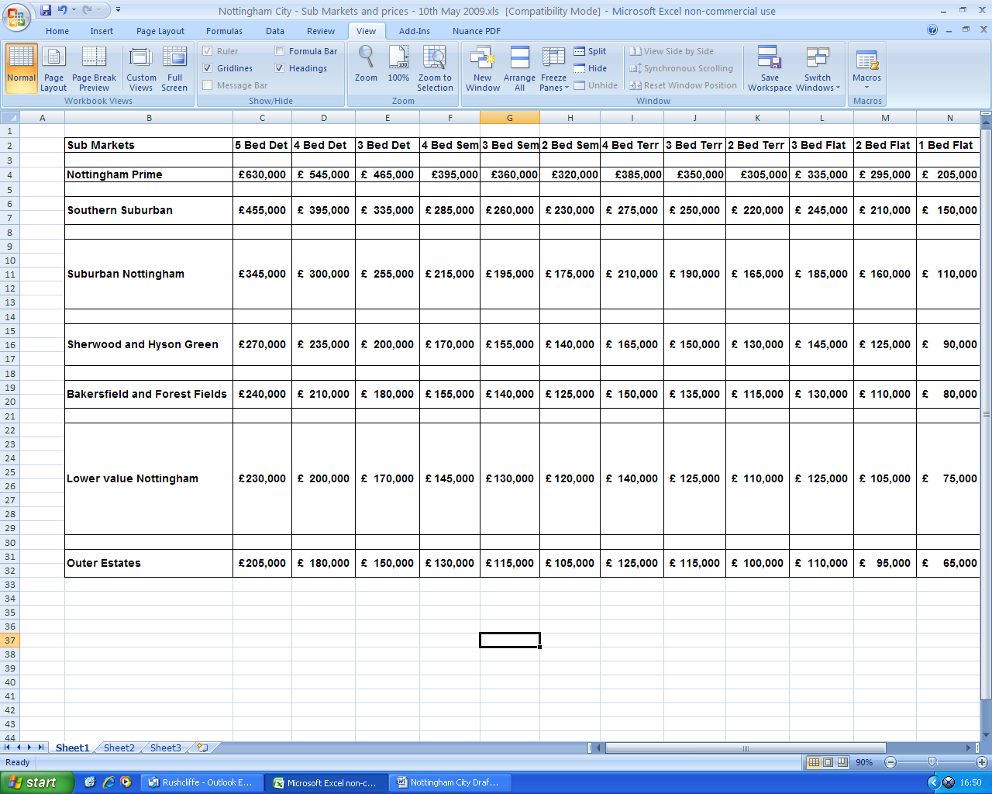

The development mixes were as follows:

- 30 dph: including 10% 2 Bed flats; 10% 2 bed terraces; 15% 3 bed terraces; 20% 3 bed semis; 25% 3 bed detached; 15% 4 bed detached; 5% 5 bed detached
- 40 dph: including 5% 1 bed flats; 15% 2 bed flats; 15% 2 bed terraces; 15% 3 bed terraces; 20% 3 bed semis; 20% 3 bed detached; 10% 4 bed detached;
- 50 dph: including 10% 1 bed flats; 20% 2 bed flats; 20% 2 bed terraces; 15% 3 bed terraces; 15% 3 bed semis; 15% 3 bed detached; 5% 4 bed detached;
- 80 dph: including 20% 1 bed flats; 30% 2 bed flats; 30% 2 bed terraces and 20% 3 bed terraces;
- 250 dph: including 50% 1 bed flats; 50% 2 bed flats.
Affordable housing targets:

10%
20%;
25%;
30%;
35%;
40%;

Affordable housing split: 70% to 30% Social Rent to Shared Ownership

Typical unit sizes adopted (m²):

 | Market | Affordable
1 Bed Flat | 45 | 46
2 Bed Flat | 60 | 67
2 Bed Terrace | 65 | 76
3 Bed Terrace | 80 | 84
3 Bed Semi | 90 | 86
3 Bed Detached | 120 | 90
4 Bed Detached | 150 | 110

Other Affordable Housing Factors:

Social rents

 | Weekly Rent
1 Bed Flat | £58
2 Bed Flat | £65
2 Bed Terrace | £66
3 Bed Terrace | £72
3 Bed Semi | £76
3 Bed Detached | £79
4 Bed Detached | £89

Gross to net factors (Affordable housing revenue)

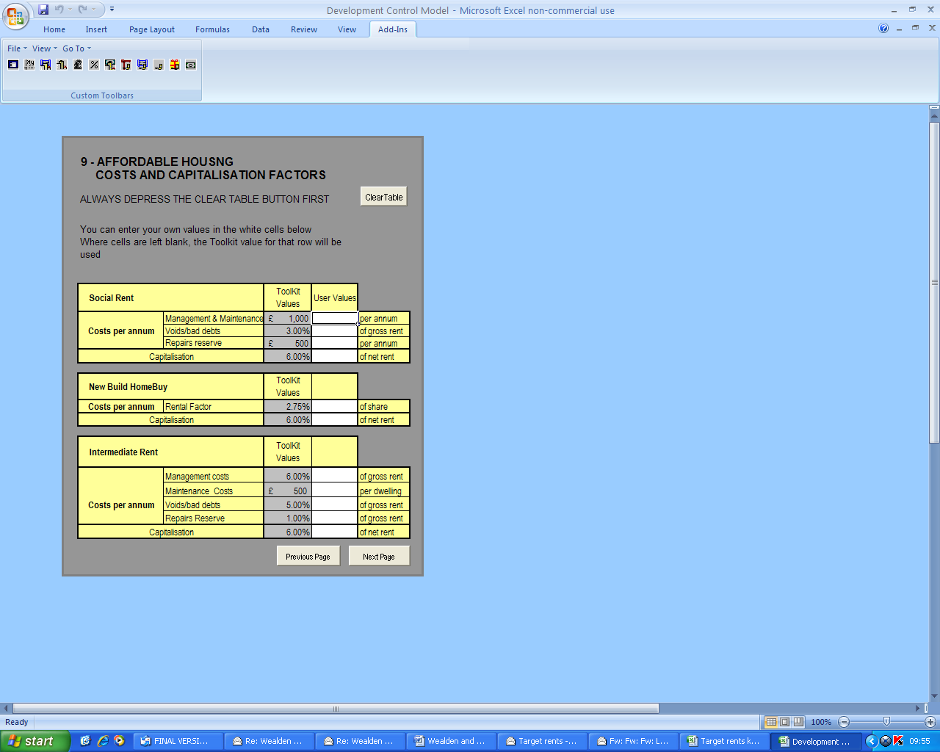

Appendix 3 Results – Residual values – no grant scenarios
At 30 dph | 0% | 10% | 15% | 20% | 25% | 30% | 35% | 40%
Nottingham Prime | £5.88 | £5.31 | £5.02 | £4.74 | £4.46 | £4.18 | £3.90 | £3.61
Southern Suburban | £3.33 | £2.95 | £2.76 | £2.57 | £2.38 | £2.19 | £2.00 | £1.81
Suburban Nottingham | £1.72 | £1.46 | £1.32 | £1.20 | £1.06 | £0.93 | £0.80 | £0.67
Sherwood & Hyson Green | £0.65 | £0.47 | £0.37 | £0.28 | £0.19 | £0.10 | £0.00 | -£0.08
Bakersfield & Forest Fields | £0.24 | £0.08 | £0.01 | -£0.06 | -£0.02 | -£0.23 | -£0.30 | -£0.38
Lower Value Nottingham | £0.04 | -£0.09 | -£0.17 | -£0.23 | -£0.31 | -£0.38 | -£0.44 | -£0.51
Outer Estates | -£0.31 | -£0.42 | -£0.48 | -£0.53 | -£0.59 | -£0.65 | -£0.71 | -£0.77
At 40 dph | 0% | 10% | 15% | 20% | 25% | 30% | 35% | 40%
Nottingham Prime | £7.22 | £6.48 | £6.08 | £5.74 | £5.37 | £5.00 | £4.85 | £4.21
Southern Suburban | £4.06 | £3.55 | £3.30 | £3.05 | £2.79 | £2.54 | £2.47 | £2.04
Suburban Nottingham | £2.08 | £1.71 | £1.54 | £1.36 | £1.19 | £1.01 | £0.97 | £0.68
Sherwood & Hyson Green | £0.77 | £0.51 | £0.38 | £0.25 | £0.12 | £0.01 | -£0.10 | -£0.22
Bakersfield & Forest Fields | £0.26 | £0.04 | -£0.07 | -£0.19 | -£0.29 | -£0.40 | -£0.47 | -£0.57
Lower Value Nottingham | £0.00 | -£0.23 | -£0.35 | -£0.44 | -£0.49 | -£0.55 | -£0.65 | -£0.74
Outer Estates | -£0.42 | -£0.59 | -£0.68 | -£0.75 | -£0.84 | -£0.92 | -£0.95 | -£1.04
At 50 dph | 0% | 10% | 15% | 20% | 25% | 30% | 35% | 40%
Nottingham Prime | £8.07 | £7.24 | £6.82 | £6.41 | £5.99 | £5.57 | £5.16 | £4.74
Southern Suburban | £4.51 | £3.85 | £3.65 | £3.37 | £3.09 | £2.80 | £2.51 | £2.23
Suburban Nottingham | £2.28 | £2.05 | £1.67 | £1.47 | £1.26 | £1.06 | £0.86 | £0.65
Sherwood & Hyson Green | £0.82 | £0.52 | £0.37 | £0.22 | £0.07 | -£0.08 | -£0.23 | -£0.38
Bakersfield & Forest Fields | £0.23 | -£0.02 | -£0.14 | -£0.28 | -£0.41 | -£0.53 | -£0.66 | -£0.78
Lower Value Nottingham | -£0.04 | -£0.28 | -£0.40 | -£0.51 | -£0.63 | -£0.75 | -£0.86 | -£0.98
Outer Estates | -£0.51 | -£0.70 | -£0.81 | -£0.91 | -£1.02 | -£1.12 | -£1.22 | -£1.31
At 80 dph | 0% | 10% | 15% | 20% | 25% | 30% | 35% | 40%
Nottingham Prime | £10.79 | £9.59 | £9.00 | £8.40 | £7.80 | £7.20 | £6.61 | £6.00
Southern Suburban | £5.96 | £5.11 | £4.70 | £4.27 | £3.85 | £3.43 | £3.05 | £2.58
Suburban Nottingham | £2.92 | £2.30 | £1.99 | £1.67 | £1.37 | £1.05 | £0.75 | £0.43
Sherwood & Hyson Green | £0.96 | £0.49 | £0.25 | £0.01 | -£0.23 | -£0.47 | -£0.70 | -£0.95
Bakersfield & Forest Fields | £0.14 | -£0.28 | -£0.49 | -£0.69 | -£0.91 | -£1.11 | -£1.31 | -£1.52
Lower Value Nottingham | -£0.21 | -£0.60 | -£0.80 | -£1.00 | -£1.19 | -£1.39 | -£1.58 | -£1.77
Outer Estates | -£0.80 | -£1.15 | -£1.32 | -£1.49 | -£1.67 | -£1.85 | -£2.02 | -£2.20
At 250 dph | 0% | 10% | 15% | 20% | 25% | 30% | 35% | 40%
Nottingham Prime | £26.60 | £23.37 | £21.75 | £20.13 | £18.51 | £16.89 | £15.28 | £13.66
Southern Suburban | £13.69 | £11.40 | £10.25 | £9.12 | £7.97 | £6.82 | £5.68 | £4.54
Suburban Nottingham | £5.38 | £3.71 | £2.87 | £2.03 | £1.19 | £0.35 | -£0.50 | -£1.33
Sherwood & Hyson Green | £0.32 | -£0.99 | -£1.65 | -£2.30 | -£2.95 | -£3.61 | -£4.27 | -£4.92
Bakersfield & Forest Fields | -£1.99 | -£3.13 | -£3.70 | -£4.27 | -£4.84 | -£5.41 | -£5.98 | -£6.55
Lower Value Nottingham | -£2.92 | -£3.99 | -£4.52 | -£5.06 | -£5.59 | -£6.13 | -£6.67 | -£7.12
Outer Estates | -£4.76 | -£5.97 | -£6.17 | -£6.63 | -£7.10 | -£7.57 | -£8.04 | -£8.51

Illustrative scheme – 40 dph at 30% AH; Suburban Nottingham

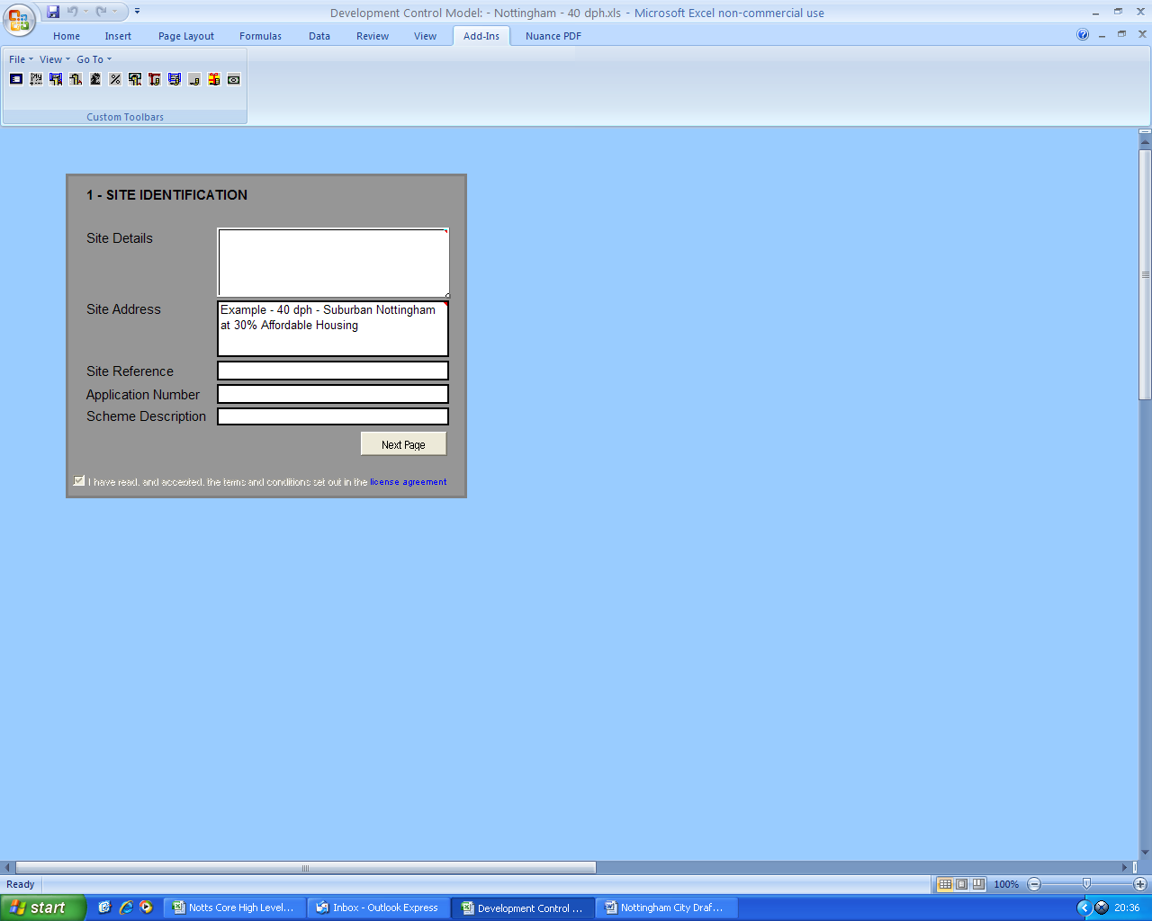

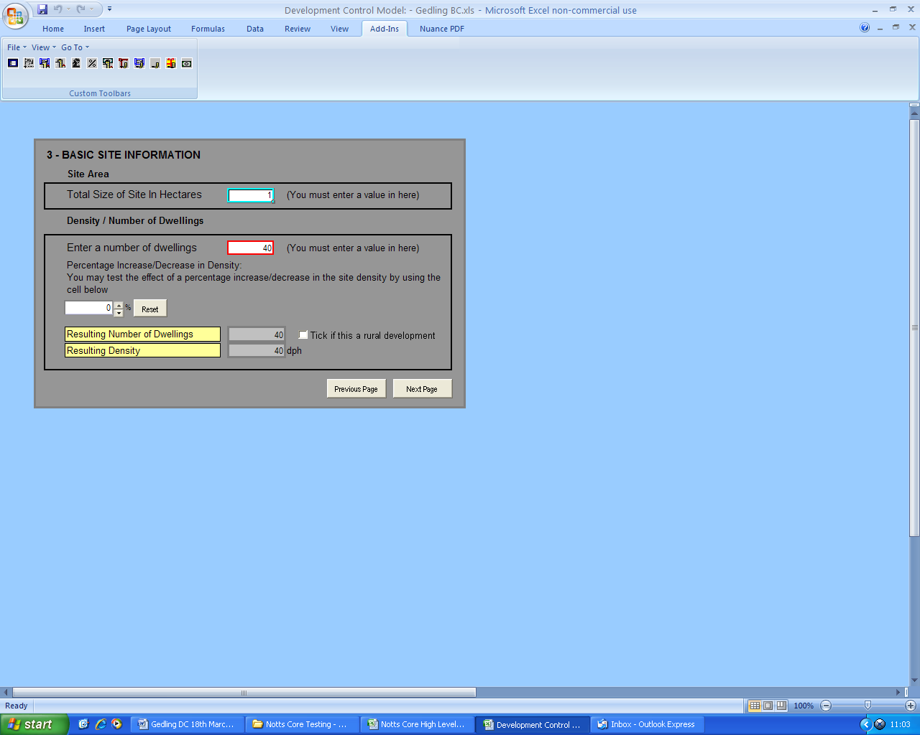

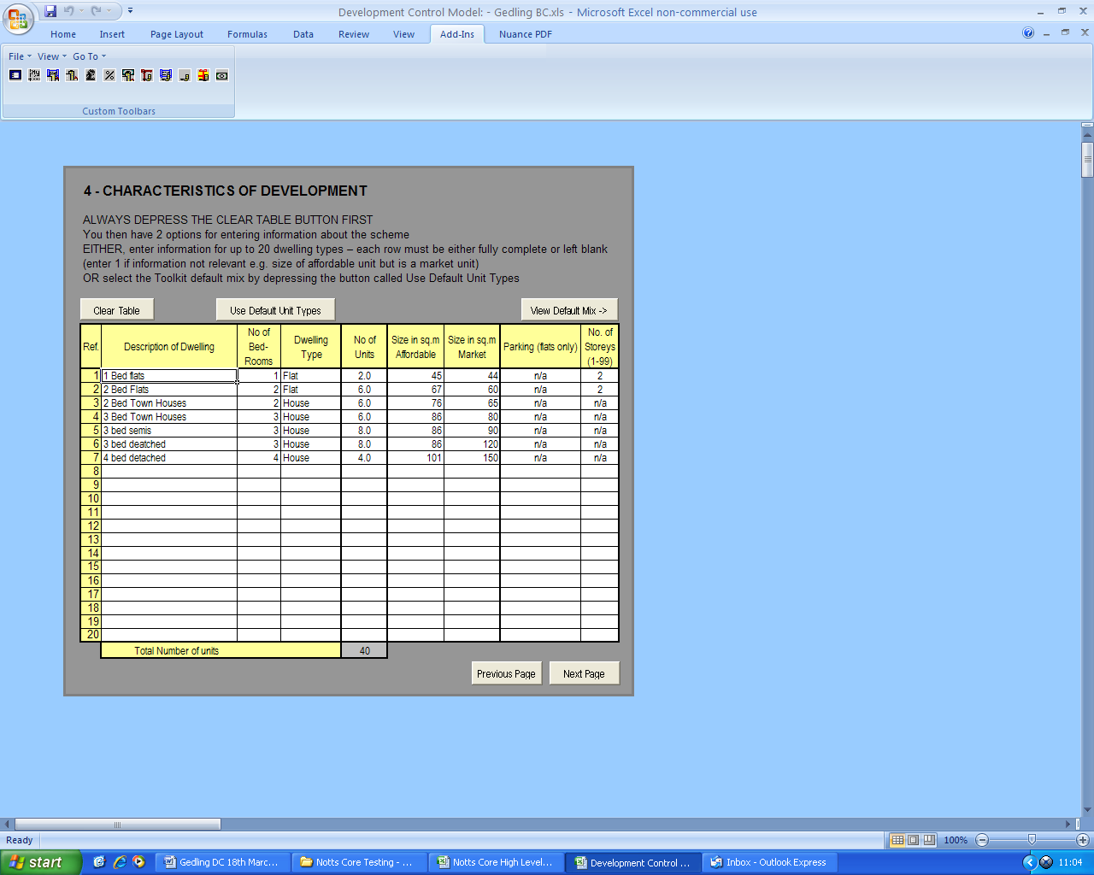

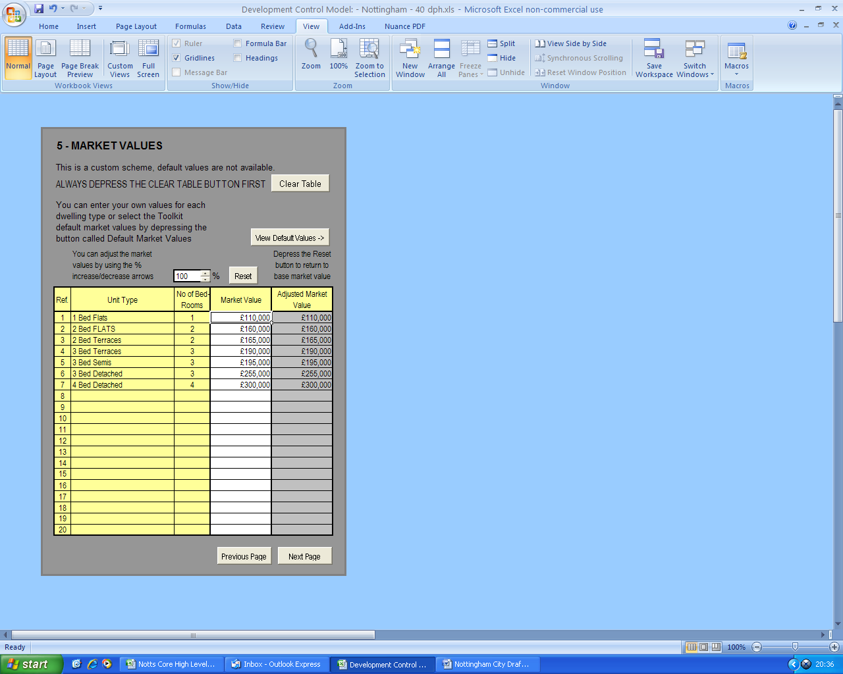

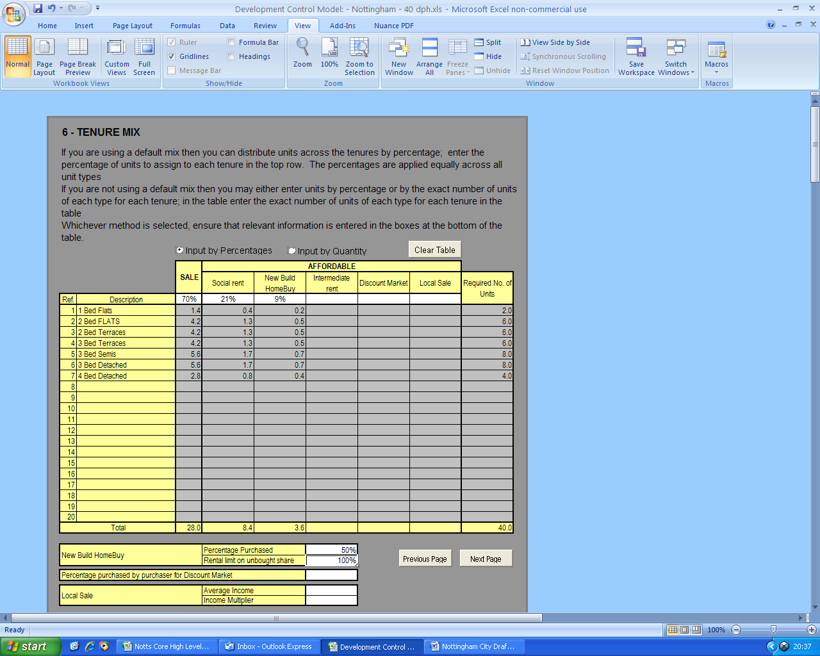

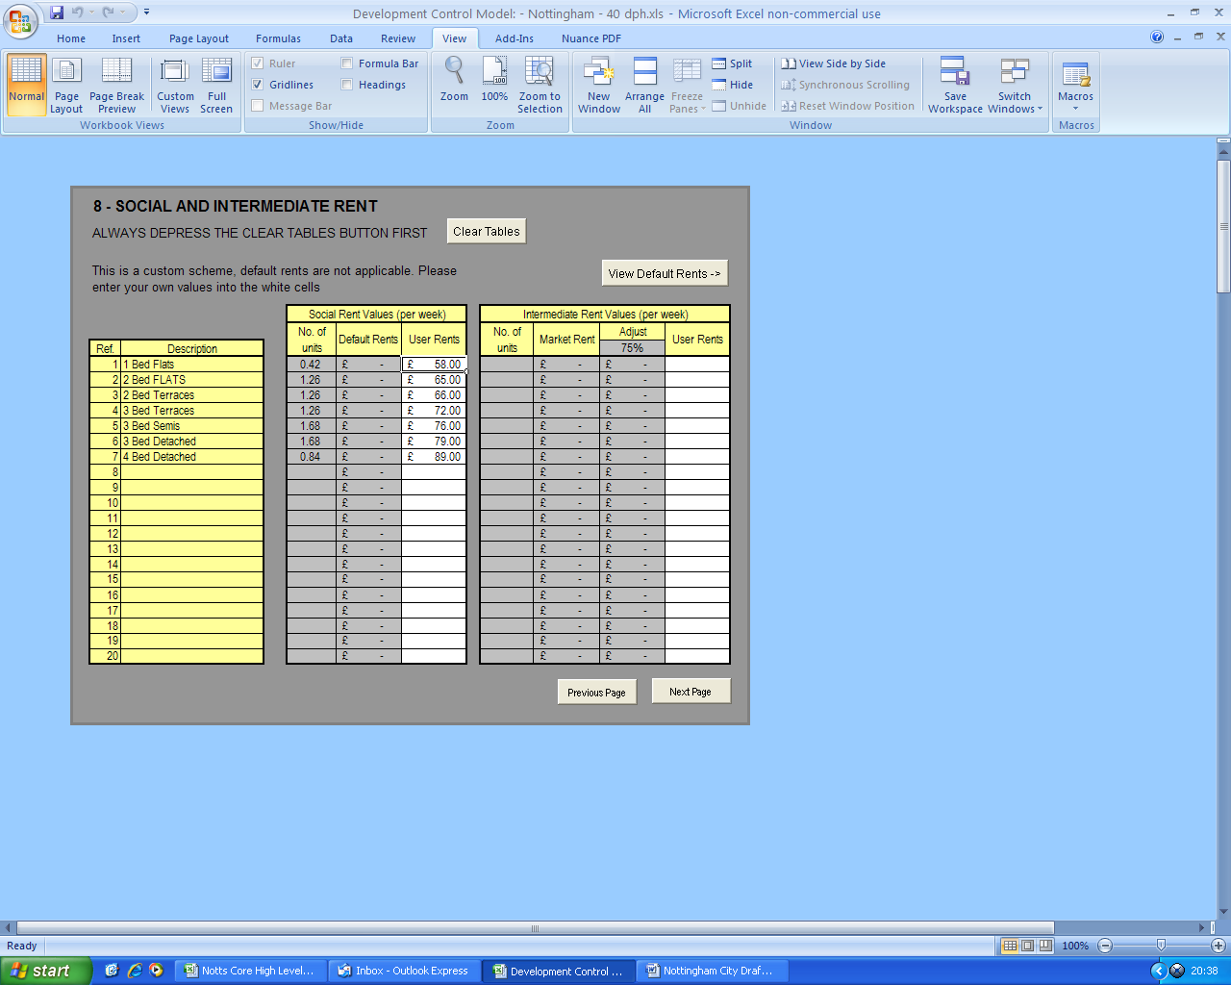
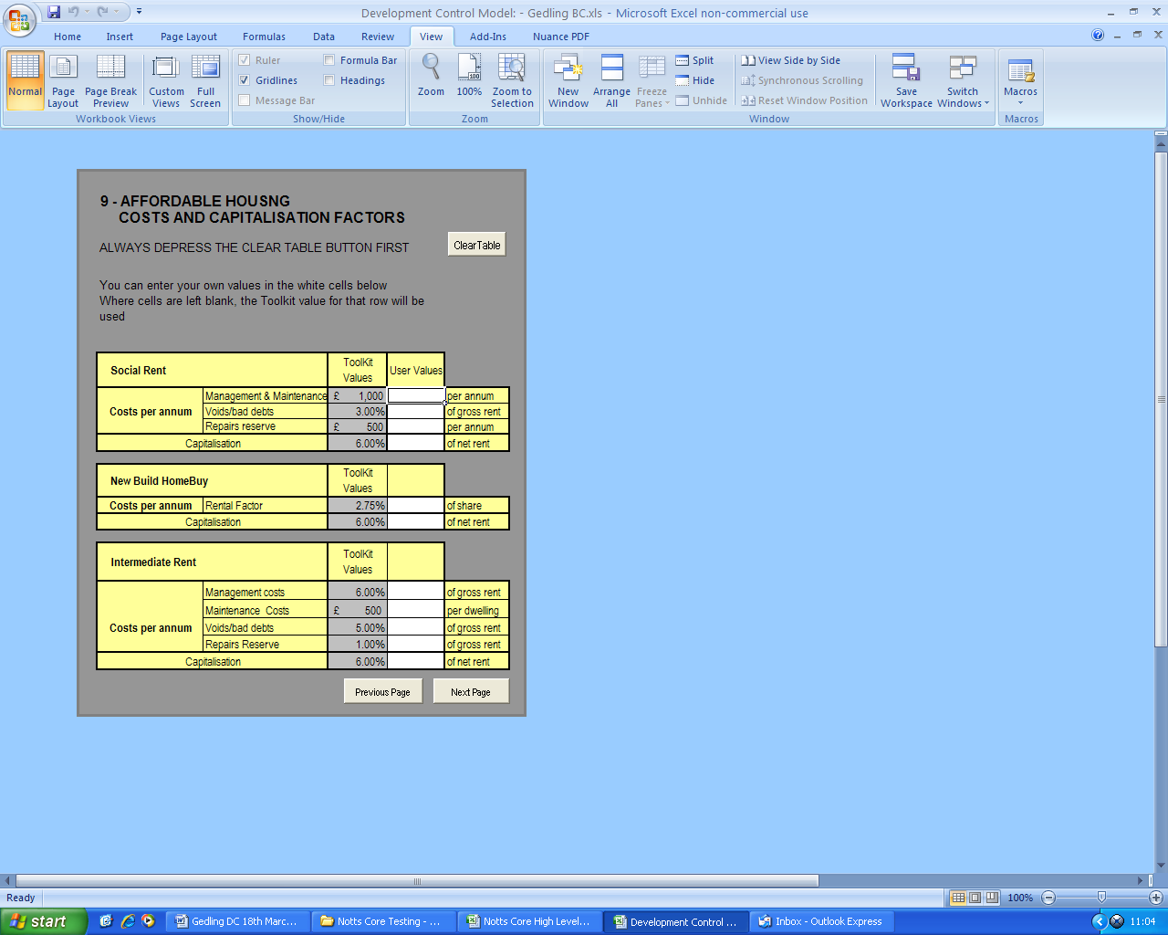

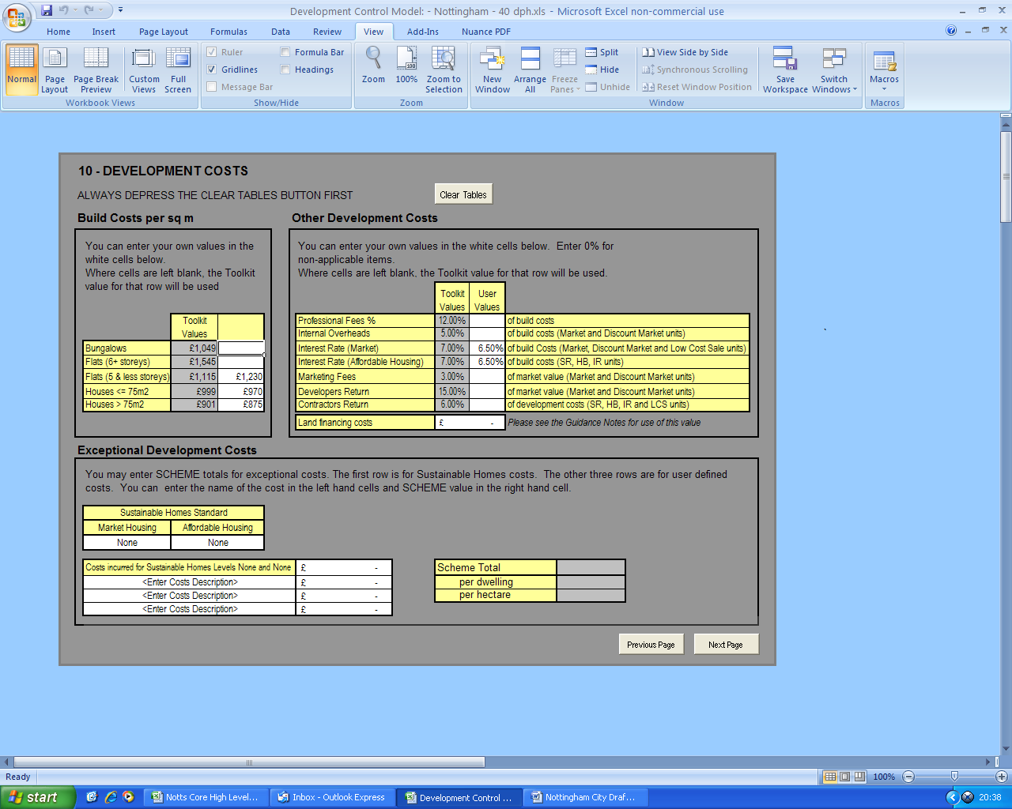

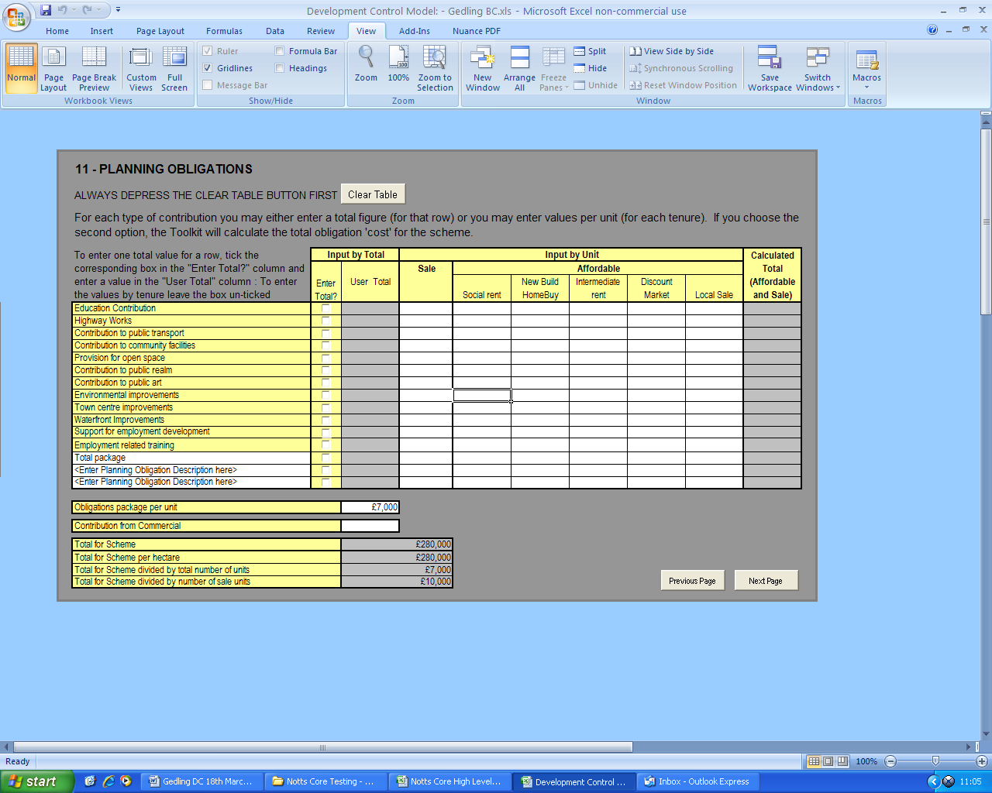
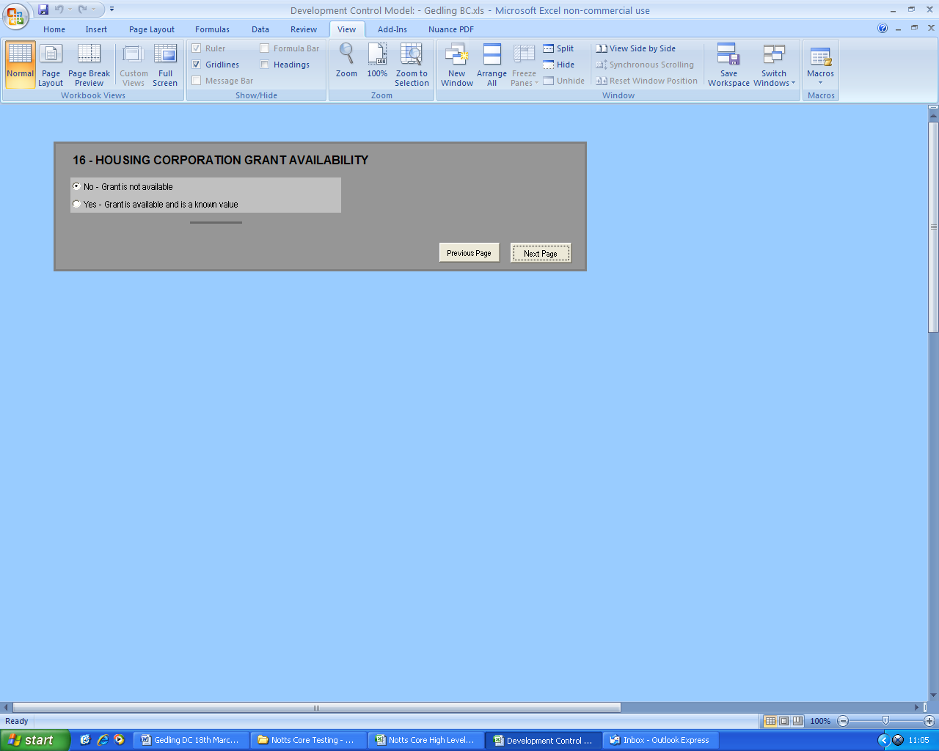
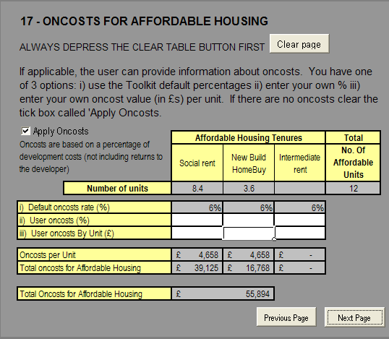

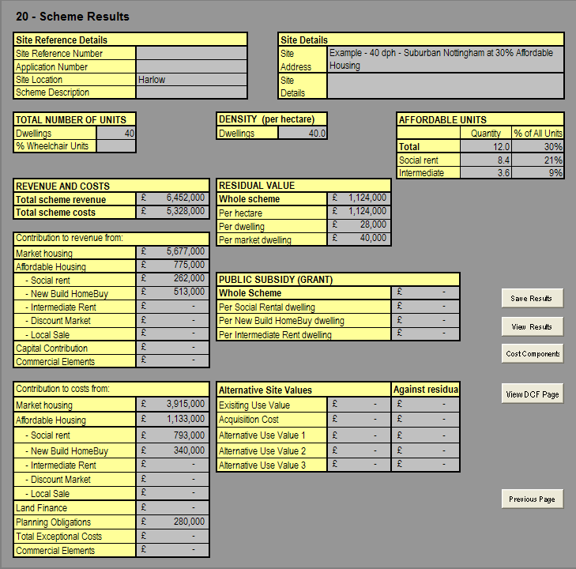

Based on the East Midlands Regional Plan, 2009.
CLG, Delivering Affordable Housing, November 2006
The year the Local Plan was adopted and taken as a mid year figure
CLG Live Table Mean House Prices by District. Q2 2005 = £123,626 Q4 2008 = £123,190

