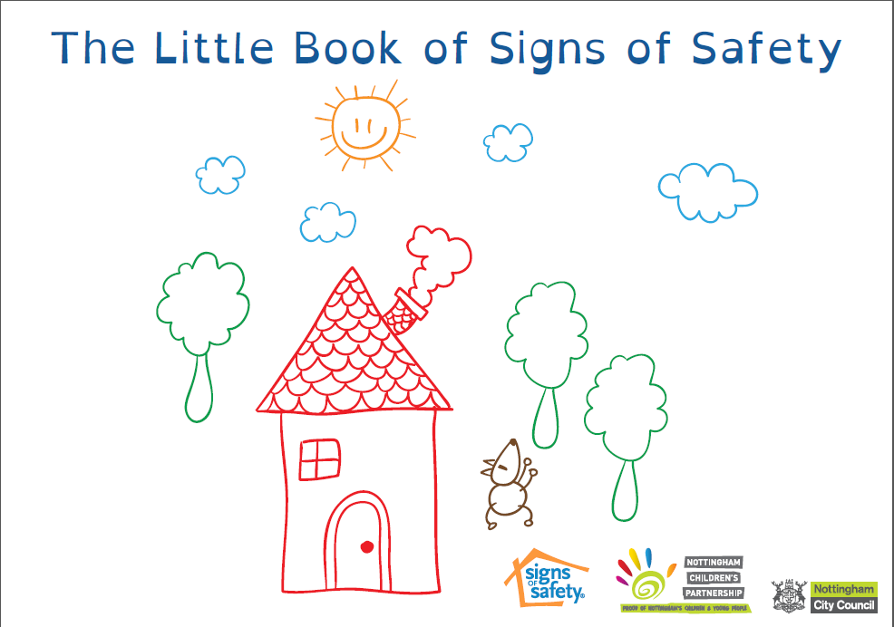
The Little Book of Signs of Safety Order Form

Books are sold at cost price of £5 per book (plus postage)

Please complete all the boxes below and send this form back to Lisa Hazell to order your book(s). Payment in advance of dispatch or collection of the book is required.

Email: lisa.hazell@nottinghamcity.gov.uk
Postal: Lisa Hazell, Nottingham City Council, 3rd floor, Loxley House, Station Street, Nottingham, NG2 3NG

Number of Books Required

Your Name
Organisation
Email address
Contact Telephone Number
Purchase order number
Finance Invoice Address
Finance Invoice email

Delivery Options – please select your choice of delivery option
Postal Options | Price | Your Choice
1st Class Recorded | £2.30
1st Class | £1.40
2nd Class | £0.94
Collect in person from Loxley House | No charge

Total Price
Total price to be invoiced including postage | £

Your Signature:

Date:

