Nottingham City Council:

Highway Maintenance Hierarchy & Resilient Network Strategy

August 2025

Council
Developing an Infrastructure Maintenance Hierarchy

Document Information
Title | Highway Maintenance Hierarchy & Resilient Network Strategy
Product Number | AMD180
Author | Mark Bradbury
Description | Describes the council’s approach to the development of its maintenance hierarchies and resilient network

Document History
Version No. | Status | Author | Date | Changes from Previous Version
1.0 | Final | SM | Mar 21 | DRAFT
2.0 | Revision | SM/MB | Mar 22 | Add Resilient network
3.0 | Revision | MB | Feb 25 | Hierarchy and inspection frequency updated
4.0 | Revision | MB | Aug 25 | Resilient Network Review

Contents
Document Information 2
Document History 2
1. Introduction 4
2. M100 – Carriageway Maintenance Hierarchy 6
2.1. Process in Developing the Carriageway Maintenance Hierarchy 6
2.2. Nottingham’s Six Steps to Creating a Carriageway Maintenance Hierarchy 8
3. M200 – Footway Maintenance Hierarchy 16
3.1. Process in Developing the Footway Maintenance Network 17
3.2. Nottingham’s Four Steps to Creating a Footway Maintenance Hierarchy 18
4. Safety Inspection Frequency 26
5. Resilient Network 28
5.1. Process in Developing the Resilient Network 28
5.2. Responses to Potential Climatic Events 31
5.2.1. Snow 31
5.2.2. Flooding 31
5.2.3. Heatwaves 32
5.2.4. High Winds 32
5.2.5. Other Incidents 32
5.3. Consultation 32
6. Monitoring and Review 35
Appendix A – Consultation Letter – Resilient Network 36

Introduction
If you live, work or pass through Nottingham City you will use the largest and most visible asset Nottingham City is responsible for – the Highway Infrastructure Network.

A Highway Infrastructure Network road hierarchy is the foundation of a coherent, consistent, well managed and auditable infrastructure maintenance strategy. It is crucial to asset management planning as it enables different levels of service to be associated with different maintenance categories to ensure key infrastructure assets are maintained appropriate to their use and agreed levels of service.

Recommendation 12 of the Well-managed Highway Infrastructure Code of Practice states;
“A network hierarchy, or a series of related hierarchies, should be defined which include all elements of the highway network, including carriageways, footways, cycle routes, structures, lighting and rights of way. The hierarchy should consider current and expected use, resilience, and local economic and social factors such as industry, schools, hospitals and similar, as well as the desirability of continuity and of a consistent approach for walking and cycling.”

A highway infrastructure network hierarchy should be based on asset function, providing the foundation of a risk-based maintenance strategy in line with the risk-based approach detailed in the new Code of Practice. It is crucial in establishing achievable levels of service and to the statutory network management role for developing co-ordination and regulating occupation.

Whilst different infrastructure assets may have their own maintenance hierarchies there is a need to ensure they are related, so that they can all be considered in a holistic approach to prioritising works across all highway infrastructure assets in relation to each other and in relation to the whole highway infrastructure network.

This document explains how the Council has considered the carriageway and footway asset groups and how the maintenance hierarchy for those assets has been derived.

To ensure consistency and an understanding of maintenance hierarchies the Council has created a “series” of maintenance hierarchies for the major asset group as indicated in the following table:

Table 1 - Maintenance Hierarchy “Series”

Series | Asset Group
M100 | Carriageways
M200 | Footways
M300 | Street Lighting*
M400 | Cycle Routes*
M500 | Bridges & Structures*
M600 | Drainage*
M700 | Traffic Signals*
M800 | Street Scene*

* work is ongoing in developing maintenance hierarchies for these infrastructure asset groups

The maintenance hierarchies developed to date are dynamic and will be reviewed regularly to ensure any changes within the Council are reflected in the assets functionality and therefore considered in its maintenance strategy to reflect the current situation.

The following chapters discuss the process and consideration in the development of the maintenance hierarchy for the carriageway and footway asset groups.

Separate to maintenance hierarchies is the requirement to define and maintain a resilient network, which will be an attribute of the new maintenance hierarchies.
The Secretary of State commissioned an Independent Review of the resilience of the nation’s transport network, resulting in the 2014 Transport Resilience Review by Department for Transport (DfT). The Transport Resilience Review recommended that Local Highway Authorities should;
“Identify a 'resilient network' to which they will give priority, in order to maintain economic activity and access to key services during extreme weather” (DfT, 2014).

This document also discusses the creation of the resilient network.

Local officers and inspectors have the opportunity to provide feedback, challenging the maintenance hierarchy and resilient network, each of which will be reviewed on an annual, and case by case basis and updates made where appropriate.

Where roads cross from NottinghamCity into the wider Nottinghamshire County area, the cross-boundary hierarchies will be compared to ensure the same level of service is maintained i.e. SKID resistance, safety Inspections, winter treatment routes etc., and adjusted where considered necessary.

M100 – Carriageway Maintenance Hierarchy

The classification of Britain’s roads dates back to the 1920s, when it had become clear that it was necessary to have a system to help motorists identify good routes for driving. In the 1960s, the existing system was overhauled to help deal with an age of mass-motoring.

All UK roads (excluding motorways) fall into the following four categories:
- A roads – major roads intended to provide large - scale transport links within or between areas.
- B roads – roads intended to connect different areas, and to feed traffic between A roads and smaller roads on the network.
- C roads -– smaller roads intended to connect together unclassified roads with A and B roads, and often linking a housing estate or a village to the rest of the network. Similar to ‘minor roads’ on an Ordnance Survey map.
- U roads – Unclassified local roads, principally residential or minor rural roads intended for local traffic. The vast majority (60%) of roads in the UK fall within this category.

As originally conceived, these four classes form a hierarchy. There has never been a comprehensive review of the road hierarchy within the Council. Maintenance need and prioritisation has always been based upon the generic road classification carried out in the 1960’s, however, much has changed since that time and consequently the reliance on the road classification system to identify roads most in need of maintenance may not represent the best approach or value.

The current road network hierarchy should reflect the needs, priorities and actual use of each road and the new code makes particular reference to the importance of continuity with the road hierarchy of neighbouring authorities. The benefit of providing consistency of approach across the region is that it will strengthen a Council’s legal position on its management of the highway network and ensure the same levels of service are adopted between the authorities

Process in Developing the Carriageway Maintenance Hierarchy

In order to develop the carriageway maintenance hierarchy, there is a need to identify a criterion which affects the maintenance of each road maintenance category. The Council has decided to follow the new Code of Practice to deliver it’s maintenance hierarchy and make a fresh assessment of the importance and use of the network. Therefore, there has been no consideration of its existing road hierarchy and each road section has been assessed on its own merits based around data which is auditable, repeatable and transparent. The hierarchy definitions contained in Table 2 were developed through the course of the process.

Table 2 – Carriageway Hierarchy Definitions

Maintenance Hierarchy | Type of Road | Description
M101 | Strategic Roads | Major national cross-country roads between places of traffic importance across the UK, with the aim of providing easily identifiable routes to access the whole of the country i.e. motorway network. Typically, major dual carriageways and major single A roads.
M102 | Primary Roads | Primary roads within the city providing quick access to urban areas, linking to major industrial/ retail areas and main centres of employment. These roads will typically be inner and outer ring roads.
M103 | Secondary Roads | Roads connecting urban areas to the inner and outer ring road. Typically, major bus routes and roads serving smaller retail i.e. District Centres, business and leisure facilities. Also including roads serving the city centre from the inner ring roads.
M104 | Local Link Roads | Roads providing alternative but less direct links between urban areas and the inner and outer ring roads. They typically are the main routes through residential and industrial areas and will have less traffic than secondary roads.
M105 | Major Residential Roads | Roads providing links within residential areas, often bus routes, small shopping frontages <4 shops. Typically, the spine road through an urban estate, collecting traffic from access and minor residential roads.
M106 | Access Roads | Roads serving to distribute users from major residential roads to minor residential roads, often with on street parking serving >30 properties including long cul-de-sacs and minor industrial estate roads
M107 | Minor Residential Roads | Urban residential roads including those with a shared road space. Typically, cul-de-sacs with <30 properties, including paved service roads i.e. rear of residential properties/shops

Nottingham’s Six Steps to Creating a Carriageway Maintenance Hierarchy

Step 1: Workshop-First Draft (Hierarchies M101 to M104)

A workshop was held in Nottingham where the network was produced on Four 1:10000 A1 size plans, printed to cover the complete road network. Using the experience and local knowledge of a group of highway technicians a first attempt was then made to determine roads that were included in the top four hierarchies. Roads were coloured with felt tip pen to identify hierarchies M101, M102, M103 and M104. Though based on local knowledge only this was a useful exercise in that it developed the thought processes required.

Step 2: Digital Platform
The road hierarchies determined within step 1, were transferred to GIS such that is could be represented alongside the Local street Gazetteer.

Step 3: Traffic Data
The digital plans produced in Step 2 were then sense checked against available traffic flow data for the City.
The data used can be found here:
https://drakewell01.drakewell.com/multinodemap.asp
As a result, some significant changes were made to certain routes. In the course of scrutinising the traffic data some clear bandings of AADT (Annual Average Daily Traffic) emerged to provide differentiation between hierarchies M101, M102 and M103. Roads previously identified as Hierarchy M104 were also sense checked using traffic data, where available and against a definition which had now been established as ‘the main routes within and through residential and industrial areas.

Step 4: Public Transport
Public transport routes were assessed using the following resources:
http://www.Nottinghamsbus.info/images/Nottingham_a.pdf
http://www.Nottinghamconnected.com/wp-content/uploads/2016/05/Nottingham-public-transport-map-2016.pdf
Bus routes were added to the digitised map representation parts of which were already covered by hierarchies M101, M102 M103 and M104. Any bus / public transport routes that were not covered by the top four hierarchies were assigned to hierarchy M105.

Step 5: Lower Hierarchies (M105 to M107)
Attention then switched to establishing the lower hierarchy levels.
From examining the road layouts, particularly in residential areas, it was clear that there were a large number of M107 small cul-de-sacs and then there were other M106 roads, that collected traffic from these cul-de-sacs to feed in turn to hierarchies M105 and M104. Further examination of the numbers of properties served by the small cul-de-sacs enabled a definition to be established in that they would serve 30 or fewer properties.
By this process hierarchies M107 (small cul-de-sacs serving less than 30 properties) and M106 (roads collecting traffic from the small cul-de-sacs to feed into hierarchies M104 and M105) were established.
Hierarchies M106 and M107 were then added to the digitised layer.
During the course of digitising M106 and M107, some additional M104 and M105 routes were established on the basis that they shared the characteristics of routes already assigned to these hierarchies.

Step 6: Review
Through the course of this stepped process, the technician team developed a good and developing understanding of assigning hierarchies to Nottingham City’s roads in the course of the whole exercise. As understanding developed previous work was reviewed and sense checked multiple times to ensure that a consistent approach was applied across the city.

Figures 1 & 2 illustrate the above process which was adopted in determining the maintenance hierarchy.

Figure 1: The process chart below illustrates the ‘step procedure process’ which is adopted by the Council’s Highway Authority in determining the carriageway maintenance hierarchy definitions.

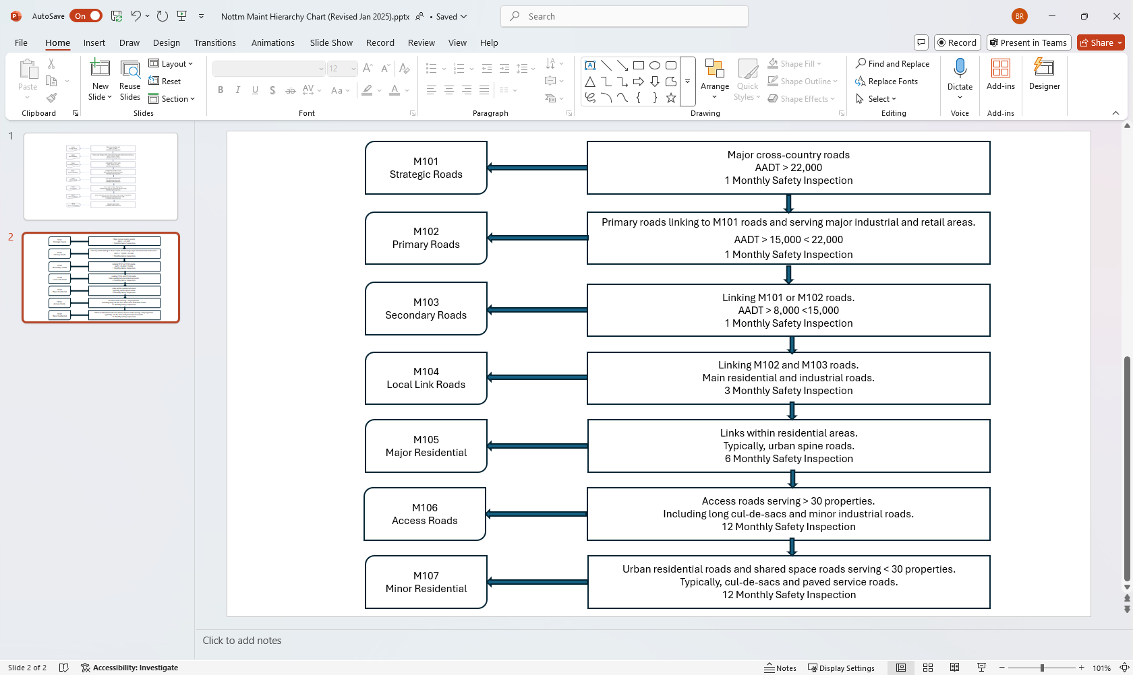

Figure 1 – Carriageway Maintenance Hierarchy Process

Figure 2 – Carriageway Maintenance Hierarchy Process Chart

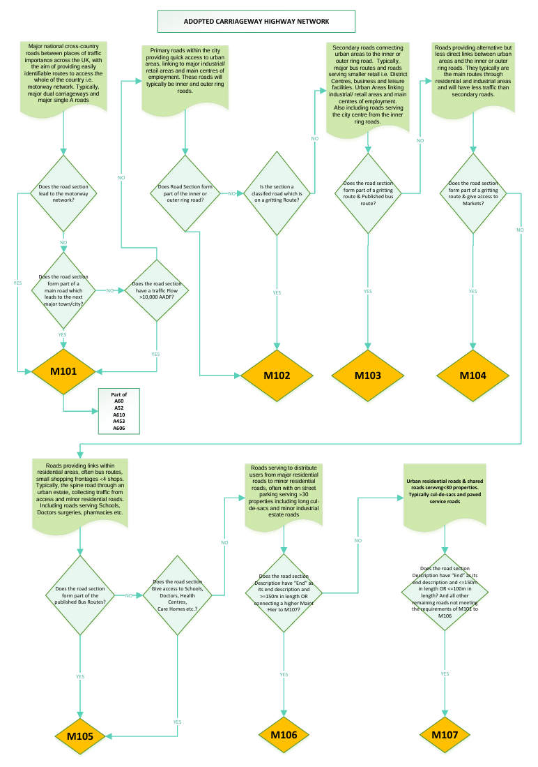

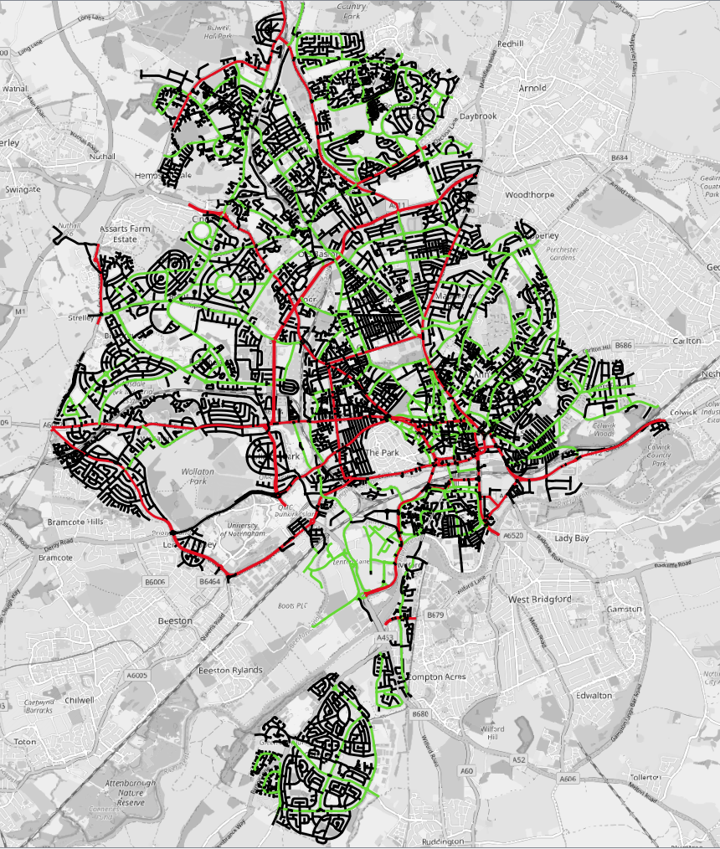
Figure 3 – Carriageway Maintenance Hierarchy M101, M102 (Red), M103 and M104 (Green)

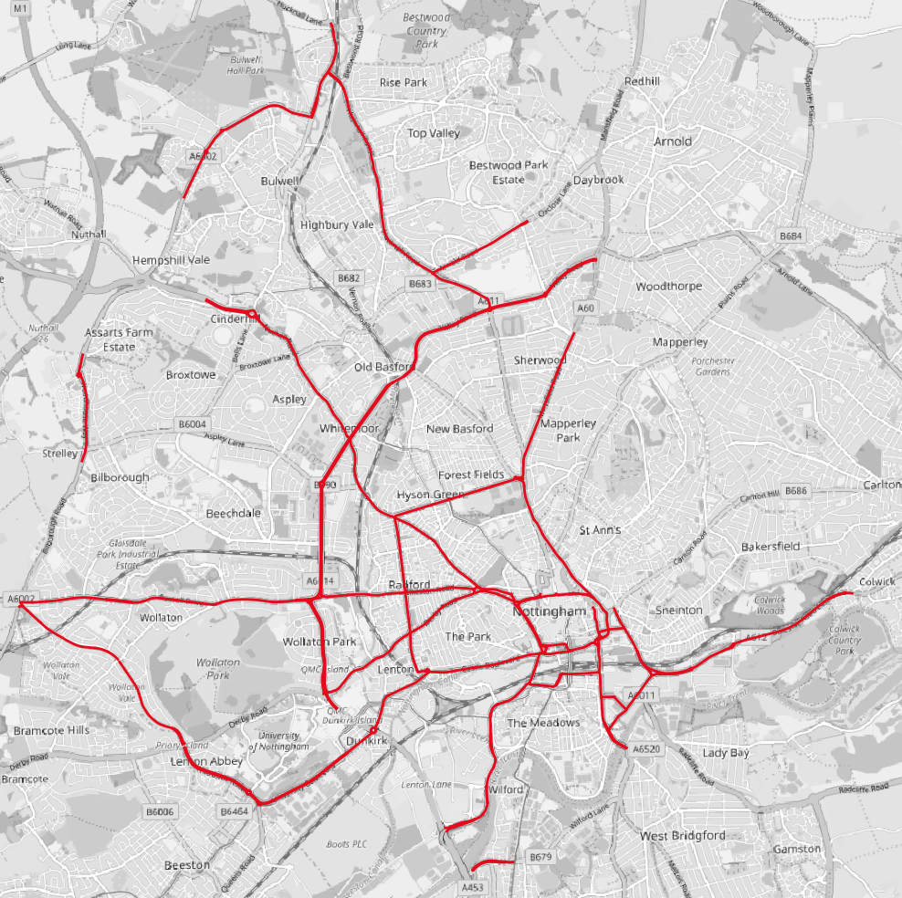

Figure 3a – Carriageway Maintenance Hierarchy– Hierarchies M101 & M102

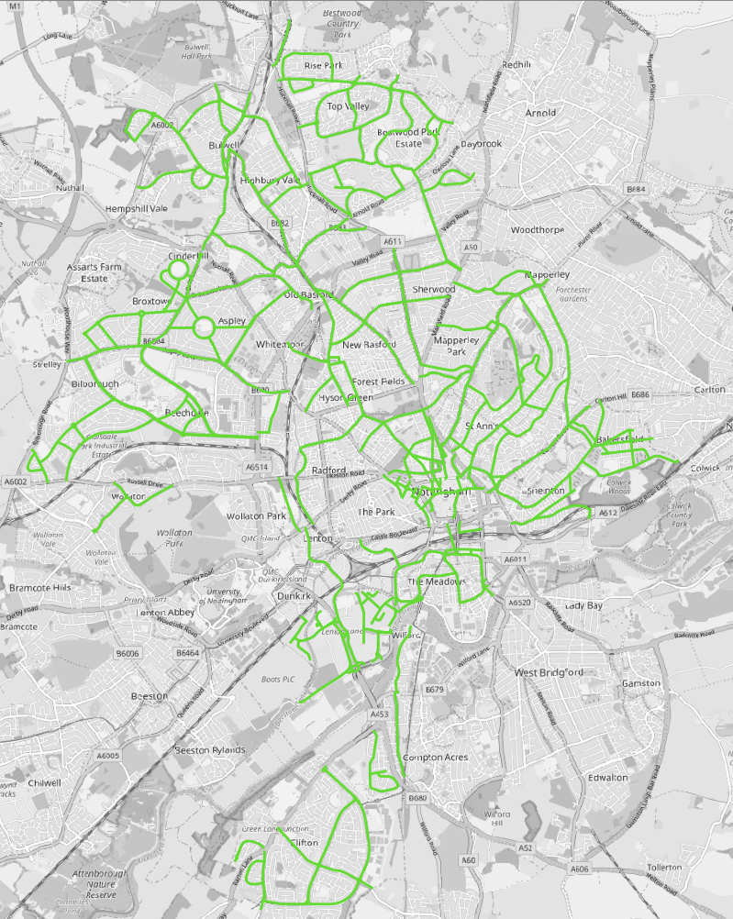

Figure 4 – Carriageway Maintenance Hierarchy– Hierarchies M103 & M104
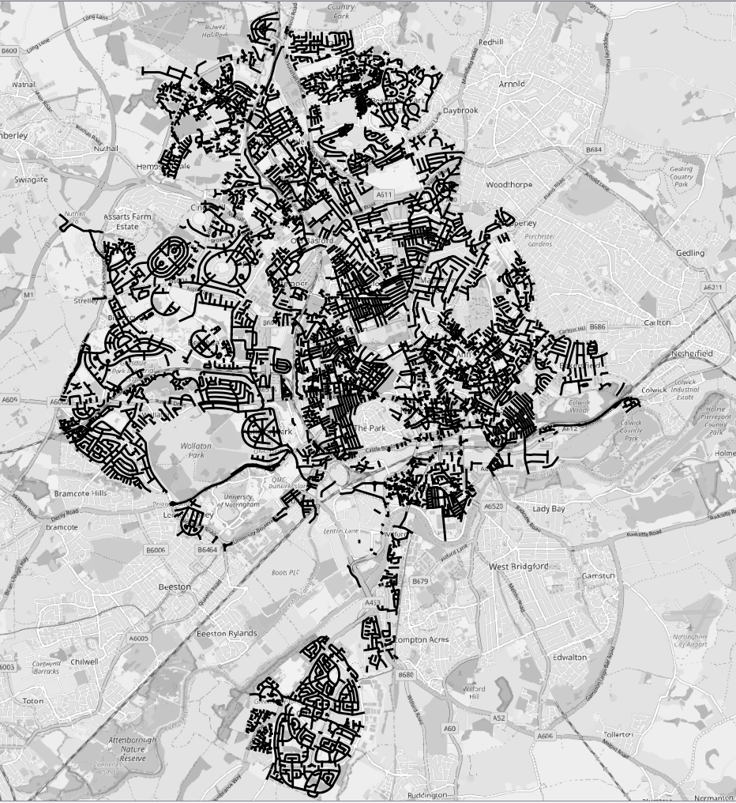
Figure 5 – Carriageway Maintenance Hierarchy– Hierarchies M105, M106 & M107

M200 – Footway Maintenance Hierarchy

Whilst the classification of Britain’s roads dates back to the 1920s, footway hierarchies existed for authorities but weren’t officially defined until the introduction of the Local Authority Association publication of the Highway Maintenance Code of Good Practice (LAA Code). The TRL Report, TRL535 (2002), saw the introduction of the following footway hierarchies which were adopted nationally and formed the basis for Best Value reporting BV187.

Table 3 – Footway Hierarchy Definitions LAA Code

Footway Category | Category Name | Description
1a | Prestige Walking Zones | Prestige areas in towns and cities with exceptionally high usage, such as Princes Street in Edinburgh and Oxford Street in London
1 | Primary Walking Zones | Busy urban shopping and business areas, and main pedestrian routes linking interchanges between different modes of transport, such as railway and underground stations and bus stops etc
2 | Secondary Walking Zones | Medium usage routes through local areas feeding into primary routes, local shopping centres, large schools and industrial centres etc.
3 | Link Footways | Linking local access footways through urban areas and busy rural footways.
4 | Local Access Footways | Footways associated with low usage, including estate roads and cul-de-sac.

To align this with the new Code of Practice, and in particular with…

Recommendation 12 “… a series of related hierarchies, should be defined which include all elements of the highway network, including carriageways, footways …”,

…a review of the footway hierarchies is required to ensure they follow the same principles as carriageways, in that they recognised the use and importance of the footways.

Process in Developing the Footway Maintenance Network

In order to develop the footway maintenance hierarchy, there is a need to identify a criterion which affects the maintenance of each footway maintenance category. The Council has decided to follow the new Code of Practice to deliver the maintenance hierarchy and therefore the existing footway hierarchy has been assessed against the criteria in Table 4. Each footway section has been considered on its own merits, based around data which is auditable, repeatable and transparent with the aim of developing consistent lengths of footway. This will then help towards any disclosure packs required to defend claims against the Council.

The hierarchy definitions are contained in Table 4

Maintenance Hierarchy | Type of Footway / Cycleway | Description
M201 | Prestige Walking Zones | Very busy areas of the city with high public space and street scene contribution – City Centre
M202 | Primary Walking Routes | Busy urban shopping and business areas and main pedestrian routes – District Centres
M203 | Secondary Walking Routes | Medium usage routes through local areas feeding into primary routes, local neighbourhood shopping centres, including signed and lined cycle routes.
M204 | Link Footways | Linking local access footways through urban areas, and busy etstate footways, short estate road to the main routes and cul-de-sacs
M205 | Local Access Footways | Footways associated with low usage, short estate roads to the main routes and cul-de-sacs

Table 4 – Footway Maintenance Hierarchies

Nottingham’s Four Steps to Creating a Footway Maintenance Hierarchy

The following stepped apporoach has been adopted for defining footway maintenance hierarchy.

Step 1: Identification of M201-Prestige Walking Zones and M202-Primary Walking Routes
Consideration will initially be given to identifying the M201 Prestige Walking Zones and M202 Primary Walking Routes. This will be supported by reference to a GIS mapping layer showing shopping areas across the City to assist with this process.

Local knowledge gained through the existing highway inspection arrangements is utilised in this process such that an appropriate distinction could be made between the main City Centre shopping areas and the outer City District shopping centres. City Centre shopping area footways (and pedestrian areas) are designated as M201-Prestige Walking Zones, whilst pedestrian routes in the outer City District shopping centres are designated as M202-Primary Walking Routes.

Step 2: Identfication of M203 - Secondary Walking Route
It is appropriate to consider the presence of other significant local amenities in the City environment and to reflect their presence and impact on the footway network. A GIS mapping layer is derived from the ‘Local Property Gazetteer’ using a property classification attribute.
The locations of properties with the following amenity characteristics are included on the mapping layer:
- Arena/Stadium
- Care/Nursing Home
- Children’s Nursery/Crèche
- College
- Hospital/Hospice
- Educational Establishment
- Preparatory/First/Primary/Infant/Junior/Middle School
- Public/Village Hall/Other Community Facility
- Secondary/High School
- Special Needs Establishment
- Station/Interchange/Terminal/Halt
- University
- Place of Worship

Any streets with one or more of these amenities present are designated as a M203-Secondary Walking Route.

Step 3: Identfication of M204 and M205 Footways
Finally, attention is then switched to establishing the lower footway hierarchy levels M204 and M205:
- M204 Link Footways - routes principally found in residential areas linking or collecting footfall from local access footways typically collecting pedestrian traffic from more than 100 properties associated with neighbouring roads.
- M205 Local Access Footways – low usage footways serving individual streets…typically on short estate roads and cul-de-sacs.

Through the examination of a number of localities across the City this enables a definition to be established for what constitutes the M204 Link Footways. The threshold set is that a link footway would collect pedestrian traffic from more than 100 properties from adjacent roads. It should be noted that the properties associated with the link footway street itself are not included in this count as the aim is to identify footways attracting pedestrian traffic from neighbouring routes.

Step 4: Review
During the course of this stepped process the hierarchy development team will develop a good understanding of assigning maintenance hierarchies to the footway network. As experience, knowledge and understanding developes, previous work may be reviewed and sense checked multiple times to ensure that a consistent approach is applied across the City.

Figure 6 – Footway Maintenance Hierarchy Process Chart

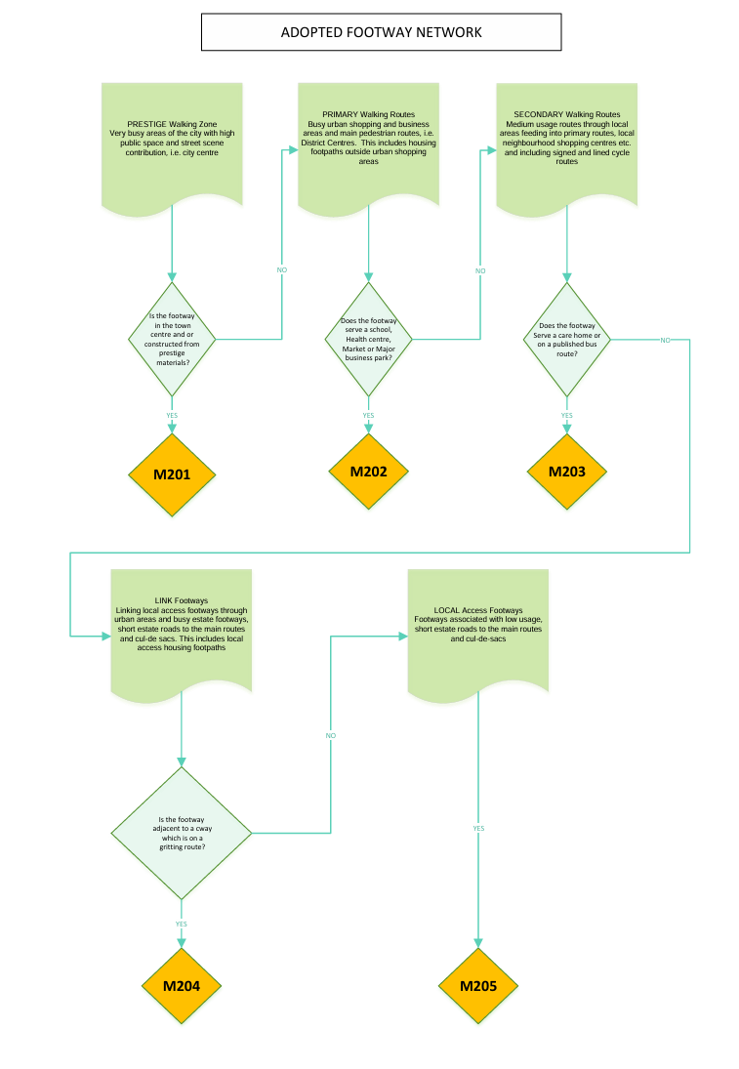

Figure 6a – Footway Maintenance Hierarchy – M201 Prestige Walking Zones

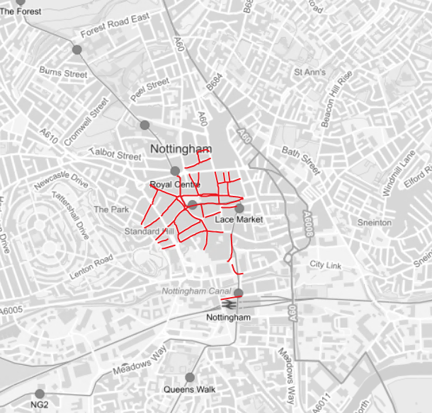

Figure 6b – Footway Maintenance Hierarchy – M202 Primary Walking Routes

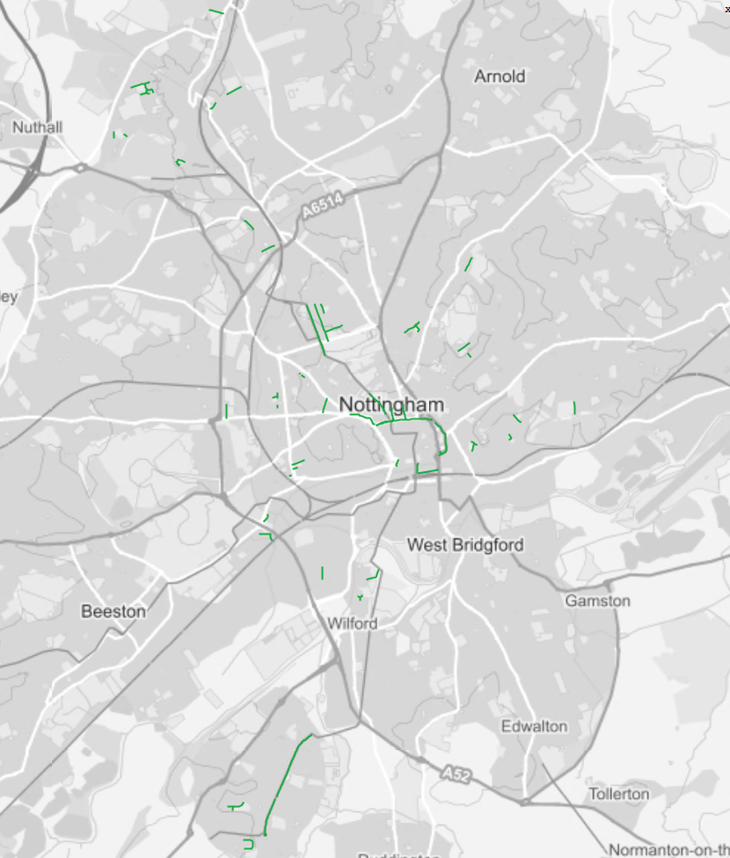

Figure 6c – Footway Maintenance Hierarchy – M203 Secondary Walking Routes

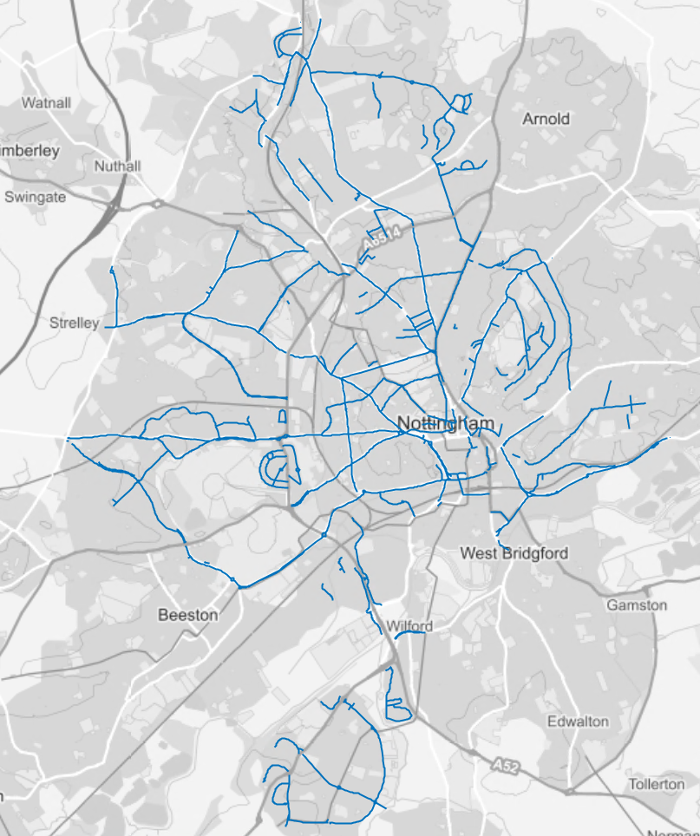

Figure 6d – Footway Maintenance Hierarchy – M204 Link Footways

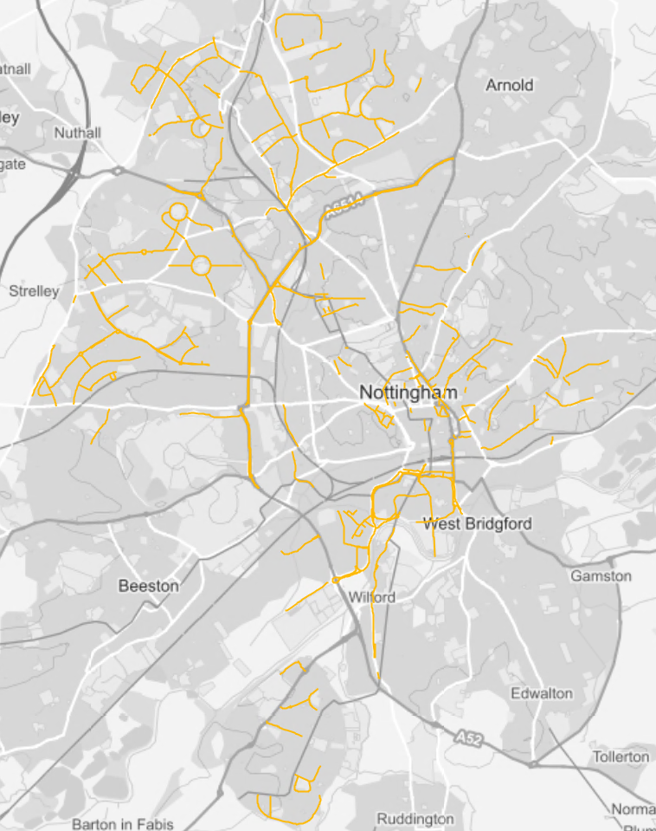

Figure 6e – Footway Maintenance Hierarchy – M205 Local Access Footways

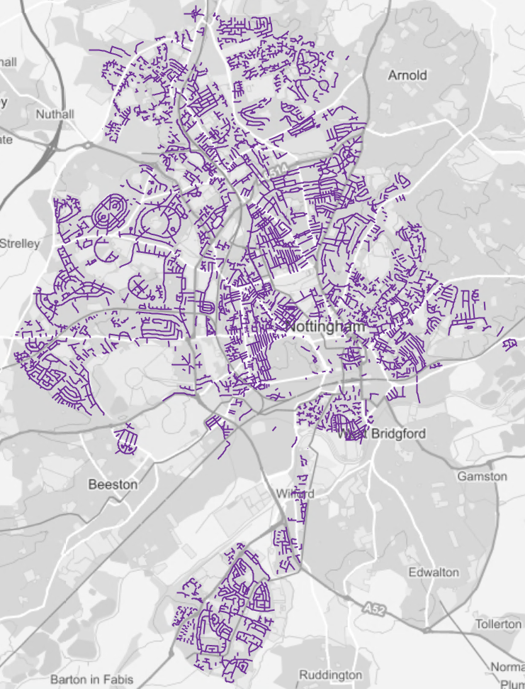

Safety Inspection Frequency
The significance, importance, usage and risk associated with individual roads and footways are reflected in their maintenance hierarchy status. This hierarchy definition underpins the operational and service delivery needs of the highway asset and impacts on how and when the highway is safety inspected and maintained.

The safety inspection frequency for a given street section will be the shorter of the inspection frequencies determined separately for the carriageway and footway elements, i.e.. where carriageway hierarchy dictates an inspection frequency of 3 monthly and footway hierarchy requires an inspection frequency of monthly the street will be inspected monthly

A table of carriageways inspection frequencies for is shown below in Table 5.

Colour Code on Map | Maintenance Hierarchy | Type of Road | Inspection Frequencies
 | M101 | Strategic Roads | 1-MONTHLY
 | M102 | Primary Roads
 | M103 | Secondary Roads
 | M104 | Local Link Roads | 3-MONTHLY
 | M105 | Major Residential Roads | 6 MONTHLY
 | M106 | Access Roads | 12 MONTHLY
 | M107 | Minor Residential Roads

Table 5 - Carriageway Maintenance Hierarchy Inspection Frequencies

A table of footway inspection frequencies is shown below in Table 6.

Colour Code on Map | Maintenance Hierarchy | Type of Footway / Cycleway | Inspection Frequency
 | M201 | Prestige Walking Zones | 1-MONTHLY
 | M202 | Primary Walking Routes
 | M203 | Secondary Walking Routes | 3 MONTHLY
 | M204 | Link Footways | 6 MONTHLY
 | M205 | Local Access Footways | 12 MONTHLY

Table 6 - Footway Maintenance Hierarchy Inspection Frequencies

Resilient Network

The Resilient Network is not intrinsically a maintenance hierarchy per se, however it is the network of roads used to maintain economic activity, access to key services and to enable the citizens, businesses and visitors of Nottingham to go about their daily business in times of extreme weather, or other significant disruption.

During periods of prolonged extreme weather, the highway network can be disrupted. This was highlighted during the winters of 2013/14 where many areas of the Country suffered disruption due to the severe weather. In response, the Secretary of State commissioned an Independent Review of the resilience of the nation’s transport network, resulting in the 2014 Transport Resilience Review by Department for Transport (DfT). This review made 63 recommendations; 14 of which were directed at Local Authorities.

The Transport Resilience Review recommended that Local Highway Authorities should;
“Identify a 'resilient network' to which they will give priority, in order to maintain economic activity and access to key services during extreme weather” (DfT, 2014).

This is reinforced in the the Well-managed Highway Infrastructure Code of Practice (2016).

Recommendation 20 of the Well-managed Highway Infrastructure Code of Practice states…
“Within the highway network hierarchy a “Resilient Network” should be identified to which priority is given through maintenance and other measures to maintain economic activity and access to key services during extreme weather”.

Process in Developing the Resilient Network
The process for identifying the Resilient Network considers which routes are absolutely essential and those which can be considered less of a priority and may be subject to access and trafficking restrictions for a period of time.

The process considers priorities in a time of difficulty when resources may be limited or otherwise engaged, and it also takes account of which roads are key to…
- The preservation of life and property
- The protection of those who are vulnerable
- Providing access for emergency services
- The availability of food, water electricity, gas and communications
- Maintaining a viable economy
- Providing serviceable access to critical infrastructure assets
It is implicit that these decisions will not simply follow road classification or categorisation and that the process in determining the resilient network for Nottingham City should engage key business, stakeholders, interest groups and involve the community. Appendix A denotes a typical consultation letter to key stakeholder service providers inviting them to engege in this development process.

The resilient network is based on risk and need, it should also align with the networks of neighbouring areas and be consistent with the wider resilience strategy for Nottinghamshire and surrounding areas

The Government considers asset management to be a key part of the provision and ongoing maintenance of an available resilient network, as well as effective contingency planning and prioritisation.

The increase in potential for extreme weather events is generally acknowledged to be an impact of climate change and this is likely to increase the severity and magnitude of weather events.

Local authorities are expected to make the best use of the most up-to-date climate change forecasting information available and to consider this in the prioritisation of works to increase the resilience of the highway infrastructure assets to the extreme effects of climate change.

Drainage is considered an important function in addressing the increase in localised flooding issues as a consequence of climate change and in the understanding of the condition of the drainage network and ensuring its effective maintenance and performance assists in minimising the damage caused by extreme weather events. The Government’s response to the ‘Transport Resilience Review’ identifies the importance of maintaining an effective drainage infrastructure to ensure a reduction of scale and threat of flooding with a focus on known problem areas.

In order to develop the resilient network, there is a need to identify routes that can fulfil the more specific roles of resilience for a range of issues beyond extreme weather events. The resilient network is the bare minimum that a highway authority needs to maintain when resources are scarce, and in this context the following key service locations and critical infrastructure assets have been considered:

Key Service Locations
- Highway Depots
- Ministry of Defence
- Police stations
- Ambulance stations
- Fire stations
- Hospitals with Accident and Emergency
- Bus Stations
- Railway Stations
- Access to motorway network
- Critical infrastructure identified in the council’s emergency plan
- COMAH sites
- Fuel Stations
- Power Distribution Points
- Communications i.e. essential fibre optic cables etc.

Access to Key Locations of Economic value
- Main business parks
- Main industrial estates
- Main employment centre

Where appropriate it may also be necessary to consider …
- Large Medical Clinics/ non A & E Hospitals
- Critical utility facilities in need of access (on request),eg sewereage and land drainage pumping stations, electricity sub-stations, gas terminals, etc
- Access to Town and District Centres

Responses to Potential Climatic Events
The availability of a resilient network route should also consider locations which under certain conditions should be closed and bypassed for safety purposes, i.e.
- Sections of road liable to flood.
- Exposed locations in extreme weather conditions.
  - ice or snow build up
  - strong winds
  - dense fog
- Where it is dangerous or impractical to maintain open routes for all road users.

When responding to a particular climatic event, the Council will prioritise the clearing/repair of the resilient network routes to keep them open.
Nottingham will consider the need to minimise the consequential risk of…
- Snow & Ice
- Flooding
- Heatwaves
- High Winds
- Other incidents

Actions will include but will not be limited to gritting the roads, snow plough (removal of snow and debris), closing roads and defect repairs.

Snow
Issues that are likely to arise due to extreme snow conditions are:
- Reduced visibility
- Reduced surface friction
- Failure in road signals
- Roads become impassable due to snow and vehicular accidents
Nottingham City Council will take priority corrective measures to address and mitigate the consequences of these occurrences should they arise on the resilient road network.

Flooding
A flooding event may result in the closure of roads and footpaths, therefore, to mitigate the consequential risk Nottingham have consulted with the Flood Risk Management Team to understand which routes may be affected and therefore to consider alternative routes as part of the resilient network. On the resilient network routes, the gullies and drainage systems shall be maintained in good working order should an extreme rainfall event be forecasted.

Heatwaves
Issues are likely to arise as part of any heatwave emergency, such as power failures and transport disruption, road surfaces melting and distorting. These will be dealt with by the departments concerned as part of a coordinated response unless they are declared a national disaster/concern in which case the overall responsibility may be transferrred to Central Government.

High Winds
Issues likely to arise as part of high wind include; fallen trees or branches, debris in the road, difficult driving conditions, potential increase of crash risk or risk of vehicles over-turning, electrical failure.
Consultation on weather warnings for high winds will provide information on the risk and dangers of driving in such extreme weather conditions, the expectation of widespread uprooting of trees, widespread damage to buildings, with potential for severe structural damage. The public may be advised not to venture outdoors unless really necessary.

Other Incidents
Other incidents not related to weather, e.g. acts of terrorism, mass protests, major crash incidents, may impact on the highway availability and they will have the same resilience mitigation and maintenance prioritisation activities applied where appropriate.

Consultation
The following groups have been consulted during the formulation of the resilient network.
A letter was sent to these groups asking for their requirements for a resilient network…see Appendix A.

- Neighbouring Highway Authorities – Nottinghamshire County Council
- Nottinghamshire Fire and Rescue
- Nottinghamshire Ambulance Service
- Nottinghamshire Police
- Network Rail
- Bus Operators
- D2N2 (Nottingham and Nottingham City) Local Enterprise Partnership
- Nottingham Chamber of Commerce
- Ministry of Defence
- Nottingham City Emergency Planning department
- Utility Operators
- Nottingham City Council Stakeholders
  - Highways Maintenance
  - Traffic and Safety
  - Street lighting
  - Structures
  - Public Rights of Way

The time line for this consultation process was;

March 2025 | Initial consultation letter sent
May 2025 | 2nd Request letter sent to none respondants, Consultation Closed
May 2025 | Responses Collated.  Consultation Closed Meeting held where all resilience requests were considered, and a Draft Resilient Network produced for consultation
September 2025 | Draft Resilient Network issued for comment
October 2025 | Consultation closed  Final Resilient Network created for 2025

Following the consultation process, the resilient road network has been defined as shown in Figure 7 below.

The Resilient Network will form part of the annual infrastructure review.

Figure 7 – Agreed Resilient Network 2025

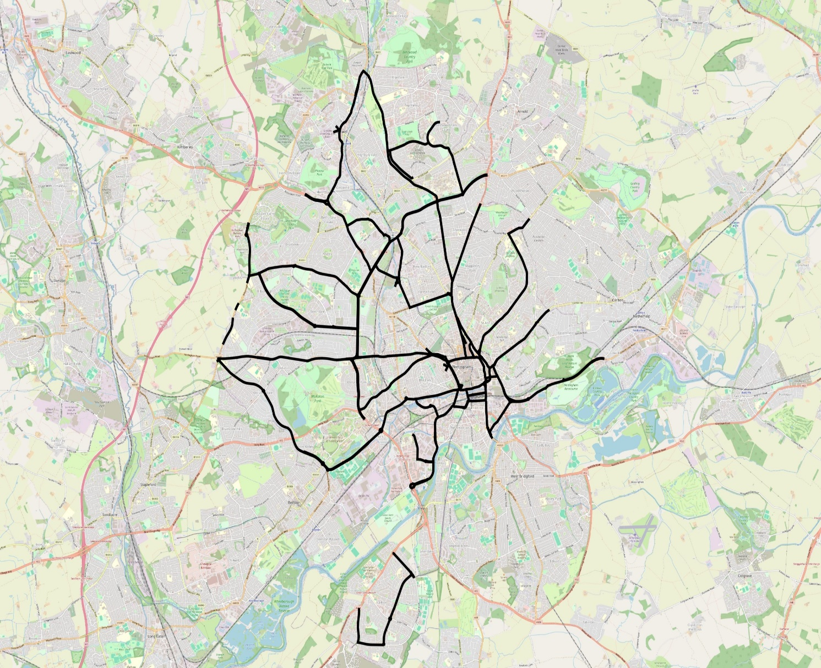

Monitoring and Review
The network has been created using data currently available. The identification of the maintenance hierarchy and resilient network is a dynamic process subject to transformation as the network grows, its usage changes and critical infrastructure is added or removed.

To ensure the network is kept current and up to date a review will be undertaken annually to take consideration of any changes to the network status and to reflect any lessons learned.

This will involve the following:
- Review critical infrastructure and service locations and update GIS information
- Update traffic flow data
- Review the status of neighbouring Council resilient networks to ensure cross-boundary continuity arrangements are in place.

Review Date | Comments | By

It is evident that ‘Maintenance Hierarchy’ and ‘Resilient Netwrok’ is critical to the risk-based operational maintenance management of Nottingham City Council’s highways infrastructure assets and for the prioritisation and adequacy of its financial investment in suport of asset condition and its durability.

The consistency and reliability of the maintenance hierarchy modelling process is of particular significance and importance in association with legal challenge whereupon the hierarchy designation process may be questioned and explored in some detail to ascertain how it was derived and to determine the correctness of the safety inspection frequency.

Any changes to the designated maintenance hierarchy and resilient network should be registered, date stamped and evidenced, as this may have an impact on the Council’s defense of legal challenges.

Appendix A – Consultation Letter – Resilient Network

UPDATE OF RESILIENT HIGHWAY NETWORK

A review of the Resilient Highway Network is to be commenced shortly by the Council, we are therefore engaging with Key Stakeholders for their input and update.

Background: During periods of prolonged extreme weather or unexpected events the local and / or national highway network can be disrupted. This was highlighted during recent flooding and storm events across the country.
The Transport Resilience Review recommended that Local Highway Authorities should “Identify a 'Resilient Network' to which they will give priority, in order to maintain economic activity and access to key services during extreme weather” (DfT, 2014). This has been reinforced with the release of the Well Managed Highway Infrastructure Code of Practice of October 2016.

Nottingham City Council’s Resilient Network is due for a periodic review; therefore, we are contacting all key service providers and businesses to help identify areas of economic value and ascertain locations which are essential to maintain access to or consider in the management of a Resilient Network. I am writing to you to determine whether you have any “critical” assets which you consider would need maintaining or require access to, in the event of a prolonged period of network disruption or that are vulnerable should the roads, footways, verges or structures that support or carry your assets becomes unusable.

The process for reviewing the Resilient Network considers which routes are absolutely essential and which can be managed without for a short time. It is implicit that these decisions will not simply follow road classification or categorisation, therefore your information is essential to enable the authority to make an informed decision.

The Resilient Network will be the bare minimum a highway authority needs to maintain when events or extreme weather reduce the capacity of the authority’s resources.

We are contacting yourselves as we consider that you own or manage one of the following key assets, service locations and routes of economic / emergency importance below:

- Highway Depots
- Ministry of Defence
- Police stations
- Ambulance stations
- Fire stations
- Hospitals with Accident and Emergency
- Bus Stations
- Railway Stations
- Access to motorway network
- Critical infrastructure identified in the council’s emergency plan
- COMAH sites
- Key petrol stations
- Power distribution points
- Water distribution points
- Communications networks, i.e., essential fibre optic cables etc.
- Main Business parks
- Main Industrial estates
- Main employment centres

However, the above list is not exhaustive, so if you consider any asset under your ownership / management needs to form part of the decision process, please inform us accordingly. We would be grateful if you could respond within 28 days, with a plan (preferably GIS) or a description of your asset with bulleted reasons justifying why you require access during these periods or have concerns over the delivery of your service in the event the road, footway, verge or structure your asset is located is unusable.
Please email me on Lisa.Barton2@nottinghamcity.gov.uk
Should you not be in a position to respond with the information required within 28 days, then please let me know at your earliest convenience, as otherwise we shall conclude that you do not have an essential asset to maintain. I look forward to your reply.

Yours faithfully

Lisa Barton – Lisa.Barton2@nottinghamcity.gov.uk (On behalf of)

Mark Bradbury
Contracts & Compliance Manager
Highway Services | Operational & Resident Services | Nottingham City Council | Eastcroft | London Road | Nottingham | NG2 3AH
m: 07983 477526 | e: mark.bradbury@nottinghamcity.gov.uk

