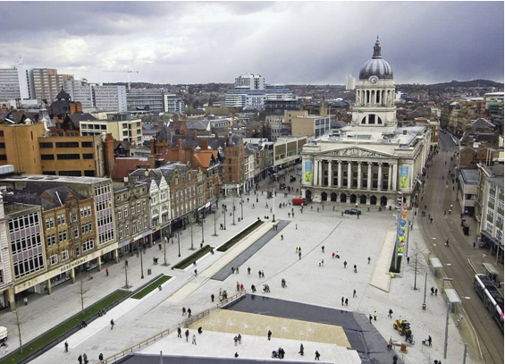

**Version 1.0 July 2018**

**Prepared by:**

**Nottingham City Council’s Emergency Planning Team**

**In conjunction with the:**

**City Centre Emergency Planning Group (CCEPG)**

**Nottingham City Centre**

**Emergency Planning Guide**

**For Businesses**

This guide has been prepared by:

Nottingham City Council Emergency Planning Team

In conjunction with:

Nottingham City Centre Emergency Planning Group (CCEPG)

Includes representatives from the following organisations:

* Boots
* British Transport Police
* Capital One
* Cross Country Trains
* Debenhams
* East Midlands Ambulance Service
* East Midlands Trains
* Environment Agency
* EON
* Ikano Bank
* Intu Broadmarsh Centre
* Intu Victoria Centre
* John Lewis
* Land Securities
* National Ice Centre & Motorpoint Arena
* Network Rail
* NHS England
* Nottingham BID
* Nottingham British Transport Police
* Nottingham City Council
* Nottingham City Homes
* Nottingham City Transport
* Nottingham College
* Nottingham Express Transit
* Nottingham Trent University
* Nottingham University
* Nottinghamshire Fire and Rescue Service
* Nottinghamshire Police
* Trent Barton Bus Company

**Contents**

|  |  |  |
| --- | --- | --- |
| **No** | **Section** | **Page** |
| 1.0 | **Introduction** | 3 |
| 1.1 | Aim & Objectives of the guide | 3 |
| 1.2 | Scope of the guide | 3 |
| 1.3 | Preparing for an emergency | 4 |
| 1.4 | Definition of an Major Incident and an Emergency | 4 |
|  |  |  |
| 2.0 | **Emergency Services and Supporting Agencies** | 5 |
| 2.1 | Roles and responsibilities | 5 |
| 2.2 | Incident scene management and co-ordination | 8 |
| 2.3 | Evacuation | 11 |
| 2.4 | Emergency Assistance Centres | 11 |
| 2.5 | Public information and communications | 12 |
| 2.6 | 'All clear' | 13 |
| 2.7 | Business & community recovery | 13 |
|  |  |  |
| 3.0 | **Advice for creating an emergency plan** | 14 |
| 3.1 | Consider risks | 14 |
| 3.2 | Evacuation advice | 15 |
| 3.3 | METHANE | 16 |
| 3.4 | Emergency services actions and expectations | 17 |
| 3.5 | Business continuity | 18 |
| 3.6 | Insurance | 18 |
| 3.7 | Nottinghamshire Alert Scheme | 19 |
| 3.8 | Counter terrorism | 20 |
| 3.9 | Emergency grab bag - contents suggestions | 22 |
| 3.10 | Checklists (considerations) – what to do in an emergency | 24 |
|  |  |  |
| 4.0 | **Maintenance & training** | 26 |
| 4.1 | Guide review schedule | 26 |
|  |  |  |
|  | **Appendices** | 27 |
| 1 | Map of emergency zones | 27 |
|  |  |  |

\

|  |  |
| --- | --- |
| **1.0** | **Introduction** |

|  |  |
| --- | --- |
| **1.1** | **Aim & Objectives of the guide** |

**Aim**

Provide information to allow businesses to plan more effectively for emergencies /incidents.

**Objectives**

* To raise awareness of the effects that major incidents or emergencies would have to the normal operations of the businesses in the City.
* To provide guidance on how businesses can more effectively interact with emergency services during an emergency/incident.
* Provide an outline of the roles and responsibilities and initial actions of key organisations during the initial stages of an emergency or major incident within the city centre.
* Describe multi-agency arrangements for incident control and co-ordination.
* Provide advice and information to city centre organisations on how best to safeguard themselves and their business.
* Supply of a zoned city centre map displaying emergency information to all city centre businesses.
* Raise awareness of ‘Nottinghamshire Alert’ scheme’, which enables businesses to receive first-hand information about incidents in the City centre and the County.
* Raise awareness of counter terrorist information sources.
* Raise awareness of Business Continuity.

|  |  |
| --- | --- |
| **1.2** | **Scope of the guide** |

The guide gives basic information required for businesses to plan and respond to emergencies that would disrupt normal business and/or place people at risk within the City Centre of Nottingham. The Emergency Services and City Council have both multi-agency generic response plans and plans for specific risks such as Flooding, Pandemics etc. This guide dovetails with multi-agency arrangements for: incident management, evacuation, assembly, transportation, temporary accommodation, public information, major incident procedures, business and community recovery.

There are already well-established multi-agency arrangements in place to deal with emergencies and major incidents, wherever they occur. This guide does not replace these existing arrangements, but provides a more detailed guide for enabling businesses to better plan for dealing with such events.

|  |  |
| --- | --- |
| **1.3** | **Preparing for an Emergency** |

With the aid of the guide, each organisation/business within the defined area is encouraged to have in place the appropriate plans to deal with any incident, which may affect their premises or staff. These include:

Incident Response Plan (Emergency plan) - A plan to deal with any incident which may affect their premises.

Evacuation Plan – Plans on how to evacuate the building in a timely manner (these plans should also cover circumstances where staff are advised to stay inside, close windows doors etc and tune into local radio).

Business Continuity Plan – it makes good business sense to have a business continuity plan to cover all eventualities to help ensure the recovery of your business from any incident or business disruption.

|  |  |
| --- | --- |
| **1.4** | **Definition of a Major Incident and an Emergency** |

There are numerous definitions of Major incident and Emergency, however, for the purpose of the guide any incident that would involve a multi-agency response and a disruption to the City and it businesses would be covered by this guide.

The terms Major Incident and Emergency are used consistently and interchangeably throughout this guidance to encompass:

* All challenges that require the use of assets beyond the scope of normal operations and, as such, require special deployments and/or
* The threshold of an incident that will initiate a response under an organisation’s major incident plan has been met and/or
* An incident or situation that poses a considerable test for an organisation‘s ability to perform its functions.

**A Major incident**

An event or situation with a range of serious consequences, which requires special arrangements to be implemented by one or more emergency responder agency.

As a guide, a major incident will generally include some or all of the following features:

* The involvement, either directly or indirectly, of large numbers of people
* The initial treatment, rescue and transportation of a large number of casualties
* The handling of a large number of enquiries, likely to be generated from both the public and the news media
* Large-scale combined resources of two or more of the emergency services
* Mobilisation and organisation of the emergency services and partner organisations to cater for threat of death, serious injury or homelessness to a large number of people.

**An Emergency**

An ‘Emergency’ as defined by the Civil Contingencies Act (2004). Section 1 of the Civil Contingencies Act (2004) defines an ‘emergency’ as:

An event or situation which threatens serious damage to human welfare in a place in the UK;

An event or situation which threatens serious damage to the environment in the UK;

War, or terrorism, which threatens serious damage to the security of the UK.

|  |  |
| --- | --- |
| **2.0** | **Emergency Services and Supporting Agencies** |

The purpose of this section is to raise awareness of the roles and responsibilities of the Emergency Services and their partner agencies, to help inform your own planning arrangements.

|  |  |
| --- | --- |
| **2.1** | **Roles and Responsibilities** |

**Police**

The primary areas of responsibility for the Police are:

* To save life in conjunction with the other emergency services.
* To secure, protect and preserve the scene until all evidence has been retrieved.
* Obtain and secure evidence in conjunction with other investigative bodies where applicable.
* The implementation of traffic management arrangements to control the general public and traffic, through the use of cordons, diversions and filters.
* To ensure effective access and egress to the scene for all responding agencies
* To prevent crime.
* To collate information regarding persons involved and distribute to other responders as necessary.
* To support the role of HM Coroner in the investigation of the cause and circumstances of unexplained or sudden death.
* To recover deceased victims and their personal property and to ensure positive identification on behalf of HM Coroner.
* To assist in measures to restore the scene to normality after all necessary operational actions have been taken.

Unless the incident has occurred as a result of natural causes, the scene(s) will be treated as a crime scene and will be preserved accordingly. The Police will appoint a Senior Investigating Officer (SIO) who will have overall responsibility for investigation. All scenes where death has occurred will require appropriate preservation and thorough recording, evidence gathering and processing for HM Coroner.

**Fire and Rescue**

The primary areas of responsibility for the Fire and Rescue Service are:

* Life-saving through search and rescue.
* Firefighting and fire prevention.
* Performing urban search and rescue.
* Salvage and damage control at the scene.
* To rescue victims trapped in wreckage or debris.
* Prevent further escalation of the disaster by tackling fires and dealing with chemicals and other hazards.
* Detection, identification and monitoring of substances.
* Provide and/or obtain specialist advice and assistance in the management of hazardous materials.
* Protection and consideration of all environmental issues.
* Work with the ambulance service to provide a mass decontamination service.
* Provide an early indication of a radiological dispersal device containing gamma or beta radiation and to give a capability to monitor radiation dose.
* Provide weather information from the Met Office via the Hazard Manager system.
* Rendering humanitarian services in conjunction with East Midlands Ambulance Service (EMAS) and local authorities.
* In consultation with the police, agree the boundary of the inner cordon and determine the boundary of the outer cordon at an incident, other than in the initial phases of a confirmed terrorist incident.
* Coordinate health and safety of personnel working within the inner cordon.
* In consultation with the police, coordinate access to scientific advice.
* Provide and support a multi-agency coordination centre.

**East Midland Ambulance Service (EMAS)**

The primary areas of responsibility for EMAS are:

* To save life together with the other emergency services.
* To provide treatment, stabilisation and care of those injured at the scene.
* To provide appropriate transport for medical staff, equipment and resources.
* To establish effective triage points and systems to determine the priority treatment

and evacuation needs of those injured.

* To provide a focal point at the incident for all national health service and other medical resources.
* To lead and provide communication facilities for national health service resources at the scene, with direct communication links to hospitals, control facilities and any other agency as required.
* To alert the local receiving and other east midlands hospitals.
* To act as the gateway to the rest of the Nottinghamshire healthcare organisations via NHS England on call team.
* To provide transport (if required) to the incident scene for the medical incident advisor, mobile medical/surgical teams and their equipment.
* To arrange the most appropriate means of transporting those injured to the receiving and specialist hospitals.
* To inform the NHS England on call team and local NHS trusts of all potential major incidents.
* To maintain the health and safety of all personnel at the scene.
* To maintain emergency cover throughout EMAS area and return to a state of normality at the earliest time.

Working with a Medical Incident Advisor and emergency medical teams, the Ambulance Service seeks to save life through effective treatment, at the scene of an emergency. They will liaise closely with the Fire and Rescue Service to determine the priority for release of trapped casualties, and transport the injured according to priority of treatment to nominated receiving hospitals. The Ambulance Service also has responsibility for decontamination of casualties, supported by the Fire Service with specialist facilities, if mass decontamination is a requirement.

**Nottingham City Council**

The primary areas of responsibility for the Local Authority are:

* To support the emergency services and other agencies engaged in the response to an incident.
* To be prepared to take the lead role in certain major incidents, for example, major incidents at City centre schools.
* To activate and coordinate the response of the voluntary agencies and other supporting organisations.
* To coordinate/provide appropriate short, medium and long term humanitarian assistance to support all those affected by major incidents.
* To establish suitable premises for use as an emergency mortuary if required.
* To provide, on request, engineering, highways, environmental health, public health, communications and other specialist support.
* To lead on the recovery from a major incident or emergency.
* To maintain services and ensure a return to normality as soon as possible.

**Other Agencies**

Many other agencies may be involved depending on the event and its location, these may include:

* NHS
* Acute trusts
* Public Health England
* Environment Agency
* Highways England
* British Transport Police
* Other Government agency such as DEFRA and MCLG.
* Military
* Voluntary Agencies such as Red Cross and St John
* Utility Companies.

We have only listed the role and responsibilities in detail of the Agencies that would respond the most often, other agencies may be involved depending on the incident.

|  |  |
| --- | --- |
| **2.2** | **Incident scene management and co-ordination** |

**Initial actions**

When attending an incident the emergency responders use the acronym METHANE to record key information and ensure that all blue light services have the same information.

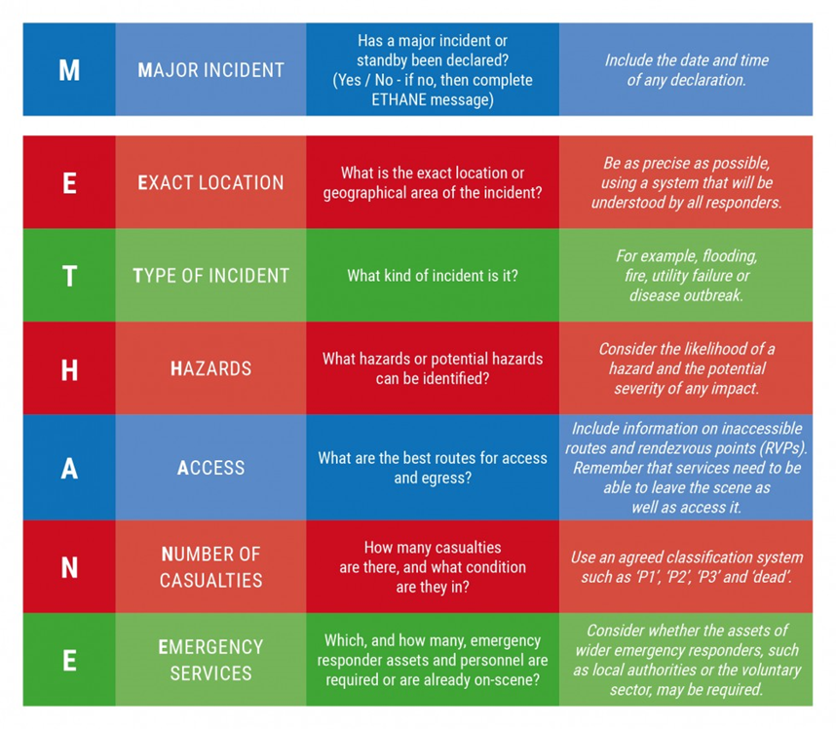

Efficient scene management can only be achieved through liaison. Therefore, exchange of information from the onset is vital. On-going joint assessments and briefings must be held periodically to ensure a response to new developments, escalation or changes to operational requirements. All organisations at scene should be involved in this multi- agency briefing.

**Forward Control Point (FCP)**

While the Police generally coordinate the multi-agency response to an incident, each responding service/agency retains responsibility for the command and control of their own personnel. A suitable Forward Control Point (FCP) will be established to effectively direct/co-ordinate the joint response of all the responding agencies. The ‘JESIP Joint Doctrine; the Interoperability Framework’ provides responders at the scene and elsewhere, with principles for effectively managing a major or complex incident.

[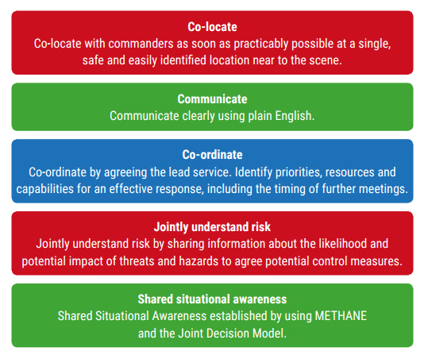](https://www.google.co.uk/url?sa=i&source=images&cd=&cad=rja&uact=8&ved=2ahUKEwjhpdeE8YnbAhWCYVAKHRQdB88QjRx6BAgBEAU&url=http://www.jesip.org.uk/jesip-images&psig=AOvVaw0bq2nDhfCYLIBjXU1kqrMg&ust=1526548114578698)

The Scene Incident Commanders from each agency will be wearing identifiable tabards.

Depending on the incident additional personnel maybe required these will be mustered first at a Rendezvous Point RVP at a suitable location away from the incident.

**Representation at Forward Control Point FCP**

Depending on the incident, a suitable representative from your organisation **may** need to attend the FCP, as your representative may have pertinent information regarding your premises and staff e.g. Staff unaccounted for at role call; specific knowledge of your premises and the incident. It would be useful for the representative to wear an identifiable Hi-Viz jacket/vest and the representative should make themselves known to the Incident Commander. Your representative may be able to give specific information and should use the METHANE acronym as a standard for the dissemination of their specific information.

**N.B.** Only send a representative if your building is involved and is part of the incident or if you are asked to provide a representative at the FCP by the Emergency Services.

**Cordons**

The Police will establish inner, outer and traffic cordons following consultation with the other emergency services in accordance with the circumstances of the incident.

Cordons may need to be moved during the course of the incident depending on the current and changing situation. The Local Authorities can assist with permanent cordon deployments. Cordons should be instigated as soon as possible, their purpose is to:

* Assist in protecting the public and those working within the scene
* Control unauthorised access
* Prevent unauthorised interference with, for example, wreckage, property
* Facilitate emergency service operations

**Inner Cordon**

If an inner cordon is set up, the size will depend on the perceived hazard and can range from 100 to 1000 metres to enclose the scene of the incident and contain any area of hazardous contamination. Recommended minimum cordon distances are:

For an explosive risk:

100 metres – for a minor explosive risk (small rucksack, letter bomb, small package)

200 metres – for a moderate explosive risk (large suitcase, large rucksack)

400 metres – for a serious explosive risk (vehicle borne)

N.B. These are minimum distances and may be increased depending on the dynamic risk assessment at the time.

For incidents where there is no explosive or contamination risk, these distances can be used as a guide depending on a risk assessment at the time.

An inner cordon is identified by

Only authorised personnel are permitted within the inner cordon area and this is facilitated through the implementation of inner cordon gateway control procedures. Generally there should only be one entry and exit point to the inner cordon, jointly controlled by the Police and Fire and Rescue Service.

**Outer Cordon**

The outer cordon creates a safe and controlled area in which the responding agencies are able to work unhindered. The radius of the outer cordon depends on the type and scope of the incident, the availability of resources and the needs of the affected community. The Incident Commanders will consult to determine the extent of the outer cordon.

An outer cordon is identified by

Note: During the rescue phase, the area within the inner cordon will become the responsibility of the Fire and Rescue Service, unless the incident is of a terrorist nature. Once this phase is complete, the police take responsibility for the inner cordon in order to commence identification and investigation procedures.

|  |  |
| --- | --- |
| **2.3** | **Evacuation** |

The purpose of evacuation is to move people and where appropriate, other living creatures, away from an actual or potential danger to a place of safety via a safe route. Types of evacuation include:

* Full evacuation of the cordoned area
* Dispersal (people make their way home, such as from a Sports Stadium or town centre)
* Invacuation – a group of people remaining within or being gathered into a particular building as it is safer to do so than to be outdoors in the area.
* Shelter in situ (people remaining in their own premises and being advised to ‘Go in, Stay in, Tune in’, for situations such as a toxic plume).
* Evacuation by Zone.

It has to be accepted that in certain situations the public may remove themselves from the area, which can pose problems to the coordination and monitoring of the movements of evacuees.

Generally, evacuation would be from a cordoned area; the cordons would be a circular distance from the incident/hazard. The size of the cordon would depend on the risk/hazard and would be decided by the emergency services at the scene (see previous section 2.2). If large swathes of the City required evacuating, we would evacuate the City by zones (see below).

**Evacuation of the City centre using Zones**

In the unlikely event that large parts of the City need to be evacuated, the City centre has been dividing into 16 clearly defined zones. A map identifying these zones is located in Appendix 1 page 28. The Zone maps have been distributed to all City organisations in the past. The maps include generic information on preparing for an emergency incident. Organisations are encouraged to place the maps in their work places for use in an emergency. Further copies can be obtain from the City Council’s Emergency Planning Team.

Evacuated citizens would be accommodated in either a place of safety, a rest centre or survivor reception centre. (See section 2.4 below)

|  |  |
| --- | --- |
| **2.4** | **Emergency Assistance Centres** |

The Emergency Services and the City Council will set up various centres depending on the requirement at the time, as described below. They are usually set up for people who have been displaced from their homes; or have suffered injury or lose because of the incident. It is the responsibility of all organisations to consider how they would look after their own staff in an emergency.

**Places of Safety**

Evacuees would initially be directed by the Police or Fire Service to a temporary Place of Safety. These are not pre-identified as they are usually the nearest safe place to the incident. Places of Safety will usually be suitable buildings such as: community centres, leisure centres, or in some cases a public houses or other community buildings. It is possible in a larger incident that more than one Place of Safety may be in use at any one time.

The Place of Safety will be used as an assessment centre to determine the number of evacuees who have no alternative means of accommodation. If there are significant numbers of evacuees needing shelter, the City Council would open, organise and manage a Rest Centre and arrange transportation from the Place of Safety

**Rest Centres**

Possible sites for a Rest Centre have been pre-identified by the City Council Emergency Planning Team to provide temporary accommodation for evacuees, with overnight facilities if necessary. A Rest Centre may be opened directly if the number of evacuees involved in the incident dictates it. These Rest Centres are usually sports centres with large rooms which can accommodate a significant number of evacuees. If numbers requiring overnight accommodate are small, the City Council may accommodate these people in a hostel, B&B or hotel.

**Survivor Reception Centre**

Secure area set up to which survivors not requiring acute hospital treatment can be taken for short-term shelter, first aid, interview and documentation.

**Friends and Relatives Reception Centre**

Secure area set aside for use and interview of friends and relatives arriving at the scene or location associated with an incident.

**Humanitarian Assistance Centre**

A Humanitarian Assistance Centre would be activated following a catastrophic event to provide a one-stop-shop for survivors, family and friends and all those impacted by an emergency through which they can access support, care and advice.

|  |  |
| --- | --- |
| **2.5** | **Public information and communications** |

There are multi-agency plans in place to warn and inform the public in the event of an impending or actual incident. Communication pathways include the following:

* Social media e.g. Twitter, Facebook etc.
* Media releases, in particular use of local press and radio including BBC ‘Communicating in a Crisis’ service usually broadcast on BBC Radio Nottingham.
* Nottingham Express Transit PA system.
* PA systems in shops and shopping centres.
* Highways England public information system.
* Nottinghamshire Alert Scheme (see page 19 for further details).
* Police loudhailers - Police helicopter ‘Sky Shout’.
* Visits by Police Officers to individual premises.

Be aware that your neighbour may not be aware of the incident, so be a ‘good neighbour’ and inform adjacent premises, but only if it is safe to do so. Also, be aware that the message may advise the public to stay indoors, closing all windows and doors and tuning into local radio.

|  |  |
| --- | --- |
| **2.6** | **'All Clear'** |

In consultation with partner agencies, Nottinghamshire Police may take the decision to declare an ‘All Clear’ which will allow for a controlled resumption of traffic flows and return of any evacuated workers, residents and the general public to properties that were affected. The following factors are considered as a part of this process by the Police.

* The return of people to evacuated zones should be phased and controlled.
* Normal transport services should be resumed as soon as possible.
* The approval for the public to return to their cars should only occur when the Police deem it safe for normal travel to be resumed.
* During re-entry to the area, empty properties should remain secure.

Once the decision to declare an ‘All Clear’ has been taken, the Police issue an ‘All Clear’ message(s) via various systems including the Nottingham Alert Scheme, together with any specific information that is deemed necessary in line with their strategy for a controlled re-entry to the affected areas.

|  |  |
| --- | --- |
| **2.7** | **Business and Community Recovery** |

In the event of an incident resulting in serious wide-scale impact on the business and/or residential community or the environment, the City Council would establish a multi-agency Recovery Co-ordinating Group and, if required, sub-groups tasked with leading economic, social and environmental recovery using the Nottingham & Nottinghamshire LRF Recovery Plan.

Such a group would be convened as soon as practicable and work initially alongside the Strategic Co-ordinating Group. (SCG). Any Recovery Group would normally be chaired by a senior representative of Nottingham City Council.

|  |  |
| --- | --- |
| **3.0** | **Advice when creating an emergency plan** |

This section gives you some information that may help you with writing your own organisation’s emergency plan. However, it is up to each organisation to decide what is appropriate for them.

It is recommended your emergency plan should refer to a set of key objectives for example:

* Save, preserve and protect life
* Mitigate and minimise social, environmental and economic impact
* Protect property

|  |  |
| --- | --- |
| **3.1** | **Main Risks** |

The Emergency Services develop their contingencies plans based on risk assessments. It is useful to understand:

* What we are at risk from (Risk)
* What the impact would be (Impact- severity)
* How likely it is it to happen

The Civil Contingencies Act 2004 requires all Local Resilience Forums (LRF) to write and publish a Community Risk Register. LRFs are the local senior body that ultimately decides on the strategy of how locally we deal with these risks. They are chaired by the Chief Constable and are made up of senior officers from all local government, emergency services, government agencies, utility companies and voluntary service organisations. The “Community Risk Register” is available on the Nottinghamshire Police website at the address below:

<http://www.nottinghamshire.police.uk/sites/default/files/Community%20risk%20register%20-%20public%20version1.pdf>

The document gives advice on the main risks that we face locally and details the 10 top risks. This list can change from time to time, for the most up to date list, look at the current edition.

It also is a source of other useful information and it would be useful to look at the full description of the 10 top risks, which may influence your own planning.

Risks can be split into two types:

Hazards, which are naturally occurring and human made (by accident).

Threats, which are malicious and human made.

|  |  |
| --- | --- |
| **3.2** | **Evacuation advice** |

You may have to evacuate your premises due to an internal problem e.g. internal fire or an internal water leak. You may also have to evacuate due to an external incident, as you may be in a cordon or zone set up by the Police. For further information on how the emergency services manage evacuations, see sections:

2.2 Incident scene management and co-ordination

2.3 Evacuation

Consider creating an Evacuation plan either separately or as part of your Emergency plan or Business Continuity plan

Consider the Following:

* The reasons you may decide to evacuate your own work place, it may be due to: fire, smoke, suspect package (seek police advice in this case) etc.
* Plan in advance where you would evacuate to. You may need to have a flexible approach if you are being asked to evacuate by the Police, as cordon distances are generally 100 to 400metres and may even be up 1000metres. Make sure your plan considers these distances. Also if there is wind born contamination, you don’t want to assemble downwind of the hazard.
* Liaise with your neighbouring businesses to ensure that the same evacuation points are not chosen by all businesses in the area. Consider a key contacts sheet of your neighbours to pass information on during an incident.
* How you are going to help your staff if they are unable to access their vehicles or get back into you building to retrieve personal belongings, which may include house / car keys, money, mobile phones etc.
* Is there enough money in your grab bag (if you have one) to provide money for getting all your staff home? You may be able to negotiate a contract with one of the local taxi firms.
* Become familiar with alternative routes and other means of getting out of your building/area.
* What provision have you made for staff with special needs, mobility etc, to ensure they can get to the assembly point?
* Take your emergency supply kit (see page 21) and lock the doors behind you when you leave, ensure your company’s security policies are followed. But if there is a suspect package you may be asked by the police to leave doors open to aid their route.
* Decide who will pick up the grab bag and how it will be used.
* Detail who will liaise with the emergency services at the FCP, ensuring they have the appropriate information with them (See the next section on METHANE).
* Arrange alternative accommodation or shelter for you staff?
* How good is your Business Continuity Plan regarding dealing with a disruption?
* Have regard for your own organisation’s security regulations when evacuating.

There is no legal authority for the Police to enforce evacuation, except in terrorist incidents. However the Police have a Common Law duty and power to take reasonable steps to save and preserve life. Although the Police may recommend evacuation, the final decision rests with individual residents, or managers, or individual staff of the affected organisations.

|  |  |
| --- | --- |
| **3.3** | **METHANE** |

As we indicated in section “2.2 Incident scene management and co-ordination” ,information is gathered and shared between responding agencies using the METHANE format.

We suggest that all parties involved adopt this format for consistency and clarity. You should create your own METHANE statement as suggested below:

|  |  |
| --- | --- |
| **Major Incident** | This will be declared by one of the Emergency services.  You do not need to include this in your report. |
| **Exact location** | If it is within your premises, clarify exactly where and the extent.  If it is in the near vicinity, again record the details, it may help to clarify the location previously known more accurately. |
| **Type of incident** | Exact nature and environment |
| **Hazards** | Present already and likely, which maybe involve the incident or any other hazard that my harm responders. |
| **Access and egress** | Report on this only if the incident involves your premises. Detail to include safe routes in and out for emergency responders. |
| **Number of casualties** | Number of casualties and types of injuries. Estimated fatalities. |
| **Emergency Services + Evacuation** | Confirm whether you have evacuated, where to, numbers involved, building empty, report anyone missing. |

**N.B. Remember to keep your report concise and factual.**

|  |  |
| --- | --- |
| **3.4** | **Emergency services actions and expectations** |

Your Emergency plan will need to understand the Emergency Service actions and their expectations of your organisation.

The Emergency Services operate a Gold, Silver, Bronze management system:

* Gold deals with strategy and communication
* Silver is tactical, organising the required support for Bronze
* Bronze is the operational team

Bronze is the management team who operate and co-ordinate the response at the scene.

Each emergency service agency will have a Bronze Incident Commander at the scene. These bronze commanders are responsible for co-ordinating the response, they will quickly set up a multi-agency Forward Control Point (FCP). If you need to go to the FCP, make yourself known to one of the Incident Commanders.

**The Incident Commanders will**

* Attend the scene promptly. In liaison with the other Emergency Services present, if not already in place, locate / establish a Forward Control Point. This will need to be multi-agency.
* Obtain a full briefing from the first officer at the scene and deploy their resources appropriately.
* Ensure that the scene is protected. If not already in place, establish inner and outer cordons and safe access and evacuation routes.
* Ensure that staff are fully briefed and that they understand their role, responsibility and limits.
* Consider that the incident may require more than a Bronze ‘on Scene’ Commander, based geographically or function specific such as:
  + Bronze Cordons (if a large area affected)
  + Bronze Rendezvous / Marshalling Officer
  + Bronze Traffic Management
  + Bronze Evacuation
  + Bronze Survivor / Family and Friends Reception Centre(s)
  + Bronze Media (Corporate Communications Officer)
  + Bronze Community
* Ensure that an appropriate Place of Safety and Survivor Reception Centre has been identified and established if required. (Note: the Local Authority will establish a Rest Centre(s)).
* Where a number of fatalities have occurred, ensure that a suitable victim holding area is located and established.
* Safeguard property / possible evidence.
* Consider that the media will arrive on the scene within a short time frame.
* Consider the best means to alert the public; Nottinghamshire Alert, Neighbourhood Alerts, good media liaison, use of police personnel on scene.

**Emergency Services expectations of City Centre Organisations**

* City centre organisations are responsible for the health and safety of their own staff as well as visitors while they are on their premises.
* They are responsible for evacuating their own staff from their buildings safely and swiftly to appropriate pre-agreed assembly points, and considering the needs of their staff at the assembly point.
* On receipt of an alert or standby message from the Police or via the 'Nottinghamshire Alert’, the designated staff (e.g. Building Managers or Security staff) in City Centre organisations place staff on standby or initiate evacuations in line with their own internal evacuation procedures (if required).
* The designated staff identify appropriate assembly points in light of the incident location.
* Take responsibility for their own staff at assembly points until an ‘All Clear’ message is given, ensuring that the needs of disabled staff and visitors are addressed.
* Organisations located in the City Centre should have clear and concise internal fire and bomb/counter terrorism evacuation procedures in place with which their staff are familiar.
* Organisations should test and review their emergency plans on a regular basis.
* It is also expected that City Centre organisations are aware of the cordon distances and City Centre evacuation zone map.
* Send an appropriate manager to the FCP if required, you only need to send someone if the incident involves your building, or you have been asked to attend by the Police. **Do not send anyone if you have only been asked to evacuate.**

|  |  |
| --- | --- |
| **3.5** | **Business Continuity** |

The objective of a Businesses Continuity Plan (BCP) is to provide businesses with an effective means of recovery from a business disruption. It can minimise the impact on operations, employees, customers and suppliers, and ultimately protect the organisation and its reputation.

Further advice can be obtained from the Nottinghamshire Police website, and a Business Continuity Management Toolkit can be accessed at the link below:

<https://www.nottinghamshire.police.uk/sites/default/files/Business_Continuity_Managment_ToolkitNotts.pdf>

|  |  |
| --- | --- |
| **3.6** | **Insurance** |

In an incident, insurance companies can be a source of immediate help to limit the effect on your business and may be able to offer solutions to aid your response. They like to get involved early as it helps them and you to control the overall cost of the incident. Speak to them prior to writing your plan and gauge what they can do for you; put any good practice in your Emergency plan.

|  |  |
| --- | --- |
| **3.7** | **Nottingham Alert Scheme** |



Nottinghamshire Alert Scheme is a free alerting system administered by Nottinghamshire Police and is designed for both the public and businesses within Nottingham and Nottinghamshire. Participants will receive information about Major incidents or emergencies, crimes, scams, road closures etc. in your area or relevant to your business, usually generated by Nottinghamshire Police.

The service is totally free with no charges. Messages are usually received by e-mail. The customer has total control of their message settings and customers can unsubscribe at any time. There are no contracts or obligations.

Should any agency consider it necessary to originate a message for the Nottinghamshire Alert system they should contact the following numbers:-

Nottinghamshire Police Emergency Planning Tel 101 (ext 310 4142 / 9987)

**To join the scheme visit**

Individuals: www.nottinghamshirealert.co.uk

Businesses: www.nottsbusinesswatch.co.uk

The Nottingham Alert Scheme may be used for a variety of policing purposes including stand-by or alert messages, crime information, missing vulnerable persons, traffic information etc.

|  |  |
| --- | --- |
| **3.8** | **Counter Terrorism** |

When developing your plan, it would be sensible to include some advice regarding the threat of Terrorism. Current advice changes dynamically, as we face ever-changing methods of attack, therefore this section will signpost you to the most current and up to date advice and information.

Firstly, it is useful to understand what the current threat level is and you can get this from the Government Security Service website:

https://www.mi5.gov.uk/threat-levels

This site will give you current threat levels for International Terrorism and Northern Ireland related terrorism.

Threat levels are designed to give a broad indication of the likelihood of a terrorist attack.

* LOW means an attack is unlikely.
* MODERATE means an attack is possible, but not likely.
* SUBSTANTIAL means an attack is a strong possibility.
* SEVERE means an attack is highly likely.
* CRITICAL means an attack is expected imminently.

The most relevant and up to date UK Government terrorist information can be obtained from “The National Counter Terrorism Security Office” website:

https://www.gov.uk/government/organisations/national-counter-terrorism-security-office

The information on this site will change as the threat changes and develops. As of May 2018 the following guidance is available:

**Run, Hide, Tell**

This is advice for dealing with a firearms or weapons attack.

It may be useful to consider how you would deal with such an event, routes to use to enable colleagues to flee etc.

**Crowded Places Guidance**

Guidance on increasing the protection of crowded places from a terrorist attack. This 175 page guide has generic and relevant advice on many subjects.

This guide also contains information on the following sector specific themes:

* Night-Time Economy
* Cinemas And Theatres
* Stadia And Arenas
* Retail
* Health
* Education
* Places Of Worship
* Hotels And Restaurants
* Major Events
* Visitor Attractions
* Commercial Centres
* Transport

As well as sections on:

* Managing the threat
* Attack methodology
* Physical security
* Personnel and people security
* Personal security
* Cyber security
* Checklists

You may find some of the checklists useful for example:

* Bomb Threat
* Checklists
* Personal security.
* CCTV
* Access Bomb threats
* Emergency and business continuity
* ETHANE
* Cyber security
* Search planning
* Crisis response kits
* Good housekeeping
* Suspicious behaviour reporting

**Reporting suspicious behaviour**

The Crowded Places Guide has a section on reporting suspicious behaviour and has a form on page 162 of the guide. Once filled in report it to the Police locally on:

Tel no’ 101 and inform the switchboard you want to report suspicious behaviour and you will be put through to the relevant section.

Or

Use the national confidential Anti-Terrorist hotline on 0800 789 321.

**Further information/Advice**

Contacting a Counter Terrorist Security Advisor (CTSA)

If you require any further information or indeed want to contact a Counter Terrorist Security Advisor (CTSA), you can email them on CTSA@nottinghamshire.pnn.police.uk.

|  |  |
| --- | --- |
| **3.9** | **Emergency grab bag contents suggestions** |

**Build your own Emergency Grab Bag**

Each organisation is encouraged to maintain a ‘grab bag’ for use in emergencies, which should contain essential items of use in an emergency. It is better to be prepared, and having a bag containing useful items may assist your response and the care of your staff.

The contents list below cannot be definitive; all organisations vary in size, complexity, and will be vastly different in many ways. Therefore all we are suggesting in this section is that you decide what is appropriate for your organisation and if you deem that it is sensible to have a grab bag, here is a list of items you may consider including. A typical grab bag is small rucksack/wheelie bag/messenger bag that is easy to carry and easy to identify. It should be situated en-route to the nearest fire exit and unencumbered by anything that might delay individual getting to their safe exit.

|  |  |
| --- | --- |
| **Emergency Go Bag Contents List** | |
| Additional power for mobile phones and laptops | Battery power packs and/or chargers may be useful during a protracted event. |
| Adhesive tape | e.g. Duct Tape or Sellotape |
| Baby wipes |  |
| Clothing | May not be appropriate, and will depend on your circumstances and space available in the bag, a few polythene ponchos to shelter from the rain are light enough and small enough to be carried in the grab bag. |
| Compact megaphone | May not be appropriate, and will depend on your circumstances, but may be useful for talking to large numbers of your staff. |
| Disposable camera |  |
| First aid kit | Your first aid kit contents should reflect your training and ability. |
| Foil Blankets | As above, they are good for sheltering from the elements and have the added advantage of aiding heat retention as well as being small and light. |
| Food | May not be appropriate, and will depend on your circumstances, although a few high calorie, long shelf- life snack bars that are compact and easy to store and have a long shelf live maybe a useful addition. |
| Gloves | Disposable rubber/nitrile gloves and/or leather work gloves |
| Glow sticks | May not be appropriate, and will depend on your circumstances |
| Hand sanitizer | Small hand gel |
| Hand wipes | Anti-bacterial hand wipes |
| Hard Hats |  |
| Hi-visibility jackets | Armbands/high-visibility tabards |
| Masks | Dust and debris is often overwhelming at the site of an accident or incident and these may be useful for colleagues that may be helping at the scene |
| Money | Money & company credit card, change/card for payphone. |
| Multi-tool | e.g. a Leatherman. |
| Nylon rope |  |
| Pens/ pencils | Biros, pencils and Marker pens |
| Radios | Wind-up radios would be best; radios are useful as local radio will be a source of public advice and updates. |
| Scissors |  |
| Spare Mobile phone | May not be appropriate, and will depend on your circumstances but could be used by your staff if they have left their belongings during evacuation. |
| Torches | Obviously useful at night but the batteries would need to be changed at regular intervals. Lithium batteries have a shelf life of over 10 years. |
| walkie-talkie radios | Licence-free walkie-talkie radios are an excellent choice as they operate independently of any networks and can be valuable in keeping in touch with your evacuated staff and your on-scene representative/s. |
| Water | May not be appropriate, and will depend on your circumstances |
| Whistle | A good device for attracting attention but should not be over used during an incident |
| Writing pad/s | Hard backed notebooks can be useful if there is nothing to rest against whilst writing. |
| **Documents** | |
| Business continuity plan | Should contain valuable information including contact lists, which will negate the need to have separate lists. |
| Contact lists | Head office, staff, other branches, clients, suppliers, utilities, neighbours. |
| Copies of your building plans | Several copies of a clear plan ideally laminated to protect against the elements to give out to Emergency Services if required. This should include: fire escape routes, fire safety measures such as detection, lighting and fire equipment, service isolation points (gas, water, electricity), sprinkler stop valves, location of ventilation switches (if installed) and location of any substance that may be hazardous to the emergency services. |
| Emergency checklist |  |
| IDs | Staff ID’s |
| Incident response/ Emergency plan | Can contain your emergency evacuation procedure (inclusive of personal emergency evacuation plans and highlighting any mobility issues of users) |
| Insurance details | Copies of insurance documents and insurance company contact numbers |
| Local maps | Include directions to the recovery locations, assembly points |
| Spare keys | Spare keys and access codes |
| USB / memory drives | Containing critical business information to aid with continuity (remember to update regularly). |

Each organisation is encouraged to maintain a ‘grab bag’ for use in emergencies, which should contain essential items for use in an emergency. (For further information, see City Centre Evacuation Zone Map.)

|  |  |
| --- | --- |
| **3.10** | **Checklists** |

As before, we cannot offer a one solution fits all, but we can offer suggested tasks for a checklist, which you can chose to use in part or to develop your own. We also suggest you use the format below, but it is entirely up to you to decide what is appropriate for your organisation.

**Emergency Checklist**

N.B. When considering the suggested actions below or in your actual plan, be sure that any actions you decide to take **do not** put yourself or your staff at further risk.

|  |  |  |  |
| --- | --- | --- | --- |
| **Generic Task for all Incidents** | | | |
| No | **Tasks** | **Assigned to** | **Done** |
| 1 | Obtain an accurate assessment of the incident record it in a METHANE format. |  |  |
| 2 | Decide whether there is a need to evacuate your premises |  |  |
| 3 | If the incident originates at your premises, phone 999 and report the incident using the METHANE format. |  |  |
| 4 | Make sure you maintain a log of your actions, decisions and any reason you have deviated from your plan. This record will help when you debrief the incident to consider what improvements can be made to your plans, if any. |  |  |
| 5 | Designate someone to pick up the Grab bag. |  |  |
| 6 | Decide where you will evacuate to based on the situation. |  |  |
| 7 | If you have decided to evacuate, consider what interventions are needed to aid personnel with additional needs e.g. mobility , sight etc. |  |  |
| 8 | Ensure all of your staff and visitors have left the building |  |  |
|  | Carry out a systematic and thorough search of your premises as a part of the evacuation but only if safe to do so. Report any findings during the roll call. |  |  |
| 9 | Take a roll call of your staff at the assembly point. |  |  |
| 10 | If you are not attending the FCP, ensure that emergency services are made aware of any missing staff after you have actioned a role call at your designated assembly point. Check if anyone has seen the missing staff since leaving your building. |  |  |
| 11 | Secure your premises in line with you organisation’s policies. |  |  |
| 12 | Staff will be concerned and maybe unduly worried; keep them informed with regular updates, even if there is nothing new to tell them. (at least every 30mins, unless an immediate communication is required.) |  |  |
| 13 | Be prepared to update your METHANE statement as and when updates are available. |  |  |
| **Considerations depending on the actual Incident** | | | |
| 1 | If the incident is marauding type attack at your premises or in the near vicinity, consider whether to Run or Hide, follow your policy regarding this, if you have one. |  |  |
| 2 | Decide if there is a requirement to be represented at the FCP and if so, who will attend. Ensure that the representative has your own incident information in the METHANE format. |  |  |
| 3 | If you have been given an indication of how long the event is going to last, decide what you are going to do with your staff. |  |  |
| 4 | Consider who to phone:  Your company’s senior manager/head office  Insurance company, if the incident has affected your site. |  |  |
| 5 | Consider what measure to put in place regarding actions contained in your Business Continuity plan. |  |  |
| 6 | Consider your staff welfare, especially regarding the weather. |  |  |

The suggested format is:

* Numbered so each point can easily be referenced and identified.
* Tasks split into generic tasks for all incidents and considerations which will depend on the circumstances at the time.
* A column to record who the task has been assigned to.
* A column to indicate that the action is complete.

|  |  |
| --- | --- |
| **4** | **Maintenance** |

|  |  |
| --- | --- |
| **4.1** | **Guide Review** |

This Guide will be reviewed by the Nottingham City Centre Emergency Planning Group every three years. The guide should also be revised sooner if:

* A new risk assessment indicates that the plan is out of date.
* A new risk is identified.
* Lessons are learned following an emergency.
* Lessons are learned from an exercise or training event.
* Significant restructuring and other changes occur in responding organisations.
* Government legislation.

|  |  |  |  |  |  |  |  |
| --- | --- | --- | --- | --- | --- | --- | --- |
| Year | 2021 | 2022 | 2023 | 2024 | 2025 | 2026 | 2027 |
| Review | X |  |  | X |  |  | X |

Any suggestions for plan amendments in the meantime should be sent to:

Nottingham City Council Emergency Planning Section,

LH31, Loxley House, Station Street, Nottingham, NG2 3NG

Tel: 0115 8762987

Email : emergency.planning@nottinghamcity.gov.uk

**Appendix 1 Evacuation Zones**

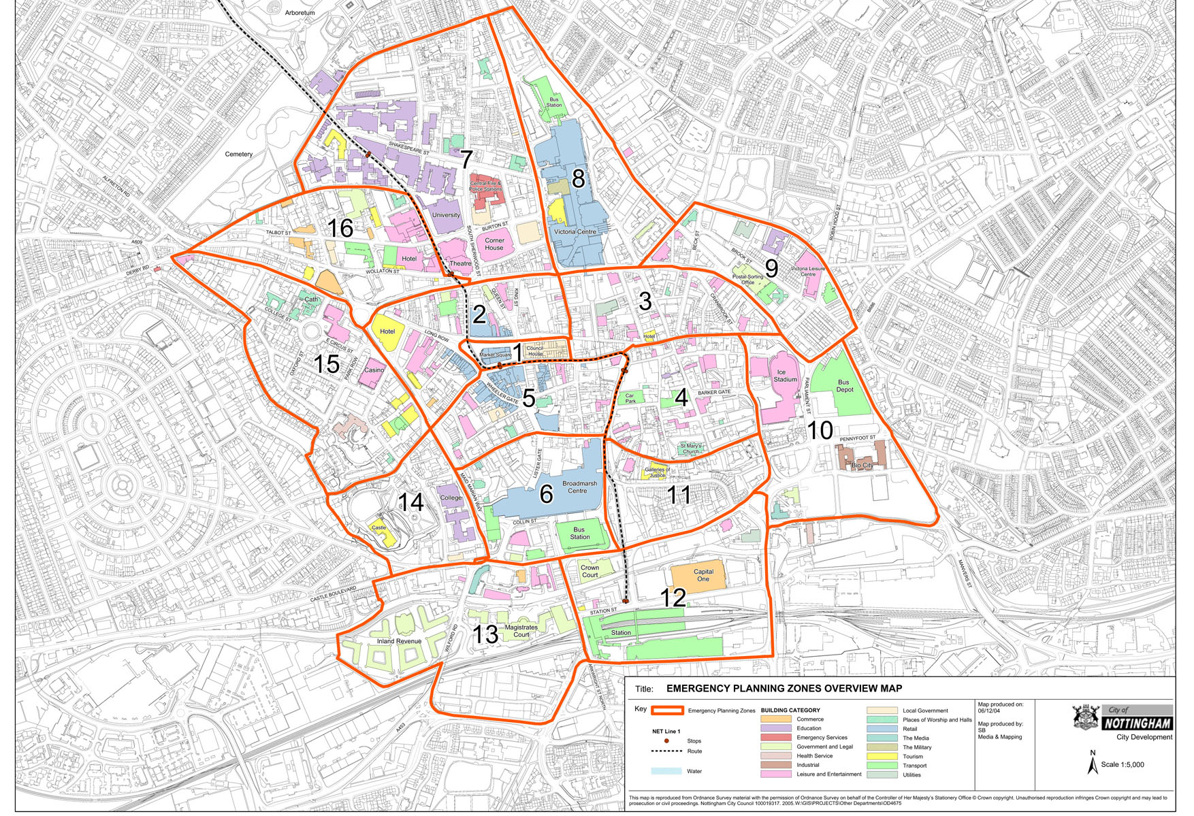

**28**