

Determined admission arrangements for Nottingham city community schools - 2021/22

Contents

Appendix 1 - Overall procedures and practices

Appendix 2 - Oversubscription criteria for Nottingham City community schools

Appendix 3 - Published admission numbers (PAN)

Appendix 4 - catchment areas

Appendix 5 - Timetable

Appendix 6 - Fair Access Protocol

Appendix 1
Admissions Arrangements for 2021/22

- Parents/carers living in Nottingham City must apply for a school place online or on Nottingham City Council’s common application form by 31 October 2020 for places in year 7 at secondary schools and by 15 January 2021 for places in reception year at infant or primary schools and year 3 at junior schools.

- Parents/carers may name up to 4 schools in order of preference for a place in year 7 at secondary schools and for a place in reception year at infant or primary schools and up to 3 schools in order of preference for a place in year 3 at junior schools. Parents/carers are strongly encouraged to name the maximum number of preferences allowed to increase their chances of being offered a place at one of their named schools.

- Reference will be made to the parent/carer’s ranked order of preference in order to determine the school for which a single offer of a place will be made.

- An email will be sent to all parents/carers who applied online by the closing date and a letter will be sent to all parents/carers who applied on a paper application form by the closing date advising of the single offer of a place on 1 March 2021 for places in year 7 at secondary schools and year 10 at 14-19 academies, university technical colleges or studio schools; and on 16 April 2021 for places in reception year at infant or primary schools and year 3 at junior schools.

- Parents/carers should confirm to the Local Authority whether or not they wish to accept the place offered within 14 days of receipt of their offer letter. Failure to do so will result in the place being withdrawn and it may be offered to another pupil.

- If a place has been offered in error or on the basis of a fraudulent or intentionally misleading application the offer may be withdrawn and the place offered to a pupil with a higher priority to that place.

- Late applications received after the closing date for places in year 7 at secondary schools will be considered after 1 March 2021; and late applications received after the closing date for places in reception year at infant or primary schools and year 3 at junior schools will be dealt with after 16 April 2021. Under exceptional circumstances the Local Authority may be willing to accept applications which are received late but by no later than 5 pm on 30 November 2020 for places in year 7 at secondary schools and 5 pm on 10 February 2021 for places in reception year at infant or primary schools and year 3 at junior schools.

- In accordance with the Council’s co-ordinated scheme for infant, primary and junior school applications and secondary school applications where it is not possible to offer a place at any of the schools named by parents/carers, the Local Authority will make an offer of an alternative school place where this is possible (known as alternative offers).

- Parents/carers living within the catchment area are not guaranteed a place. Parents/carers can check which is the catchment school for their home address by visiting the website (www.nottinghamcity.gov.uk/schooladmissions), emailing the School Admissions Team (schooladmissions@nottinghamcity.gov.uk) or by telephoning the Team (0115 841 5568).

- Attending a nursery attached to a primary school has no bearing or benefit in securing a place at that school. Parents/carers must make an application for admission to the main school as referred to in the first bullet point above.

- All applications for admission to community nursery schools must be made to the head teacher of the relevant nursery school.

- Applications for admission are considered against the planned admission number for the year group.

- Requests for in-year applications (i.e. transfers outside the time of normal transfer from one stage of education to another) are partially co-ordinated by the Local Authority. Parents/carers must apply to the Local Authority for a place at a city community school, and for a place at those schools/academies for whom the Local Authority co-ordinates in-year applications. For those schools/academies that the Local Authority does not co-ordinate in-year applications, parents/carers should contact that school/academy directly to find out how to apply for a place there. The Local Authority will strongly discourage parents/carers from transferring schools for their child where this is not as a result of a change of address. This is because if children change schools they are less likely to achieve educationally.

- The 2009 School Admissions Code required all local authorities to establish in-year fair access protocols to ensure that access to education is secured quickly for children who have no school place, and to ensure that all schools in an area admit their fair share of vulnerable and challenging children and young people. Nottingham City Council established a fair access protocol in October 2007. The fair access protocol was updated in May 2019.

- Waiting lists for reception year to year 5 will be maintained for community primary schools which are oversubscribed until the last day of the 2022 summer half term (no waiting list will be maintained for year 6).

- Children whose fifth birthday falls between 1 September 2021 and 31 August 2022 will be admitted to full-time school at the beginning of the 2021/22 school year regardless of the term start date.

- Some parents/carers may choose to defer the start of full-time education for their child until compulsory school age. If parents/carers wish to take up this option, they may arrange the details with the head teacher of the school. However, if their child’s birthday falls between 1 April and 31 August, deferring admission until compulsory school age would result in the child being admitted into a different school year. In this case, the child could not be allocated a reception place at the school during the 2021/22 year and the parent would have to apply for a place during the 2022 summer term for admission into year 1 in September 2022. The Local Authority strongly recommends that parents/carers do not defer the start of their child’s full-time education as children’s learning chances are likely to be better if they start school with their peers at the beginning of the 2021/22 school year. Parents/carers can request that their child takes up a school place part-time until their child reaches compulsory school age.

- Parents/carers may request admission for their child outside their normal age group. In general, it is considered that children should be educated in their normal age group, with the curriculum differentiated as appropriate, and they should only be educated out of their normal age group in very limited circumstances. The decision to allow a child to repeat a year or to admit a child into a cohort outside their chronological year group, in most cases lies with the school or educational setting. However, the following requests must be referred to the School Admissions Team at Children and Adults for consideration and advice:

- for children on roll at community schools due to transfer from one phase of education to another (i.e. key stage 1 to key stage 2 or key stage 3 to key stage 4);

- for children who are chronologically due to start Reception/Foundation 2, regardless of which school they are applying for

  - parents are required to make an application for their child’s normal age group at the usual time (by 15 January) but should also submit a request for admission out of the normal age group at the same time;
  - the relevant admission authority will be required to make a decision on which age group the child should be admitted to. One admission authority is not required to honour the decision made by another admission authority on admission out of the normal age group;
  - if the request is agreed by all admission authorities, the application for the normal age group may be withdrawn before a place is offered. Parents will then need to make a new application for reception/Foundation 2 as part of the main admissions round for the following year. The application will then be considered alongside other applications received and determined against the admission arrangements;
  - if the request to be admitted out of age group is refused, the parent must decide whether or not accept the offer of a place for the normal age group, or to refuse it.

- For children due to transfer from key stage 2 to key stage 3 (with the exception of pupils on roll at Nottingham Academy who wish to continue to attend the academy)

  - parents are required to make an application for their child’s normal age group at the usual time (by 31 October) but should also submit a request for admission out of the normal age group at the same time;
  - the relevant admission authority will be required to make a decision on which age group the child should be admitted to. One admission authority is not required to honour the decision made by another admission authority on admission out of the normal age group;
  - if the request is agreed by all admission authorities, the application for the normal age group may be withdrawn before a place is offered. Parents will then need to make a new application for year 6 as part of the main admissions round for the following year. The application will then be considered alongside other applications received and determined against the admission arrangements;
  - if the request to be admitted out of age group is refused, the parent must decide whether or not accept the offer of a place for the normal age group, or to refuse it.

All requests should be forwarded or referred to the School Admissions Team at the Education Department. Such requests will need to made in writing and can be from the parent/carer of a child and/or the Head Teacher of the child’s present school. The admission authority will make a decision on the basis of the circumstances of the case and in the best interests of the child concerned.

A copy of the Council’s accelerated/delayed school admissions policy can be found at www.nottinghamcity.gov.uk/schooladmissions .

- Parents/carers are advised that they may be at risk of having to apply for a new school place if their child does not attend school for a period of 20 or more school days.
APPENDIX 2

First admission to primary schools criteria: 2021/22

In the event of oversubscription within any of the criteria listed below, preference will be given to applicants who live closest to the school, as measured in a straight line (i.e. as the crow flies) from a point at the school campus to a point at the pupil’s home, both identified by the Local Land and Property Gazetteer (by a computerised geographical information system). Where two or more pupils are equal in all respects, and it is therefore not possible to differentiate between them, a method of random allocation by drawing lots will be used to allocate places (supervised by someone independent of the School Admissions Team).

Pupils who have an Education, Health and Care Plan, where that school is named in the child’s statement or plan will be admitted. In this event, the number of places that remain available for allocation will be reduced.

- Places will first be allocated to a ‘looked after child’ or a child who was previously looked after but immediately after being looked after became subject to an adoption, child arrangements, or special guardianship order including children who were previously in state care outside of England and who ceased to be in state care as a result of being adopted. A looked after child is a child who is (a) in the care of a local authority, or (b) being provided with accommodation by a local authority in the exercise of their social services functions in accordance with section 22(1) of the Children Act 1989 at the time of making an application to a school. A child is regarded as having been in state care outside of England if they were in the care of or were accommodated by a public authority, a religious organisation, or any other provider of care whose sole or main purpose is to benefit society. An adoption order is an order under the Adoption Act 1976 (see section 12 adoption orders) and children who were adopted under the Adoption and Children’s Act 2002 (see section 46 adoption orders). Child arrangements orders are defined in Section 8 of the Children Act 1989, as amended by Section 12 of the Children and Families Act 2014. Child arrangements orders replace residence orders and any residence order in force prior to 22 April 2014 is deemed to be a child arrangements order. Section 14A of the Children Act 1989 defines a ‘special guardianship order’ as an order appointing one or more individuals to be a child’s special guardian (or special guardians).

2. Places will then be allocated to pupils who, at the closing date for applications, live within the catchment area*, whose parents have requested a place at the school and who have a sibling already attending the school whom is expected still to be on roll at the proposed date of admission of the applicant sibling.

3. Places will then be allocated to other pupils who, at the closing date for applications, live within the catchment area* and whose parents have requested a place at the school.

4. Places will then be allocated to pupils who live outside the catchment area, whose parents have requested a place at the school and who, at the closing date for applications, have a sibling already attending the school whom is expected still to be on roll at the proposed date of admission of the applicant sibling.

5. Places will then be allocated to other pupils who live outside the catchment area whose parents have requested a place at the school.

*This relates to those pupils living in the catchment area for the school set for the 2021/22 school year. Younger siblings of Fernwood Primary pupils, currently living in Tom Blower Close, who are on roll at July 2021 (in Years Reception up to Year 5), who will still be on roll in the academic year that the sibling is applying for, will have priority over ‘non-catchment’ siblings and will effectively be considered as ‘catchment siblings’ for the purpose of first admission. This protected priority would not apply for subsequent siblings. Therefore, it would apply for up to a maximum of 6 years up to 2026/27 academic year of admission.

The above criteria (2-5) may be overridden and priority given to an applicant who can establish any of the following:

- pupils with special educational needs that can only be met at a specific school (e.g. where the school has specialist provision)**;
- children of travellers, pupils with exceptional medical, mobility, or social grounds that can only be met at a specific school**.

**Applications in these categories must be supported by a statement in writing from a doctor, social worker or other relevant professional. This is necessary because you will be asking the Authority to assess your child as having a stronger case than other children. Each case will be considered on its merits by Nottingham City Council.

Waiting lists will be maintained until the last day of the summer half term for reception year to year 5 (i.e. May 2022). Waiting lists will not be maintained for year 6.

For admission purposes the Local Authority considers a sibling connection to relate to any of the following:

- a brother or sister who share the same parents;
- a half brother or sister, where two children share one common parent;
- a step brother or sister, where two children are related by a parent’s marriage or civil
partnership;
- adopted or fostered children or children living in the same household under the terms of a child arrangements or special guardianship order.

Where applications are received in respect of twins, triplets or children of other multiple births, the authority will endeavour to offer places in the same school, admitting above the planned admission number where necessary. If this is not possible, the parent/carer will be asked which child(ren) should take up the place(s). The parent/carer will still have a right of appeal against a refusal of a place.

Any parent/carer whose child is refused a school place for which they have applied has the right of appeal to an independent appeals panel***. (Full details will be provided at the time of refusal).

***(Except, the parent/carer of a child who has been permanently excluded from two schools and where at least one of those exclusions took place after 1 September 1997. This applies to a twice excluded pupil for a period of two years beginning with the date the last exclusion took place).

Attendance at a particular nursery does not guarantee admission to the main school for primary education. All applications for admission to the main school must be made to the Local Authority and will be considered against the oversubscription criteria listed in 1-5 above.
APPENDIX 3

Admission Numbers 2021/22

Name of Primary School | Proposed No. |  | Name of Primary School | Proposed No.
Bentinck | 30 |  | Henry Whipple | 30
Berridge | 90 |  | Melbury | 30
Cantrell | 60 |  | Mellers | 60
Carrington | 30 |  | Middleton | 90
Claremont | 60 |  | Rise Park | 60
Crabtree Farm | 60 |  | Robin Hood | 60
Dovecote | 60 |  | Rufford | 60
Dunkirk | 60 |  | Seely | 75
Fernwood | 150 |  | Snape Wood | 30
Forest Fields | 90 |  | Southglade | 60
Glade Hill | 60 |  | Southwold | 30
Greenfields Community | 30 |  | Walter Halls | 60
Haydn | 60 |  | Welbeck | 45
Heathfield | 100 |  | Westglade | 30
Hempshill Hall | 60 |  | Whitegate | 60

Capacity assessments were undertaken by the Capital and Assets Team, Nottingham City Council using Department for Education guidance. Admission numbers are calculated by dividing the net capacity of the school by the number of year groups to be accommodated in the school.

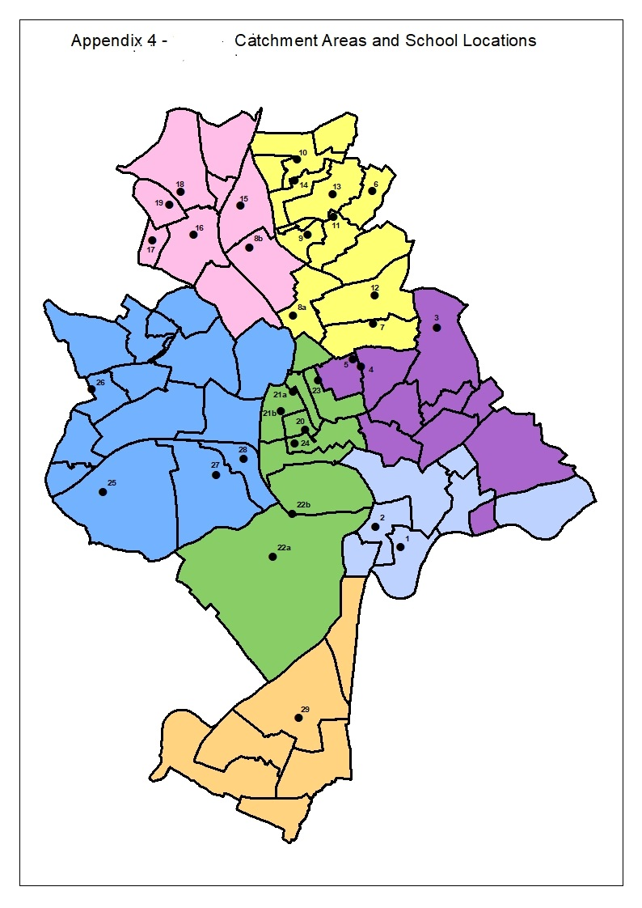
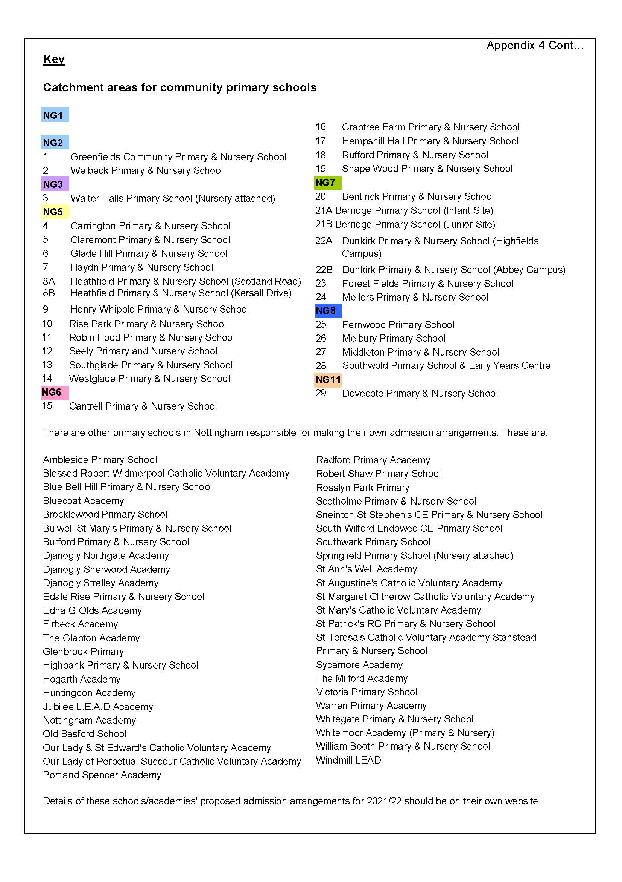
APPENDIX 5

TIMETABLE FOR CO-ORDINATED ADMISSIONS PROCESS 2021/22

2021/22  ADMISSION ROUND | Distribution of information from Local Authority to schools | Distributions of information by schools to parents/carers | Closing date | Decisions issued to parents/carers by:
Transfers from junior/primary to secondary school | By Friday 4th September 2020 | On Monday 7th September 2020 | Saturday 31st October 2020 (national closing date) | On Monday 1st March 2021 (national offer date)
First admission to infant/primary school and transfers from infant to junior school | By Wednesday 11th November 2020 | On Monday 16 November 2020  Local Authority to distribute for children not attending a nursery attached to a city infant or primary school | Wednesday 15th January 2021 (national closing date) | Friday16th April 2021 (national offer date)

APPENDIX 6


Fair Access Protocol
May 2019

Contents
1. Introduction 1
2. Fair Access Protocol – Guidance and Law 1
3. Key Principles 2
4. Fair Access Protocol Criteria and Triggers 3
5. Fair Access Protocol Membership and Meetings 6
6. Managed Move Process 8
7. Children without a school place process 10
8. Decisions and Appeals 10
9. Fair Access Funding 10
10. Information sharing and Data Protection 11
11. Monitoring and Strategic Overview 12
12. Permanent Exclusion Reintegration 12

Fair Access Protocol

Introduction
  - The School Admission Code (December 2014) requires each local authority (LA) to have a Fair Access Protocol in operation which has been agreed with the majority of schools in the area to ensure that - outside the normal admissions round - unplaced children, especially the most vulnerable, are offered a place at a suitable school as quickly as possible.

  - Fair Access Protocols have operated in Nottingham City since 2005. The protocol applies to all primary and secondary mainstream schools (including mainstream free schools) and academies.

  - The Protocol ensures local authorities, schools and academies work together as mutual stakeholders to improve behaviour and tackle persistent absence. All admission authorities must participate in the Fair Access Protocol in order to ensure that unplaced children are allocated a school place quickly. This includes admitting children above the published admission number where the year group is already full or giving priority over waiting list or admission appeals for the school/academy.

  - The Fair Access Protocol exists to ensure that access to education is secured quickly for children who have no school place, but for whom a place at a mainstream school/Academy or alternative provision is appropriate, and to ensure that all schools/Academies in an area admit their fair share of children with challenging behaviour.

Fair Access Protocol – Guidance and Law
  - Paragraph 3.10 of the school admissions code states that, “The operation of Fair Access Protocols is outside the arrangements of co-ordination and is triggered when a parent of an eligible child has not secured a school place under in-year admission procedures”. In Nottingham City, children are considered through the in-year admissions process, until they are identified as meeting triggers of the fair access protocol; in order to intervene as quickly as possible and ensure equitable distribution of pupils.

  - The School Admissions Code states in paragraph 3.8:
“Admission authorities must not refuse to admit children in the normal admissions round on the basis of their poor behaviour elsewhere. Where a child has been permanently excluded from two or more schools there is no need for an admission authority to comply with parental preference for a period of two years from the last exclusion.”

  - However, the School Admissions Code continues in paragraph 3.12:
“Where a governing body does not wish to admit a child with challenging behaviour outside the normal admissions round, even though places are available, it must refer the case to the local authority for action under the Fair Access Protocol. This will normally only be appropriate where a school has a particularly high proportion of children with challenging behaviour or previously excluded children. The use of this provision will depend on local circumstances and must be described in the local authority’s Fair Access Protocol. This provision will not apply to a looked after child, a previously looked after child or a child with a statement of special educational needs naming the school in question, as these children must be admitted.”

  - The School Admissions Code stipulates that, “There is no duty for local authorities or admission authorities to comply with parental preference when allocating places through the Fair Access Protocol” (School Admissions Code, 3.11).

  - All schools and academies (required by their funding agreements) are to comply with the Admissions Code and the law relating to admissions, including full participation with the locally agreed Fair Access Protocol and to admit pupils who are hard to place.

  - Children with an Education, Health and Care Plan will not be considered through the Fair Access Protocol but through the Special Education Needs Team processes.

Key Principles
Balancing between a quick placement and the right placement
  - There must be a balance between finding a place quickly, when the place might be in an undersubscribed school/academy or one facing challenging circumstances, and finding a place that is appropriate for the child. The principle of considering the individual circumstances of the pupil, in terms of what is best for them; whether they are ready for mainstream schooling and, if so, which mainstream school/academy will be best able to meet their needs, should guide the operation of Fair Access Protocol.
Equitable distribution
  - The School Admissions Code states local authorities must ensure that no school/academy, including undersubscribed schools/academies, is asked to admit a disproportionate number of children who have been excluded from other schools/Academies or who have challenging behaviour (School Admissions Code 2014, paragraph 3.9). Nottingham City Fair Access Protocol will try and ensure that there is equitable distribution across all categories where possible.

  - Through years of consideration of fair access cases, an established precedent has been created regarding pupil returning to the City or returning to mainstream education from Elective Home Education or alternative provision. If the pupil has previously been on roll at a Nottingham City school or academy, the pupil will return to their previous City school, unless there are significant reasons why this would not be appropriate.

  - Equitable distribution does not imply equal number of cases to each school. There may be circumstances where schools will have to admit more pupils according to need. However; the panel will take into account relevant contextual information when considering placement, such as:
  - Data in context to other local schools
  - Context of numbers on roll
  - Number of exclusions and transfers into and out of the school
  - Location of pupils home address
  - Most appropriate school to meet a student’s needs
Open, honest and relevant information sharing
  - It is expected that pupils on roll at a school or academy within the City of Nottingham, considered through the fair access protocol, will have evidence of school based intervention, and where appropriate, additional support agency involvement. Information will be shared between schools, academies and other support services as required. It will be expected that information will be shared openly and honestly, whilst ensuring confidentially and abiding to data protection laws (see section 9).

  - If a pupil is not considered through the Fair Access Protocol as a result of withheld or missing information, this will be challenged by the LA and raised at a subsequent panel meeting or directly with the Head Teacher of the school/academy. If there are ongoing concerns, the LA will monitor any further applications from the school/academy and may refer the matter to the DfE and other national bodies.

Working with other Admission Authorities and other local authorities
  - Whilst each protocol only covers the schools/academies in its local authority area, the home Local Authority should contact neighbouring authorities to help secure a place in that area under their protocol.. If there are illegal practices, the LA will take appropriate action to challenge and resolve these situations.

Fair Access Protocol Criteria and Triggers
  - A pupil placed under this Protocol is not necessarily a “challenging” pupil. Any child in this category is however potentially a vulnerable child as long as an appropriate educational placement has not been secured.

  - Fair access protocol cases will be given priority, however this does not guarantee a place at their preferenced schools. The local authority must ensure that no school – including those with available places – is asked to take a disproportionate number of children and the admission authority does not have to comply with parental preference. Priority through fair access protocols does not override infant class size legislation, unless they would be admitted under the prescribed limited exceptional circumstances.

  - The School Admissions Code 2014 states 7 minimum categories to include in a Fair Access Protocol. These categories identify a child as potentially “Hard to Place or vulnerable”. These categories are not meant to be exhaustive but provide an example of pupils who must be considered under the protocol. Nottingham City, in consultation with schools and support services, have added additional categories based on local needs. All categories are broken down between three fair access priority triggers:

  - Priority 1 – Fair Access Core Triggers
- Children in Care.
- Children permanently excluded and who need to be reintegrated back into mainstream education. (See Reintegration Protocol below)
- Children seeking an alternative to permanent exclusion with a history of intensive multi-agency support or children at risk of permanent exclusion due to a significant one-off event.
- Children who have been out of mainstream education for longer than one school term (at point of initial application) or Children with a history of serious attendance problems (serious attendance problems would be below 50% attendance within a 12 month period)
- Children fleeing domestic violence, where a school move is unavoidable (Move must be supported by relevant professions, i.e. Social Worker, WAIS, or family moved to live in a women’s refuge)
- Children returning from the criminal justice system, if not enrolled at a local school or academy.
- Vulnerable groups which have been identified under exceptional circumstances by a government mandate, to ensure education provision is established as a matter of urgency.
- Children for whom a change of school is necessary because of significant safeguarding concern, supported by children’s integrated services

  - Priority 2 – Pupil at Risk Triggers (Secondary aged children only)
Child must be on roll at a school within the City or a local neighbouring county school.
- Children with poor attendance due to lack of engagement despite school or external intervention; and attendance between 50%-70% within 12 months; and seeking a change of school.
- Children with a history of internal/external support as an early intervention to avoid further exclusions with the full commitment of parents and child.

  - Priority 3 – Children without a school place Triggers*
- children who have been out of education for two months or more;
- children of Gypsies, Roma, Travellers, refugees and asylum seekers;
- children who are homeless;
- children with unsupportive family backgrounds for whom a place has not been sought;
- children who are carers; and
- children with special educational needs, disabilities or medical conditions (but without a statement or Education, Health and Care Plan).

*To be considered under Priority 3 as a ‘child without a school place’, the child must be compulsory school age and not on roll at another school; live within the Nottingham City boundary; and, already been considered through the in-year admission process, but has had difficulty securing a school place.

  - Admission Authorities who manage their own in-year admissions are responsible for providing the LA of evidence of any in-year application that they feel meet the Fair Access Panel triggers. If agreed, the LA will request additional information as outlined in paragraph 4.9. If the pupil does not meet the Fair Access criteria, the application will be processed through the in-year admissions procedures, including year 10 and 11 pupils.

  - Children in Care are given the highest priority for admission and will be brokered as quickly as possible. The LA will establish, in consultation with Social Care, the Virtual School and other agencies, the preferred preferences for their education. The views of the schools preferenced and any potential prejudice as a result of the placement will always be considered. In most circumstances children in care will be offered and admitted, in agreement with school or academy, regardless of the time of year or if the year group is oversubscribed; if the offer is considered in their best interests. Once an offer has been made, the Social Worker will normally, but not always, arrange a multi-agency meeting to bring together all the professionals that have been working with the child to support their transition into their new educational provision.

  - The LA inclusion officers will determine if a pupil meets the fair access protocol criteria. The in-year application form includes questions to guide if a case should be considered through the fair access protocol. Further background information will be collated by the LA to support any application and determine consideration through the protocol. All schools and academies will ensure background information is shared without delay and provide the following documents:
- Full and complete Previous School Information (PSI) form
- Parental Consent form
- Last 2 years attendance certificate
- Last academic report
- Full behaviour log
- Evidence of effective intervention
- Risk assessment (if applicable)

Fair Access Protocol Membership and Meetings
Secondary
Membership
  - Membership of the panel is split between Core Membership, School Membership and Support Membership. Core members of the Fair Access Panel will attend each meeting. It is expected that at each meeting senior representatives from every school will also be in attendance, including appropriate support service representatives.

  - The collective panel membership will use their expertise and knowledge to secure a decision for each individual pupil that is best for them. When a decision is not able to be reached, the final decision will rest with Core Panel Members. The Panel will need to balance between the pupil’s individual circumstances and what school/Academy or provision can best meet their needs, whilst ensuring that the pupil is supported and that no school/Academy is asked to admit a disproportionate amount of pupils through the protocol.

  - All schools and academies will provide educational expertise and knowledge as well as represent an overall educational perspective for the City. All schools and academies will be provided with case information at least 48 hours before a panel meeting, through a secure and encrypted system.

  - Representatives from Children & Adult Services, and other relevant agencies will constitute the Support Membership of the panel. They will be expected to represent their Service Area and provide relevant information about any involvement and support that can be offered. Attendance at panel meetings for these services is as required, except for Education Welfare Service and Social Care.

  - All Panel members are responsible for arranging for an informed colleague to attend in their place should they be unable to attend. All professionals must come fully prepared with information pertaining to the individual cases to be discussed. School/Academy representatives must have the power to make decisions regarding admissions on behalf of their school/Academy.

  - The core membership of the Fair Access Panel will be:
Core Membership
Fair Access Panel Chair
Inclusion Officer
Complex Case Co-ordinator
School Membership
Bluecoat Aspley Academy  Bluecoat Beechdale Academy  Bluecoat Wollaton Academy  Denewood and Unity Learning Centre  Djanogly City Academy Nottingham  Ellis Guilford School & Sports College  Farnborough Academy  The Fernwood School  Nottingham Academy  Nottingham Free School  Nottingham Girls Academy  Nottingham University Academy Science and Technology  Nottingham University Samworth Academy  Park Vale Academy  The Bulwell Academy  The Fernwood School  The Nottingham Emmanuel School  The Oakwood Academy  Trinity Catholic School | Must be a designated senior staff member from every school / Academy that has the authority to make decision on behalf of the school/academy admission authority.
Support Membership
Children’s Social Care  Education Welfare Service  Behaviour Support Team  Special Educational Needs | Essential support services
Educational Psychology Service  Inclusive Education Service  Elective Home Education  Child & Adolescent Mental Health Service  Youth Offending Team  Ask Us Nottingham  Nottingham Virtual School  Safeguarding | Support as required

Meetings
  - The Secondary Fair Access Panel will meet regularly over the academic year. However; if there are limited cases to be considered a meeting may be cancelled and cases brokered outside of panel. The meetings are scheduled for the entire academic year.

  - All applications that meet the criteria for secondary fair access will be considered at the next available panel, however; Children in care and children who have recently experienced a traumatic family or domestic event or for whom there are clear grounds to support placement in a particular secondary school or Academy, may be considered prior to panel. Such cases will be discussed in detail between the Inclusion Officer, Fair Access Panel Chair and the Headteacher/Principal in order to agree placements as soon as possible and the decision will be ratified at the next available panel.

  - Case information will be shared securely with panel members at least 48 hours prior to the panel meeting. These cases will be collated by the LA and detailed data and statistics about Fair Access will be provided at the meeting.

  - In order to meet the 10 days admission standard, it is expected that school representatives will inform their admissions teams about the allocation of pupils for their school/academy from the panel in order to avoid any delays to the process. The school or academy must admit the pupil within 10 working days of being informed, unless an alternative date has been agreed. If the Panel agree that a multi-agency meeting take place before admission, schools/academies will have 15 working days in which to admit the pupil.
Primary
  - The local authority do not operate a panel for primary fair access due to the high number of primary schools. Cases are prepared and schools consulted regarding pupils to be considered. Based on the feedback from school consultations; placement of other pupils through fair access; consultation with support services; consideration of infant class size legislation; and the needs of the pupil; the Inclusion Officer will determine an appropriate offer. This decision will be shared with the school without delay. There will be an opportunity to discuss the decision and the support required with the Inclusion Officer before a decision letter is sent to parents. All schools and academies will support the decision of the Inclusion Officer.

Managed Move Process
  - Local authority approved managed moves are a mechanism for supported transfer between local schools through the fair access protocol unless receiving school or parents wish to opt for direct admission. This process seeks to support all parties involved to enable a ‘fresh start’ and strive for a successful move. Managed moves will be appropriate for pupils where they has been a serious breakdown in relationships within the school, or at growing risk of further exclusion or at risk of imminent permanent exclusion, due to a ‘one-off’ incident.

  - Pupils who are currently on roll at a local school, who meet the fair access criteria (priority 1 or 2) and seeking a transfer to another school, will be considered as a Managed Move. Exceptions to this process will be determined by the LA Officer.

  - To be considered for a Managed Move the school will need to provide complete background information to the LA. The LA officer will then contact or visit parents/carers to discuss the managed move process, seek their views and confirm their agreement to a move. Based on the information and feedback the LA officer will determine if a Managed Move is considered or declined. The home school should continue to provide full-time supervised educational provision whilst a managed move is arranged.

  - Direct pupil funding from the home school will follow the pupil on a sliding scale formula at the point of permanent transfer following a successful Managed Move. This will not apply for direct admissions.

  - All managed moves must be agreed by the Inclusion Officer and brokered through the fair access protocol. Any managed moves cases arranged outside of this process will not be included in fair access support, funding or data. These cases will not have fair access priority and must be considered in line with the in-year admissions process.

  - Headteachers/Principals should consider reporting periodically to Governors on Managed Moves as with exclusions.
Managed Move Meetings
  - The Inclusion Officer will arrange a meeting between all relevant parties to discuss the arrangements for the Managed Move. The meeting will be held at a mutually convenient time within the extended school day (8am – 4.30pm). The meeting objectives will be to agree the terms of the managed move. This includes agreeing a start date, duration of the move trial (agreed at the meeting but normally 6-8 weeks), support/intervention strategies, and success criteria such as expected targets, attendance and behaviour. These will be agreed by all parties and form part of the review process.

  - Managed Moves will be reviewed at least twice during the trial period; however, further reviews may be agreed at the initial meeting or during the trial period. Reviews should focus on the agreed success criteria providing an opportunity for all parties to discuss successes and concerns. Any concerns must be addressed and appropriate plans agreed and put in place. In exceptional circumstances, this may lead to a short-term extension to the trial period. A serious breach of the agreements could invoke an immediate review resulting in a termination of the managed move and a return to the home school.

  - Following a final review meeting, if successful, the pupil will go on roll of the host school and this signifies an end to the Managed Move process. If unsuccessful, arrangements will be made for the pupil to return to their home school or other educational provision and the trial placement ended.

  - Managed Move arrangements:

Registration and Roll Arrangements:
All students will be dual registered (home school as the main registered base) and CLM will be used daily to monitor and communicate attendance. Should a host school wish to issue a fixed term exclusion this MUST be negotiated in advance with the home school who retains the legal responsibility for determining an exclusion and following the exclusion process.

School Uniform:
Parent(s)/Carers will be responsible for purchasing and providing appropriate uniform, however, if the move fails, the host school may buy back school specific uniform. Some discretionary financial assistance may be given as agreed by the Inclusion Officer.

School Transport:
Parent(s)/Carers will be responsible for transport arrangements and costs to the host school if within a reasonable travelling distance. If beyond this distance, some discretionary financial assistance may be given as agreed by the Inclusion Officer.

Free School Meals:
Pupils eligible for free school meals will have this provided by the host school and the home school will be invoiced to cover this cost.

Children without a school place process
  - Children considered under priority 3 of the fair access protocol will be case managed by the responsible LA Officer. They will seek a reasonable offer of a school place, which will take into consideration reasonable walking distances and potential travel assistance.

  - The aim of this process is to secure an appropriate school place as quickly as possible. Parents/carers will still have the ability to make new preferences and have the right to appeal against a decision. However; if parents do not accept the local authority’s reasonable offer, and are unable to secure another educational provision, the local authority will seek to issue a school attendance order through the Education Welfare Service and the appropriate legal system.

  - The process for cases considered under fair access protocol priority 3 is designed to ensure that pupils are placed without further delay and stops the need for escalation to higher fair access priority processes.

Decisions and Appeals
  - Letters to schools and parent(s)/carers will be issued within 48 hours of the agreed decision.

  - When an offer has been agreed, the school or academy must admit the pupil within 10 working days of being informed, unless an alternative date has been agreed. If the Inclusion Officer agrees that a multi-agency meeting take place before admission, schools/Academies will have 15 working days in which to admit the pupil.

  - The Fair Access Panel will consider any valid concerns about admission (e.g. a previous serious breakdown in the relationship between the school/Academy and the family or serious historical issues with other children at the preferred school/Academy). Consideration will also be given to the individual situation, and contextual data for each school or Academy, including, the number of pupils admitted through the panel and being supported by the school or academy.

  - If a school or academy refuses to comply with the fair access protocol decision, they must state their reasons in writing to the Inclusion Officer within 5 school days from the date of the decision. The Inclusion Officer will then determine a written view, based on evidence and contextual data and after consulting with the school/academy and any relevant agencies. A final written view will confirm the local authority decision and it is expected that all schools and academies will support this view and accept the final decision. If a school/academy’s admission authority refuses to accept the decision of the Fair Access Panel, the Local Authority will seek to enforce a direction or apply to the Education Funding Agency to direct admission on behalf of the Secretary of State, if required.

Fair Access Funding
  - The LA has secured funding through the Schools Forum to support the fair access protocol and provide needs led support funding to reduce barriers to admission. This funding is secured to support fair access pupils’ integration back into education through translation costs, assessments, purchasing support services and providing alternative provision for pupils who are not ready for mainstream schooling.

  - There are currently three tiers for funding available through Fair Access:
TIER 1 | No funding allocated  Students placed whose needs are met by mainstream school/academy and/or support services core involvement
TIER 2 | Assessment and access funding  Funding allocated to provide an assessment of needs to inform placement decisions (in particular where there are significant gaps in educational provision, students who speak English as an additional language (EAL) or those who have an incomplete SEND profile.  Access funding provides for one off payments in extraordinary circumstances to remove barriers to admission and access to schools.
TIER 3 | Support funding for alternative provision  Subsidised funding agreed for an alternative provision to be managed by the allocated school.  Students who require AP, or support packages will be able to access funding subject to LA/fair access approval (minus secured pupil funding and AWPU). Funding requests must be received with 18 months of the decision date.  The funding amount and length of support will be agreed by the LA, and for secondary cases, where appropriate panel members at the meeting.

  - Request for funding must be submitted in writing to the Inclusion Officer for consideration. If the placement is withdrawn, any remaining funding will return to the fair access budget.

  - There is no funding for priority 3 (Children without a school place) protocol cases and schools would secure funding for pupil support through the normal routes.

Information sharing and Data Protection
  - All information gathered for the use of administering fair access across primary and secondary phases will be stored securely on the Councils computer network and systems. Information about pupils will be stored digitally on the network and within the Councils Education Management System.

  - Completed cases will be shared with relevant staff members at schools/academies, alternative providers and other agencies as appropriate. Any information may be shared with other council services/local authorities as required.

  - Case information and personal data will be transferred by secure electronic means, such as encrypted email or secure file transfer.

  - All parties’ receiving information from fair access will have to comply with the data handling requirements stipulated by the council. This includes ensuring that personal information sent to them is stored securely and is only shared to relevant senior leadership or support staff. If any documents are printed, they will ensure the safe storage and destruction of the data. For full details of the Councils Privacy Statement please see https://www.nottinghamcity.gov.uk/privacy-statement

Monitoring and Strategic Overview
  - Reports, data and monitoring information will be shared at regular intervals to all schools, academies and stakeholders. This information will also be used to report to the Schools Adjudicator and local Schools Forum in order to comply with performance and accountability responsibilities.

  - The Fair Access protocol and strategy is the responsibility of the LA, however; there will be an annual review in consultation with Head Teachers/Principles from City schools/academies and local authority officers, which will review the performance of the panel, discuss strategic issues and make recommendations to improve services and drive change.

Permanent Exclusion Reintegration
  - Pupils who have been permanently excluded, who have demonstrated readiness for reintegration, will be managed through this protocol. Learning Centres and AP Free Schools work to identify pupils needs, address behaviour, attitudes and academic underperformance in order to raise achievement and reintegrate permanently excluded pupils back into mainstream education. Reintegration into another mainstream school/Academy is the right option for the majority of pupils in year KS1, KS2 and KS3 whose needs have been addressed and supported.

  - Pupils will not usually be considered for reintegration into a mainstream school/academy until their behavioural and social or emotional needs have been addressed and they are ready to return to a mainstream setting. The Head Teacher and their Reintegration Team identify and support pupils who are ready to reintegrate back into mainstream education from a permanent exclusion. This will be supported by background information and evidence about the pupil and their progress whilst at the learning centre. This information will be monitored and reviewed by the current education provider and the LA before consideration through the Fair Access Protocol.

  - Pupils who live in the City boundary who have been permanently excluded will normally be placed on the roll of either Denewood or Unity Academy. Permanently excluded pupils who move into the City, who are not ready for mainstream education will attend a Learning Centre until they are ready to be reintegrated back to mainstream education.

  - All Schools and Academies will take at least 1 reintegration pupil as required. Further reintegration pupils will be allocated through the panel and consideration will be given to the number of permanent exclusions issued by the school/Academy. Fair Access Protocols must not require a school/Academy to automatically take another child with challenging behaviour in the place of a child excluded from the school.

  - Reintegration placements will be supported by staff from the Admissions and Reintegration Team (ART) at the learning centre. A reintegration package will be agreed between the learning centre and the school. The length of the package will normally be between 6-8 weeks and will be agreed between the learning centre and the allocated school. The reintegration package must start within the 10 days of the panel decision, unless an exception is agreed at the panel meeting. A meeting should be set up without delay to facilitate the start date, set appropriate targets and plan the reintegration package. There must be regular reviews and communication between all parties involved, which should be sent out in writing, ideally by email to named contacts.

  - It is anticipated that pupils will be successfully reintegrated through the support of school staff and the learning centre. Review meetings will take place regularly through the reintegration process to acknowledge success, review support and raise concerns. If the review meetings are positive, their success will be confirmed at the final review meeting and the pupil will officially go on roll the school day after the package ends. However, as an additional measure to ensure success, Denewood/Unity will continue to monitor the pupil for a further half term after the pupil is on roll in order to facilitate support, or consider a return to Denewood/Unity if appropriate and agreed by all parties.

  - If there are concerns about a pupil on a reintegration package, the school should initially communicate with the pupils named keyworker at Denewood/Unity Learning Centre to try and resolve the concerns. If a reintegration may be failing, then this cannot be terminated until an urgent review meeting is held with all relevant parties to determine if the allocation should be withdrawn, at which point arrangements would be made for their return to the learning centre. The pupil and parent(s)/carer should not be told the place is terminated, until this meeting is held and all parties agree to withdraw the reintegration. The LA Inclusion Officer should be informed if a placement is breaking down and may attend any review meetings as needed.

  - Reintegration placements will be recorded through the panel. These pupils are normally
funded outside of the protocol process through school finance. However; schools will be able to request additional support, if required, through the normal protocol funding route (see section 8).

The School Admissions Code can be viewed in full at: https://www.gov.uk/government/publications/school-admissions-code--2
This is not an exhaustive list of all factors that may be taken into consideration
The excepted children are: - children admitted outside the normal admissions round with statements of special educational needs or Education, Health and Care Plans specifying a school; - looked after children and previously looked after children admitted outside the normal admissions round; - children admitted, after initial allocation of places, because of a procedural error made by the admission authority or local authority in the original application process; - children admitted after an independent appeals panel upholds an appeal; - children who move into the area outside the normal admissions round for whom there is no other available school within reasonable distance; - children of UK service personnel admitted outside the normal admissions round; - children whose twin or sibling from a multiple birth is admitted otherwise than as an excepted pupil; - children with special educational needs who are normally taught in a special educational needs unit attached to the school, or registered at a special school, who attend some infant classes within the mainstream school.
Children who are not compulsory school age are not covered by the fair access protocols.
Registered at another school within a reasonable distance of the home address.
Difficulty in securing a school place will be triggered when an eligible child has not secured a school place under the in-year admission procedures, despite making a preference for all available schools within a reasonable walking distance (unless there are significant evidenced mitigating circumstances).
A ‘looked after child’ is a child who is (a) in the care of a local authority, or (b) being provided with accommodation by a local authority in the exercise of their social services functions (see the definition in Section 22(1) of the Children Act 1989) at the time of making an application to a school.
Nottingham City school or local neighbouring county school
Home school, host school, parent(s)/carers and the Inclusion Officer. Other agencies will be invited as required.

