NOTTINGHAM CITY COUNCIL
MANAGEMENT OF NOTTINGHAM CITY CENTRE
PULIC SPACES PROTECTION ORDER 2026
(ANTI-SOCIAL BEHAVIOUR, CRIME AND POLCIING ACT 2025, CHAPTER 2, SECTION 59-75)
- Nottingham City Council being satisfied on reasonable grounds that the activities prohibited and or restricted by Articles 4.2 and 5 to 8 and 11 to 13 of this Order in the Restricted Area:
i) have had a detrimental effect on the quality of life of those in the locality of the Restricted Area or that it is likely that these activities will be carried out in the Restricted Area and that they will have such an effect, and

ii) that the effect or likely effect of these activities is or is likely to be of a persistent or continuing nature, and

iii) that these activities are unreasonable, and

iv) justify the restrictions and prohibitions imposed by this Order

HEREBY makes the following Order:
- In this Order and Schedule to this Order:
Advertisement | has the meaning in section 336(1) of the Town and Country Planning Act 1990
Authorised Officer of the Council | means an employee of the Council who is authorised in writing by the Council for the purposes of the specific Article concerned
Authorised Person | means  i) an Authorised Officer of the Council;  ii) a police constable; or  iii) a community support officer (commonly known as police community support officer (PCSO) designated under Chapter 1 Part 3 of the Policing and Crime Act 2017
Authorised Big Issue Pitch | means a location specified on the Council’s website as amended and updated from time to time where the Council permits the sale of the Big Issue Magazine subject to Article 5.2 of this Order
Big Issue Magazine | means a periodical magazine published by The Big Issue Company Limited
Busker | means a person Busking
Busking | means the provision of the Entertainment in the Restricted Area but does not include the provision of Entertainment –  - under and in accordance with a premises licence under Part 3 of the Licensing Act 2003, or a temporary event notice having effect under Part 5 of that Act, which authorises the provision of regulated entertainment (within paragraph 2(1)(e) to (h) or 3(2) of Schedule 1 of that Act (music and dancing));  - which is authorised specifically to take place in a street under any other enactment; or  - consisting of music performed as an incident of a religious meeting, procession or service;  and “Busk” and “Busks” shall be construed accordingly
Charity | has the meaning in section 1 of the Charities Act 2011
the Council | Nottingham City Council
Distribute | means to –  - give out to;  - offer to; or  - make available to  a person or persons  and “Distributing” “Distributor” “Distribution” “Distributed” and “Distributes” shall be construed accordingly
Entertainment | includes but is not limited to the following types of behaviour –  - the playing of music or use of a musical instrument;  - mime;  - singing;  - dancing;  - street theatre; or  - other form of entertainment or activity  with the aim of attracting an audience and or receiving payment donation
Free | means without payment or charge and shall include Matter which is Distributed subject to-  - a voluntary payment or charge; or  - discretionary donations which includes required and suggested donations
Highway | has its common law meaning
Impliedly Requested By Conduct | includes but is not limited to standing, sitting, lying or loitering in the vicinity of an automated teller machine, taxi rank or public transport stop except in circumstances where they personally intend to forthwith use the same
Matter | means any item, material, substance, object or thing
Mobile Advertisement | means an Advertisement comprising of or included on a placard borne by or a sandwich board or costume worn by a person or animal
Open to the Air | means  - land which is open to the air  - a place on land notwithstanding that it is covered if it is open to the air on at least one side  - car parks and multi-story car parks whether covered, enclosed or not
Plan | the plan attached to this Order
Printed Matter | includes –  - leaflets;  - magazines;  - newspapers;  - booklets;  - stickers;  - posters;  - documents; and or  - cards  but for the sake of clarity Printed Matter does not include other Matter which is being Distributed in a vessel or receptacle which has printing on the outside
Prohibited Busking Location | means the following Highways –  - Long Row between its junctions with King Street and High Street;  - Smithy Row;  - Cheapside  - Poultry
Public Place | has the meaning given by section 74(1) of the 2014 Act
Restricted Area | means the land designated in the Schedule to this Order edged with a bold green line on the Plan
The Big Issue Company Limited | means the company registered at Companies House with company registration number 02612480
the 2014 Act | Anti-social Behaviour, Crime and Policing Act 2014
Unauthorised Requests | means a request which is not authorised by law or by permit licence or other written consent or authority of the Council

- This Order comes into force on xxx xxx 2026 and remains in effect for a period of three years from that date.

RESTRICTIONS AND PROHIBITIONS
Management of street scene environment including behaviours obstructing other users of the Restricted Area
4.1 No person (“P”) shall remain in the Restricted Area so as to:
4.1.1 obstruct ingress to or egress from any building; or
4.1.2 prevent or hinder the street cleansing activity of the Council; or
4.1.4 hinder the free passage of pedestrians or vehicles along a Highway.
4.2 Subject to Article 4.3 an Authorised Person who reasonably believes that P is in breach of prohibition of Article 4.1 of this Order may require that P stop that breach forthwith

4.3 The Authorised Person who imposes a requirement under Article 4.2 of this Order must
4.3.1 Explain to P the nature of the breach of Article 4.1 of this Order, and
4.3.2 tell P that failing without reasonable excuse to comply with that requirement is an offence
4.4 A requirement imposed by an Authorised Officer of the Council under Article 4.2 of this Order is not valid if the person
4.5.1 is asked by P to show evidence of his or her authorisation, and
4.5.2 fails to do so
5. No person shall sell or offer for sale the Big Issue Magazine in the Restricted Area unless they are:
5.1 located on an Authorised Big Issue Pitch, and
5.2 displaying their valid Big Issue vendor identification badge issued by The Big Issue Company Limited

6. No person shall display Mobile Advertisements in the Restricted Area unless:

6.1 they have written consent from the Council for that Mobile Advertisement, and

6.2 they are operating in accordance with the terms of that consent.

7. No person shall Busk in a Prohibited Busking Location within the Restricted Area.

8. Subject to Article 9 of this Order where an Authorised Person reasonably believes that a Busker (“B”) is Busking in the Restricted Area and is or has been in the opinion of the Authorised Person causing an unreasonable disturbance to persons in that locality the Authorised Person may require that Busker to stop Busking forthwith
9. The Authorised Person who imposes a requirement under Article 8 of this Order must tell B that failing without reasonable excuse to comply with that requirement is an offence
10. A requirement imposed by an Authorised Officer of the Council under Article 8 of this Order is not valid if the person
10.1 is asked by B to show evidence of his or her authorisation, and
10.2 fails to do so
11. No person shall Distribute Free Matter in the Restricted Area to a person or persons not known to the Distributor unless:

11.1 they are authorised by law, permit, licence or the written consent of the Council for that Distribution, or

11.2 they are Distributing Free Printed Matter, and

11.2.1 that Distribution is by or on behalf of a Charity where the Free Printed Matter relates to or is intended for the benefit of the Charity; or

11.2.2 that Distribution is for political purposes or for the purposes of a religion or belief.

Unauthorised Requests in the Restricted Area

12. No person in the Restricted Area shall:

12.1 make an Unauthorised Request for money, personal items, charitable and or other donations whether expressly or Impliedly Requested By Conduct; or

12.2 stop or approach another person to make an Unauthorised Request with the intention of asking that other person

12.2.1 to enter into any arrangements which involve that other person making any future payment for any charitable or other purposes; or

12.2.2 for any information to assist that other person being contacted at another time with a view to making arrangements for that person to make any payment for any charitable or other purposes.

Urination/Defecation in the Restricted Area

13. No person shall urinate or defecate in the Restricted Area (which includes a doorway or alcove of any premises to which the public has access).

OFFENCE
14. A person who fails without reasonable excuse to comply with a prohibition and or requirement imposed on him or her under Articles 4.2 and 5 to 8 and 11 to 13 of this Order commits an offence and is liable on summary conviction to a fine not exceeding level 3 on the standard scale, however, there will only be a breach of a prohibition imposed under Article 12 of this Order where the person knows of that prohibition.
15. A person does not commit an offence under this Order by failing to comply with a requirement or prohibition that the Council did not have the power to include in the Order.

Dated this ……… day of ……… 2026

Given under the COMMON SEAL )
Of NOTTINGHAM CITY COUNCIL )

Authorised Signatory

SCHEDULE
This Order applies to all land edged with a bold green line on the Plan that is Open to the Air and a Public Place

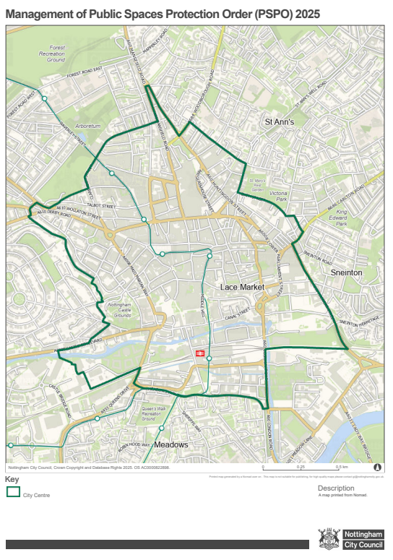

NOTTINGHAM CITY COUNCIL
MANAGEMENT OF NOTTINGHAM CITY CENTRE
PUBLIC SPACES PROTECTION ORDER 2025
(ANTI-SOCIAL BEHAVIOUR CRIME AND POLICING ACT 2014, CHAPTER 2, SECTION 59-75)

