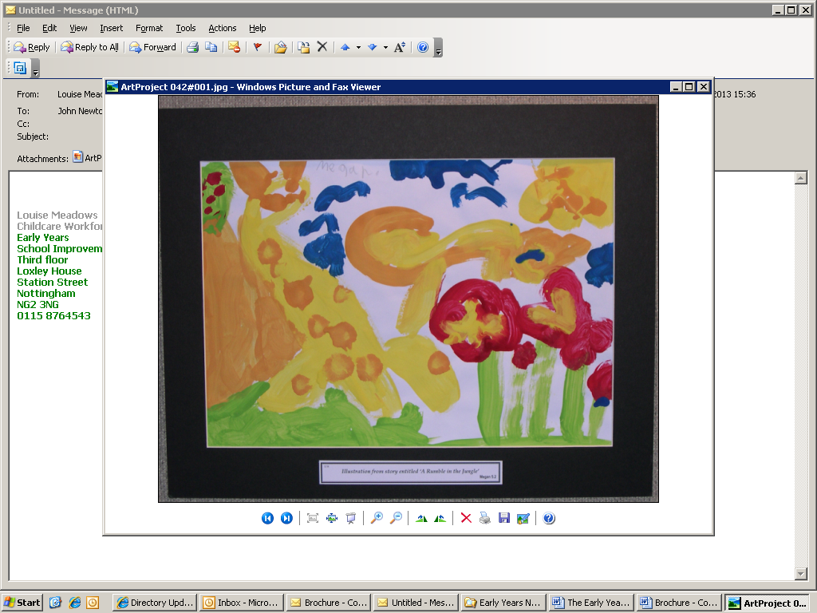

**The**

**Early Years**

**Team**

**Business Direction and Planning for Sustainability**

There is a wealth of information available regarding business support, financial support and guidance for businesses during this time. This is not an exhaustive list but collates some of the key information to enable childcare businesses to navigate the resources most appropriate for their own individual circumstances, whether that be a childminder caring for 2 children or a group-based setting caring for 120 children.

As we entered the recovery phase following the global pandemic, COVID 19, colleagues at Hempsall’s produced these useful documents to help visualise how childcare providers particularly can move through these challenging times towards ensuring future sustainability.

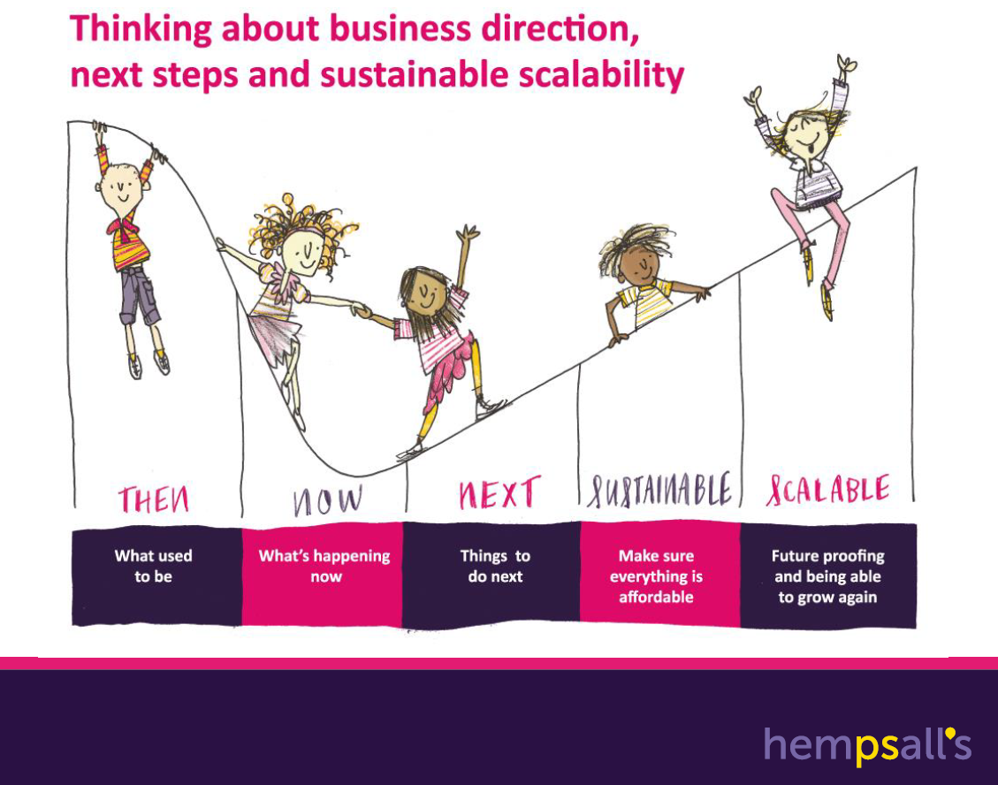

Nottingham City is fortunate to offer a rich, mixed economy of provision to local children and families. Whilst most childcare providers re-opened after the pandemic, it has become apparent that the parental demand for childcare provision has changed.

**Childcare Sufficiency – Considering Supply and Demand**

As we navigate through the ‘Now and Next’ phases of the above visual, planning is paramount and childcare businesses will need to adapt to meet changing parental demand.

Childcare providers have the best knowledge of their own customer base and through regular communication should have a reasonable understanding about how each family is feeling with regard to accessing childcare provision going forwards. Some families may have continued to use the provision during the pandemic, some may have already returned and some may still be deciding whether to return and when.

This visual, again thanks to Hempsall’s, outlines some of the factors affecting parental preferences at this time and should be given due consideration for the customer base of each individual childcare provider to enable them to plan their services going forwards.

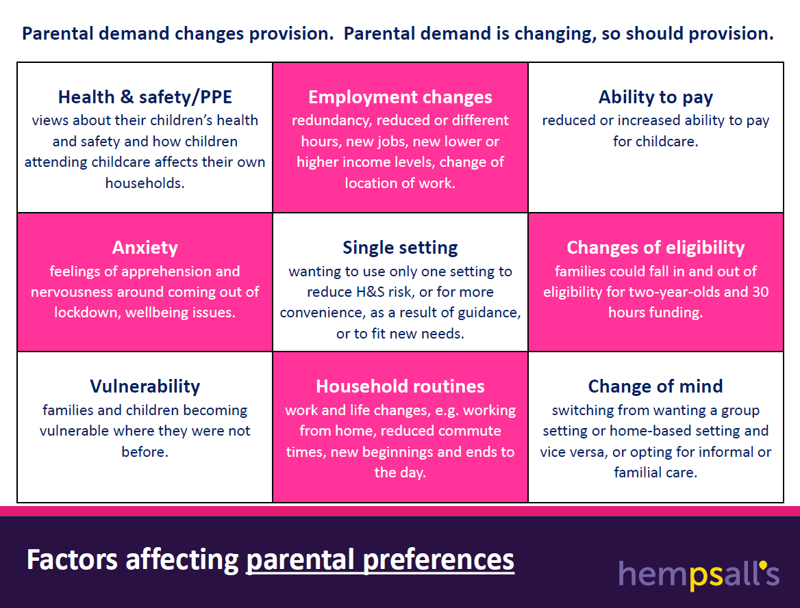

Coupled with the factors affecting demand, childcare providers need to consider what they can offer in relation to supply, it may be that not all children can be accommodated within the provision as they were before. This will impact on utilisation of space and staffing requirements, and of course, therefore, ultimately, the income that can be generated in a reduced capacity model.

In light of the need to adapt business plans, childcare providers will need to allocate sufficient time to update budget forecasts, considering the factors affecting supply and demand to realistically plan for a build in occupancy and adapting shift patterns over the coming months. A cash flow forecast may assist with this planning.

**National Support and Information**

In developing a response to planning for sustainability, childcare businesses should investigate the range of support available that could complement the two primary sources of income generation, parental fees and early years entitlements funding for 2, 3 and 4 year olds.

Continued support through early years entitlements funding for 2, 3 and 4 year olds should be factored into your planning, reflected at realistic, occupancy building levels and SEND Inclusion Funding and DAF may also be further sources of income.

Updated as guidance changes, the **Government Financial Support Checker,** is an online questionnaire tailored to individual business circumstances to identify the support available. This may include deferring VAT payments and Income Tax Self Assessments, repayment holidays on loans, mortgages and business rates holidays, the Small Business Grant Scheme and the Self Employed Income Support Scheme and can be accessed at [at this link.](http://www.gov.uk/business-coronavirus-support-finder/y)

**ACAS** are a national organisation providing guidance on a range of information for employers and employees in relation to working safely. Resources can be accessed [here](https://www.acas.org.uk/coronavirus)

**Local Support and Information**

The first port of call for childcare providers in Nottingham City with the Early Years Team should be the providers EYFS Support Worker, but updates on key issues are also provided by email and on the Early Years Website.

Further information and resources relating to starting and running a childcare business can be found on our website [www.nottinghamcity.gov.uk/earlyyears/](http://www.nottinghamcity.gov.uk/earlyyears/)

