Application for a pavement café licence

Introduction

Nottingham has much to offer local residents and visitors to the city. A compact city centre, many pedestrianised streets and a cosmopolitan ‘buzz’ make it highly attractive for outdoor seating use. We can’t guarantee fine weather all the time of course, but don’t let that put you off, visitors to Nottingham love being outside, as much as they do undercover!

This application leaflet highlights the standards and requirements usually expected of pavement café operations, and guides you through the process of applying for a licence.

The guide contains three main sections:

- General requirements
- Application forms
- Contact details for further information
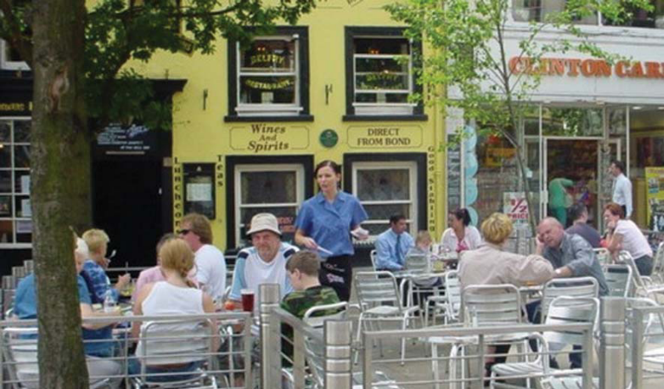

1. General requirements

Pavement cafés may be sited on the public highway and are authorised by the granting of an annually renewable licence. Seated areas on privately owned land, to the rear of buildings or in other courtyard areas do not require a pavement café licence from the Council but it is advisable to check beforehand.

It is not normally necessary to obtain planning permission in addition to the licence, provided that the main premises connected to the pavement has either Class A3 or A4 use. However, planning permission is necessary if any permanent fixtures are proposed as they may constitute development.

For applicants wishing to apply for a licence, it is advisable to discuss your proposals prior to submission. Completed applications will normally take two months to be determined. This includes a statutory notice period of 28 days, during which time objections can be addressed. Each application will be considered on its own merit and Nottingham City Council reserves the right to refuse an application if considered inappropriate.

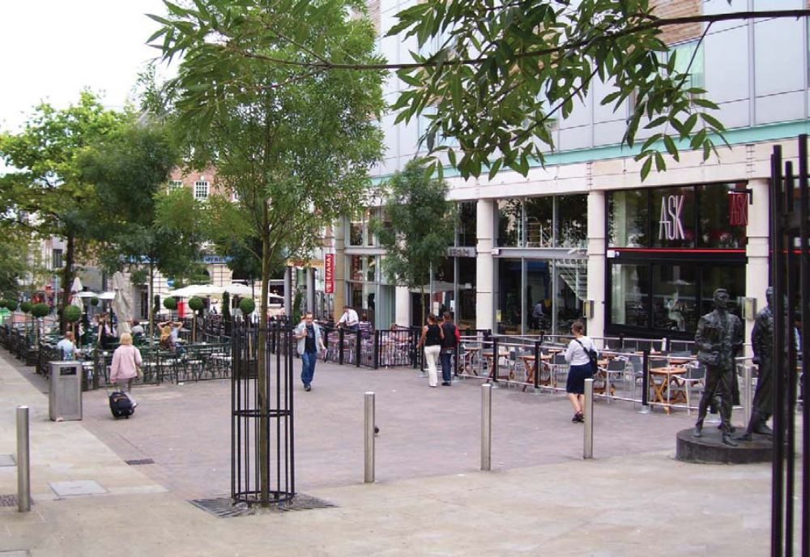

1.1. Suitable areas and local restrictions

Most city centre locations are able to accommodate pavement seating. However, there are a number of areas where access is restricted, where other obstructions or uses are permitted or where a pavement café would make pedestrian routes unsafe.

The map below highlights the streets in the city centre where restrictions apply and applications for pavement seating will not normally be considered.

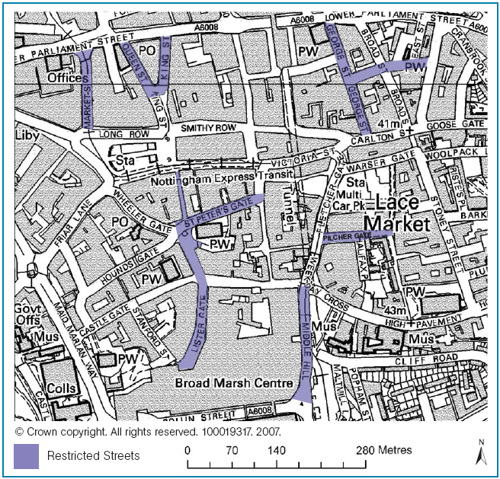

In the Old Market Square pavement cafés are only normally permitted on Long Row (to the north side of the Square). Pavement seating on Long Row is normally permitted in two specific areas; the main area from the edge of the Long Row arcade to the edge of the delivery access road, and a second area adjacent to the planters when this space is not in use for events. These are indicated on the plan below.

In the area where seating can be accommodated each application has to be considered on its own merits. Nottingham City Council reserves the right to refuse or rescind a licence if considered inappropriate or if it deems the location to be unsuitable for outdoor pavement café use.

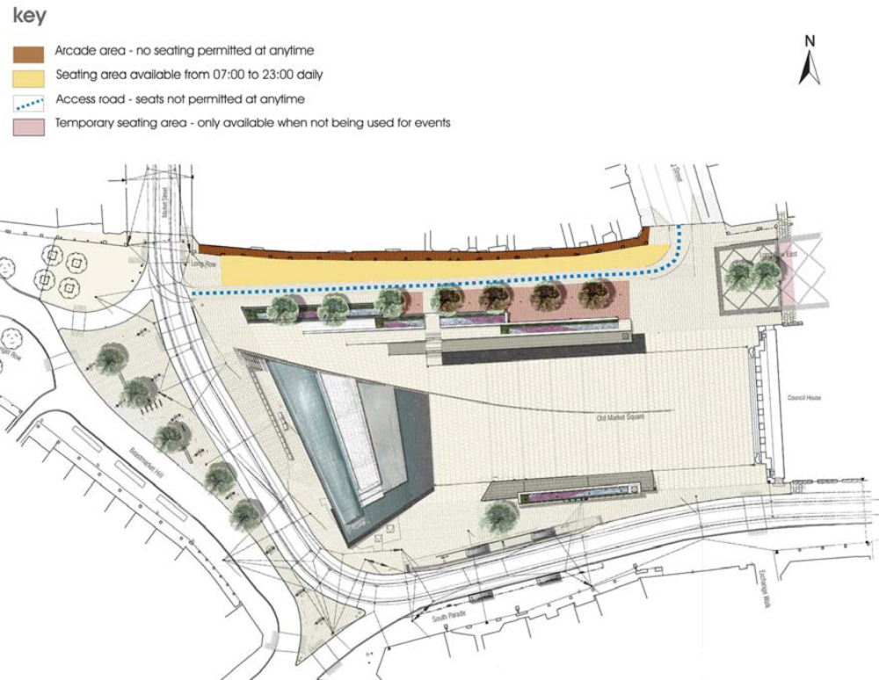
1.2. Size and layout

Pavement café areas will normally be situated parallel to, and in line with, the front of the main premises holding the licence, leaving a two metre clear gap between the building and licensed area. Where suitable recesses in the building line exist or in areas where pedestrians prefer to walk away from the building frontage, the pavement licensed area may be located adjacent to the building. If the proposed area fronts adjacent or other properties, prior consent from these owners/occupiers will be required.

The area to be used must take into account other needs and uses in the vicinity (e.g. pedestrian crossings, loading bays and street furniture). A minimum distance of 0.5 metres must be kept clear of the kerb line of regularly trafficked routes.

Consideration to size and layout must be given to allow customers with disabilities to access and move around within the licensed area.

All emergency exits and routes from buildings and those associated with the highway must be kept clear.

1.3. Means of enclosure

All pavement cafés, when in use, are to be enclosed with barriers to mark the licensed area and to reduce the risk of accidents to both customers and other pedestrians. When not in use, or outside of the licensed period, barriers must be removed. The only exception is where planning permission has been sought and arrangements for permanent/semi permanent barrier systems have been made.

Materials for the barriers need to be selected on the basis that they are strong and robust enough to withstand collapse if accidentally stumbled into. As barriers need to be portable the materials used should also be lightweight. Fabric barriers are not normally permitted due to safety issues as weather conditions can sometimes make these unsafe. Some mesh fabrics or part fabric barriers which allow the wind to pass through may be considered. Please contact the Council to discuss means of enclosure.

The design of the barrier system must compliment the character of the surrounding area. In the city centre, the Council requires a higher specification to be met, reflecting the special character of the area. Please contact the Council for more details.

All barriers must have solid/fixed rails that run both horizontally and vertically, with the upper and lower rails set at 1000mm and 100mm above ground level respectively. Rope barriers are not considered to be suitable.

Planters can be used as part of the enclosure but must be removed outside of the licensed period if you do not have planning permission. In certain circumstances existing street railings or other suitable items of furniture may be utilised as a suitable means of enclosure. Please contact the Council to discuss specific locations.

1.4. Furniture and equipment

Furniture must be of a high quality, uniform style and suitable for outside use. Plastic garden furniture and/or picnic tables will not be permitted.

Incidental items including menu boards, portable gas heaters and signs also need to be approved and form part of the conditions of licence. Cooking equipment and BBQs are not permitted.

Where umbrellas or fabric barriers are used these must be non-reflective fabric with small logos displaying ONLY the name of the establishment up to 450x150mm in size. Brewery/product branding is not permitted. Umbrellas are to be positioned to avoid impairing any vehicle sight lines and must not overhang the edge of the enclosure. They must be suitably secured and balanced to withstand reasonable winds.

All items contained within the enclosure must be portable enough to be brought in at the end of the licensed period of each working day, or to be moved quickly in the event of an emergency.

1.5. Environmental and other requirements

In certain parts of the city centre the quality of air from traffic fumes makes it inappropriate to site pavement cafés and Nottingham City Council will not issue a licence under such conditions. In other areas, consideration needs to be given to the proximity of bus stops and taxi ranks, not only from the aspect of air quality but also taking into account movement of vehicles and people. Please contact the Council to discuss this further.

It is the responsibility of the pavement café operator to keep the licensed areas free of all litter during the hours of operation, including any litter that has blown into the enclosed area. The operator is also responsible for the removal of any litter in the immediate area that is generated by the pavement café.

All pavement café operations must comply with the relevant liquor licensing, food safety and toilet requirements relating to the main premises. Further advice should be sought from the relevant Council departments in relation to these requirements prior to making a licence application.

1.6. General conditions of licence

The licence applied for is covered by Section 115E of the Highways Act: Highways Amenities Licence (HAL). The licence may be applied for directly by the applicant or via an agent. The licence will only be granted to a named individual in respect of the main premises the pavement café area is associated with. The charge for a new licence is £300.

The HAL is required in addition to an appropriate Premises Licence relating to the main licensed premises, which should also cover the outdoor seating area. If the premises sells alcohol the operator must also hold a relevant Personal Licence to comply with current licensing legislation.

The operator is required to hold Public Liability Insurance to a value of
£5 million cover, which is valid for the duration of the licence.

Any changes to the pavement café operations, including replacement furniture and operating times, must be notified and agreed in writing with Nottingham City Council. These changes do not normally attract any additional charge. If a licence is to be transferred to a new named operator this must be agreed in writing and a new licence issued. A charge of £150 is made to transfer a licence.

The pavement café licence will normally operate from 9.00am to 11.00pm to take into account delivery access times for the city centre and policing requirements. Where the Premises Licence operates beyond 11.00pm the main premises can continue to operate to the times permitted but the outside pavement café area must be cleared of all customers, furniture and equipment by 11.00pm.

All licences are granted for one year so that they can be checked annually to ensure insurance and other conditions are up to date and to provide an opportunity to approve changes. The annual renewal charge is £150.

Any permitted A boards must be located solely within the enclosed area. A copy of the Council’s A board guidance is available on request.

The Council expect CCTV equipment to be provided by the premises, to cover the whole of the outdoor seating area.

Nottingham City Council reserves the right to review the terms and conditions of the HAL at any time and in the event of non-compliance the Council may immediately rescind the licence and remove any unauthorised street furniture.

1.7. Smoke-free legislation guidance

With the introduction of smoking legislation in July 2007, customers are not permitted to smoke inside the premises, however, customers can smoke within the confines of a designated pavement seated area.

If you operate a pavement café or are applying for a licence to do so, the following guidelines will apply:

- Pavement cafés are exclusively for the use of paying customers who have to be seated for the consumption of food or drink. The same principle will apply to smokers, in that pavement café areas are for the use of paying customers only and they must be seated.

- Customers who are seated within the pavement café area and chose to smoke will not be in breach of the smoke free legislation (i.e. it will not be an offence for them to smoke).

- As the manager of a premises and licence holder for a pavement café, it is at your discretion if you designate either all, or any part of your pavement café areas as ‘smoking’/non smoking’. Where you make such designations, you must manage these areas accordingly, and in accordance with the terms of the HAL (e.g. litter/cigarette butt free).

- If you are considering alternative means of providing authorised areas for customers to smoke, such as a gazebo or external covered area, these are structures and are therefore subject to normal planning and/or building regulations.

2.0. Application documents

2.1. Location plan

Please supply an A4 plan clearly outlining the premises and the location of the proposed outdoor seating area. Suggested scales are 1:1250/1:500. The location plan may be included as part of a larger site plan.

2.2. Site plan

Please supply one copy of the site plan showing the following information:

- Access points
- Building lines
- Boundaries
- Kerbs
- Dimensions of seating area
- Table and chair arrangement
- Other furniture/items layout
- Plan and elevation (1:50) of barriers/enclosure

Suggested scales are 1:1250/1:500

2.3. Payment

If you are making a new application please enclose a cheque for £300. If you need to transfer a licence please enclose a cheque for £150. All cheques should be made payable to Nottingham City Council.

2.4. Insurance

Please supply evidence of £5 million Public Liability Insurance cover.

2.5 Application summary

Before you apply please ensure you have:

- A location and seating plan
- Pictures of your proposed tables, chairs and enclosures
- Payment fee
- Public Liability Insurance document
- Pictures / copies of proposed advertising to be used on any barriers / furnishings

Application form for pavement café licence
Applicants name/name of licensee(s):
Address of licensed premises:
 | Tel No: | Fax No:
Address for correspondence (if difference from above):
 | Tel No: | Fax No:
Location of the licensed area/pavement café:
Hours of operation (please note no later than 11 pm):
Proposed number of tables:
Proposed number of chairs:
Proposed other items of furniture/equipment (including A board):

Application for pavement café licence

Details of proposed street furniture
Please give a brief description (including suppliers and technical details where appropriate) of your proposed furniture.

Details of proposed barriers
Please give a brief description (including suppliers and technical details where appropriate) of your proposed barriers.

Details of any other items to be included in the pavement seated area
Please give a brief description (including suppliers and technical details where appropriate) of your proposal.

Application for pavement café licence

Checklist
Please indicate below which application you are submitting
- New application | □
- Transfer of licence | □
- Revision to existing licence | □

Enclosures
Please indicate below which information is enclosed with your application
- Payment | □
- Location plan | □
- Seating plan | □
- Barrier/table and chair details | □
- Public liability insurance | □
- Pictures / copies of any advertising to be used on barriers / furnishings | □

Please submit all details to:

Commercial & Operations
Licensing
Byron House
Maid Marian Way
Nottingham
NG1 6HS

For any queries please contact General Licensing by telephone on 0115 8761776/1759.

Contact details

If you require any further information relating to an outdoor seating area please contact General Licensing by telephone on 0115 876 1776/1759 or by email at general.licensing@nottinghamcity.gov.uk

Further useful information can also be obtained from:

City Centre Management
- Leon Lewis, City Centre Manager
Telephone: 0795 8511853
Email: leon.lewis@nottinghamcity.gov.uk

Change of use
- Planning Services
Telephone: 0115 876 4447
Email: development.management@nottinghamcity.gov.uk

Access/Disabilities Officer
- Paul Day
Telephone 0115 876 4031
Email: paul.day@nottinghamcity.gov.uk

Nottinghamshire Police
- City Division Licensing Team
Byron House
Maid Marian Way
Nottingham
NG1 6HS

Telephone: 101 (select option two and ask for licensing)
Email: city.licensing@nottinghamshire.pnn.police.uk

